AQA GCSE PHYSICS · PAPER 2 · FOUNDATION & HIGHER
Stopping distance and reaction time
Forces · Lesson 17 of 20
Teacher copy - includes the notes for whoever is teaching from it.
Warm-up
Answer each one, then check.
1. What is speed?
Distance divided by time
2. What is distance = speed × time?
s = vt
3. What is reaction time?
The time between seeing something and reacting
4. What does braking do?
Reduces the vehicle's kinetic energy
5. What is a typical human reaction time?
0.2 s to 0.9 s
Learning Objectives
1. Define stopping distance, thinking distance and braking distance.
2. Explain how speed affects stopping distance.
3. Describe factors that affect reaction time, and methods used to measure it.
4. Interpret graphs relating speed to stopping distance.
Stopping Distance
stopping distance = thinking distance + braking distance
Thinking distance is the distance travelled during the driver's reaction time. Braking distance is the distance travelled under the braking force. For a given braking force, the greater the speed, the greater the stopping distance.
Stopping Distance
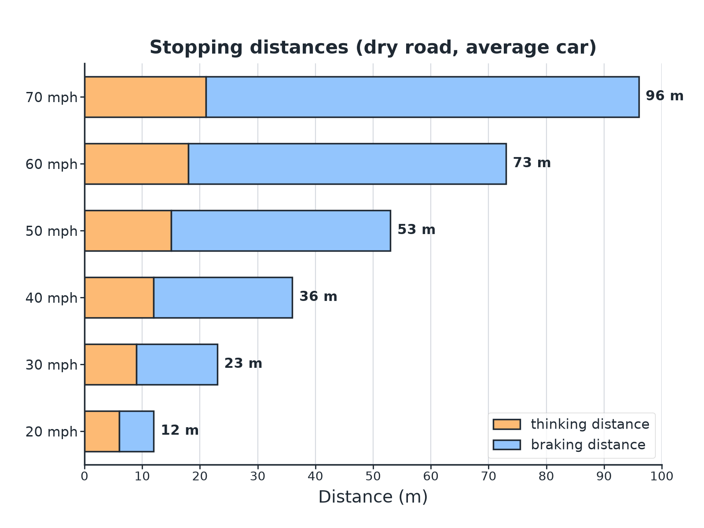
Thinking distance is proportional to speed; braking distance is not.
A stacked bar chart of thinking and braking distances for speeds from 20 to 70 miles per hour.
Reaction Time
Typical values and factors.
Idea | Detail
Typical reaction time | 0.2 s to 0.9 s
Increases with | Tiredness, drugs, alcohol, distractions such as a mobile phone
Thinking distance | s = vt: reaction time × speed
Measuring it | Ruler drop test: the distance the ruler falls gives the reaction time
Thinking Distance
A driver travelling at 15 m/s has a reaction time of 0.60 s. Calculate the thinking distance.

1. Write the equation
s = vt
2. Substitute
s = 15 × 0.60
3. Answer
s = 9.0 m
Answer: 9.0 m
Stopping Distance
A car has a thinking distance of 9.0 m and a braking distance of 14 m. Calculate the stopping distance.

1. Add
9.0 + 14 = 23 m
Answer: 23 m
Measuring Reaction Time
Describe the ruler drop method.

1. Set up
A partner holds a ruler vertically with the zero between your thumb and finger
2. Drop
Without warning they drop it, and you catch it as fast as you can
3. Measure
The distance fallen is read from the ruler
4. Convert
Use a table of distance against time, then repeat and find a mean
Answer: The longer the distance the ruler falls, the longer the reaction time.
Distractions
Explain the effect of a driver texting on the stopping distance.

1. Reaction time
Increases
2. Thinking distance
s = vt is greater
3. Stopping distance
So the total stopping distance is greater
Answer: A longer reaction time gives a longer thinking distance and so a longer stopping distance.
Why It Matters
Safety.
▸ Speed limits. Higher speed means a much greater stopping distance.
▸ Driver factors. Tiredness, alcohol, drugs and distractions raise reaction time.
▸ Estimates. Estimate how emergency stopping distance varies over typical speeds.
▸ Graphs. Interpret graphs of speed against stopping distance for different vehicles.
Key Terms
Stopping distance  Thinking distance plus braking distance. | Thinking distance  Distance travelled in the driver's reaction time.
Braking distance  Distance travelled while the brakes slow the vehicle. | Reaction time  The time between a stimulus and a response.
Distraction  Something that takes a driver's attention away. | Mean  The average of repeated readings.
Your Task: Reaction Test
12 minutes
In a ruler drop test a student's three results for the distance fallen are 14 cm, 16 cm and 15 cm. Calculate the mean. Explain why a tired driver would have a longer stopping distance.
1. Find the mean.
2. Link to s = vt.
A good answer shows: Mean = 15 cm. Tiredness increases reaction time, so thinking distance increases, increasing the stopping distance.
Note: Ask how to make the test fair.
Can I...?
☐ Define stopping distance.
☐ Define thinking and braking distance.
☐ Use s = vt.
☐ List factors affecting reaction time.
☐ Describe a reaction-time test.
☐ Read a stopping distance chart.
☐ Explain the effect of speed.
☐ Estimate stopping distances.
Summary
✓ Stopping = thinking + braking.
✓ Thinking distance: s = vt.
✓ Reaction time 0.2 to 0.9 s; increased by tiredness, drugs, alcohol, distractions.
✓ Higher speed gives a greater stopping distance.

EXAM FOCUS
A driver travels at 15 m/s with a reaction time of 0.60 s. Calculate the thinking distance. (2 marks)
Multiply speed by reaction time.
Exam Practice: Stopping distance and reaction time
Answer all questions. Use the mark allocation as a guide to how much to write. · 16 minutes
▸ Question 1 · 2 marks · Calculate. A car travels at 15 m/s. The driver's reaction time is 0.60 s. Calculate the thinking distance. Use the equation: distance = speed × time
▸ Question 2 · 2 marks · State. Give two factors that can increase a driver's reaction time.
▸ Question 3 · 4 marks · Use the chart. The chart shows the thinking distance and braking distance for a car at different speeds. (a) Use the chart to find the stopping distance…
▸ Question 4 · 3 marks · Explain. A driver is sending a text message while driving. Explain how this affects the stopping distance of the car.
▸ Question 5 · 4 marks · Describe. Describe an experiment to measure a person's reaction time using a ruler. Explain how the result is used.
Question 1 · 2 marks · Calculate
“A car travels at 15 m/s. The driver's reaction time is 0.60 s. Calculate the thinking distance. Use the equation: distance = speed × time”
HOW TO ANSWER IT Command word: Calculate. Worth 2 marks, so plan before writing.
Question 1 · mark scheme
2 marks available. Award a mark for each point made.
▸ Correct substitution. 1 mark
▸ 9.0 m. 1 mark
▸ Model answer. 15 × 0.60 = 9.0 m
Question 2 · 2 marks · State
“Give two factors that can increase a driver's reaction time.”
HOW TO ANSWER IT Command word: State. Worth 2 marks, so plan before writing.
Question 2 · mark scheme
2 marks available. Award a mark for each point made.
▸ First factor. 1 mark
▸ Second factor. 1 mark
▸ Model answer. Any two from: tiredness, alcohol, drugs, distractions (such as using a mobile phone).
Question 3 · 4 marks · Use the chart
The chart shows the thinking distance and braking distance for a car at different speeds. (a) Use the chart to find the stopping distance at 50 mph. (b) Describe how the thinking distance changes with speed. (c) Explain why the braking distance increases more quickly than the thinking distance. (4 marks) | 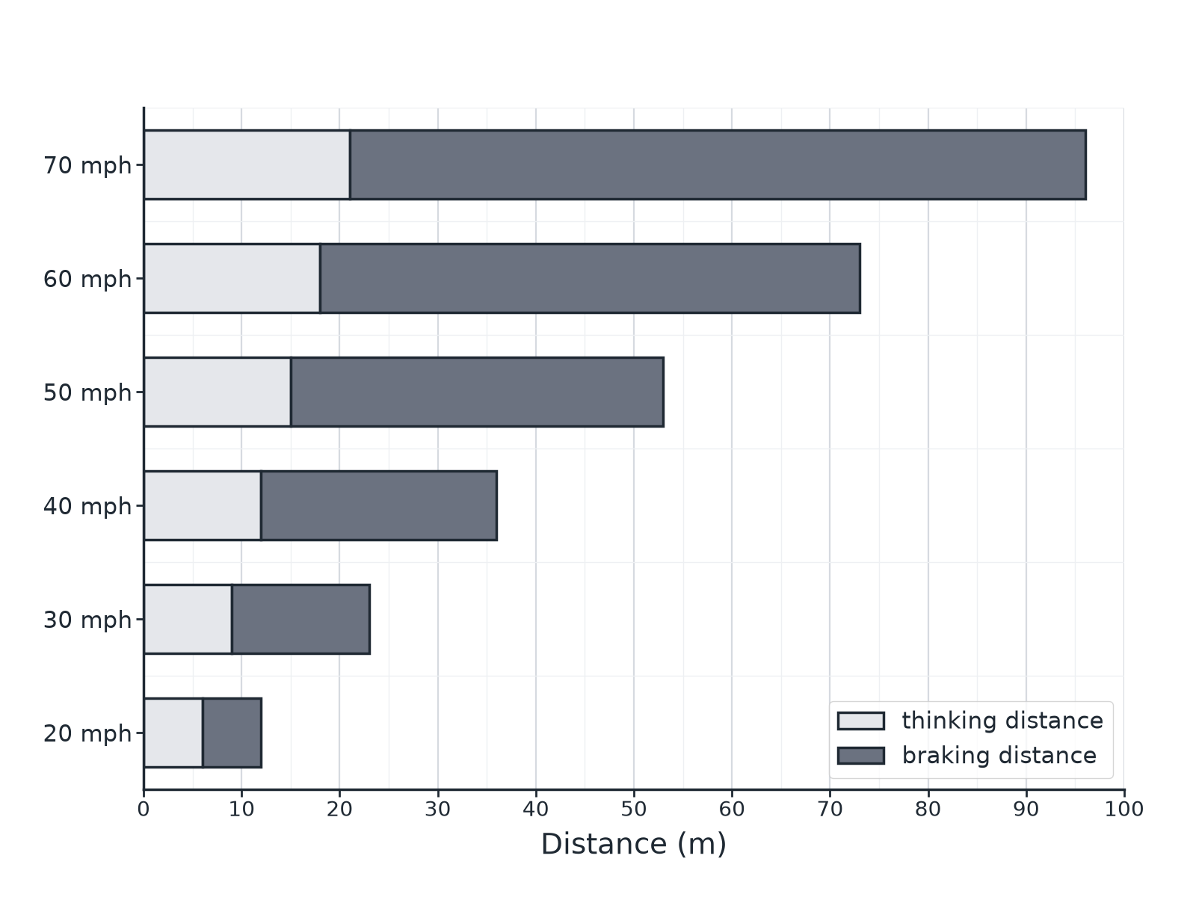

Question 3 · mark scheme
4 marks available. Award a mark for each point made.
▸ 53 m. 1 mark
▸ Thinking distance increases steadily or proportionally. 1 mark
▸ Braking distance depends on kinetic energy. 1 mark
▸ Kinetic energy ∝ speed². 1 mark
▸ Model answer. (a) About 53 m. (b) The thinking distance is directly proportional to the speed (it increases by equal amounts). (c) The braking distance depends on the kinetic energy of the car, which increases with the square of the speed.
Question 4 · 3 marks · Explain
“A driver is sending a text message while driving. Explain how this affects the stopping distance of the car.”
HOW TO ANSWER IT Command word: Explain. Worth 3 marks, so plan before writing.
Question 4 · mark scheme
3 marks available. Award a mark for each point made.
▸ Reaction time increases. 1 mark
▸ Thinking distance increases. 1 mark
▸ Stopping distance greater. 1 mark
▸ Model answer. The driver's attention is on the phone so their reaction time is longer. Thinking distance = speed × reaction time, so the thinking distance increases and the stopping distance is greater.
Question 5 · 4 marks · Describe
“Describe an experiment to measure a person's reaction time using a ruler. Explain how the result is used.”
HOW TO ANSWER IT Command word: Describe. Worth 4 marks, so plan before writing.
Question 5 · mark scheme
4 marks available. Award a mark for each point made.
▸ Ruler held and dropped without warning. 1 mark
▸ Distance fallen measured. 1 mark
▸ Converted to a reaction time. 1 mark
▸ Repeat and mean, compare conditions. 1 mark
▸ Model answer. A partner holds a ruler vertically with zero level with the person's thumb and finger. The ruler is dropped without warning and caught. The distance fallen is read off and converted to a time (from a table or calculation). The test is repeated and a mean found; different conditions (distractions) can be compared.

