AQA GCSE PHYSICS · PAPER 2 · FOUNDATION & HIGHER
Braking distances and large decelerations
Forces · Lesson 18 of 20
Teacher copy - includes the notes for whoever is teaching from it.
Warm-up
Answer each one, then check.
1. What is friction?
A force opposing motion
2. What is kinetic energy?
Energy stored in a moving object
3. What is deceleration?
Slowing down
4. What is work done?
Energy transferred by a force
5. What does the brake do to the wheel?
Uses friction to slow it
Learning Objectives
1. Explain how road conditions and the condition of the vehicle affect braking distance.
2. Explain how the brakes reduce the kinetic energy of a vehicle by work done against friction.
3. Explain why greater speed needs a greater braking force to stop in the same distance.
4. Explain the dangers of large decelerations, and estimate the forces involved (Higher tier).
Braking
When a force is applied to the brakes, the work done by the friction force between the brakes and the wheel reduces the kinetic energy of the vehicle and increases the temperature of the brakes.
The greater the braking force, the greater the deceleration. Large decelerations may cause brakes to overheat or a loss of control.
Braking Distance Depends on Conditions
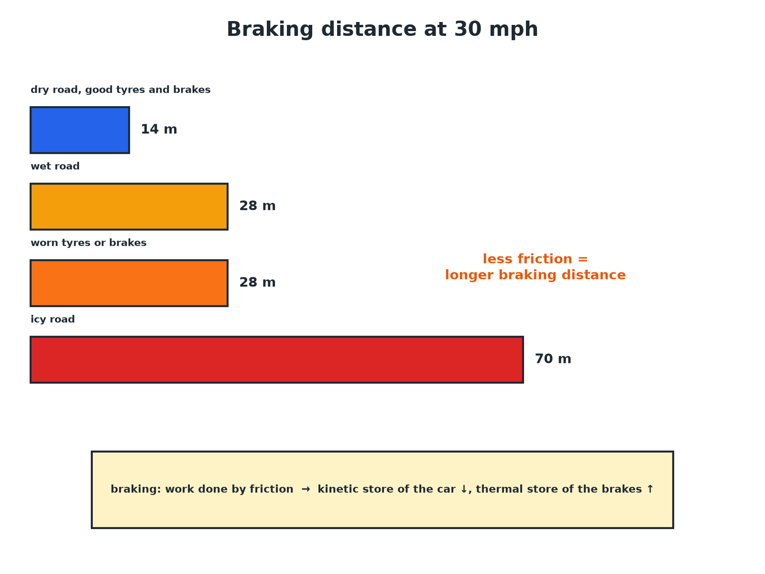
Less friction means a longer braking distance.
Bars comparing braking distances on dry, wet and icy roads and with worn tyres, and an energy transfer note.
What Affects Braking Distance
INCREASES BRAKING DISTANCE | REDUCES BRAKING DISTANCE
▸ Higher speed.  ▸ Wet or icy roads (less friction).  ▸ Worn tyres (less grip).  ▸ Worn brakes (less braking force).  ▸ A heavier vehicle (more kinetic energy). | ▸ Lower speed.  ▸ Dry road.  ▸ Good tyres with deep treads.  ▸ Well-maintained brakes.
Braking Force
A car of mass 1200 kg travelling at 25 m/s stops in 50 m. Estimate the average braking force.

1. Kinetic energy
E_k = ½mv² = 0.5 × 1200 × 25² = 375 000 J
2. Work done by the brakes
W = Fs, so F = 375 000 ÷ 50
3. Answer
F = 7500 N
Answer: About 7500 N.
Deceleration
For the same car, calculate the deceleration.

1. Use F = ma
a = F ÷ m = 7500 ÷ 1200
2. Answer
a = 6.25 m/s²
Answer: 6.25 m/s² (deceleration).
Dangers of Large Decelerations
Explain the dangers of a very large deceleration.

1. Large force
A large braking force is needed
2. Overheating
Brakes can overheat and fade
3. Loss of control
Tyres may lose grip and the car may skid
4. Passengers
Occupants experience large forces that can cause injury
Answer: Brakes overheat, the car can skid, and people in the vehicle are harmed.
Energy
What happens to the energy.
▸ Kinetic to thermal. Work done against friction transfers the car's kinetic energy to the thermal energy of the brakes and tyres.
▸ Speed. Doubling speed quadruples kinetic energy, so the braking distance is about four times as long.
▸ Braking force. A greater speed needs a greater braking force to stop in the same distance.
▸ Estimate (Higher). Use Fs = ½mv² to estimate forces.
Key Terms
Braking distance  The distance travelled while the brakes slow a vehicle. | Deceleration  A negative acceleration: slowing down.
Friction  A force between surfaces that opposes motion. | Kinetic energy  Energy of a moving object.
Brake fade  Loss of braking power when brakes overheat. | Skid  When tyres lose grip and slide.
Your Task: Why Is Wet Worse?
10 minutes
A car's braking distance at 30 mph is 14 m on a dry road and 28 m on a wet road. Explain the difference. Estimate the braking distance on a wet road at 60 mph, where the dry distance is 55 m.
1. Link to friction.
2. Use the ratio.
A good answer shows: Wet roads have less friction so the deceleration is less and the distance is longer. At 60 mph, wet braking distance is about double the dry: about 110 m.
Note: Ask about ice.
Can I...?
☐ Explain braking distance factors.
☐ Explain brakes and kinetic energy.
☐ Explain why speed matters.
☐ Explain wet and icy roads.
☐ Explain worn tyres and brakes.
☐ Explain brake overheating.
☐ Estimate a braking force.
☐ Explain dangers of deceleration.
Summary
✓ Braking: work done by friction reduces kinetic energy.
✓ Wet or icy roads and worn tyres reduce friction.
✓ Higher speed needs a larger braking force.
✓ Large decelerations can overheat brakes and cause skids.

EXAM FOCUS
Explain why the braking distance of a car is greater on a wet road than on a dry road. (2 marks)
Less friction between the tyres and the road.
Exam Practice: Braking distances and large decelerations
Answer all questions. Use the mark allocation as a guide to how much to write. · 16 minutes
▸ Question 1 · 2 marks · Explain. Explain why the braking distance of a car is greater on a wet road than on a dry road.
▸ Question 2 · 3 marks · Use the graph. The graph shows the braking distance of a car at different speeds on a dry road and on a wet road. (a) Use the graph to find the braking…
▸ Question 3 · 3 marks · Explain. When a car brakes, the brakes become hot. Explain why in terms of energy and work.
▸ Question 4 · 4 marks · Calculate. A car of mass 1000 kg travelling at 20 m/s is brought to rest in a distance of 40 m. Estimate the average braking force.
▸ Question 5 · 3 marks · Explain. Explain the dangers of a very large deceleration of a car.
Question 1 · 2 marks · Explain
“Explain why the braking distance of a car is greater on a wet road than on a dry road.”
HOW TO ANSWER IT Command word: Explain. Worth 2 marks, so plan before writing.
Question 1 · mark scheme
2 marks available. Award a mark for each point made.
▸ Less friction on a wet road. 1 mark
▸ Smaller deceleration, so longer distance. 1 mark
▸ Model answer. There is less friction between the tyres and the wet road, so the braking force (and deceleration) is smaller and the car takes a longer distance to stop.
Question 2 · 3 marks · Use the graph
The graph shows the braking distance of a car at different speeds on a dry road and on a wet road. (a) Use the graph to find the braking distance at 50 mph on a wet road. (b) Explain the difference between the two lines. (3 marks) | 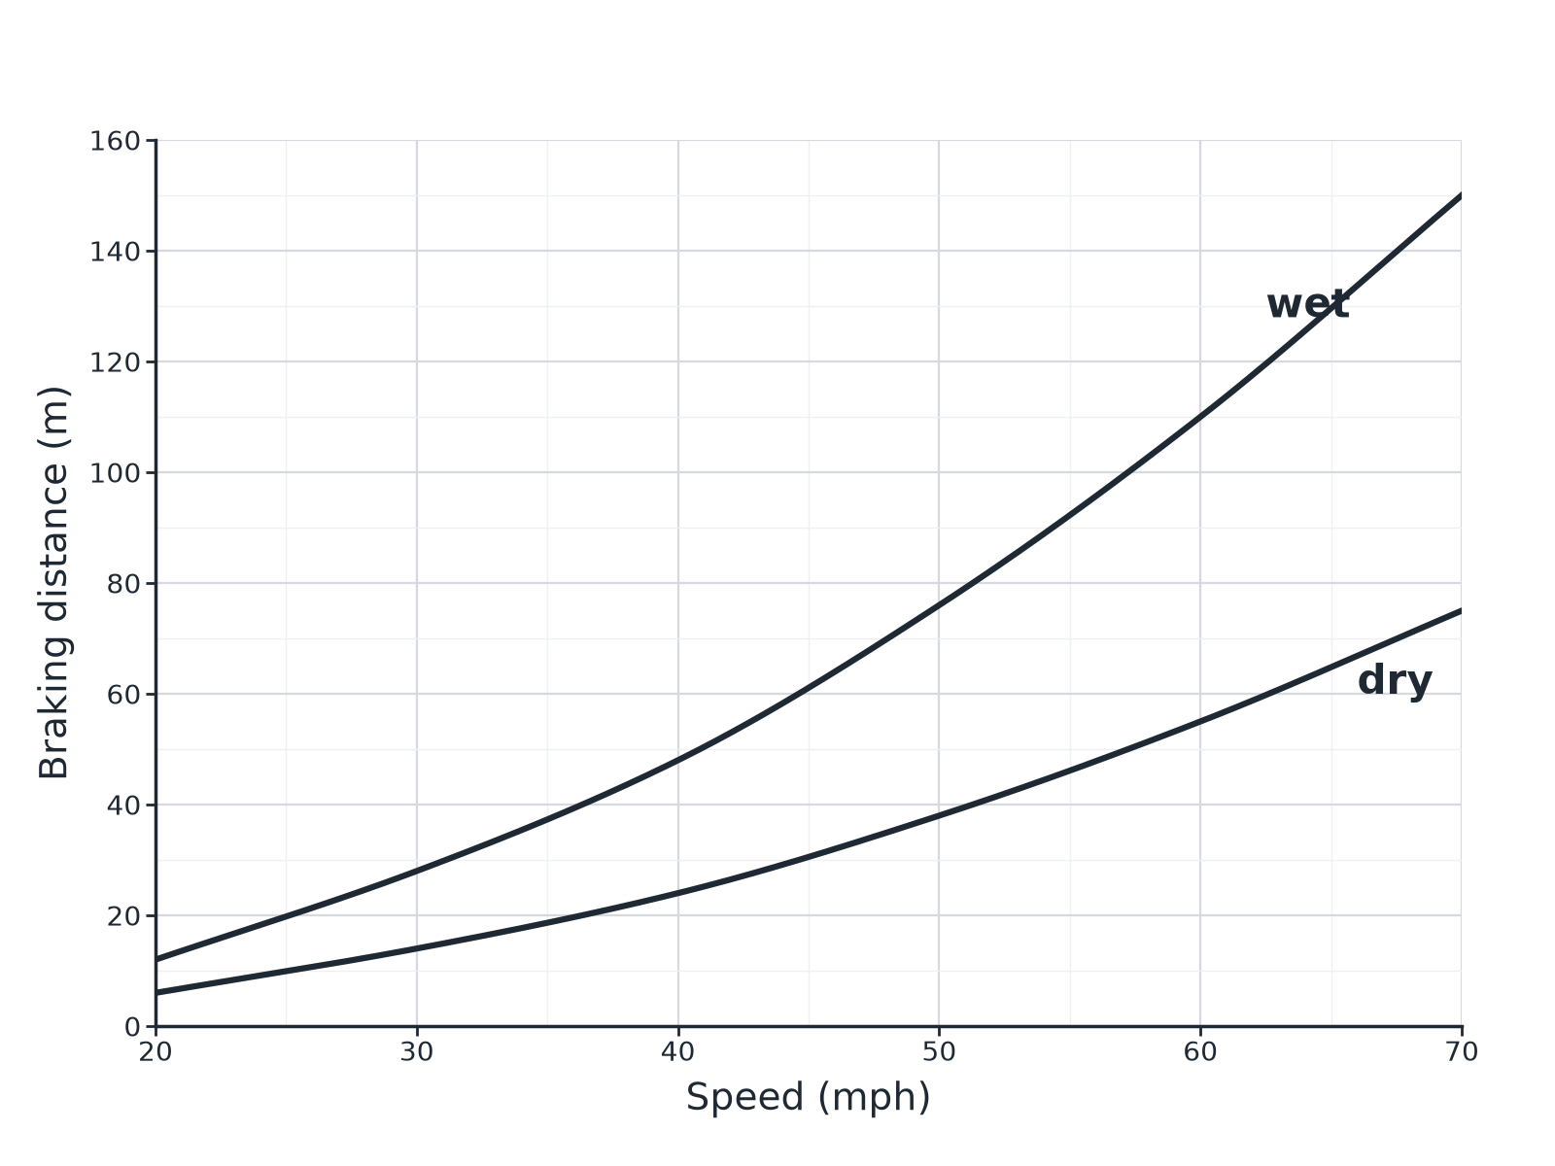

Question 2 · mark scheme
3 marks available. Award a mark for each point made.
▸ About 76 m (accept 72 to 80). 1 mark
▸ Less friction on the wet road. 1 mark
▸ So greater braking distance. 1 mark
▸ Model answer. (a) About 76 m. (b) There is less friction between the tyres and a wet road, so the braking distance is greater.
Question 3 · 3 marks · Explain
“When a car brakes, the brakes become hot. Explain why in terms of energy and work.”
HOW TO ANSWER IT Command word: Explain. Worth 3 marks, so plan before writing.
Question 3 · mark scheme
3 marks available. Award a mark for each point made.
▸ Work done by the friction force. 1 mark
▸ Kinetic energy store decreases. 1 mark
▸ Thermal energy store of brakes increases. 1 mark
▸ Model answer. The friction force between the brakes and the wheel does work. The kinetic energy of the car decreases and the thermal energy store of the brakes increases.
Question 4 · 4 marks · Calculate
“A car of mass 1000 kg travelling at 20 m/s is brought to rest in a distance of 40 m. Estimate the average braking force.”
HOW TO ANSWER IT Command word: Calculate. Worth 4 marks, so plan before writing.
Question 4 · mark scheme
4 marks available. Award a mark for each point made.
▸ Kinetic energy 200 000 J. 1 mark
▸ Work done = Fs. 1 mark
▸ Correct substitution. 1 mark
▸ 5000 N. 1 mark
▸ Model answer. E_k = 0.5 × 1000 × 20² = 200 000 J; F = 200 000 ÷ 40 = 5000 N
Question 5 · 3 marks · Explain
“Explain the dangers of a very large deceleration of a car.”
HOW TO ANSWER IT Command word: Explain. Worth 3 marks, so plan before writing.
Question 5 · mark scheme
3 marks available. Award a mark for each point made.
▸ Brakes overheat. 1 mark
▸ Loss of control or skidding. 1 mark
▸ Risk of injury. 1 mark
▸ Model answer. A large deceleration needs a large braking force, which can cause the brakes to overheat, the tyres to lose grip and the car to skid, and it may injure the people in the car.

