AQA GCSE PHYSICS · PAPER 2 · HIGHER TIER ONLY
Changes in momentum
Forces · Lesson 20 of 20
Teacher copy - includes the notes for whoever is teaching from it.
Warm-up
Answer each one, then check.
1. What is momentum?
Mass times velocity
2. What is acceleration?
Change in velocity divided by time, a = Δv ÷ t
3. What is F = ma?
Resultant force equals mass times acceleration
4. Give a safety device in a car.
Seat belt, airbag or crumple zone
5. What is a collision?
Two objects hitting each other
Learning Objectives
1. Explain that force equals the rate of change of momentum.
2. Apply F = mΔv ÷ Δt.
3. Explain safety features in terms of increasing the time of a collision.
4. Explain how changes in force, mass, velocity and time are related.
Rate Of Change Of Momentum
force = change in momentum ÷ time taken F = mΔv/Δt
Combining F = ma and a = (v − u)/t gives F = mΔv/Δt, where mΔv is the change in momentum. This equation is given on the equation sheet.
Why Crumple Zones Help
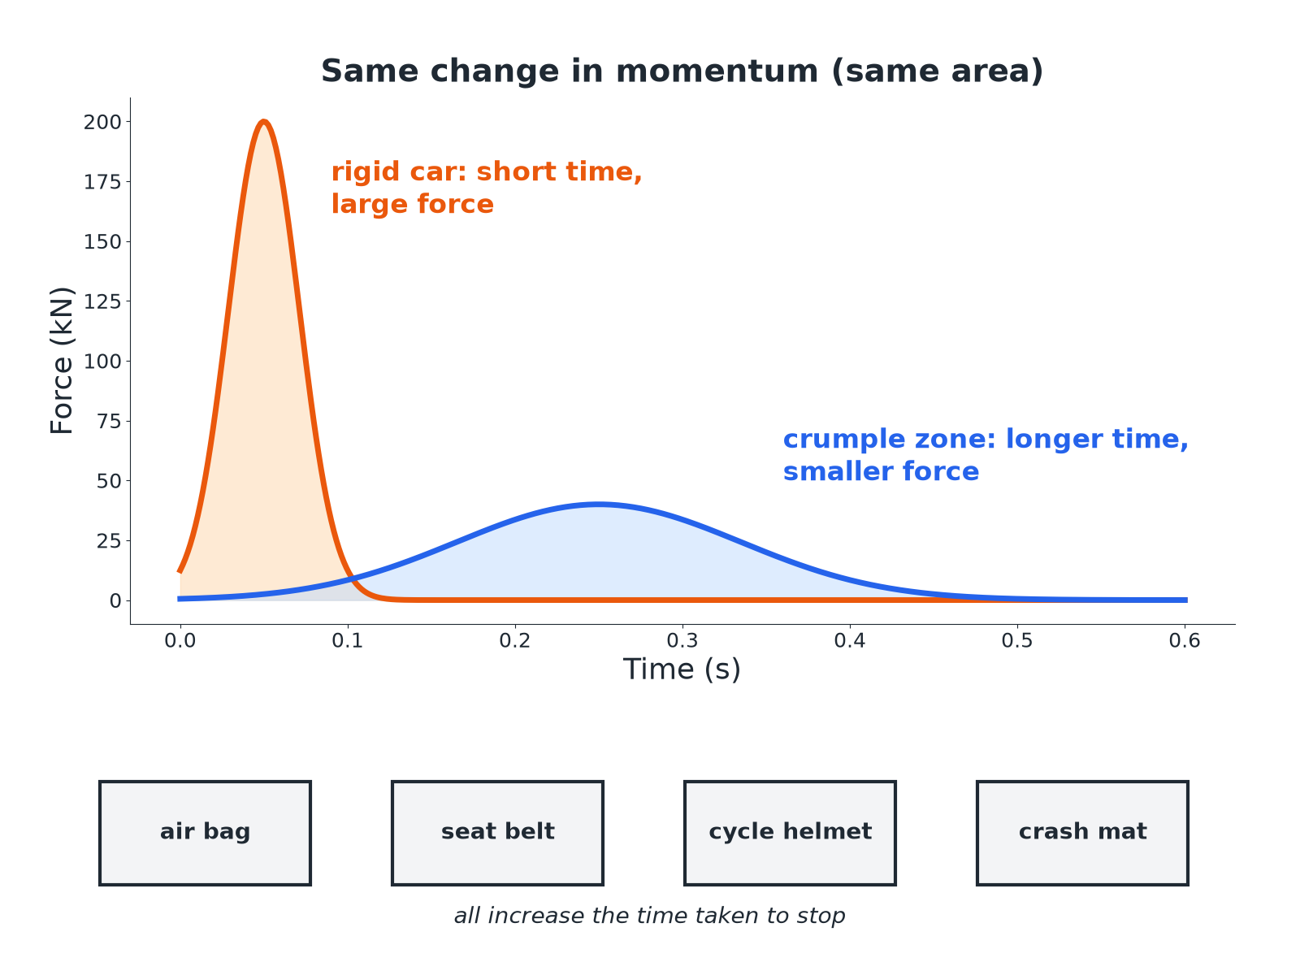
A longer time means a smaller force for the same momentum change.
Two force-time curves showing a smaller peak force when the collision time is longer.
Force in a Crash
A car of mass 1000 kg travelling at 20 m/s stops in 0.50 s. Calculate the average force.

1. Change in momentum
1000 × 20 = 20 000 kg m/s
2. Substitute
F = 20 000 ÷ 0.50
3. Answer
F = 40 000 N
Answer: 40 000 N
Increasing the Time
The same car is stopped in 0.10 s by hitting a wall. Calculate the average force and compare with the answer above.

1. Substitute
F = 20 000 ÷ 0.10 = 200 000 N
2. Compare
Five times greater
Answer: 200 000 N: a much shorter time gives a much greater force.
Safety Features
Explain how an air bag reduces injury in a collision.

1. Momentum
The change in the person's momentum is the same
2. Time
The air bag increases the time for the person to stop
3. Force
F = mΔv ÷ Δt: longer time gives a smaller force
Answer: It increases the collision time so the average force on the person is smaller.
Other Safety Features
Seat belts  Stretch slightly, increasing the stopping time. | Crumple zones  Deform on impact, increasing the stopping time.
Cycle helmets  The foam compresses, increasing the stopping time. | Crash mats and playground surfaces  Cushion the landing, increasing the time.
Key Points
For exam answers.
▸ Same momentum change. The change in momentum is the same, whatever the time.
▸ Force depends on time. Smaller rate of change of momentum means smaller force.
▸ Say it clearly. 'Increases the time of the collision, so decreases the force.'
▸ Units. Force in N, momentum in kg m/s, time in s.
Key Terms
Rate of change of momentum  Change in momentum divided by time. | Air bag  A cushion that inflates in a collision.
Crumple zone  Part of a vehicle designed to deform in a crash. | Seat belt  A strap that holds a passenger and stretches slightly.
Impact time  The time a collision lasts. | Average force  The mean force over the collision time.
Your Task: Ball Catch
10 minutes
A 0.40 kg ball moving at 15 m/s is stopped by a catcher in 0.020 s. A second catcher uses a glove that stops it in 0.10 s. Calculate the force in each case.
1. Find the momentum change.
2. Divide by time.
A good answer shows: Change in momentum = 6.0 kg m/s. First: 300 N. Second: 60 N.
Note: Ask why a cricketer pulls their hands back when catching.
Can I...?
☐ State F = mΔv ÷ Δt.
☐ Calculate a change in momentum.
☐ Calculate a force.
☐ Explain an air bag.
☐ Explain a seat belt.
☐ Explain a crumple zone.
☐ Explain a cycle helmet.
☐ Explain a crash mat.
Summary
✓ F = mΔv ÷ Δt.
✓ Longer collision time means a smaller force.
✓ Air bags, seat belts, crumple zones, helmets, crash mats.
✓ Change in momentum is the same.

EXAM FOCUS
Explain how a crumple zone reduces the force on the passengers. (3 marks)
Increases the time of the collision.
Exam Practice: Changes in momentum
Answer all questions. Use the mark allocation as a guide to how much to write. · 17 minutes
▸ Question 1 · 3 marks · Calculate. A car of mass 1000 kg travelling at 20 m/s stops in 0.50 s. Calculate the average force on the car. Use the equation: force = mass × change…
▸ Question 2 · 3 marks · Explain. Explain how an air bag reduces the force on a driver in a collision.
▸ Question 3 · 3 marks · Explain. A cyclist wears a helmet containing soft foam. Explain how the helmet reduces the risk of head injury in a fall.
▸ Question 4 · 4 marks · Calculate. A ball of mass 0.40 kg moving at 15 m/s is caught and stopped in 0.020 s. Calculate the average force on the ball. Then state the force if…
▸ Question 5 · 3 marks · Explain. A gymnast lands on a thick crash mat rather than a hard floor. Use the idea of rate of change of momentum to explain why the mat reduces…
Question 1 · 3 marks · Calculate
“A car of mass 1000 kg travelling at 20 m/s stops in 0.50 s. Calculate the average force on the car. Use the equation: force = mass × change in velocity ÷ time”
HOW TO ANSWER IT Command word: Calculate. Worth 3 marks, so plan before writing.
Question 1 · mark scheme
3 marks available. Award a mark for each point made.
▸ Change in momentum 20 000 kg m/s. 1 mark
▸ Correct substitution. 1 mark
▸ 40 000 N. 1 mark
▸ Model answer. F = 1000 × 20 ÷ 0.50 = 40 000 N
Question 2 · 3 marks · Explain
“Explain how an air bag reduces the force on a driver in a collision.”
HOW TO ANSWER IT Command word: Explain. Worth 3 marks, so plan before writing.
Question 2 · mark scheme
3 marks available. Award a mark for each point made.
▸ Increases the time to stop. 1 mark
▸ Same change in momentum. 1 mark
▸ Force = change in momentum ÷ time, so smaller force. 1 mark
▸ Model answer. The air bag increases the time taken for the driver to come to rest. The change in momentum is the same, so the force (change in momentum ÷ time) is smaller.
Question 3 · 3 marks · Explain
“A cyclist wears a helmet containing soft foam. Explain how the helmet reduces the risk of head injury in a fall.”
HOW TO ANSWER IT Command word: Explain. Worth 3 marks, so plan before writing.
Question 3 · mark scheme
3 marks available. Award a mark for each point made.
▸ Foam compresses. 1 mark
▸ Increases the stopping time. 1 mark
▸ Reduces the force. 1 mark
▸ Model answer. The foam compresses, so the head takes longer to stop. The change in momentum is the same, so the force on the head is smaller.
Question 4 · 4 marks · Calculate
“A ball of mass 0.40 kg moving at 15 m/s is caught and stopped in 0.020 s. Calculate the average force on the ball. Then state the force if a soft glove makes the stopping time 0.10 s.”
HOW TO ANSWER IT Command word: Calculate. Worth 4 marks, so plan before writing.
Question 4 · mark scheme
4 marks available. Award a mark for each point made.
▸ 6.0 kg m/s. 1 mark
▸ 300 N. 1 mark
▸ 60 N. 1 mark
▸ Comparison: longer time, smaller force. 1 mark
▸ Model answer. Change in momentum = 0.40 × 15 = 6.0; F = 6.0 ÷ 0.020 = 300 N; with the glove 6.0 ÷ 0.10 = 60 N
Question 5 · 3 marks · Explain
“A gymnast lands on a thick crash mat rather than a hard floor. Use the idea of rate of change of momentum to explain why the mat reduces the risk of injury.”
HOW TO ANSWER IT Command word: Explain. Worth 3 marks, so plan before writing.
Question 5 · mark scheme
3 marks available. Award a mark for each point made.
▸ Mat increases the stopping time. 1 mark
▸ Same change in momentum. 1 mark
▸ Smaller rate of change of momentum, smaller force. 1 mark
▸ Model answer. The mat increases the time taken to stop the gymnast. The change in momentum is the same so the rate of change of momentum, and therefore the force, is smaller.

