AQA GCSE PHYSICS · PAPER 2 · HIGHER TIER ONLY
Ultrasound and seismic waves
Waves · Lesson 6 of 12
Teacher copy - includes the notes for whoever is teaching from it.
Warm-up
Answer each one, then check.
1. What is an echo?
A reflected sound
2. What is the speed equation?
v = s ÷ t
3. What is ultrasound?
Sound with frequency above 20 kHz
4. What causes an earthquake?
Movement of the Earth's tectonic plates
5. Is a P-wave longitudinal or transverse?
Longitudinal
Learning Objectives
1. Explain how ultrasound is partially reflected at boundaries and used for imaging.
2. Use the time taken for an echo to calculate a distance.
3. Describe P-waves and S-waves and how they provide evidence about the Earth's structure.
4. Describe echo sounding.
Detection And Exploration
Ultrasound waves are partially reflected when they meet a boundary between two media. The time taken for the echo to return can be used to work out how far away the boundary is.
Seismic waves from earthquakes (P-waves and S-waves) give evidence of the structure of the Earth.
Echo Sounding
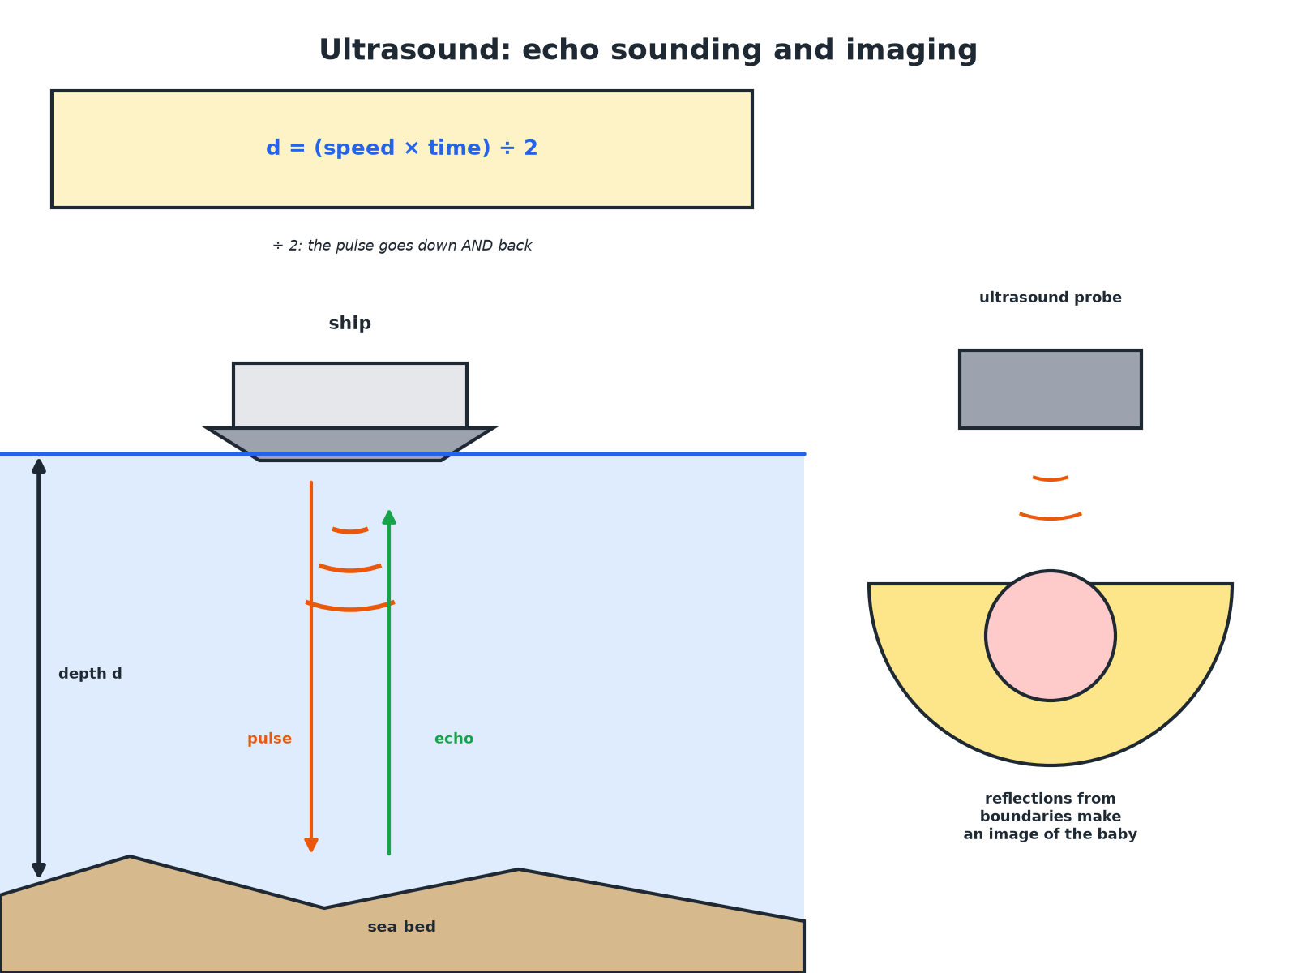
The pulse travels to the boundary and back.
A ship using ultrasound echoes to find the depth of the sea, and an ultrasound probe for medical imaging.
Seismic Waves and the Earth
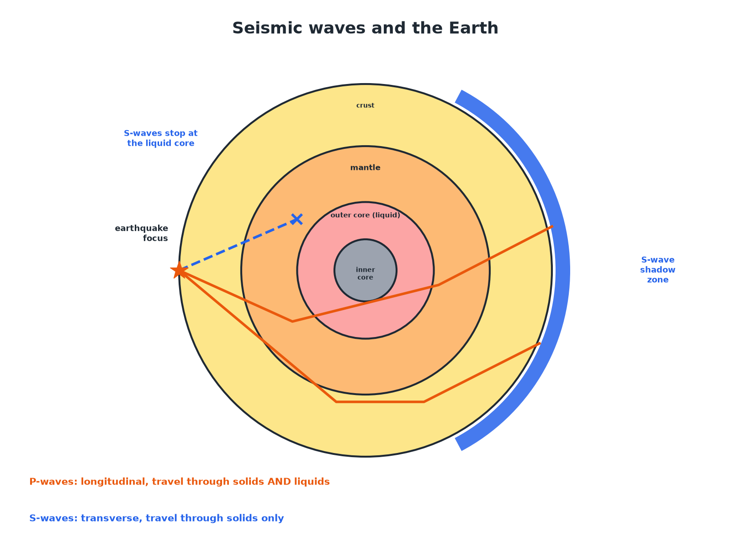
S-waves cannot pass through the liquid outer core.
The Earth's layers with P-waves passing through the liquid core and S-waves stopped by it, leaving a shadow zone.
P-waves and S-waves
P-WAVES | S-WAVES
▸ Longitudinal seismic waves.  ▸ Travel through solids and liquids.  ▸ Travel faster than S-waves.  ▸ Speed changes between solids and liquids. | ▸ Transverse seismic waves.  ▸ Cannot travel through liquids.  ▸ Travel more slowly.  ▸ Stopped by the liquid outer core.
Echo Sounding
A ship sends an ultrasound pulse down and receives the echo 0.40 s later. The speed of sound in sea water is 1500 m/s. Calculate the depth.

1. Distance there and back
1500 × 0.40 = 600 m
2. Depth is half of this
600 ÷ 2 = 300 m
Answer: 300 m
Medical Ultrasound
An ultrasound pulse is reflected from a boundary inside the body after 0.000060 s. The speed in tissue is 1500 m/s. Calculate the depth of the boundary.

1. Total distance
1500 × 0.000060 = 0.090 m
2. Depth
0.090 ÷ 2 = 0.045 m = 4.5 cm
Answer: 4.5 cm
Evidence for the Core
Explain how S-waves give evidence that part of the Earth's core is liquid.

1. S-waves
Cannot travel through liquids
2. Observation
They are not detected on the far side of the Earth
3. Conclusion
Part of the core (the outer core) must be liquid
Answer: S-waves are blocked by the outer core, so it must be liquid.
Uses
Other examples.
▸ Medical imaging. Ultrasound scans of foetuses and organs are safe (non-ionising).
▸ Industrial imaging. Ultrasound detects cracks in metal.
▸ Echo sounding. Used for water depth and to detect fish or shipwrecks.
▸ Seismology. New evidence from seismic waves led to discoveries about parts of the Earth that cannot be observed directly.
Key Terms
Ultrasound  Sound with frequency above 20 kHz. | Echo  A reflection of a sound wave.
Seismic wave  A wave produced by an earthquake. | P-wave  A longitudinal seismic wave.
S-wave  A transverse seismic wave that cannot travel through liquids. | Echo sounding  Using reflected sound to find depth.
Your Task: Depth Finder
10 minutes
A boat sends out ultrasound and hears the echo after 0.20 s (speed 1500 m/s). Calculate the depth of the water. Explain why the time must be halved.
1. Use s = vt.
2. Halve the distance.
A good answer shows: Distance there and back = 1500 × 0.20 = 300 m; depth = 150 m. The pulse travels to the bottom and back.
Note: Ask what would happen if the speed were different.
Can I...?
☐ Define ultrasound.
☐ Explain echo timing.
☐ Calculate depth by echo.
☐ Describe P-waves.
☐ Describe S-waves.
☐ Explain the liquid core.
☐ Give uses of ultrasound.
☐ Explain why the time is halved.
Summary
✓ Ultrasound is partially reflected at boundaries.
✓ Depth = speed × time ÷ 2.
✓ P-waves: longitudinal; S-waves: transverse, not through liquids.
✓ Seismic evidence shows a liquid outer core.

EXAM FOCUS
A ship sends out ultrasound and receives the echo 0.40 s later. The speed is 1500 m/s. Calculate the depth of the sea. (3 marks)
Distance there and back, then halve.
Exam Practice: Ultrasound and seismic waves
Answer all questions. Use the mark allocation as a guide to how much to write. · 16 minutes
▸ Question 1 · 3 marks · Calculate. A ship sends a pulse of ultrasound towards the sea bed and detects the echo 0.40 s later. The speed of sound in sea water is 1500 m/s…
▸ Question 2 · 3 marks · Explain. Explain how ultrasound waves can be used to produce an image of an organ in the body.
▸ Question 3 · 4 marks · Explain. S-waves cannot travel through the Earth's outer core. Explain what this tells scientists about the outer core, and how the properties of…
▸ Question 4 · 2 marks · State. State two differences between P-waves and S-waves.
▸ Question 5 · 3 marks · Explain. Suggest why ultrasound is used rather than X-rays to scan an unborn baby.
Question 1 · 3 marks · Calculate
“A ship sends a pulse of ultrasound towards the sea bed and detects the echo 0.40 s later. The speed of sound in sea water is 1500 m/s. Calculate the depth of the sea at this point.”
HOW TO ANSWER IT Command word: Calculate. Worth 3 marks, so plan before writing.
Question 1 · mark scheme
3 marks available. Award a mark for each point made.
▸ Correct substitution. 1 mark
▸ 600 m. 1 mark
▸ 300 m (halved). 1 mark
▸ Model answer. Distance there and back = 1500 × 0.40 = 600 m; depth = 600 ÷ 2 = 300 m.
Question 2 · 3 marks · Explain
“Explain how ultrasound waves can be used to produce an image of an organ in the body.”
HOW TO ANSWER IT Command word: Explain. Worth 3 marks, so plan before writing.
Question 2 · mark scheme
3 marks available. Award a mark for each point made.
▸ Partially reflected at boundaries. 1 mark
▸ Time taken for echoes measured. 1 mark
▸ Distance calculated and used to form an image. 1 mark
▸ Model answer. Ultrasound is partially reflected at boundaries between different tissues. The time for the echoes to return to a detector is used to work out the distance to each boundary, and the signals are used to build up an image.
Question 3 · 4 marks · Explain
“S-waves cannot travel through the Earth's outer core. Explain what this tells scientists about the outer core, and how the properties of P-waves give further evidence about the Earth's structure.”
HOW TO ANSWER IT Command word: Explain. Worth 4 marks, so plan before writing.
Question 3 · mark scheme
4 marks available. Award a mark for each point made.
▸ S-waves cannot travel through liquids. 1 mark
▸ So the outer core is liquid. 1 mark
▸ P-waves travel through solids and liquids at different speeds. 1 mark
▸ Changes show boundaries between layers. 1 mark
▸ Model answer. S-waves cannot travel through liquids, so the outer core must be liquid. P-waves travel through solids and liquids at different speeds, so their changes in speed and direction show the boundaries between layers of different materials.
Question 4 · 2 marks · State
“State two differences between P-waves and S-waves.”
HOW TO ANSWER IT Command word: State. Worth 2 marks, so plan before writing.
Question 4 · mark scheme
2 marks available. Award a mark for each point made.
▸ Longitudinal and transverse. 1 mark
▸ A second difference. 1 mark
▸ Model answer. P-waves are longitudinal and S-waves are transverse. P-waves travel through solids and liquids but S-waves travel only through solids (or P-waves are faster).
Question 5 · 3 marks · Explain
“Suggest why ultrasound is used rather than X-rays to scan an unborn baby.”
HOW TO ANSWER IT Command word: Explain. Worth 3 marks, so plan before writing.
Question 5 · mark scheme
3 marks available. Award a mark for each point made.
▸ Ultrasound non-ionising. 1 mark
▸ X-rays ionising. 1 mark
▸ Could damage cells of the baby. 1 mark
▸ Model answer. Ultrasound is non-ionising so it does not damage cells, whereas X-rays are ionising and could cause mutations.

