AQA GCSE PHYSICS · PAPER 2 · FOUNDATION & HIGHER
Properties and hazards of electromagnetic waves
Waves · Lesson 8 of 12
Teacher copy - includes the notes for whoever is teaching from it.
Warm-up
Answer each one, then check.
1. What is ionising radiation?
Radiation that can remove electrons from atoms
2. What is an alternating current?
A current that changes direction repeatedly
3. Where do gamma rays come from?
The nucleus of an atom
4. What is a mutation?
A change in the DNA of a cell
5. What is radiation dose measured in?
Sieverts (Sv)
Learning Objectives
1. Explain that changes in atoms and nuclei can produce and absorb electromagnetic waves.
2. Explain how radio waves are produced and detected (Higher tier).
3. Describe the hazardous effects of ultraviolet, X-rays and gamma rays.
4. Use data on radiation dose to draw conclusions about risk.
Production And Hazards
Changes in atoms and in the nuclei of atoms can result in electromagnetic waves being generated or absorbed over a wide frequency range. Gamma rays originate from changes in the nucleus.
Ultraviolet, X-rays and gamma rays can have hazardous effects on body tissue. The effects depend on the type of radiation and the size of the dose.
Radio Waves: Producing and Detecting (Higher)
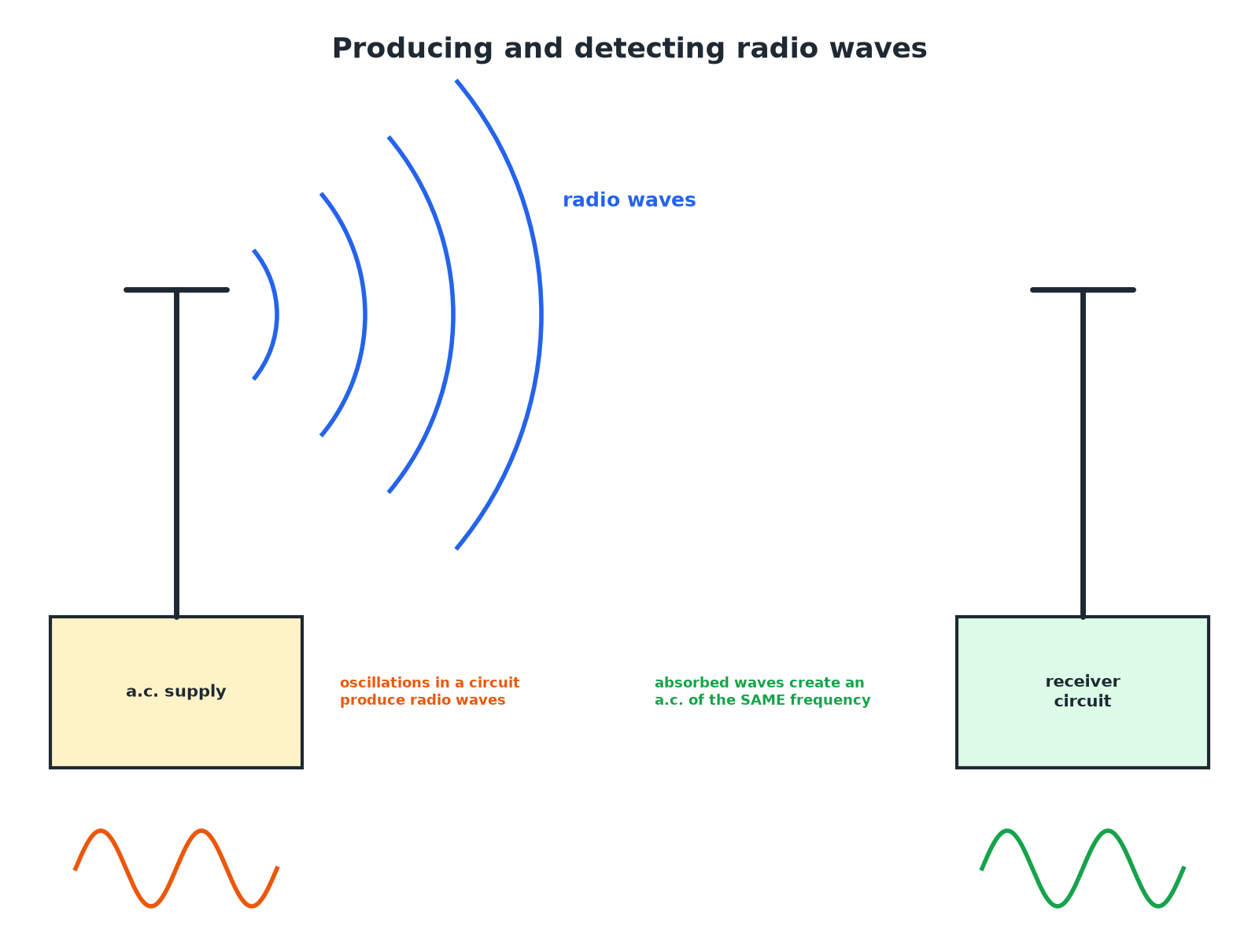
The received current has the same frequency as the wave.
A radio transmitter producing waves from an alternating current and a receiver aerial in which the waves create an alternating current.
Hazards of Electromagnetic Waves
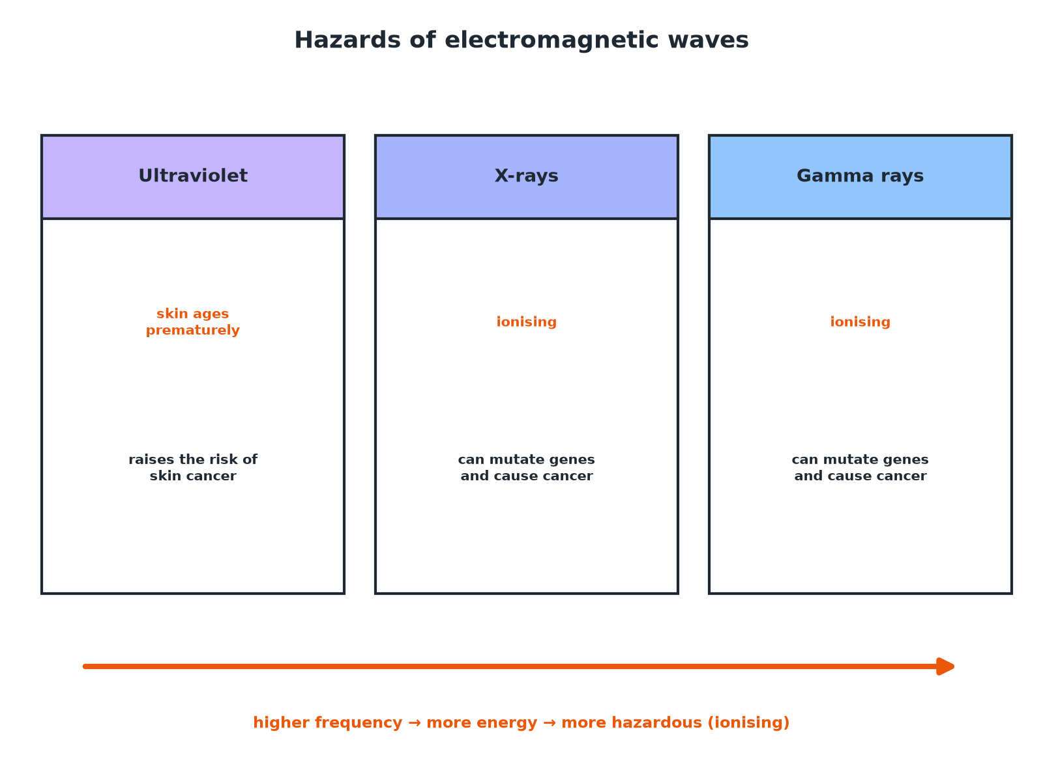
Higher frequency waves carry more energy and can ionise.
Hazards of ultraviolet, X-rays and gamma rays: skin damage, cancer and gene mutation.
Hazards
Learn the effects.
Radiation | Hazardous effect
Ultraviolet | Premature skin ageing; increased risk of skin cancer; eye damage
X-rays | Ionising: can mutate genes and cause cancer
Gamma rays | Ionising: can mutate genes and cause cancer
Producing Radio Waves (Higher)
Explain how radio waves are produced and how they can be detected.

1. Transmitter
Oscillations (an alternating current) in an electrical circuit produce radio waves
2. Receiver
When radio waves are absorbed by an aerial, they create an alternating current in the circuit
3. Frequency
The current has the same frequency as the radio wave
Answer: An alternating current produces radio waves; absorbed waves produce an alternating current of the same frequency.
Risk and Dose
A chest X-ray gives a dose of 0.02 mSv and a CT scan of the chest gives 7 mSv. Compare the doses.

1. Ratio
7 ÷ 0.02 = 350
2. Comparison
The CT scan gives 350 times the dose
Answer: The CT scan gives a dose 350 times greater, so a greater risk.
Sources of EM Waves
Explain where gamma rays come from.

1. Nucleus
An unstable nucleus changes to become more stable
2. Emission
It emits gamma radiation
3. Atoms
Changes in electron energy levels produce other parts of the spectrum
Answer: Gamma rays are emitted by changes in the nucleus of an atom.
Dose
Radiation dose units.
▸ Sievert. Dose is measured in sieverts (Sv); 1000 mSv = 1 Sv.
▸ What it shows. A measure of the risk of harm from exposure.
▸ Depends on. The type of radiation and the size of the dose.
▸ No need to recall. You do not need to recall the unit of dose.
Key Terms
Ionising radiation  Radiation that can remove electrons from atoms. | Radiation dose  A measure of the risk of harm from exposure to radiation.
Sievert  The unit of radiation dose. | Millisievert  One thousandth of a sievert.
Mutation  A change in the genes of a cell. | Aerial  A device that transmits or receives radio waves.
Your Task: Compare the Doses
10 minutes
A dental X-ray gives 0.005 mSv and a flight from London to New York gives about 0.08 mSv. Calculate how many dental X-rays have the same dose as the flight. Do you think the risk is large?
1. Divide the doses.
2. Comment on the size.
A good answer shows: 0.08 ÷ 0.005 = 16 dental X-rays. Both doses are very small, so the risk is small.
Note: Discuss benefit versus risk.
Can I...?
☐ Explain how gamma rays are produced.
☐ Explain how radio waves are produced.
☐ Explain how radio waves are detected.
☐ Name hazards of UV.
☐ Name hazards of X-rays.
☐ Define radiation dose.
☐ Compare doses.
☐ Draw conclusions from data.
Summary
✓ UV: premature ageing and skin cancer.
✓ X-rays and gamma rays: ionising; can mutate genes and cause cancer.
✓ Radio waves produced by oscillations in circuits (Higher).
✓ Dose measured in sieverts.

EXAM FOCUS
State one hazard of exposure to ultraviolet radiation. (1 mark)
Skin cancer or premature skin ageing.
Exam Practice: Properties and hazards of electromagnetic waves
Answer all questions. Use the mark allocation as a guide to how much to write. · 14 minutes
▸ Question 1 · 2 marks · State. Give two hazards of exposure to ultraviolet radiation.
▸ Question 2 · 3 marks · Explain. X-rays and gamma rays are described as ionising radiation. Explain why they are a hazard to human health.
▸ Question 3 · 4 marks · Use the chart. The chart shows the radiation dose a patient receives from different medical procedures. (a) Which procedure gives the greatest dose? (b)…
▸ Question 4 · 3 marks · Explain. Explain how radio waves are produced in a transmitter and how they can be detected by a receiver.
▸ Question 5 · 1 mark · State. State where gamma rays originate.
Question 1 · 2 marks · State
“Give two hazards of exposure to ultraviolet radiation.”
HOW TO ANSWER IT Command word: State. Worth 2 marks, so plan before writing.
Question 1 · mark scheme
2 marks available. Award a mark for each point made.
▸ First hazard. 1 mark
▸ Second hazard. 1 mark
▸ Model answer. Any two from: premature skin ageing; increased risk of skin cancer; damage to the eyes.
Question 2 · 3 marks · Explain
“X-rays and gamma rays are described as ionising radiation. Explain why they are a hazard to human health.”
HOW TO ANSWER IT Command word: Explain. Worth 3 marks, so plan before writing.
Question 2 · mark scheme
3 marks available. Award a mark for each point made.
▸ Ionising: remove electrons. 1 mark
▸ Damage or mutate genes or cells. 1 mark
▸ Can cause cancer. 1 mark
▸ Model answer. They can remove electrons from atoms and damage or mutate the genes in cells, which can lead to cancer.
Question 3 · 4 marks · Use the chart
The chart shows the radiation dose a patient receives from different medical procedures. (a) Which procedure gives the greatest dose? (b) Calculate how many times greater the dose from a chest CT scan is than from a chest X-ray. (c) Suggest why a doctor might still use a CT scan. (4 marks) | 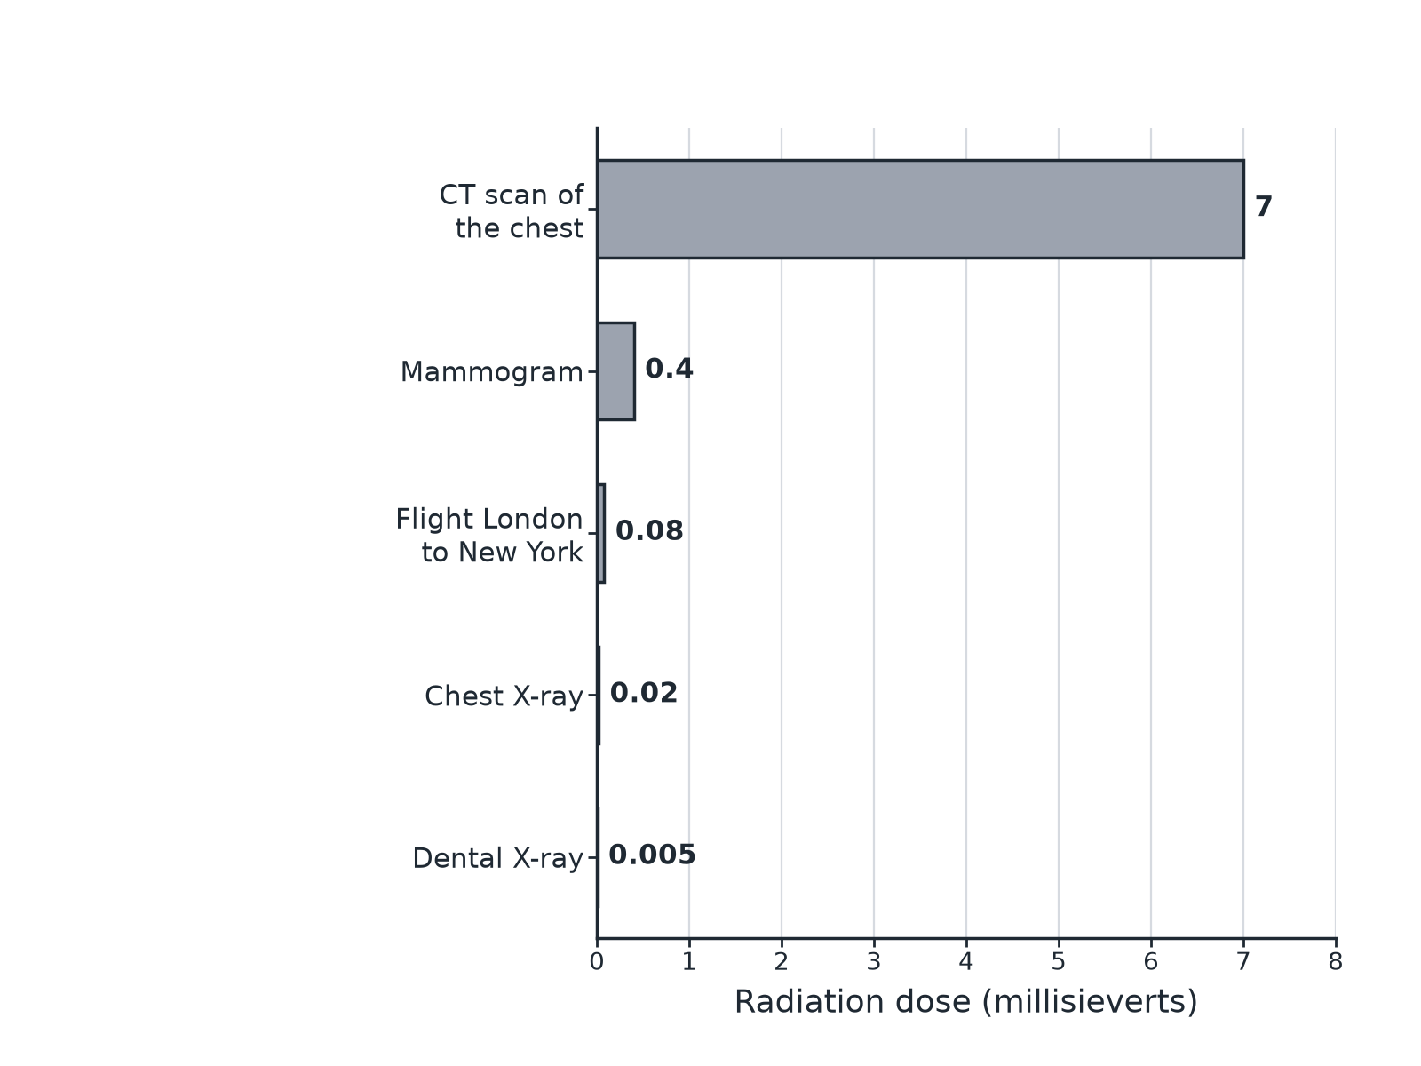

Question 3 · mark scheme
4 marks available. Award a mark for each point made.
▸ Chest CT scan. 1 mark
▸ 7 ÷ 0.02. 1 mark
▸ 350 times. 1 mark
▸ Benefit outweighs risk or more information. 1 mark
▸ Model answer. (a) CT scan of the chest. (b) 7 ÷ 0.02 = 350 times. (c) It gives more detailed information, so the benefit of diagnosis outweighs the small increase in risk.
Question 4 · 3 marks · Explain
“Explain how radio waves are produced in a transmitter and how they can be detected by a receiver.”
HOW TO ANSWER IT Command word: Explain. Worth 3 marks, so plan before writing.
Question 4 · mark scheme
3 marks available. Award a mark for each point made.
▸ Oscillations in a circuit produce radio waves. 1 mark
▸ Waves absorbed by the aerial. 1 mark
▸ Produces an alternating current of the same frequency. 1 mark
▸ Model answer. An alternating current (oscillations) in the transmitter circuit produces radio waves of the same frequency. When the radio waves are absorbed by the receiver's aerial they create an alternating current with the same frequency as the wave.
Question 5 · 1 mark · State
“State where gamma rays originate.”
HOW TO ANSWER IT Command word: State. Worth 1 mark, so plan before writing.
Question 5 · mark scheme
1 mark available. Award a mark for each point made.
▸ The nucleus. 1 mark
▸ Model answer. From changes in the nucleus of an atom.

