AQA GCSE PHYSICS · PAPER 2 · FOUNDATION & HIGHER
Lenses
Waves · Lesson 10 of 12
Warm-up
Answer each one, then check.
1. What is refraction?
A change of direction caused by a change in speed
2. What is a ray?
A line showing the path of light
3. What is an image?
What you see when light from an object is focused
4. What is magnification?
How many times bigger an image is than the object
5. Give an example of a lens use.
Glasses, cameras or magnifying glasses
Learning Objectives
1. Describe how a lens forms an image by refracting light.
2. Define principal focus and focal length for a convex lens.
3. Construct ray diagrams for convex and concave lenses.
4. Distinguish real and virtual images and calculate magnification.
Lenses
A lens forms an image by refracting light. A convex lens brings parallel rays together at the principal focus; a concave lens spreads them out.
Magnification has no units: image height and object height must be in the same units (mm or cm). The magnification equation is given on the Physics equation sheet.
A Convex Lens
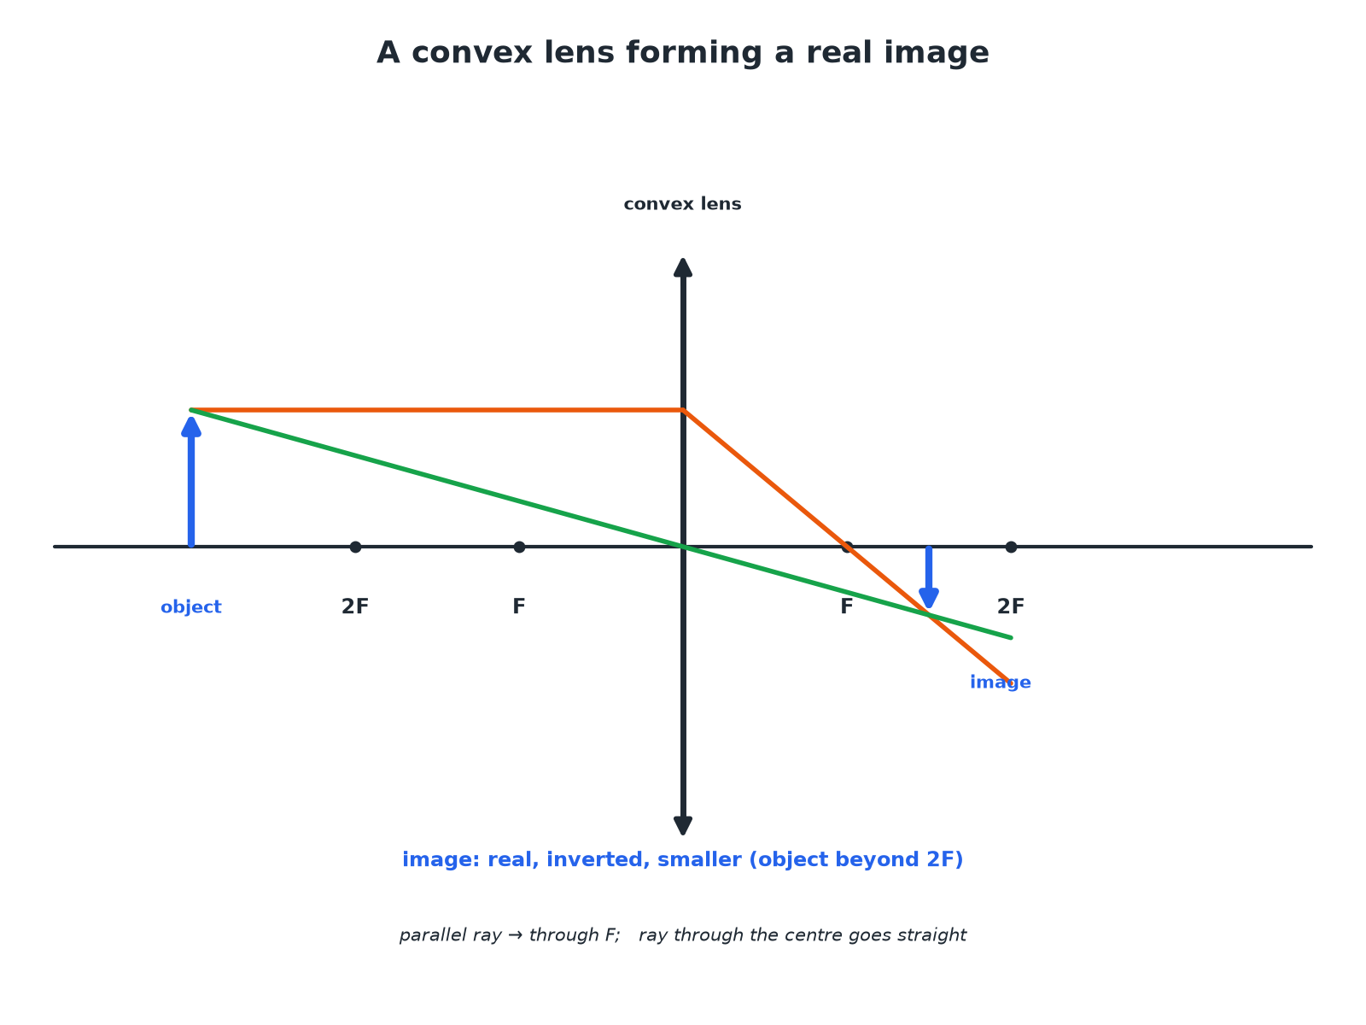
Two rays are enough to find the image position.
A ray diagram of a convex lens forming a real, inverted, diminished image of an object beyond 2F.
A Concave Lens
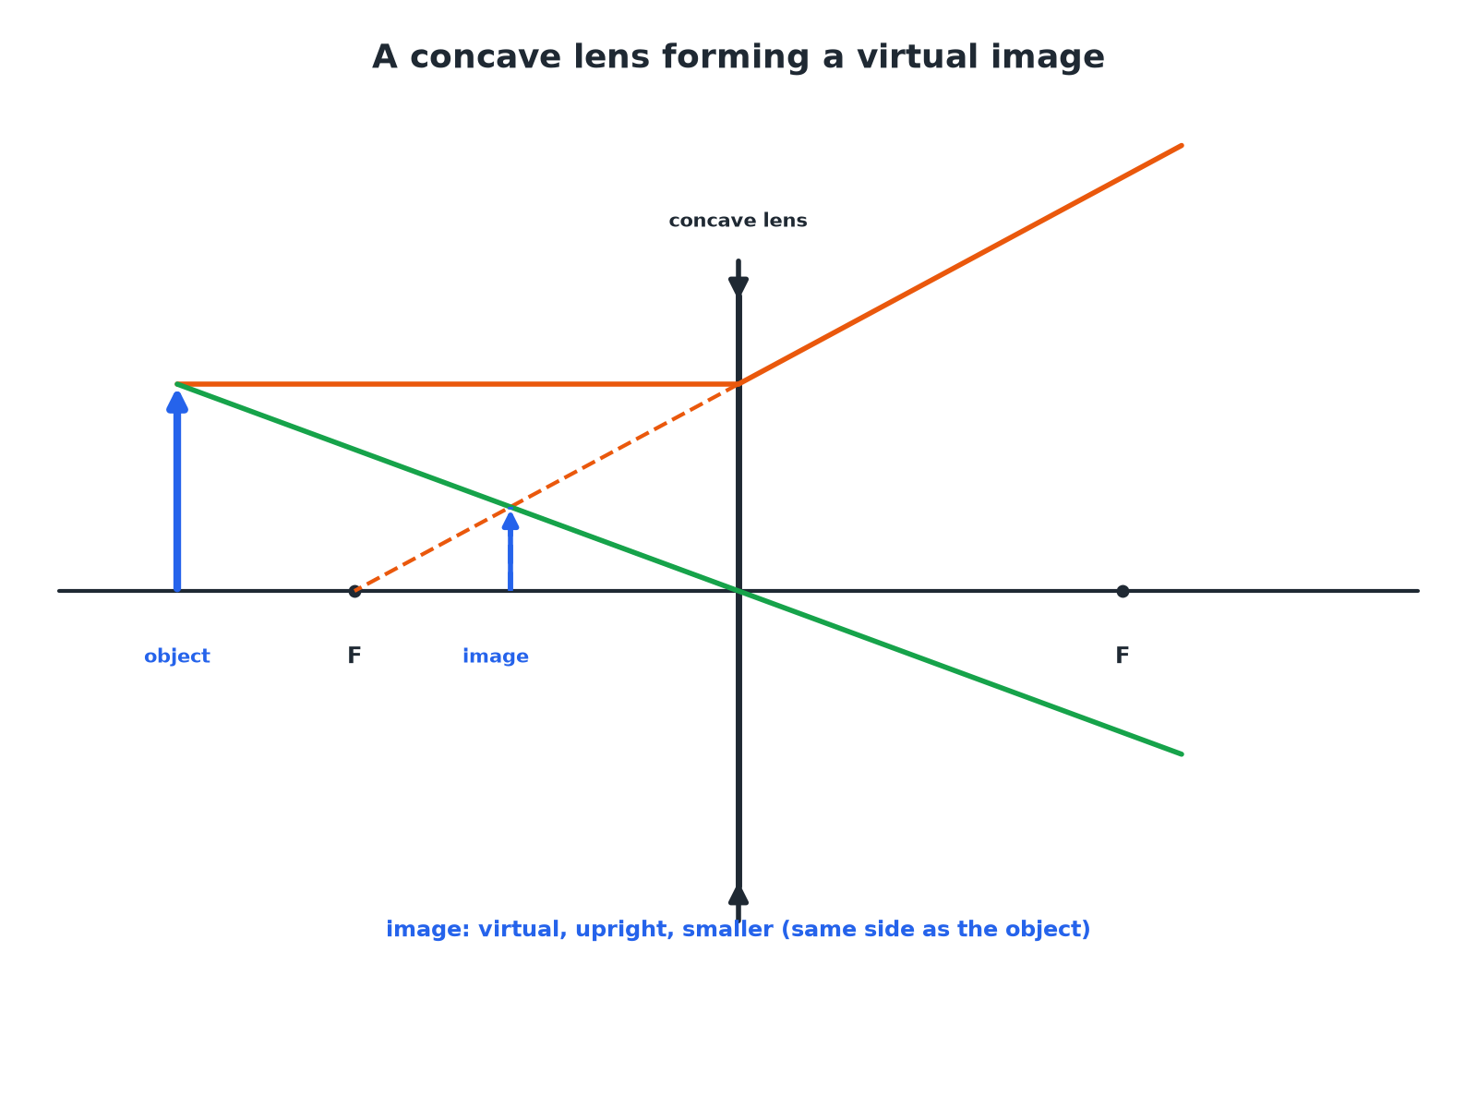
Rays spread out, so the image is virtual.
A ray diagram for a concave lens forming a virtual, upright, smaller image.
Convex and Concave Lenses
Compare them.
Feature | Convex (converging) | Concave (diverging)
Effect on parallel rays | Brings them together at the principal focus | Spreads them out
Image | Real or virtual | Always virtual
Symbol | Vertical line with outward arrowheads | Vertical line with inward arrowheads
Uses | Magnifying glass, camera, projector | Correcting short sight
Magnification
An object is 2.0 cm high. The image formed by a lens is 6.0 cm high. Calculate the magnification.

1. Write the equation
magnification = (image height)/(object height)
2. Substitute
6.0/2.0
3. Answer
3.0 (no units)
Answer: Magnification = 3.0
Finding the Image Height
A lens has a magnification of 5. The object is 4 mm high. Calculate the image height.

1. Rearrange
image height = magnification × object height
2. Substitute
5 × 4
3. Answer
20 mm
Answer: 20 mm
Real or Virtual?
Explain the difference between a real image and a virtual image.

1. Real
Light rays actually meet at the image; it can be shown on a screen
2. Virtual
Rays only appear to come from the image; it cannot be shown on a screen
Answer: A real image can be projected onto a screen; a virtual image cannot.
Drawing Tips
Get full marks.
▸ Use a ruler. Draw straight rays with arrowheads.
▸ Two rays. One parallel to the axis (through F after a convex lens), one through the centre (undeviated).
▸ Mark F. Mark the principal focus on both sides.
▸ Virtual images. Draw the rays as dashed lines behind the lens.
Key Terms
Convex lens  A lens that brings parallel rays to a focus. | Concave lens  A lens that spreads parallel rays out.
Principal focus  The point where parallel rays meet after a convex lens. | Focal length  The distance from the lens to the principal focus.
Real image  An image formed where light rays actually meet. | Virtual image  An image formed where rays appear to come from.
Your Task: Lens Sums
10 minutes
An object of height 3.0 cm gives an image of height 1.2 cm. Calculate the magnification. Is the image bigger or smaller than the object?
1. Use image ÷ object.
2. Compare with 1.
A good answer shows: Magnification = 1.2 ÷ 3.0 = 0.40. The image is smaller (diminished).
Can I...?
☐ Define convex and concave.
☐ Define principal focus.
☐ Define focal length.
☐ Draw a convex lens ray diagram.
☐ Draw a concave lens ray diagram.
☐ Define real and virtual images.
☐ Calculate magnification.
☐ Give a use of each lens.
Summary
✓ Convex: converging; concave: diverging.
✓ Convex images can be real or virtual; concave always virtual.
✓ Magnification = image height ÷ object height (no units).
✓ Two rays to locate the image.

EXAM FOCUS
An object is 2.0 cm high. The image is 6.0 cm high. Calculate the magnification. (2 marks)
Image height divided by object height.

