AQA GCSE PHYSICS · PAPER 2 · FOUNDATION & HIGHER
Lenses
Waves · Lesson 10 of 12
Teacher copy - includes the notes for whoever is teaching from it.
Warm-up
Answer each one, then check.
1. What is refraction?
A change of direction caused by a change in speed
2. What is a ray?
A line showing the path of light
3. What is an image?
What you see when light from an object is focused
4. What is magnification?
How many times bigger an image is than the object
5. Give an example of a lens use.
Glasses, cameras or magnifying glasses
Learning Objectives
1. Describe how a lens forms an image by refracting light.
2. Define principal focus and focal length for a convex lens.
3. Construct ray diagrams for convex and concave lenses.
4. Distinguish real and virtual images and calculate magnification.
Lenses
A lens forms an image by refracting light. A convex lens brings parallel rays together at the principal focus; a concave lens spreads them out.
Magnification has no units: image height and object height must be in the same units (mm or cm). The magnification equation is given on the Physics equation sheet.
A Convex Lens
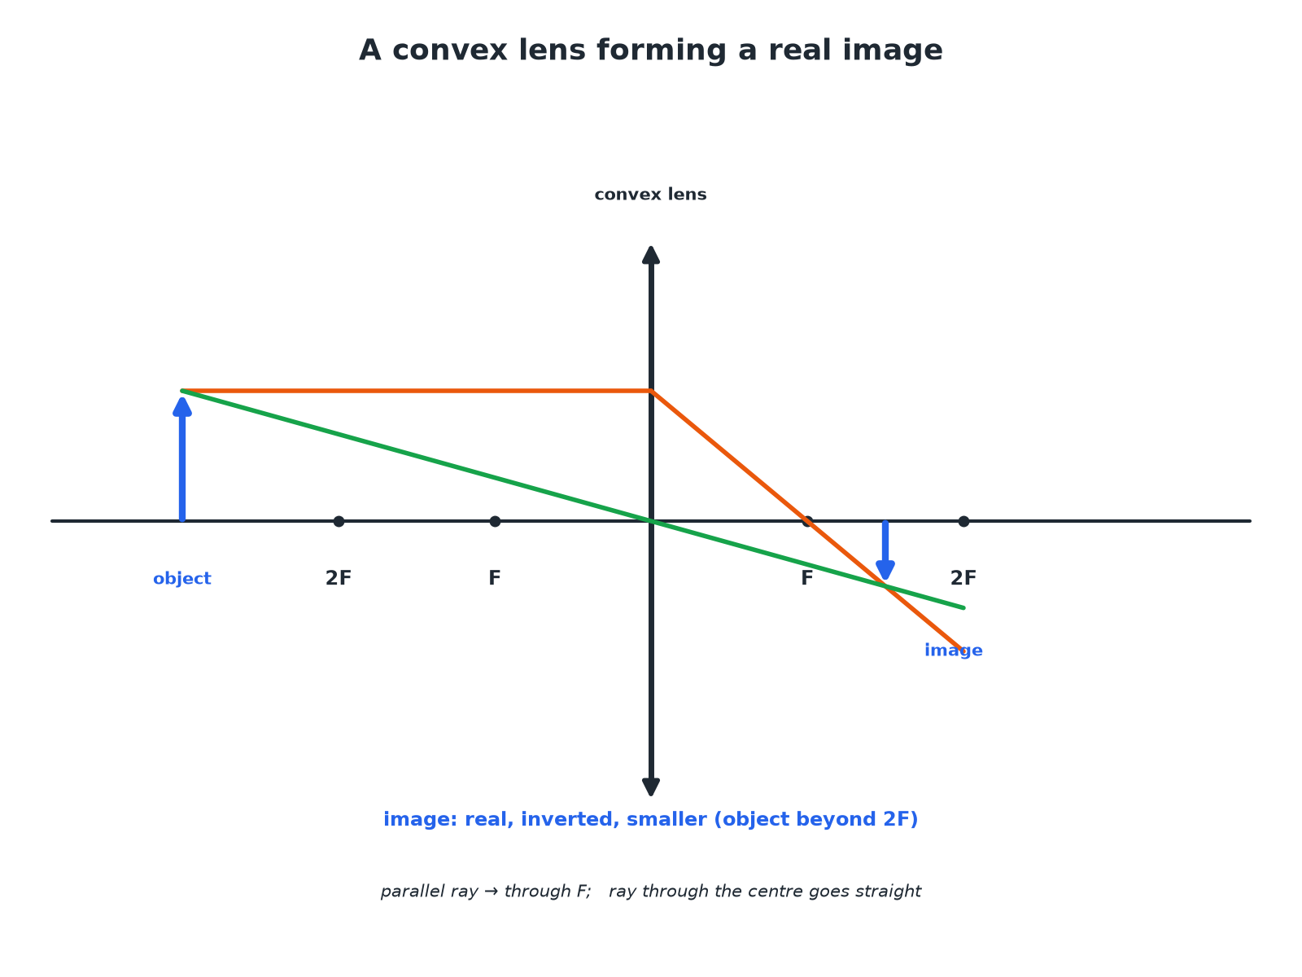
Two rays are enough to find the image position.
A ray diagram of a convex lens forming a real, inverted, diminished image of an object beyond 2F.
A Concave Lens
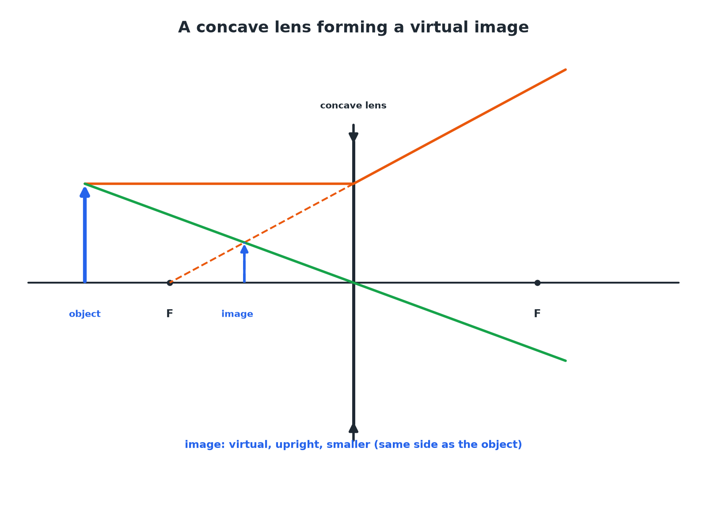
Rays spread out, so the image is virtual.
A ray diagram for a concave lens forming a virtual, upright, smaller image.
Convex and Concave Lenses
Compare them.
Feature | Convex (converging) | Concave (diverging)
Effect on parallel rays | Brings them together at the principal focus | Spreads them out
Image | Real or virtual | Always virtual
Symbol | Vertical line with outward arrowheads | Vertical line with inward arrowheads
Uses | Magnifying glass, camera, projector | Correcting short sight
Magnification
An object is 2.0 cm high. The image formed by a lens is 6.0 cm high. Calculate the magnification.

1. Write the equation
magnification = (image height)/(object height)
2. Substitute
6.0/2.0
3. Answer
3.0 (no units)
Answer: Magnification = 3.0
Finding the Image Height
A lens has a magnification of 5. The object is 4 mm high. Calculate the image height.

1. Rearrange
image height = magnification × object height
2. Substitute
5 × 4
3. Answer
20 mm
Answer: 20 mm
Real or Virtual?
Explain the difference between a real image and a virtual image.

1. Real
Light rays actually meet at the image; it can be shown on a screen
2. Virtual
Rays only appear to come from the image; it cannot be shown on a screen
Answer: A real image can be projected onto a screen; a virtual image cannot.
Drawing Tips
Get full marks.
▸ Use a ruler. Draw straight rays with arrowheads.
▸ Two rays. One parallel to the axis (through F after a convex lens), one through the centre (undeviated).
▸ Mark F. Mark the principal focus on both sides.
▸ Virtual images. Draw the rays as dashed lines behind the lens.
Key Terms
Convex lens  A lens that brings parallel rays to a focus. | Concave lens  A lens that spreads parallel rays out.
Principal focus  The point where parallel rays meet after a convex lens. | Focal length  The distance from the lens to the principal focus.
Real image  An image formed where light rays actually meet. | Virtual image  An image formed where rays appear to come from.
Your Task: Lens Sums
10 minutes
An object of height 3.0 cm gives an image of height 1.2 cm. Calculate the magnification. Is the image bigger or smaller than the object?
1. Use image ÷ object.
2. Compare with 1.
A good answer shows: Magnification = 1.2 ÷ 3.0 = 0.40. The image is smaller (diminished).
Note: Ask how a magnifying glass is different.
Can I...?
☐ Define convex and concave.
☐ Define principal focus.
☐ Define focal length.
☐ Draw a convex lens ray diagram.
☐ Draw a concave lens ray diagram.
☐ Define real and virtual images.
☐ Calculate magnification.
☐ Give a use of each lens.
Summary
✓ Convex: converging; concave: diverging.
✓ Convex images can be real or virtual; concave always virtual.
✓ Magnification = image height ÷ object height (no units).
✓ Two rays to locate the image.

EXAM FOCUS
An object is 2.0 cm high. The image is 6.0 cm high. Calculate the magnification. (2 marks)
Image height divided by object height.
Exam Practice: Lenses
Answer all questions. Use the mark allocation as a guide to how much to write. · 15 minutes
▸ Question 1 · 2 marks · Calculate. An object is 2.0 cm high. A lens produces an image that is 6.0 cm high. Calculate the magnification. Use the equation: magnification =…
▸ Question 2 · 4 marks · Complete the diagram. The diagram shows an object in front of a convex lens. Two rays have been drawn. Complete the ray diagram to find the position of the image…
▸ Question 3 · 2 marks · Explain. Explain the difference between a real image and a virtual image.
▸ Question 4 · 3 marks · Describe. State what happens to parallel rays of light when they pass through (a) a convex lens (b) a concave lens.
▸ Question 5 · 3 marks · Calculate. A lens forms an image 20 mm high. The magnification is 5. Calculate the height of the object.
Question 1 · 2 marks · Calculate
“An object is 2.0 cm high. A lens produces an image that is 6.0 cm high. Calculate the magnification. Use the equation: magnification = image height ÷ object height”
HOW TO ANSWER IT Command word: Calculate. Worth 2 marks, so plan before writing.
Question 1 · mark scheme
2 marks available. Award a mark for each point made.
▸ Correct substitution. 1 mark
▸ 3.0 (no units). 1 mark
▸ Model answer. 6.0 ÷ 2.0 = 3.0
Question 2 · 4 marks · Complete the diagram
The diagram shows an object in front of a convex lens. Two rays have been drawn. Complete the ray diagram to find the position of the image and draw the image. Describe the image. (4 marks) | 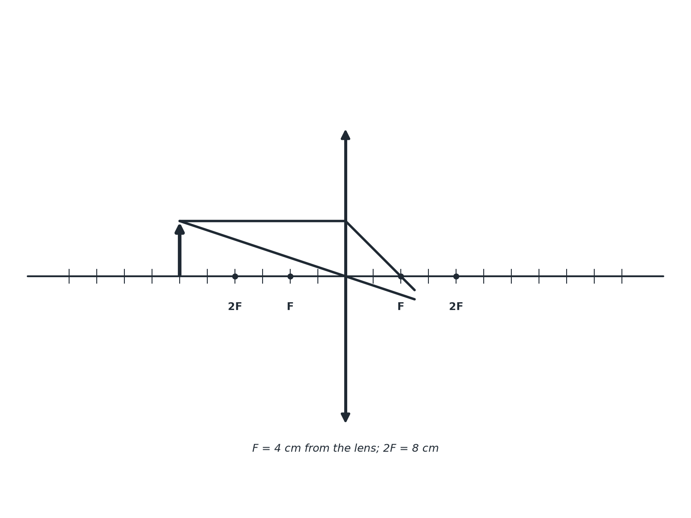

Question 2 · mark scheme
4 marks available. Award a mark for each point made.
▸ Rays continue to cross. 1 mark
▸ Image drawn from the axis to the intersection. 1 mark
▸ Real and inverted. 1 mark
▸ Smaller than the object. 1 mark
▸ Model answer. The two rays cross beyond the lens; the image is drawn from the axis to the crossing point. The image is real, inverted and smaller.
Question 3 · 2 marks · Explain
“Explain the difference between a real image and a virtual image.”
HOW TO ANSWER IT Command word: Explain. Worth 2 marks, so plan before writing.
Question 3 · mark scheme
2 marks available. Award a mark for each point made.
▸ Real: rays meet, on a screen. 1 mark
▸ Virtual: rays appear to come from, not on a screen. 1 mark
▸ Model answer. A real image is formed where light rays actually meet and can be projected onto a screen. A virtual image is where the rays only appear to come from, and cannot be shown on a screen.
Question 4 · 3 marks · Describe
“State what happens to parallel rays of light when they pass through (a) a convex lens (b) a concave lens.”
HOW TO ANSWER IT Command word: Describe. Worth 3 marks, so plan before writing.
Question 4 · mark scheme
3 marks available. Award a mark for each point made.
▸ Convex: converge at a point. 1 mark
▸ Concave: diverge. 1 mark
▸ Principal focus mentioned. 1 mark
▸ Model answer. (a) They are brought together at the principal focus. (b) They are spread out (diverge) as though they came from the principal focus on the same side.
Question 5 · 3 marks · Calculate
“A lens forms an image 20 mm high. The magnification is 5. Calculate the height of the object.”
HOW TO ANSWER IT Command word: Calculate. Worth 3 marks, so plan before writing.
Question 5 · mark scheme
3 marks available. Award a mark for each point made.
▸ Rearranges the equation. 1 mark
▸ Correct substitution. 1 mark
▸ 4.0 mm. 1 mark
▸ Model answer. Object height = 20 ÷ 5 = 4.0 mm.

