AQA GCSE PHYSICS · PAPER 2 · FOUNDATION & HIGHER
Electromagnetism
Magnetism and electromagnetism · Lesson 2 of 8
Teacher copy - includes the notes for whoever is teaching from it.
Warm-up
Answer each one, then check.
1. What is an electric current?
A flow of charge
2. What is a circuit?
A complete loop for current to flow round
3. What is a coil of wire called?
A solenoid
4. Name a magnetic material.
Iron
5. What does a battery do?
Provides a potential difference
Learning Objectives
1. Describe the magnetic field around a straight wire carrying a current.
2. Explain how the field changes with current and distance.
3. Describe the field of a solenoid and compare it with a bar magnet.
4. Explain how to increase the strength of a solenoid's field and how an iron core affects it.
5. Describe an electromagnet.
Current And Magnetism
When a current flows in a wire it produces a magnetic field around the wire. The field is stronger with a bigger current and closer to the wire.
The field lines around a straight wire are concentric circles. Reversing the current reverses the direction of the field.
Fields Around a Wire and a Solenoid
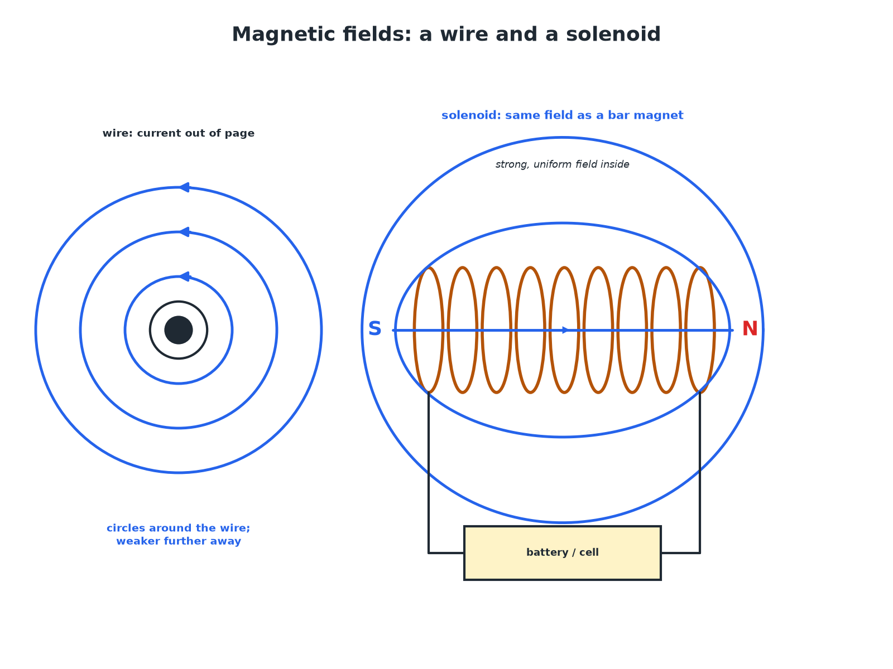
A solenoid's field looks like a bar magnet's field.
Circular field lines around a straight wire and the bar-magnet-like field of a solenoid.
Changing the Strength
Learn what makes a stronger field.
Change | Effect
Bigger current | Stronger field
More turns of wire in the coil | Stronger field
Iron core inside the solenoid | Much stronger field
Reverse the current | Field direction reverses
Move further from the wire | Weaker field
Making an Electromagnet
Describe how to make a strong electromagnet.

1. Wind a coil
Many turns of insulated wire round an iron core (nail)
2. Connect to a cell
Current in the coil magnetises the core
3. Increase the strength
More turns, larger current, or an iron core
Answer: Coil with an iron core and a large current.
Why Use an Electromagnet?
Give two advantages of an electromagnet over a permanent magnet.

1. Switch on and off
The field disappears when the current is turned off
2. Change the strength
Change the current to change the field
Answer: It can be switched off and its strength controlled.
Uses
Where are electromagnets used?
▸ Scrapyards. Lift and drop scrap iron.
▸ Electric bells. Current magnetises an iron core that attracts a hammer.
▸ Relays. A small current switches a large current.
▸ Maglev trains. Strong electromagnets lift and move the train.
Key Terms
Electromagnet  A solenoid with an iron core that is magnetic only when a current flows. | Solenoid  A coil of wire.
Magnetic field  The region around a magnet or current where a force acts on magnetic materials. | Current  The rate of flow of charge.
Core  A piece of iron inside a solenoid. | Turns  Loops of wire in a coil.
Your Task: Build One
15 minutes
Wrap insulated wire round a nail and connect it to a cell. Count how many paper clips it picks up with 10, 20 and 30 turns.
1. Keep the current the same.
2. Do not leave it connected: the wire gets hot.
A good answer shows: More turns pick up more paper clips. Stop current flowing and the clips drop.
Note: Ask what else would increase the field.
Can I...?
☐ Describe the field round a wire.
☐ State that the field circles the wire.
☐ Say what a solenoid is.
☐ Compare with a bar magnet.
☐ List ways to strengthen the field.
☐ Say what an iron core does.
☐ Describe an electromagnet.
☐ Give uses.
Summary
✓ Current produces a magnetic field.
✓ More turns, more current or an iron core gives a stronger field.
✓ A solenoid field is like a bar magnet's field.
✓ Reversing the current reverses the field.

EXAM FOCUS
State two ways to increase the strength of an electromagnet. (2 marks)
Number of turns, current, iron core.
Exam Practice: Electromagnetism
Answer all questions. Use the mark allocation as a guide to how much to write. · 14 minutes
▸ Question 1 · 2 marks · State. State two ways of increasing the strength of the magnetic field of a solenoid.
▸ Question 2 · 2 marks · Describe. Describe the magnetic field around a straight wire carrying a current.
▸ Question 3 · 3 marks · Explain. Explain why a solenoid with an iron core is used in a scrapyard to lift cars and then drop them.
▸ Question 4 · 3 marks · Describe. Describe the magnetic field of a solenoid and explain how it is similar to the field of a bar magnet.
▸ Question 5 · 3 marks · Explain. A student increases the current in a solenoid. Explain what happens to the field and to the number of paper clips the solenoid can lift.
Question 1 · 2 marks · State
“State two ways of increasing the strength of the magnetic field of a solenoid.”
HOW TO ANSWER IT Command word: State. Worth 2 marks, so plan before writing.
Question 1 · mark scheme
2 marks available. Award a mark for each point made.
▸ One way. 1 mark
▸ A second way. 1 mark
▸ Model answer. Increase the current. Increase the number of turns. Put an iron core inside the coil. (any two)
Question 2 · 2 marks · Describe
“Describe the magnetic field around a straight wire carrying a current.”
HOW TO ANSWER IT Command word: Describe. Worth 2 marks, so plan before writing.
Question 2 · mark scheme
2 marks available. Award a mark for each point made.
▸ Circles around the wire. 1 mark
▸ Weaker with distance. 1 mark
▸ Model answer. The field lines are concentric circles around the wire, and the field gets weaker further from the wire.
Question 3 · 3 marks · Explain
“Explain why a solenoid with an iron core is used in a scrapyard to lift cars and then drop them.”
HOW TO ANSWER IT Command word: Explain. Worth 3 marks, so plan before writing.
Question 3 · mark scheme
3 marks available. Award a mark for each point made.
▸ Iron core strengthens the field. 1 mark
▸ Electromagnet only works when a current flows. 1 mark
▸ Switching off releases the car. 1 mark
▸ Model answer. The iron core makes the magnetic field much stronger so it can lift heavy iron. The magnet can be switched off by turning off the current, so the car is released.
Question 4 · 3 marks · Describe
“Describe the magnetic field of a solenoid and explain how it is similar to the field of a bar magnet.”
HOW TO ANSWER IT Command word: Describe. Worth 3 marks, so plan before writing.
Question 4 · mark scheme
3 marks available. Award a mark for each point made.
▸ Lines pass through and loop round outside. 1 mark
▸ Same shape as a bar magnet with two poles. 1 mark
▸ Strong and uniform inside the coil. 1 mark
▸ Model answer. Field lines pass through the coil and loop round outside from one end to the other. The shape is the same as a bar magnet, with a north and a south end. Inside the coil the field is strong and uniform.
Question 5 · 3 marks · Explain
“A student increases the current in a solenoid. Explain what happens to the field and to the number of paper clips the solenoid can lift.”
HOW TO ANSWER IT Command word: Explain. Worth 3 marks, so plan before writing.
Question 5 · mark scheme
3 marks available. Award a mark for each point made.
▸ Field is stronger. 1 mark
▸ Greater force on the paper clips. 1 mark
▸ More clips lifted. 1 mark
▸ Model answer. The field gets stronger. The solenoid exerts a greater force on the paper clips so it can lift more of them.

