AQA GCSE PHYSICS · PAPER 2 · FOUNDATION & HIGHER
Our solar system
Space physics · Lesson 1 of 4
Warm-up
Answer each one, then check.
1. What force holds planets in orbit?
Gravity
2. Name the star at the centre of our solar system.
The Sun
3. Name the galaxy we live in.
The Milky Way
4. Name three planets.
For example Earth, Mars and Jupiter
5. What is a moon?
A natural satellite of a planet
Learning Objectives
1. Describe the structure of the solar system and our galaxy.
2. Describe how the Sun and the planets formed.
3. Describe the orbits of planets, moons and satellites.
4. Describe the force that keeps an object in orbit.
5. Explain the difference between natural and artificial satellites.
The Solar System
Our solar system is made up of the Sun at the centre, eight planets, dwarf planets, moons, asteroids and comets. It is part of the Milky Way galaxy. Gravity causes objects to orbit.
Our Sun is one of about 100 billion stars in the Milky Way galaxy.
The Solar System
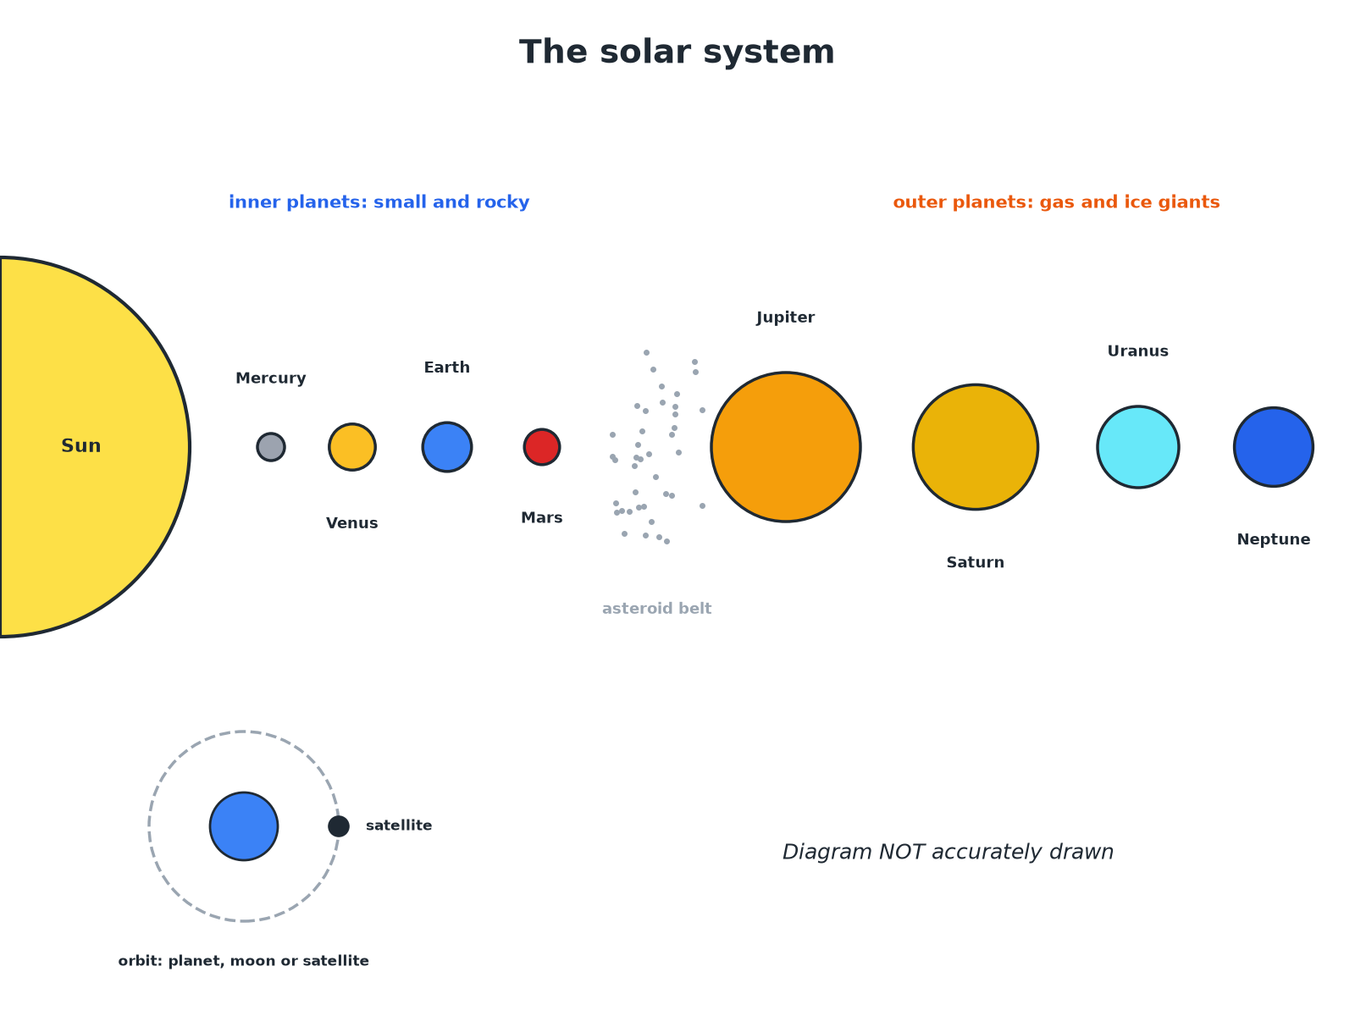
The four inner planets are rocky; the outer four are gas and ice giants.
The Sun, eight planets in order, and the asteroid belt, not to scale.
How the Solar System Formed
Follow the steps.
1  A nebula  A huge cloud of dust and gas collapses under gravity. | 2  Protostar  Gravity pulls the gas together. It gets hot and dense. | 3  A star is born  Nuclear fusion begins; the Sun starts to shine. | 4  Planets  Material left over clumps together to form planets and moons.
Orbits
Learn what orbits what.
Object | Orbits | Type
Planets | The Sun | Natural
Moons | A planet | Natural satellites
Weather and communications satellites | The Earth | Artificial satellites
Comets | The Sun | Elliptical orbits
Orbits and Gravity
Explain why the Moon stays in orbit around the Earth.

1. Gravity
The Earth's gravity pulls the Moon towards it
2. Centripetal force
Gravity is the force towards the centre of the orbit
3. Result
The Moon keeps changing direction so it follows a circular path
Answer: Gravity acts as the force towards the centre.
Key Facts
Learn these.
▸ Planets. Eight; Mercury, Venus, Earth, Mars, Jupiter, Saturn, Uranus and Neptune.
▸ Galaxy. A huge collection of billions of stars, like the Milky Way.
▸ Dwarf planets. Small bodies that orbit the Sun but have not cleared their path, such as Pluto.
▸ Comets. Icy bodies on very elliptical orbits round the Sun.
Key Terms
Solar system  The Sun and all the objects that orbit it. | Galaxy  A huge group of billions of stars held together by gravity.
Natural satellite  A moon that orbits a planet. | Artificial satellite  A human-made object that orbits a planet.
Nebula  A cloud of gas and dust in space. | Orbit  The curved path of an object round another because of gravity.
Your Task: Solar Order
10 minutes
Put the planets in order from the Sun. Make a mnemonic. Then state which are rocky and which are gas giants.
1. Inner four rocky, outer four giants.
A good answer shows: Mercury, Venus, Earth, Mars, Jupiter, Saturn, Uranus, Neptune. The first four are rocky; Jupiter and Saturn are gas giants; Uranus and Neptune are ice giants.
Can I...?
☐ Describe the solar system.
☐ Name the eight planets.
☐ Define a galaxy.
☐ Describe how a star forms.
☐ Describe how planets form.
☐ Name natural satellites.
☐ Name artificial satellites.
☐ Say what keeps orbits going.
Summary
✓ Sun, eight planets, moons, asteroids and comets.
✓ Gravity pulls a cloud of dust and gas together to form the Sun.
✓ Moons are natural satellites; weather satellites are artificial.
✓ Gravity is the force towards the centre of an orbit.

EXAM FOCUS
Name the force that keeps the planets in orbit round the Sun. (1 mark)
Gravity.

