AQA GCSE PHYSICS · PAPER 2 · FOUNDATION & HIGHER
Our solar system
Space physics · Lesson 1 of 4
Teacher copy - includes the notes for whoever is teaching from it.
Warm-up
Answer each one, then check.
1. What force holds planets in orbit?
Gravity
2. Name the star at the centre of our solar system.
The Sun
3. Name the galaxy we live in.
The Milky Way
4. Name three planets.
For example Earth, Mars and Jupiter
5. What is a moon?
A natural satellite of a planet
Learning Objectives
1. Describe the structure of the solar system and our galaxy.
2. Describe how the Sun and the planets formed.
3. Describe the orbits of planets, moons and satellites.
4. Describe the force that keeps an object in orbit.
5. Explain the difference between natural and artificial satellites.
The Solar System
Our solar system is made up of the Sun at the centre, eight planets, dwarf planets, moons, asteroids and comets. It is part of the Milky Way galaxy. Gravity causes objects to orbit.
Our Sun is one of about 100 billion stars in the Milky Way galaxy.
The Solar System
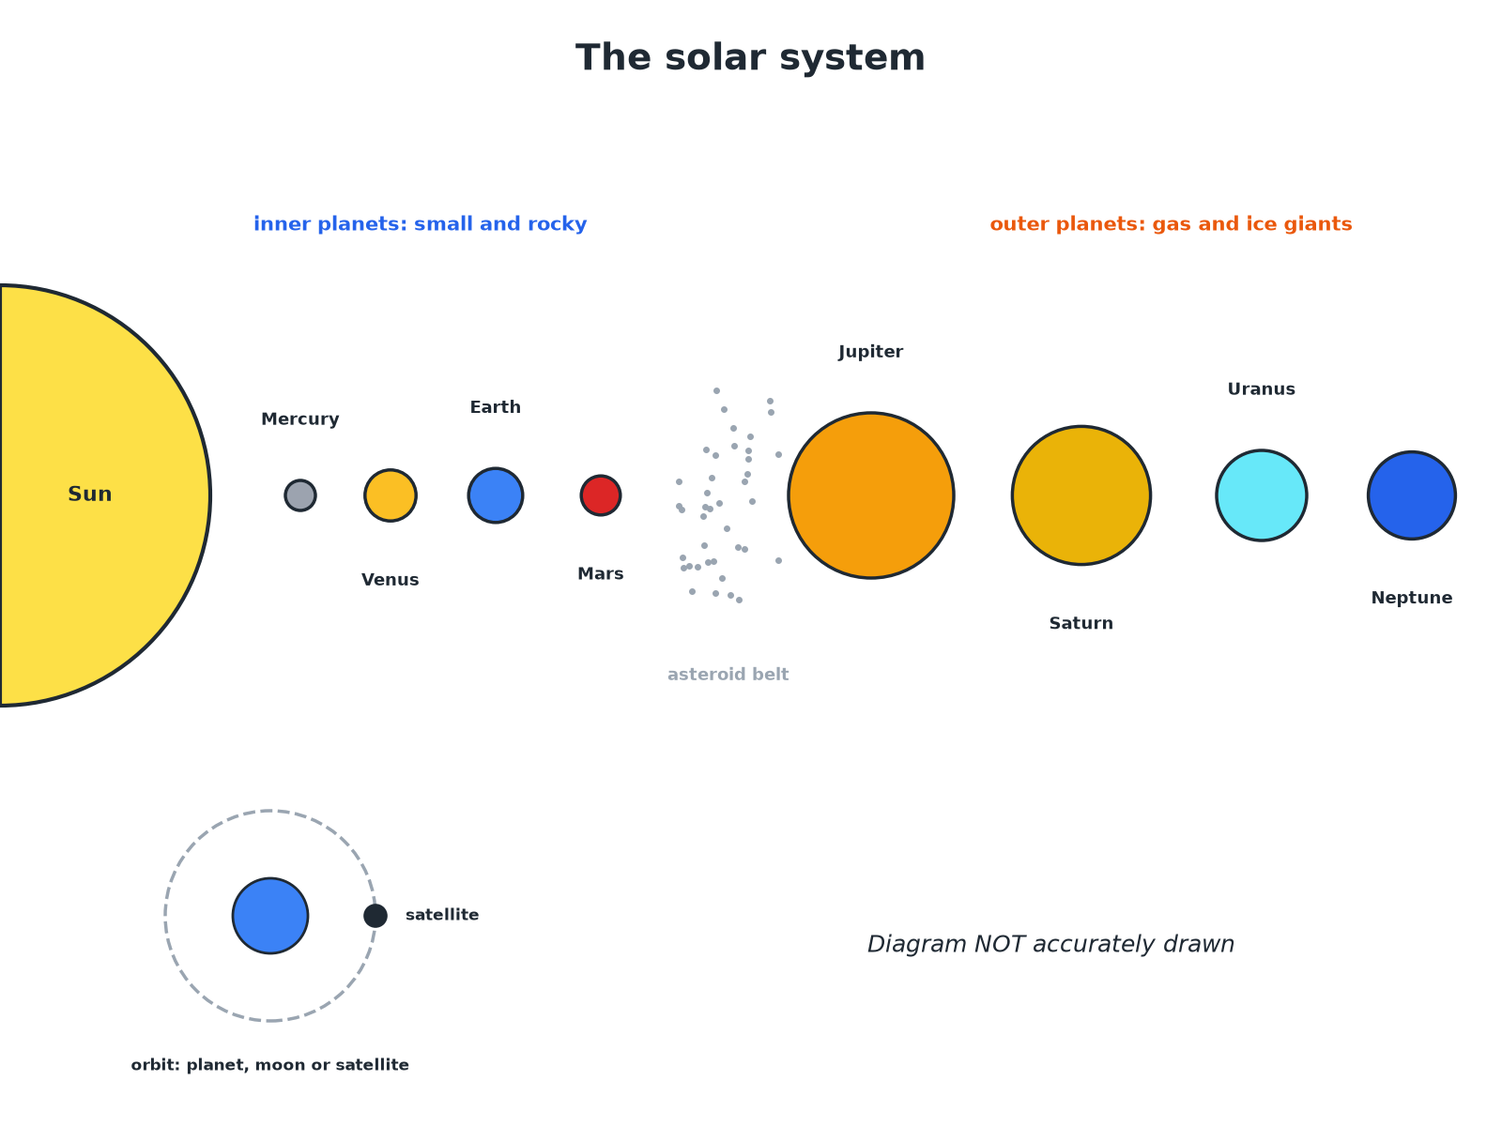
The four inner planets are rocky; the outer four are gas and ice giants.
The Sun, eight planets in order, and the asteroid belt, not to scale.
How the Solar System Formed
Follow the steps.
1  A nebula  A huge cloud of dust and gas collapses under gravity. | 2  Protostar  Gravity pulls the gas together. It gets hot and dense. | 3  A star is born  Nuclear fusion begins; the Sun starts to shine. | 4  Planets  Material left over clumps together to form planets and moons.
Orbits
Learn what orbits what.
Object | Orbits | Type
Planets | The Sun | Natural
Moons | A planet | Natural satellites
Weather and communications satellites | The Earth | Artificial satellites
Comets | The Sun | Elliptical orbits
Orbits and Gravity
Explain why the Moon stays in orbit around the Earth.

1. Gravity
The Earth's gravity pulls the Moon towards it
2. Centripetal force
Gravity is the force towards the centre of the orbit
3. Result
The Moon keeps changing direction so it follows a circular path
Answer: Gravity acts as the force towards the centre.
Key Facts
Learn these.
▸ Planets. Eight; Mercury, Venus, Earth, Mars, Jupiter, Saturn, Uranus and Neptune.
▸ Galaxy. A huge collection of billions of stars, like the Milky Way.
▸ Dwarf planets. Small bodies that orbit the Sun but have not cleared their path, such as Pluto.
▸ Comets. Icy bodies on very elliptical orbits round the Sun.
Key Terms
Solar system  The Sun and all the objects that orbit it. | Galaxy  A huge group of billions of stars held together by gravity.
Natural satellite  A moon that orbits a planet. | Artificial satellite  A human-made object that orbits a planet.
Nebula  A cloud of gas and dust in space. | Orbit  The curved path of an object round another because of gravity.
Your Task: Solar Order
10 minutes
Put the planets in order from the Sun. Make a mnemonic. Then state which are rocky and which are gas giants.
1. Inner four rocky, outer four giants.
A good answer shows: Mercury, Venus, Earth, Mars, Jupiter, Saturn, Uranus, Neptune. The first four are rocky; Jupiter and Saturn are gas giants; Uranus and Neptune are ice giants.
Note: Ask learners where the asteroid belt is.
Can I...?
☐ Describe the solar system.
☐ Name the eight planets.
☐ Define a galaxy.
☐ Describe how a star forms.
☐ Describe how planets form.
☐ Name natural satellites.
☐ Name artificial satellites.
☐ Say what keeps orbits going.
Summary
✓ Sun, eight planets, moons, asteroids and comets.
✓ Gravity pulls a cloud of dust and gas together to form the Sun.
✓ Moons are natural satellites; weather satellites are artificial.
✓ Gravity is the force towards the centre of an orbit.

EXAM FOCUS
Name the force that keeps the planets in orbit round the Sun. (1 mark)
Gravity.
Exam Practice: Our solar system
Answer all questions. Use the mark allocation as a guide to how much to write. · 14 minutes
▸ Question 1 · 2 marks · State. Name the galaxy that contains our solar system and state what holds the galaxy together.
▸ Question 2 · 3 marks · Describe. Describe how the Sun and the planets in our solar system were formed.
▸ Question 3 · 2 marks · State. Give one example of a natural satellite and one example of an artificial satellite.
▸ Question 4 · 3 marks · Explain. Explain why the Moon stays in orbit around the Earth.
▸ Question 5 · 3 marks · Explain. Explain why the outer planets take longer to orbit the Sun than the inner planets.
Question 1 · 2 marks · State
“Name the galaxy that contains our solar system and state what holds the galaxy together.”
HOW TO ANSWER IT Command word: State. Worth 2 marks, so plan before writing.
Question 1 · mark scheme
2 marks available. Award a mark for each point made.
▸ Milky Way. 1 mark
▸ Gravity. 1 mark
▸ Model answer. The Milky Way. Gravity.
Question 2 · 3 marks · Describe
“Describe how the Sun and the planets in our solar system were formed.”
HOW TO ANSWER IT Command word: Describe. Worth 3 marks, so plan before writing.
Question 2 · mark scheme
3 marks available. Award a mark for each point made.
▸ Gravity pulls dust and gas together. 1 mark
▸ Fusion starts forming the Sun. 1 mark
▸ Planets form from the remaining material. 1 mark
▸ Model answer. A cloud of dust and gas (nebula) was pulled together by gravity. It became hot and dense and nuclear fusion began, forming the Sun. Material left over in orbit clumped together under gravity to form the planets.
Question 3 · 2 marks · State
“Give one example of a natural satellite and one example of an artificial satellite.”
HOW TO ANSWER IT Command word: State. Worth 2 marks, so plan before writing.
Question 3 · mark scheme
2 marks available. Award a mark for each point made.
▸ Natural satellite. 1 mark
▸ Artificial satellite. 1 mark
▸ Model answer. Natural: the Moon (or any moon). Artificial: a weather, communications or GPS satellite.
Question 4 · 3 marks · Explain
“Explain why the Moon stays in orbit around the Earth.”
HOW TO ANSWER IT Command word: Explain. Worth 3 marks, so plan before writing.
Question 4 · mark scheme
3 marks available. Award a mark for each point made.
▸ Gravitational attraction between Earth and Moon. 1 mark
▸ Force is towards the centre of the orbit. 1 mark
▸ Changes direction so a curved path is followed. 1 mark
▸ Model answer. The Earth's gravity pulls the Moon towards the Earth. This force is always towards the centre of the orbit and continually changes the direction of the Moon's velocity, so it follows a curved path.
Question 5 · 3 marks · Explain
“Explain why the outer planets take longer to orbit the Sun than the inner planets.”
HOW TO ANSWER IT Command word: Explain. Worth 3 marks, so plan before writing.
Question 5 · mark scheme
3 marks available. Award a mark for each point made.
▸ Longer orbit or further distance. 1 mark
▸ Weaker gravity further away. 1 mark
▸ Lower orbital speed. 1 mark
▸ Model answer. The outer planets are further from the Sun, so they travel a longer orbit. Gravity is weaker further away, so they also move more slowly.

