AQA GCSE PHYSICS · PAPER 2 · HIGHER TIER ONLY
Orbital motion and satellites
Space physics · Lesson 3 of 4
Teacher copy - includes the notes for whoever is teaching from it.
Warm-up
Answer each one, then check.
1. What is speed?
Distance travelled per unit time
2. What is velocity?
Speed in a given direction
3. What is gravity?
An attractive force between masses
4. What is an orbit?
The curved path round a planet or star
5. What is a satellite?
An object that orbits a larger object
Learning Objectives
1. Explain why an object moving in a circle at constant speed has a changing velocity.
2. Explain that gravity provides the force for circular orbits.
3. Explain how orbital radius, speed and time for an orbit are linked.
4. Describe what happens if a satellite's speed changes.
Circular Orbits
An object in a circular orbit moves at constant speed but its velocity is always changing because its direction is changing. The resultant force is gravity, which acts towards the centre of the orbit.
For an orbit of a given radius, the speed must be a particular value. If the speed changes, the radius changes.
A Satellite in Orbit
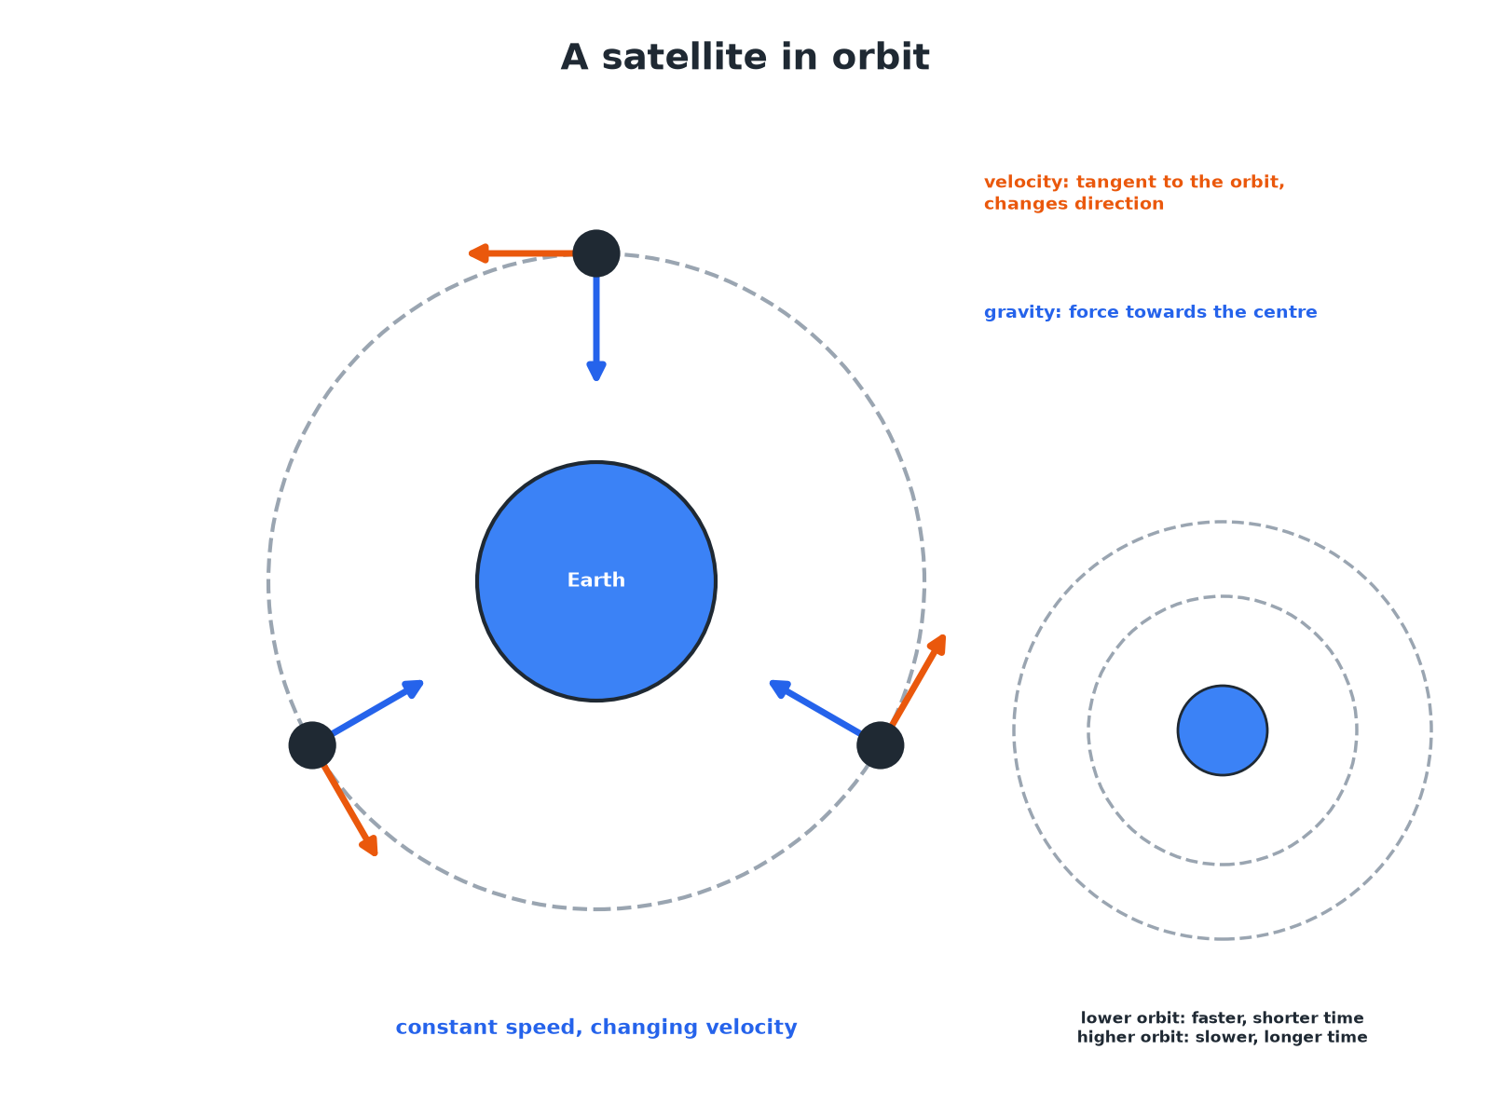
Velocity is tangent; force is towards the centre.
A satellite on a circular orbit with velocity tangent to the orbit and gravity towards the centre.
Orbits at Different Heights
Learn the links.
Orbit | Speed | Time for one orbit
Low orbit (closer) | Faster | Shorter
High orbit (further away) | Slower | Longer
Geostationary (about 36 000 km) | Matches the Earth's rotation | 24 hours
If the speed changes | Radius must change too | Time changes
Constant Speed, Changing Velocity
Explain why a satellite moving at constant speed in a circle is accelerating.

1. Speed
Constant
2. Direction
Always changing
3. Velocity
Has speed and direction, so it changes
4. Acceleration
A change in velocity is an acceleration, towards the centre
Answer: Velocity changes because direction changes, so it accelerates.
Orbital Speed
A satellite orbits at a radius of 7000 km and completes one orbit in 5800 s. Calculate its speed.

1. Distance
circumference = 2πr = 2 × π × 7.0 × 10⁶ = 4.4 × 10⁷ m
2. Speed
v = d ÷ t = 4.4 × 10⁷ ÷ 5800
3. Answer
v ≈ 7600 m/s
Answer: About 7600 m/s.
Key Points
Learn these.
▸ Gravity. Provides the force towards the centre.
▸ Constant speed. But velocity changes.
▸ Closer orbit. Faster and a shorter orbit time.
▸ Change of speed. Changes the radius of the orbit.
Key Terms
Orbit  The curved path of an object round a planet or star. | Orbital speed  The speed of an object as it moves in its orbit.
Velocity  Speed in a given direction. | Geostationary orbit  An orbit with a period of 24 hours, so the satellite stays above one point on Earth.
Acceleration  A change in velocity. | Satellite  An object in orbit around a larger object.
Your Task: Orbit Sums
12 minutes
Explain why a satellite does not fall to Earth even though gravity pulls on it. Then calculate its speed if one orbit of radius 7000 km takes 5800 s.
1. Speed = distance ÷ time.
A good answer shows: It is falling but moves sideways fast enough to keep missing the Earth. v = 2π × 7.0 × 10^6 ÷ 5800 ≈ 7600 m/s.
Note: Ask about a geostationary satellite.
Can I...?
☐ Define orbit.
☐ Explain changing velocity.
☐ Explain the force.
☐ Link radius and speed.
☐ Describe geostationary.
☐ Calculate orbital speed.
☐ Explain a change in speed.
☐ Give examples.
Summary
✓ Constant speed but changing direction means changing velocity.
✓ Gravity acts towards the centre.
✓ Lower orbit: faster; higher orbit: slower.
✓ Change of speed gives a change of radius.

EXAM FOCUS
Explain why the velocity of a satellite moving at constant speed is changing. (2 marks)
Direction changes.
Exam Practice: Orbital motion and satellites
Answer all questions. Use the mark allocation as a guide to how much to write. · 14 minutes
▸ Question 1 · 2 marks · Explain. A satellite orbits the Earth at constant speed. Explain why its velocity is not constant.
▸ Question 2 · 3 marks · Explain. Explain what provides the force that keeps a satellite in a circular orbit and state the direction of the force.
▸ Question 3 · 3 marks · Calculate. A satellite completes one circular orbit of circumference 4.4 × 10^7 m in 5800 s. Calculate its orbital speed.
▸ Question 4 · 3 marks · Explain. Satellite A orbits the Earth at a smaller radius than satellite B. Compare the orbital speeds and the times taken for one orbit, and…
▸ Question 5 · 2 marks · Explain. A geostationary satellite stays above the same point on the Earth. State the time taken for one orbit and explain why this is useful.
Question 1 · 2 marks · Explain
“A satellite orbits the Earth at constant speed. Explain why its velocity is not constant.”
HOW TO ANSWER IT Command word: Explain. Worth 2 marks, so plan before writing.
Question 1 · mark scheme
2 marks available. Award a mark for each point made.
▸ Velocity has direction. 1 mark
▸ Direction is changing. 1 mark
▸ Model answer. Velocity is speed in a given direction. The direction of motion is always changing, so the velocity changes even though the speed is constant.
Question 2 · 3 marks · Explain
“Explain what provides the force that keeps a satellite in a circular orbit and state the direction of the force.”
HOW TO ANSWER IT Command word: Explain. Worth 3 marks, so plan before writing.
Question 2 · mark scheme
3 marks available. Award a mark for each point made.
▸ Gravity. 1 mark
▸ Between Earth and satellite. 1 mark
▸ Towards the centre. 1 mark
▸ Model answer. The force is gravity between the Earth and the satellite. It acts towards the centre of the orbit (the centre of the Earth).
Question 3 · 3 marks · Calculate
“A satellite completes one circular orbit of circumference 4.4 × 10^7 m in 5800 s. Calculate its orbital speed.”
HOW TO ANSWER IT Command word: Calculate. Worth 3 marks, so plan before writing.
Question 3 · mark scheme
3 marks available. Award a mark for each point made.
▸ Distance ÷ time. 1 mark
▸ Correct substitution. 1 mark
▸ About 7600 m/s. 1 mark
▸ Model answer. v = 4.4 × 10⁷ ÷ 5800 = 7600 m/s (about)
Question 4 · 3 marks · Explain
“Satellite A orbits the Earth at a smaller radius than satellite B. Compare the orbital speeds and the times taken for one orbit, and explain the difference in speed.”
HOW TO ANSWER IT Command word: Explain. Worth 3 marks, so plan before writing.
Question 4 · mark scheme
3 marks available. Award a mark for each point made.
▸ A faster than B. 1 mark
▸ A has a shorter orbit time. 1 mark
▸ Gravity is stronger at smaller radius, so a higher speed is needed. 1 mark
▸ Model answer. A moves faster than B and takes less time to complete an orbit. Gravity is stronger closer to the Earth, so a greater orbital speed is needed for a stable orbit at a smaller radius; A also has a shorter path.
Question 5 · 2 marks · Explain
“A geostationary satellite stays above the same point on the Earth. State the time taken for one orbit and explain why this is useful.”
HOW TO ANSWER IT Command word: Explain. Worth 2 marks, so plan before writing.
Question 5 · mark scheme
2 marks available. Award a mark for each point made.
▸ 24 hours. 1 mark
▸ Fixed position above the Earth: useful for communications. 1 mark
▸ Model answer. 24 hours. It stays above one place, so a fixed dish can communicate with it.

