AQA GCSE PHYSICS · PAPER 1 · FOUNDATION & HIGHER
Density of materials
Particle model of matter · Lesson 1 of 6
Teacher copy - includes the notes for whoever is teaching from it.
Warm-up
Answer each one, then check.
1. What is the unit of mass in physics calculations?
Kilograms (kg)
2. How do you find the volume of a cuboid?
length × width × height
3. Convert 1 cm³ to m³.
1 × 10⁻⁶ m³
4. What are the three states of matter?
Solid, liquid and gas
5. What does displacement mean when finding volume?
The volume of water pushed out or the rise in water level
Learning Objectives
1. Recall and apply the equation for density.
2. Explain differences in density between solids, liquids and gases using the arrangement of particles.
3. Describe how to measure the density of regular and irregular solids and of liquids.
4. Convert between g/cm³ and kg/m³.
Density
density = mass ÷ volume ρ= m/V
Density is in kilograms per metre cubed (kg/m³), mass in kilograms (kg) and volume in metres cubed (m³). Mass is conserved when a substance changes state.
Solids, Liquids and Gases
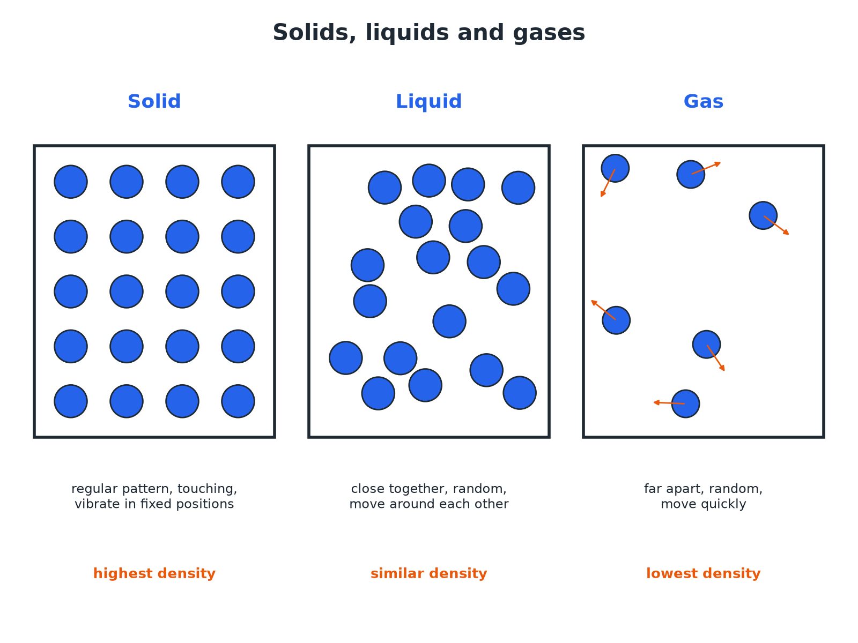
In a solid or liquid the particles are close, so the density is high.
Particle diagrams of a solid, a liquid and a gas.
Required Practical 5: Measuring Density
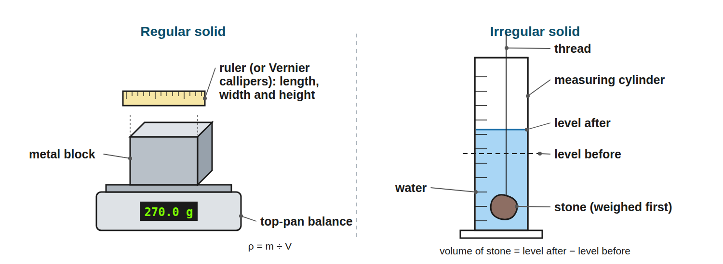
Mass with a balance; volume from dimensions or by displacement.
Apparatus for finding the density of a regular solid using a balance and ruler, and of an irregular solid using a balance and a measuring cylinder of water.
Why the Densities Differ
Solids  Particles are packed closely in a regular arrangement: high density. | Liquids  Particles are close but randomly arranged: similar to solids, usually slightly lower.
Gases  Particles are far apart: very low density. | Mass is conserved  When a substance changes state the number of particles is unchanged, so the mass stays the same.
Required Practical 5: Method
Find the density of a solid or liquid.
1  Mass  Measure the mass on a balance (for a liquid, subtract the container's mass). | 2  Regular solid: volume  Measure length, width and height with a ruler or micrometer and use V = l × w × h. | 3  Irregular solid: volume  Lower it into water in a measuring cylinder, or a displacement can; the volume is the rise in water level (or the volume collected). | 4  Liquid: volume  Read it from a measuring cylinder at eye level. | 5  Calculate  ρ= m ÷ V; repeat and find a mean.
Density of a Block
A metal block has a mass of 0.60 kg and a volume of 0.00020 m³. Calculate its density.

1. Write the equation
ρ= m ÷ V
2. Substitute
ρ= 0.60 ÷ 0.00020
3. Answer
ρ= 3000 kg/m³
Answer: 3000 kg/m³
Unit Conversion
A cube of side 4.0 cm has a mass of 512 g. Calculate the density in kg/m³.

1. Volume
4.0³ = 64 cm³ = 64 × 10⁻⁶ m³
2. Mass
512 g = 0.512 kg
3. Density
0.512 ÷ (64 × 10⁻⁶) = 8000 kg/m³
Answer: 8000 kg/m³ (or 8.0 g/cm³)
Irregular Solid by Displacement
A stone of mass 45 g is lowered into a measuring cylinder. The water level rises from 50 cm³ to 68 cm³. Calculate the density in g/cm³.

1. Volume of stone
68 − 50 = 18 cm³
2. Density
45 ÷ 18 = 2.5 g/cm³
Answer: 2.5 g/cm³ (2500 kg/m³)
Watch Out
Common mistakes.
▸ Units. Convert cm³ to m³ (× 10⁻⁶) and g to kg (÷ 1000) before using kg/m³.
▸ Reading volume. Read the bottom of the meniscus at eye level.
▸ Mass conserved. Density changes with volume, not with mass, when a substance changes state.
Key Terms
Density  Mass per unit volume of a material. | Displacement  The volume of water moved aside by an object placed in it.
Meniscus  The curved surface of a liquid in a tube. | Regular  A solid with a shape whose volume can be worked out from its dimensions.
Particle model  A model in which matter is made of tiny moving particles. | Conserved  Stays the same in total.
Your Task: Which Floats?
10 minutes
Water has a density of 1000 kg/m³. A block has a mass of 0.80 kg and a volume of 0.0010 m³. Calculate its density and say if it floats.
1. Calculate the density.
2. Compare with water.
A good answer shows: Density = 0.80 ÷ 0.0010 = 800 kg/m³. This is less than 1000 kg/m³, so it floats.
Note: Ask what would happen to a block of density 1200 kg/m³.
Can I...?
☐ Recall the equation for density.
☐ Use correct units.
☐ Convert cm³ to m³.
☐ Explain density using particles.
☐ Describe measuring density of a regular solid.
☐ Describe measuring density of an irregular solid.
☐ Read a measuring cylinder.
☐ Say why mass is conserved.
Summary
✓ ρ= m ÷ V.
✓ Solids and liquids have close particles: high density; gases: far apart, low density.
✓ Mass is conserved in changes of state.
✓ Volume of an irregular object: use displacement.

EXAM FOCUS
A metal block has a mass of 0.60 kg and a volume of 0.00020 m³. Calculate its density. (2 marks)
Substitute and include kg/m³.
Exam Practice: Density of materials
Answer all questions. Use the mark allocation as a guide to how much to write. · 21 minutes
▸ Question 1 · 2 marks · Calculate. A block of metal has a mass of 0.60 kg and a volume of 0.00020 m³. Calculate the density of the metal. Use the equation: density = mass ÷…
▸ Question 2 · 4 marks · Calculate. A cube has sides of length 4.0 cm and a mass of 512 g. Calculate the density of the cube in kg/m³.
▸ Question 3 · 3 marks · Use the diagram. A student measures the volume of a stone using a measuring cylinder. The mass of the stone is 45 g. Use the diagram to calculate the…
▸ Question 4 · 3 marks · Explain. Explain, in terms of particles, why the density of a gas is much lower than the density of a solid.
▸ Question 5 · 6 marks · Describe. Describe how to determine the density of an irregularly shaped solid, such as a stone. Your answer should include the apparatus, the…
▸ Question 6 · 2 marks · Explain. 1.0 kg of ice melts. Explain what happens to the mass and to the density.
Question 1 · 2 marks · Calculate
“A block of metal has a mass of 0.60 kg and a volume of 0.00020 m³. Calculate the density of the metal. Use the equation: density = mass ÷ volume”
HOW TO ANSWER IT Command word: Calculate. Worth 2 marks, so plan before writing.
Question 1 · mark scheme
2 marks available. Award a mark for each point made.
▸ Correct substitution. 1 mark
▸ 3000 kg/m³. 1 mark
▸ Model answer. 0.60 ÷ 0.00020 = 3000 kg/m³
Question 2 · 4 marks · Calculate
“A cube has sides of length 4.0 cm and a mass of 512 g. Calculate the density of the cube in kg/m³.”
HOW TO ANSWER IT Command word: Calculate. Worth 4 marks, so plan before writing.
Question 2 · mark scheme
4 marks available. Award a mark for each point made.
▸ Volume = 64 cm³. 1 mark
▸ Converts to m³ and kg. 1 mark
▸ Correct substitution. 1 mark
▸ 8000 kg/m³. 1 mark
▸ Model answer. V = 64 cm³ = 6.4 × 10⁻⁵ m³; m = 0.512 kg; ρ= 0.512 ÷ 6.4 × 10⁻⁵ = 8000 kg/m³
Question 3 · 3 marks · Use the diagram
A student measures the volume of a stone using a measuring cylinder. The mass of the stone is 45 g. Use the diagram to calculate the density of the stone in g/cm³. (3 marks) | 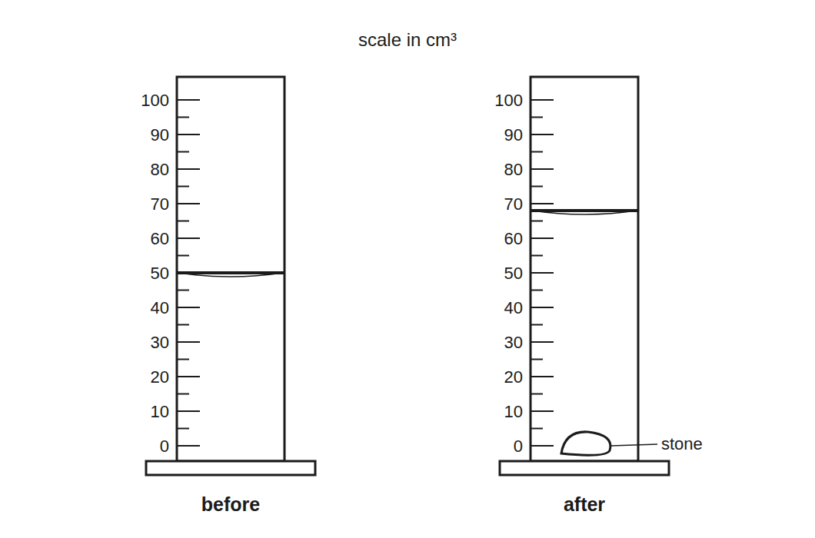

Question 3 · mark scheme
3 marks available. Award a mark for each point made.
▸ Volume of stone = 18 cm³. 1 mark
▸ Correct substitution. 1 mark
▸ 2.5 g/cm³. 1 mark
▸ Model answer. Volume = 68 − 50 = 18 cm³; ρ= 45 ÷ 18 = 2.5 g/cm³
Question 4 · 3 marks · Explain
“Explain, in terms of particles, why the density of a gas is much lower than the density of a solid.”
HOW TO ANSWER IT Command word: Explain. Worth 3 marks, so plan before writing.
Question 4 · mark scheme
3 marks available. Award a mark for each point made.
▸ Particles far apart in a gas. 1 mark
▸ Close together in a solid. 1 mark
▸ More volume for the same mass so lower density. 1 mark
▸ Model answer. In a gas the particles are far apart, but in a solid they are packed closely together. The same mass of material occupies a much greater volume in a gas, so the density is lower.
Question 5 · 6 marks · Describe
“Describe how to determine the density of an irregularly shaped solid, such as a stone. Your answer should include the apparatus, the measurements and the calculation.”
HOW TO ANSWER IT Command word: Describe. Worth 6 marks, so plan before writing.
Question 5 · mark scheme
6 marks available. Award a mark for each point made.
▸ Level 3 (5 to 6 marks): a complete method with a balance to measure mass, a measuring cylinder or displacement can with water, the volume from the change in water level, the calculation of density = mass ÷ volume and a repeat or precaution. 5 to 6 marks
▸ Level 2 (3 to 4 marks): a method covering mass and volume but with some detail missing. 3 to 4 marks
▸ Level 1 (1 to 2 marks): simple statements about measuring mass or volume. 1 to 2 marks
▸ Model answer. See levels-of-response scheme.
Question 6 · 2 marks · Explain
“1.0 kg of ice melts. Explain what happens to the mass and to the density.”
HOW TO ANSWER IT Command word: Explain. Worth 2 marks, so plan before writing.
Question 6 · mark scheme
2 marks available. Award a mark for each point made.
▸ Mass stays the same (conserved). 1 mark
▸ Density changes because the volume changes. 1 mark
▸ Model answer. The mass stays at 1.0 kg because mass is conserved. The density increases because the volume decreases as ice becomes water.

