AQA GCSE PHYSICS · PAPER 1 · FOUNDATION & HIGHER
The development of the model of the atom
Atomic structure · Lesson 3 of 10
Teacher copy - includes the notes for whoever is teaching from it.
Warm-up
Answer each one, then check.
1. Who discovered the electron?
J. J. Thomson
2. What is a scientific model?
A simplified representation used to explain observations
3. What is an alpha particle?
Two protons and two neutrons (a helium nucleus)
4. What is evidence?
Results from experiments that support or reject an idea
5. Who discovered the neutron?
James Chadwick
Learning Objectives
1. Describe how the atomic model has changed over time.
2. Describe the plum pudding model and the nuclear model.
3. Explain why the alpha particle scattering experiment led to the nuclear model.
4. Describe the contributions of Bohr, the discovery of the proton and Chadwick's neutron.
Changing Models
New experimental evidence may lead to a scientific model being changed or replaced.
The atom has been thought of as a solid sphere, a plum pudding, a nuclear atom, then with electrons in specific orbits, and finally with protons and neutrons in the nucleus.
How the Atom Model Changed
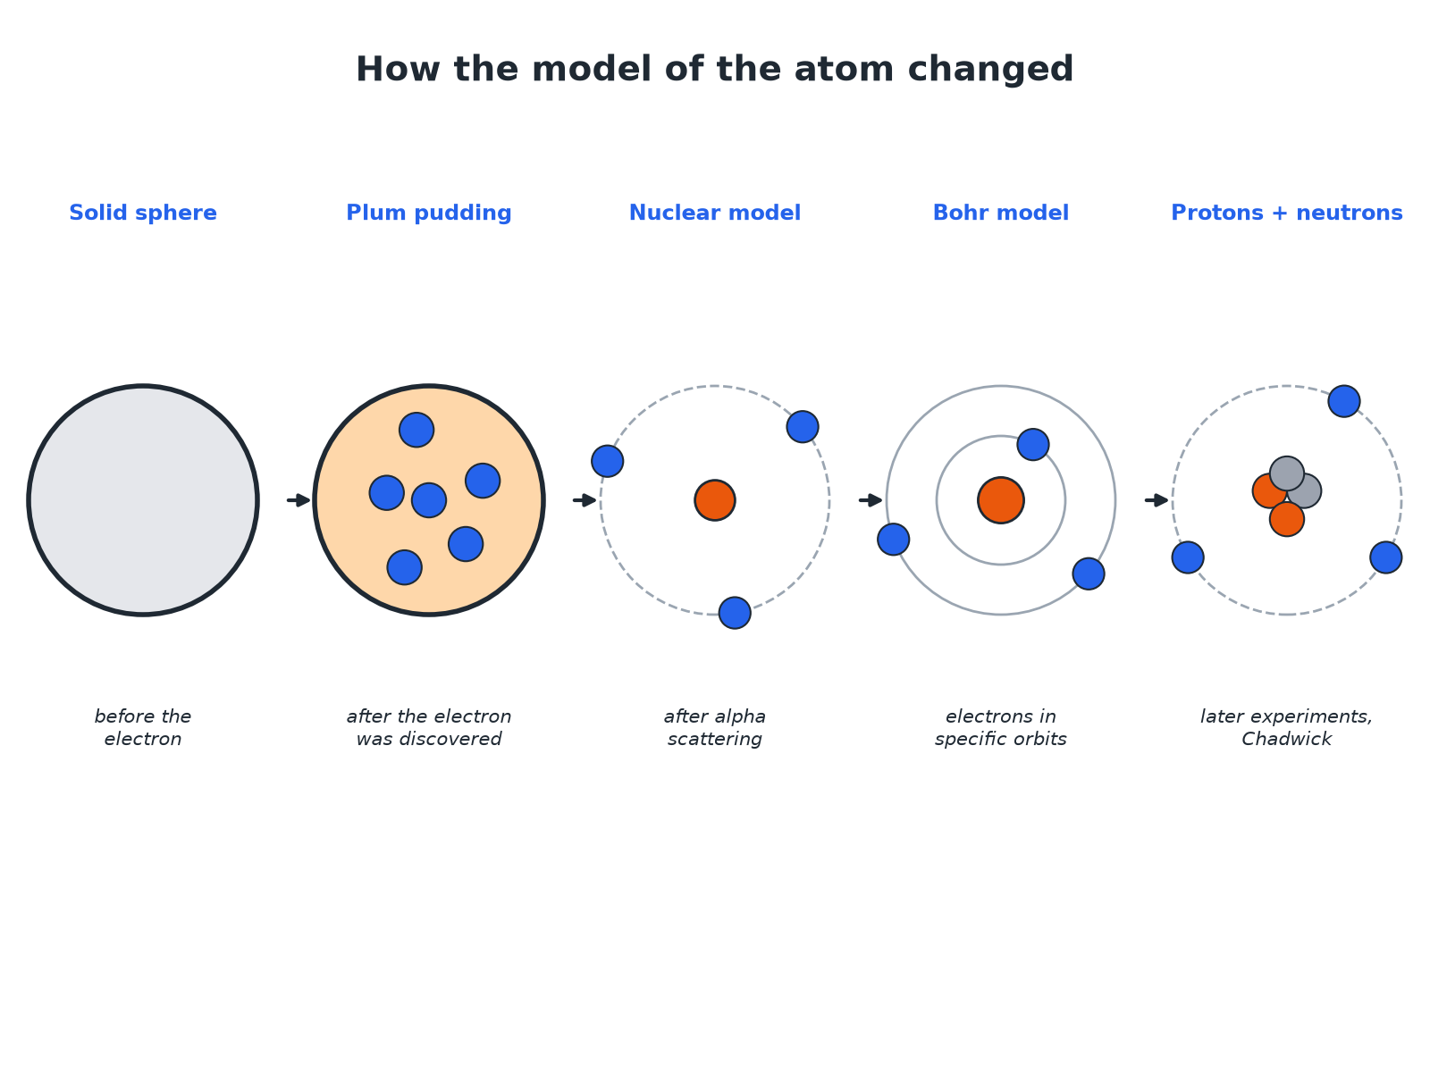
Each new model came from new evidence.
A timeline of atomic models: solid sphere, plum pudding, nuclear model, Bohr model and a nucleus with protons and neutrons.
The Alpha Scattering Experiment
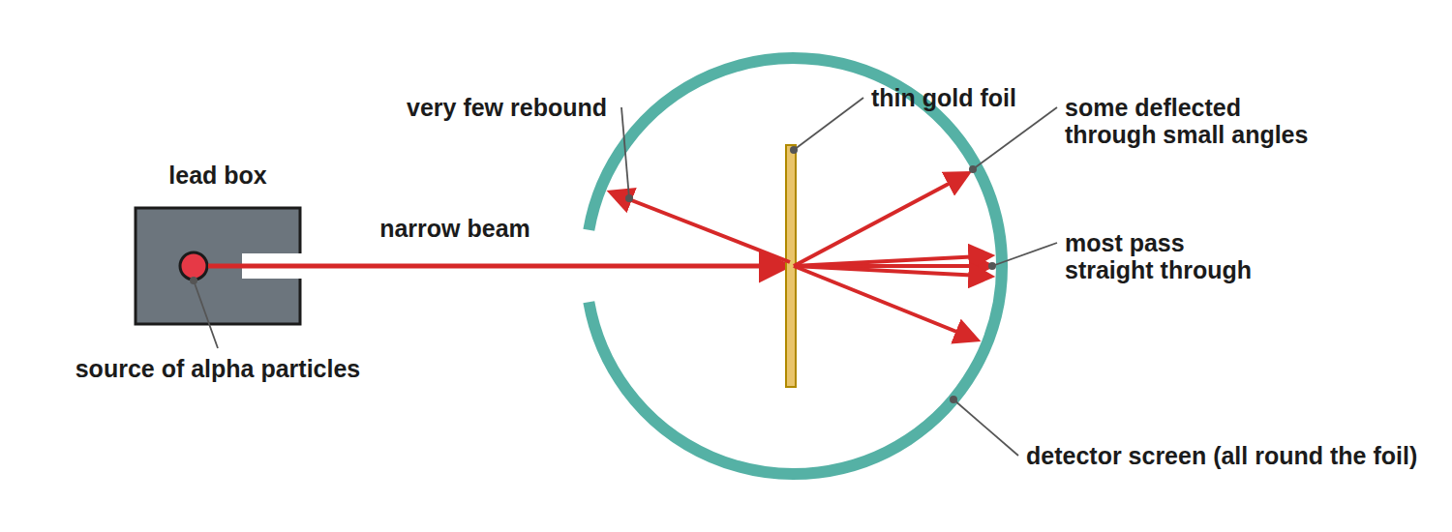
Most alpha particles passed straight through.
The alpha scattering experiment with most particles passing straight through gold foil, some deflected and a few rebounding.
Evidence and Conclusions
Match each result to its explanation.
Observation | Conclusion
Most alpha particles went straight through | Most of the atom is empty space
Some were deflected through small angles | The nucleus is positive and repels the positive alpha particles
A very few bounced back | The mass is concentrated in a tiny, dense, charged nucleus
Plum Pudding or Nuclear?
PLUM PUDDING MODEL | NUCLEAR MODEL
▸ A ball of positive charge.  ▸ Negative electrons embedded in it.  ▸ Charge and mass spread throughout the atom. | ▸ A tiny, positively charged nucleus at the centre.  ▸ Electrons orbit at a distance.  ▸ Most of the atom is empty space.
Why the Model Changed
Explain why the results of the alpha scattering experiment led to the plum pudding model being replaced.

1. Plum pudding prediction
Alpha particles should pass through with only small deflections
2. Result
Some were deflected by large angles and a few rebounded
3. Conclusion
A concentrated, positive nucleus must exist, so the nuclear model replaced the plum pudding model
Answer: The scattering results could not be explained by the plum pudding model, so the nuclear model replaced it.
The Story
Learn the sequence.
▸ Before the electron. Atoms were thought to be tiny spheres that could not be divided.
▸ Discovery of the electron. Led to the plum pudding model.
▸ Alpha scattering. Led to the nuclear model; the nucleus was charged.
▸ Bohr. Adapted the nuclear model with electrons orbiting at specific distances; his calculations agreed with experiments.
▸ Protons. The nucleus's charge was divided into whole-number units: protons.
▸ Chadwick. Provided evidence for neutrons about 20 years after the nucleus was accepted.
Key Terms
Model  A representation used to explain observations. | Plum pudding model  A ball of positive charge with electrons embedded.
Alpha scattering  An experiment in which alpha particles are fired at gold foil. | Nuclear model  An atom with a small, dense, positive nucleus.
Bohr model  Electrons orbit the nucleus at specific distances. | Evidence  Experimental results that support or contradict a model.
Your Task: Predict the Result
12 minutes
If the plum pudding model were correct, what would happen to alpha particles fired at gold foil? What actually happened, and what did it show?
1. Predict with plum pudding.
2. Compare with the result.
A good answer shows: They would pass through with small deflections. In fact most passed straight through, some were deflected by large angles and a few bounced back, showing a small dense positive nucleus.
Note: Discuss how science changes when evidence changes.
Can I...?
☐ Describe the plum pudding model.
☐ Describe the nuclear model.
☐ Describe the alpha scattering results.
☐ Explain why the model changed.
☐ Say what Bohr added.
☐ Say what Chadwick showed.
☐ Explain why models change.
☐ Order the models.
Summary
✓ Plum pudding: ball of positive charge with electrons in it.
✓ Nuclear: small positive nucleus with electrons around it.
✓ Alpha scattering evidence changed the model.
✓ Bohr: specific orbits. Chadwick: neutrons.

EXAM FOCUS
Describe the difference between the plum pudding model and the nuclear model of the atom. (3 marks)
Say where the positive charge and mass are in each.
Exam Practice: The development of the model of the atom
Answer all questions. Use the mark allocation as a guide to how much to write. · 18 minutes
▸ Question 1 · 2 marks · Describe. Describe the plum pudding model of the atom.
▸ Question 2 · 4 marks · Explain. The diagram shows the paths of alpha particles fired at thin gold foil. Explain how these results led to the nuclear model of the atom.
▸ Question 3 · 3 marks · Describe. Describe how the nuclear model of the atom differs from the plum pudding model.
▸ Question 4 · 2 marks · State. State two ways in which Bohr changed the nuclear model, or what the later experiments showed.
▸ Question 5 · 6 marks · Explain. Describe how the model of the atom has changed, from the idea of a solid sphere to the model with protons and neutrons in the nucleus…
Question 1 · 2 marks · Describe
“Describe the plum pudding model of the atom.”
HOW TO ANSWER IT Command word: Describe. Worth 2 marks, so plan before writing.
Question 1 · mark scheme
2 marks available. Award a mark for each point made.
▸ Ball of positive charge. 1 mark
▸ Electrons embedded in it. 1 mark
▸ Model answer. The atom is a ball of positive charge with negatively charged electrons embedded in it.
Question 2 · 4 marks · Explain
The diagram shows the paths of alpha particles fired at thin gold foil. Explain how these results led to the nuclear model of the atom. (4 marks) | 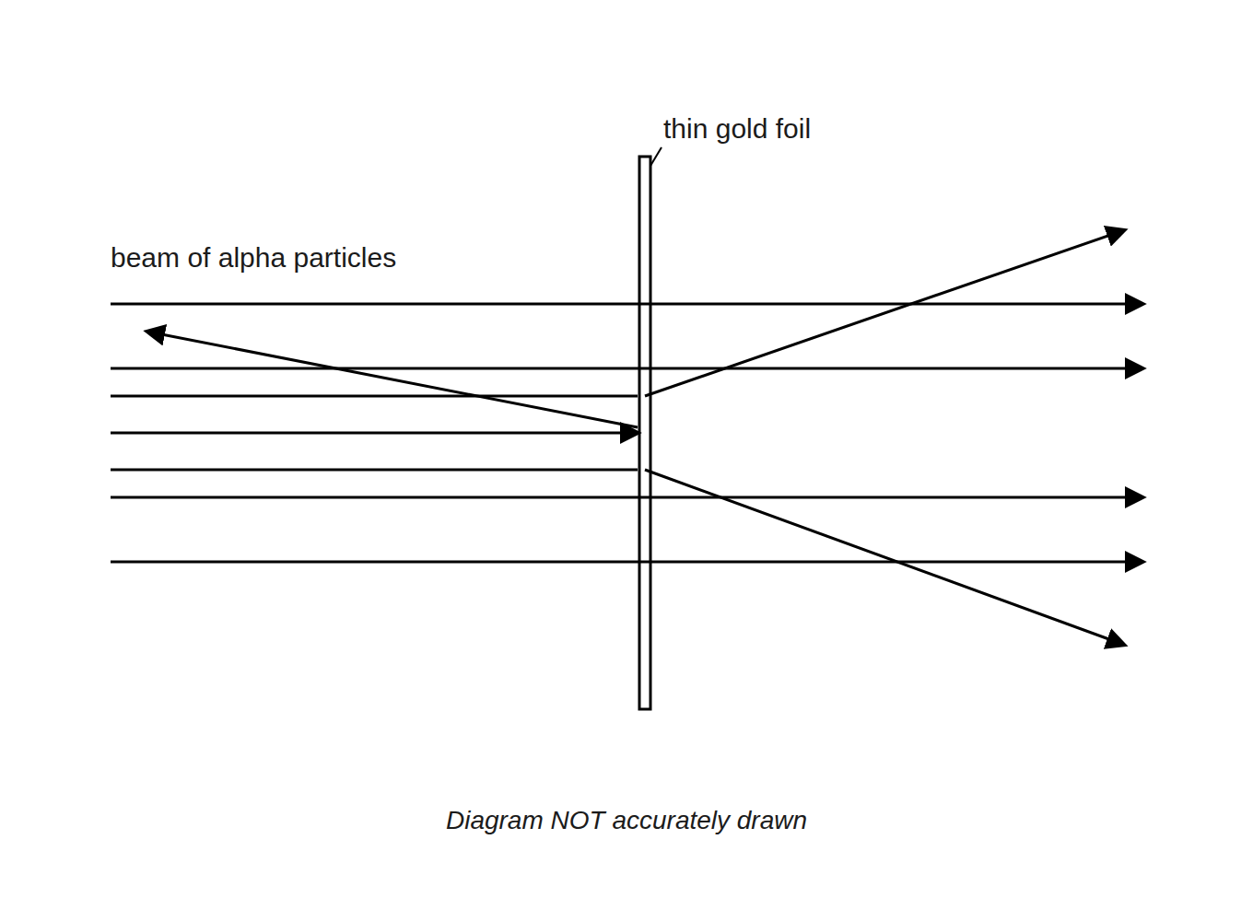

Question 2 · mark scheme
4 marks available. Award a mark for each point made.
▸ Most went straight through so the atom is mostly empty space. 1 mark
▸ Some deflected: the nucleus is positive. 1 mark
▸ A few rebounded: mass concentrated in a small nucleus. 1 mark
▸ Plum pudding could not explain this. 1 mark
▸ Model answer. Most alpha particles went straight through, so most of the atom is empty space. Some were deflected, so the nucleus is positively charged (repelling alpha particles). A few bounced back, so the mass is concentrated in a small, dense nucleus. The plum pudding model could not explain this.
Question 3 · 3 marks · Describe
“Describe how the nuclear model of the atom differs from the plum pudding model.”
HOW TO ANSWER IT Command word: Describe. Worth 3 marks, so plan before writing.
Question 3 · mark scheme
3 marks available. Award a mark for each point made.
▸ Nuclear: positive charge and mass in a small nucleus. 1 mark
▸ Electrons outside the nucleus. 1 mark
▸ Plum pudding: charge spread out. 1 mark
▸ Model answer. In the nuclear model the positive charge and most of the mass are concentrated in a tiny nucleus with electrons around it; in the plum pudding model the positive charge is spread throughout the atom with electrons embedded in it.
Question 4 · 2 marks · State
“State two ways in which Bohr changed the nuclear model, or what the later experiments showed.”
HOW TO ANSWER IT Command word: State. Worth 2 marks, so plan before writing.
Question 4 · mark scheme
2 marks available. Award a mark for each point made.
▸ Electrons orbit at specific distances. 1 mark
▸ Protons and neutrons in the nucleus. 1 mark
▸ Model answer. Bohr suggested electrons orbit the nucleus at specific distances. Later experiments showed the nucleus contains protons and neutrons (Chadwick for neutrons).
Question 5 · 6 marks · Explain
“Describe how the model of the atom has changed, from the idea of a solid sphere to the model with protons and neutrons in the nucleus. Explain why each change was made.”
HOW TO ANSWER IT Command word: Explain. Worth 6 marks, so plan before writing.
Question 5 · mark scheme
6 marks available. Award a mark for each point made.
▸ Level 3 (5 to 6 marks): a correct sequence (solid sphere, plum pudding, nuclear model, Bohr, protons and neutrons) with the evidence for at least three changes, including alpha scattering. 5 to 6 marks
▸ Level 2 (3 to 4 marks): at least three models named with some evidence. 3 to 4 marks
▸ Level 1 (1 to 2 marks): one or two models described. 1 to 2 marks
▸ Model answer. See levels-of-response scheme.

