AQA GCSE PHYSICS · PAPER 2 · FOUNDATION & HIGHER
Forces and elasticity
Forces · Lesson 5 of 20
Teacher copy - includes the notes for whoever is teaching from it.
Warm-up
Answer each one, then check.
1. What is a spring?
A coiled wire that can be stretched or compressed
2. What does proportional mean?
Doubling one doubles the other
3. Convert 6 cm to m.
0.06 m
4. What is elastic potential energy?
Energy stored in a stretched spring
5. What is the unit of force?
Newton
Learning Objectives
1. Explain why more than one force is needed to stretch, bend or compress an object.
2. Describe elastic and inelastic deformation.
3. Recall and apply F = ke and E_e = ½ke².
4. Interpret force-extension graphs and describe Required Practical 6.
Hooke's Law
force = spring constant × extension F = ke
The extension of an elastic object is directly proportional to the force applied, provided the limit of proportionality is not exceeded. The same applies to compression.
Force and Extension
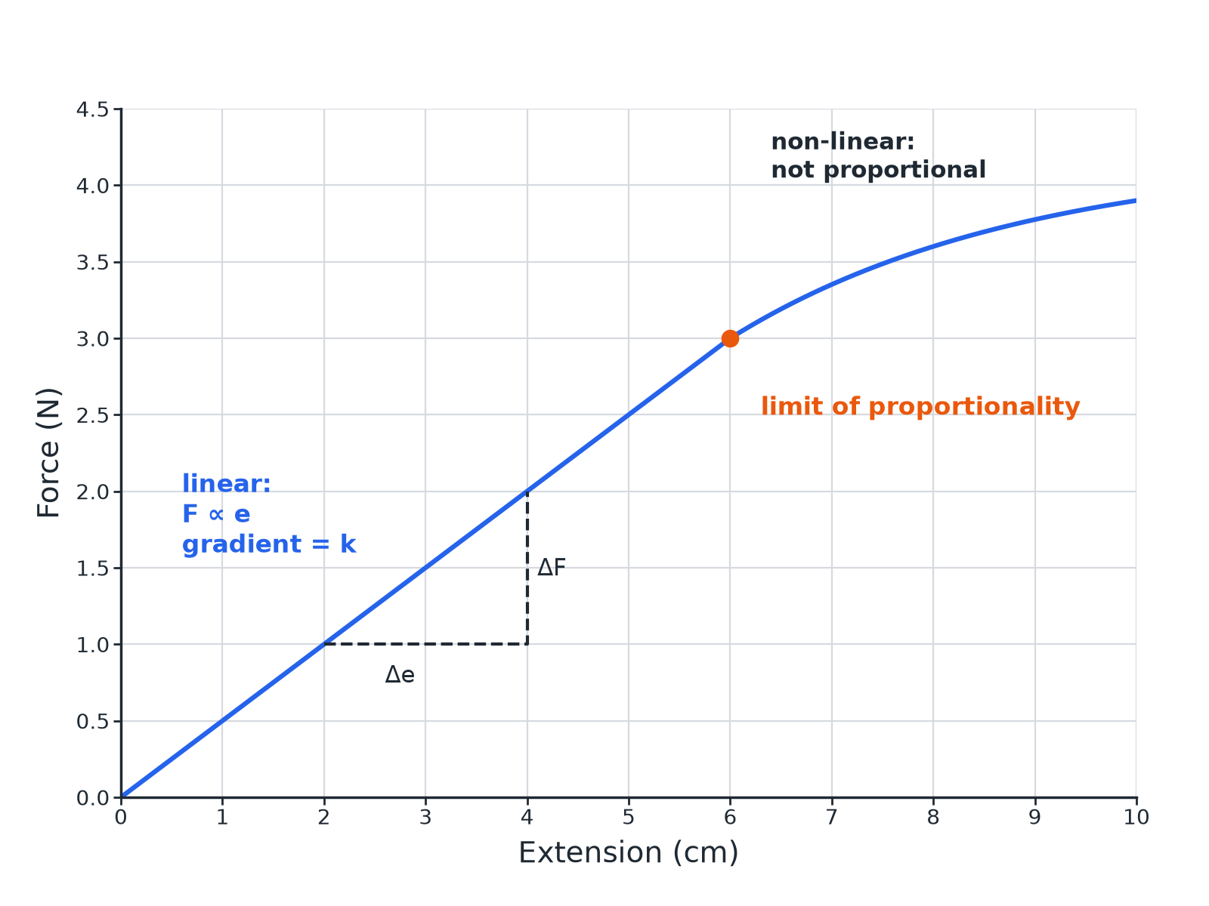
Beyond the limit, the spring does not return to its original length.
A force-extension graph with a straight linear section and a curved section beyond the limit of proportionality.
Required Practical 6: Stretching a Spring
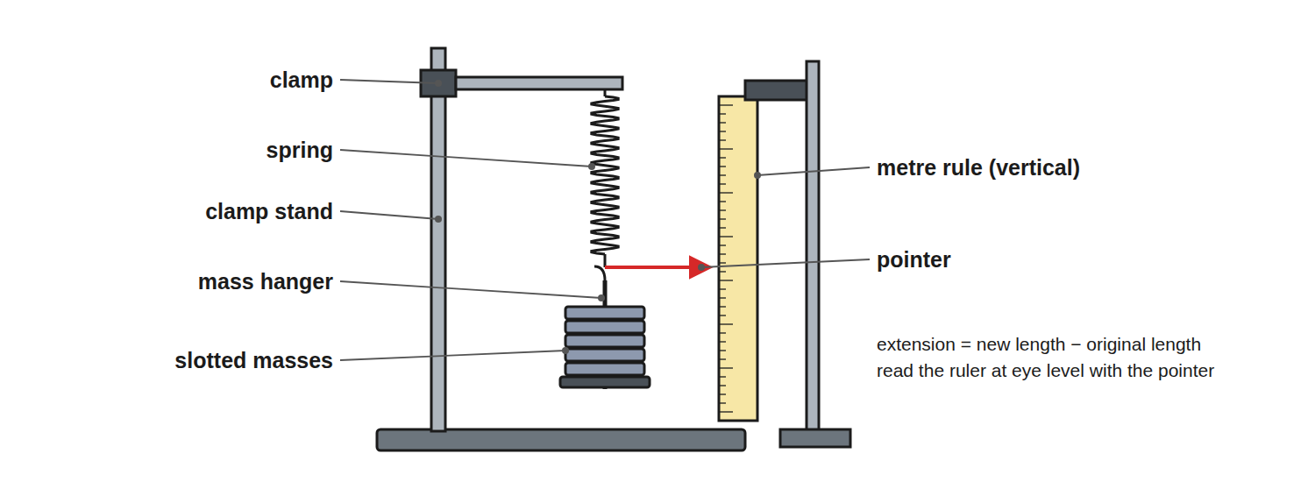
Measure the length with each extra mass added.
A spring hanging from a stand with a ruler beside it and masses on a hanger, used to measure extension.
Required Practical 6: Method
Investigate force and extension.
1  Measure the original length  With no masses on the spring. | 2  Add a mass  Record the force (weight = mg) and the new length. | 3  Calculate the extension  New length minus original length. | 4  Repeat  Add masses one at a time, keeping below the limit of proportionality at first. | 5  Plot  Force (y-axis) against extension (x-axis). | 6  Gradient  Gradient of the straight part = spring constant k.
Spring Constant
A force of 3.0 N stretches a spring by 6.0 cm (within the limit of proportionality). Calculate the spring constant.

1. Convert
6.0 cm = 0.060 m
2. Rearrange
k = F ÷ e
3. Substitute
k = 3.0 ÷ 0.060
4. Answer
k = 50 N/m
Answer: 50 N/m
Elastic Potential Energy
Calculate the energy stored in the spring when the extension is 0.040 m and k = 50 N/m.

1. Write the equation
E_e = ½ke²
2. Substitute
E_e = 0.5 × 50 × 0.040²
3. Answer
E_e = 0.040 J
Answer: 0.040 J
Elastic or Inelastic?
ELASTIC DEFORMATION | INELASTIC DEFORMATION
▸ The object returns to its original shape when the force is removed.  ▸ Happens within the limit of proportionality. | ▸ The object does not return to its original shape.  ▸ Happens beyond the limit of proportionality.
Key Ideas
Learn these.
▸ Two forces. To stretch, bend or compress a stationary object, more than one force is needed (for example pull at both ends).
▸ Work done. The work done on an elastic object equals the elastic potential energy stored, provided it is not inelastically deformed.
▸ Linear. A straight line through the origin: proportional.
▸ Non-linear. A curve: not proportional.
Key Terms
Extension  The increase in length of a spring. | Spring constant  The force needed per metre of extension (N/m).
Limit of proportionality  The point beyond which force and extension are no longer proportional. | Elastic deformation  A change of shape that is reversed when the force is removed.
Inelastic deformation  A permanent change of shape. | Linear  Following a straight line.
Your Task: Spring Test
12 minutes
A spring stretches 4.0 cm when a 2.0 N force is applied. (a) Calculate k in N/m. (b) What force gives an extension of 10 cm if the limit is not exceeded? (c) What energy is stored at 10 cm?
1. Convert cm to m.
2. Use F = ke and Ee = ½ke².
A good answer shows: (a) 50 N/m. (b) F = 50 × 0.10 = 5.0 N. (c) E = 0.5 × 50 × 0.10² = 0.25 J.
Note: Ask why the spring may not return to shape if overstretched.
Can I...?
☐ State F = ke.
☐ Convert cm to m.
☐ Calculate a spring constant.
☐ Calculate stored energy.
☐ Describe elastic and inelastic deformation.
☐ Read a force-extension graph.
☐ Describe Required Practical 6.
☐ Find the gradient.
Summary
✓ F = ke.
✓ E_e = ½ke².
✓ Beyond the limit of proportionality: non-linear, may not return.
✓ Spring constant = gradient of the linear part.

EXAM FOCUS
A spring has a spring constant of 50 N/m. Calculate the force needed to stretch it by 0.10 m. (2 marks)
Use F = ke.
Exam Practice: Forces and elasticity
Answer all questions. Use the mark allocation as a guide to how much to write. · 18 minutes
▸ Question 1 · 2 marks · Calculate. A spring has a spring constant of 50 N/m. Calculate the force needed to stretch the spring by 0.10 m. Use the equation: force = spring…
▸ Question 2 · 5 marks · Use the graph. A student investigates a spring. The graph shows how the force changes with extension. (a) State the extension at the limit of…
▸ Question 3 · 2 marks · Describe. Describe the difference between elastic deformation and inelastic deformation of a spring.
▸ Question 4 · 6 marks · Describe. Describe how to investigate the relationship between the force applied to a spring and the extension of the spring. Your answer should…
▸ Question 5 · 2 marks · Explain. Explain why two forces are needed to stretch a spring that is fixed to a wall.
Question 1 · 2 marks · Calculate
“A spring has a spring constant of 50 N/m. Calculate the force needed to stretch the spring by 0.10 m. Use the equation: force = spring constant × extension”
HOW TO ANSWER IT Command word: Calculate. Worth 2 marks, so plan before writing.
Question 1 · mark scheme
2 marks available. Award a mark for each point made.
▸ Correct substitution. 1 mark
▸ 5.0 N. 1 mark
▸ Model answer. 50 × 0.10 = 5.0 N
Question 2 · 5 marks · Use the graph
A student investigates a spring. The graph shows how the force changes with extension. (a) State the extension at the limit of proportionality. (b) Calculate the spring constant of the spring. (c) Calculate the elastic potential energy stored when the extension is 0.040 m. (5 marks) | 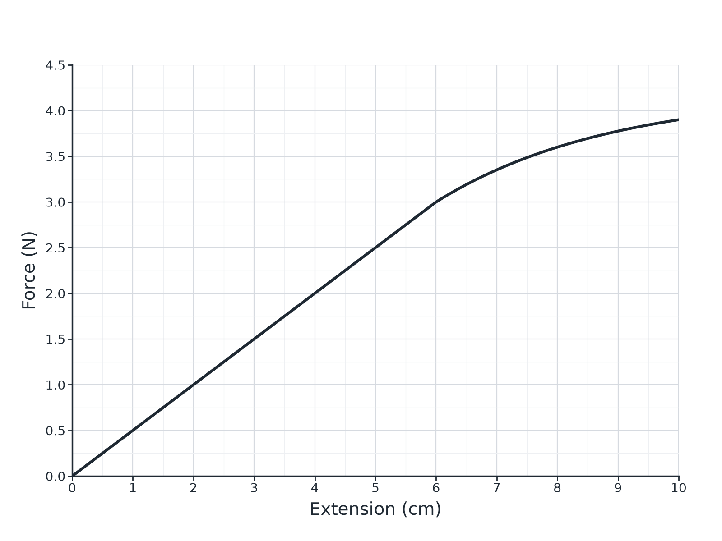

Question 2 · mark scheme
5 marks available. Award a mark for each point made.
▸ 6 cm (accept 5.5 to 6.5). 1 mark
▸ Uses 3.0 N at 0.060 m. 1 mark
▸ 50 N/m. 1 mark
▸ Correct substitution. 1 mark
▸ 0.040 J. 1 mark
▸ Model answer. (a) About 6 cm. (b) k = 3.0 ÷ 0.060 = 50 N/m. (c) E_e = 0.5 × 50 × 0.040² = 0.040 J
Question 3 · 2 marks · Describe
“Describe the difference between elastic deformation and inelastic deformation of a spring.”
HOW TO ANSWER IT Command word: Describe. Worth 2 marks, so plan before writing.
Question 3 · mark scheme
2 marks available. Award a mark for each point made.
▸ Elastic: returns to original shape. 1 mark
▸ Inelastic: does not return. 1 mark
▸ Model answer. In elastic deformation the spring returns to its original length when the force is removed; in inelastic deformation it does not and is permanently changed.
Question 4 · 6 marks · Describe
“Describe how to investigate the relationship between the force applied to a spring and the extension of the spring. Your answer should include the apparatus, the measurements, and how you would use them.”
HOW TO ANSWER IT Command word: Describe. Worth 6 marks, so plan before writing.
Question 4 · mark scheme
6 marks available. Award a mark for each point made.
▸ Level 3 (5 to 6 marks): a complete method with stand, ruler and masses, original length measured, several forces (weights) applied with the new length each time, extension calculated, graph plotted and spring constant from the gradient, with a precaution (eye level, avoid overstretching). 5 to 6 marks
▸ Level 2 (3 to 4 marks): a method covering force and extension with some detail missing. 3 to 4 marks
▸ Level 1 (1 to 2 marks): simple statements about adding masses and measuring length. 1 to 2 marks
▸ Model answer. See levels-of-response scheme.
Question 5 · 2 marks · Explain
“Explain why two forces are needed to stretch a spring that is fixed to a wall.”
HOW TO ANSWER IT Command word: Explain. Worth 2 marks, so plan before writing.
Question 5 · mark scheme
2 marks available. Award a mark for each point made.
▸ Forces act at both ends. 1 mark
▸ Equal and opposite forces. 1 mark
▸ Model answer. The wall applies a force in the opposite direction to the pulling force, so the spring is stretched; with only one force the object would accelerate rather than change shape.

