AQA GCSE PHYSICS · PAPER 2 · FOUNDATION & HIGHER
Properties of waves
Waves · Lesson 2 of 12
Teacher copy - includes the notes for whoever is teaching from it.
Warm-up
Answer each one, then check.
1. What is the unit of frequency?
Hertz (Hz)
2. What is the unit of wavelength?
Metres (m)
3. What is the speed of sound in air?
About 330 m/s
4. What is a crest?
The highest point of a transverse wave
5. What is period?
The time for one wave to pass
Learning Objectives
1. Define amplitude, wavelength, frequency and period.
2. Recall and apply T = 1 ÷ f and v = fλ.
3. Identify amplitude and wavelength from diagrams.
4. Describe methods to measure the speed of sound and of ripples, and Required Practical 8.
5. Explain how v, f and λ change when sound passes from one medium to another (Physics only).
The Wave Equation
wave speed = frequency × wavelength v = fλ
Period T = 1/f. v = fλ is given on the equation sheet. Wave speed is in m/s, frequency in Hz, wavelength in m and period in s.
Labelling a Wave
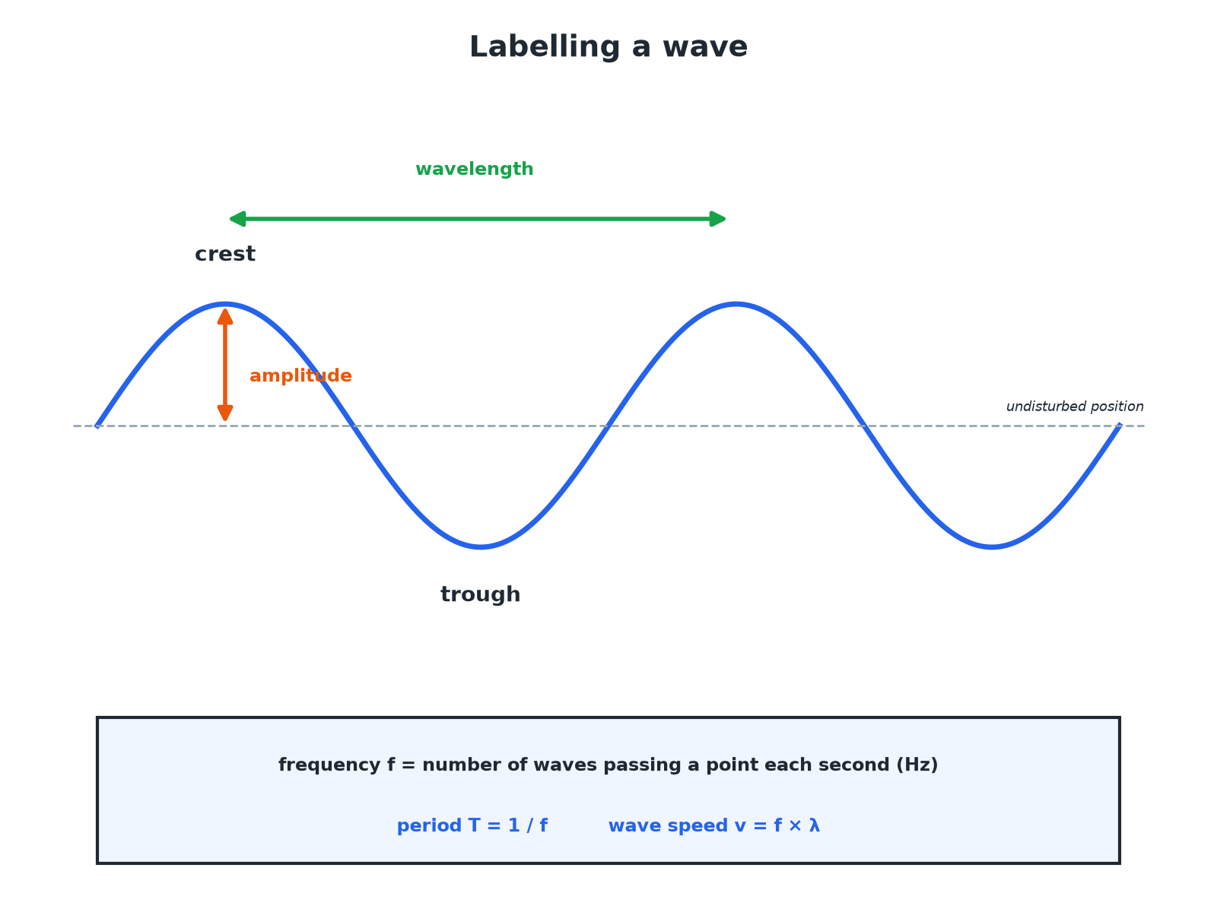
Amplitude is measured from the undisturbed position, not from trough to crest.
A labelled wave showing crest, trough, amplitude and wavelength.
Required Practical 8: Waves in a Ripple Tank
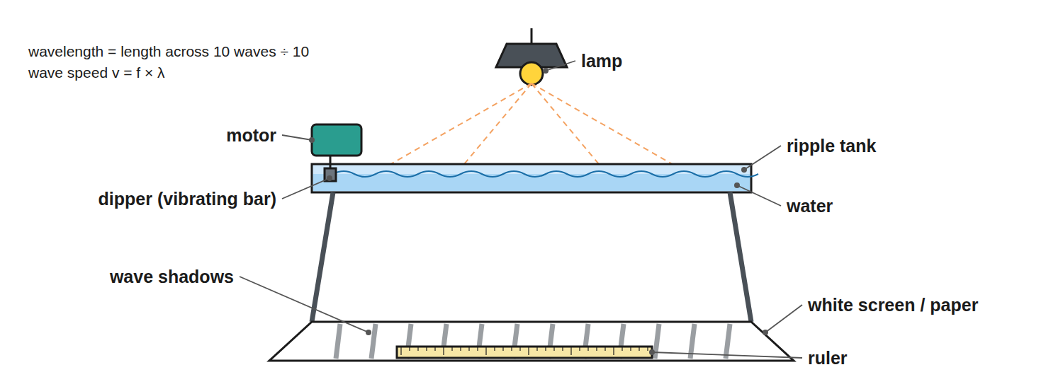
Measure the wavelength from the pattern and the frequency from the motor.
A ripple tank with a lamp above, a dipper making waves and a screen below showing the wave pattern.
Wave Quantities
Learn the definitions and units.
Quantity | Symbol | Unit | Meaning
Amplitude | A | m | Maximum displacement from the undisturbed position
Wavelength | λ | m | Distance between equivalent points on adjacent waves
Frequency | f | Hz | Number of waves passing a point each second
Period | T | s | Time for one complete wave
Wave speed | v | m/s | Speed at which the wave moves or transfers energy
Using the Wave Equation
Sound waves of frequency 50 Hz travel at 330 m/s. Calculate the wavelength.

1. Rearrange
λ= v ÷ f
2. Substitute
λ= 330 ÷ 50
3. Answer
λ= 6.6 m
Answer: 6.6 m
Finding Speed
Water waves have a frequency of 2.0 Hz and a wavelength of 0.50 m. Calculate the wave speed.

1. Write the equation
v = fλ
2. Substitute
v = 2.0 × 0.50
3. Answer
v = 1.0 m/s
Answer: 1.0 m/s
Period
A wave has a frequency of 250 Hz. Calculate the period.

1. Write the equation
T = 1 ÷ f
2. Substitute
T = 1 ÷ 250
3. Answer
T = 0.0040 s
Answer: 0.0040 s
Speed of Sound by Echo
Describe a method to measure the speed of sound in air.

1. Set up
Stand a measured distance (for example 100 m) from a large wall and clap
2. Time
Start a stopwatch at the clap and stop at the echo
3. Calculate
v = distance there and back ÷ time
4. Repeat
Take several readings and find a mean
Answer: Speed = 2d ÷ t, with repeats to reduce error.
Changing Medium (Physics only)
A sound wave of frequency 500 Hz travels from air (330 m/s) into water (1500 m/s). What happens to f, v and λ?

1. Frequency
Unchanged: it is set by the source
2. Speed
Increases to 1500 m/s
3. Wavelength
λ= v ÷ f increases: from 0.66 m to 3.0 m
Answer: f stays the same; v and λ both increase.
Required Practical 8: Ripple Tank Method
Measuring frequency, wavelength and speed of water waves.
1  Set up  Fill a ripple tank and set the signal generator so the dipper makes steady waves; a lamp above casts shadows on paper below. | 2  Wavelength  Measure across 10 wavelengths with a ruler on the shadow pattern and divide by 10. | 3  Frequency  Count the waves passing a point in 10 seconds and divide by 10, or read the generator. | 4  Speed  Calculate v = fλ. | 5  Improve  A strobe or a photo with a ruler in shot freezes the pattern for easier measuring.
Measuring Waves on a String
The second part of Required Practical 8.
▸ Set up. A string runs over a pulley with masses hung on the end, and a vibration generator near the other end.
▸ Standing wave. Adjust the frequency until a clear, stationary pattern of loops appears. Measure across several half-wavelengths with a metre ruler.
▸ Calculate. Read the frequency from the signal generator and use v = fλ. Changing the frequency changes the wavelength, but the speed stays the same for the same string and tension.
Reading a Wave Diagram
Where marks are lost on labelled diagrams.
▸ Amplitude. Measure from the middle line (undisturbed position) to a crest, not from trough to crest.
▸ Wavelength. Measure from one crest to the next crest, or between any two matching points.
▸ Time axis. If the x-axis is time instead of distance, the gap between crests is the period, not the wavelength.
Key Terms
Amplitude  The maximum displacement of a point on a wave from its undisturbed position. | Wavelength  The distance from a point on one wave to the same point on the next wave.
Frequency  The number of waves passing a point each second. | Period  The time for one complete wave.
Wave speed  The speed at which energy is transferred through a medium. | Ripple tank  A shallow tray of water used to show wave behaviour.
Hertz  The unit of frequency: one wave per second. | Undisturbed position  The position of the medium when no wave is passing.
Signal generator
A device that produces a vibration at a set frequency.
Your Task: Wave Sums
12 minutes
Ripples have a wavelength of 4.0 cm and a frequency of 5.0 Hz. Calculate the speed in m/s. What is the period?
1. Convert cm to m.
2. Use v = fλ and T = 1/f.
A good answer shows: λ = 0.040 m; v = 5.0 × 0.040 = 0.20 m/s. T = 1 ÷ 5.0 = 0.20 s.
Note: Ask how the speed changes if the frequency doubles.
Can I...?
☐ Define amplitude.
☐ Define wavelength.
☐ Define frequency and period.
☐ Use v = fλ.
☐ Use T = 1 ÷ f.
☐ Read a wave diagram.
☐ Describe measuring wave speed.
☐ Explain changes at a boundary.
Summary
✓ v = fλ and T = 1 ÷ f.
✓ Amplitude from the undisturbed position to a crest.
✓ Wavelength between equivalent points.
✓ Frequency stays constant when a wave changes medium.
✓ Measure amplitude from the middle line, not trough to crest.
✓ Measure across several waves and divide for accuracy.

EXAM FOCUS
Sound of frequency 50 Hz travels at 330 m/s. Calculate the wavelength. (2 marks)
Rearrange v = fλ to λ = v ÷ f, substitute 330 ÷ 50 and give 6.6 m. If the frequency is given in kHz, multiply by 1000 first.
Exam Practice: Properties of waves
Answer all questions. Use the mark allocation as a guide to how much to write. · 17 minutes
▸ Question 1 · 2 marks · Calculate. Sound waves travel through air at 330 m/s. A sound has a frequency of 50 Hz. Calculate the wavelength of the sound waves. Use the equation…
▸ Question 2 · 4 marks · Use the diagram. The diagram shows a water wave. (a) State the amplitude of the wave. (b) State the wavelength. (c) The wave passes a point 5 times each…
▸ Question 3 · 2 marks · Calculate. A wave has a frequency of 250 Hz. Calculate its period.
▸ Question 4 · 4 marks · Describe. Describe how you would measure the speed of sound in air using a wall and a stopwatch.
▸ Question 5 · 4 marks · Explain. A sound wave travels from air into water. Its frequency is 500 Hz. The speed of sound is 330 m/s in air and 1500 m/s in water. Explain what…
Question 1 · 2 marks · Calculate
“Sound waves travel through air at 330 m/s. A sound has a frequency of 50 Hz. Calculate the wavelength of the sound waves. Use the equation: wave speed = frequency × wavelength”
HOW TO ANSWER IT Command word: Calculate. Worth 2 marks, so plan before writing.
Question 1 · mark scheme
2 marks available. Award a mark for each point made.
▸ Rearranges to λ = v ÷ f. 1 mark
▸ 6.6 m. 1 mark
▸ Model answer. λ= 330 ÷ 50 = 6.6 m
Question 2 · 4 marks · Use the diagram
The diagram shows a water wave. (a) State the amplitude of the wave. (b) State the wavelength. (c) The wave passes a point 5 times each second. Calculate the wave speed. (4 marks) | 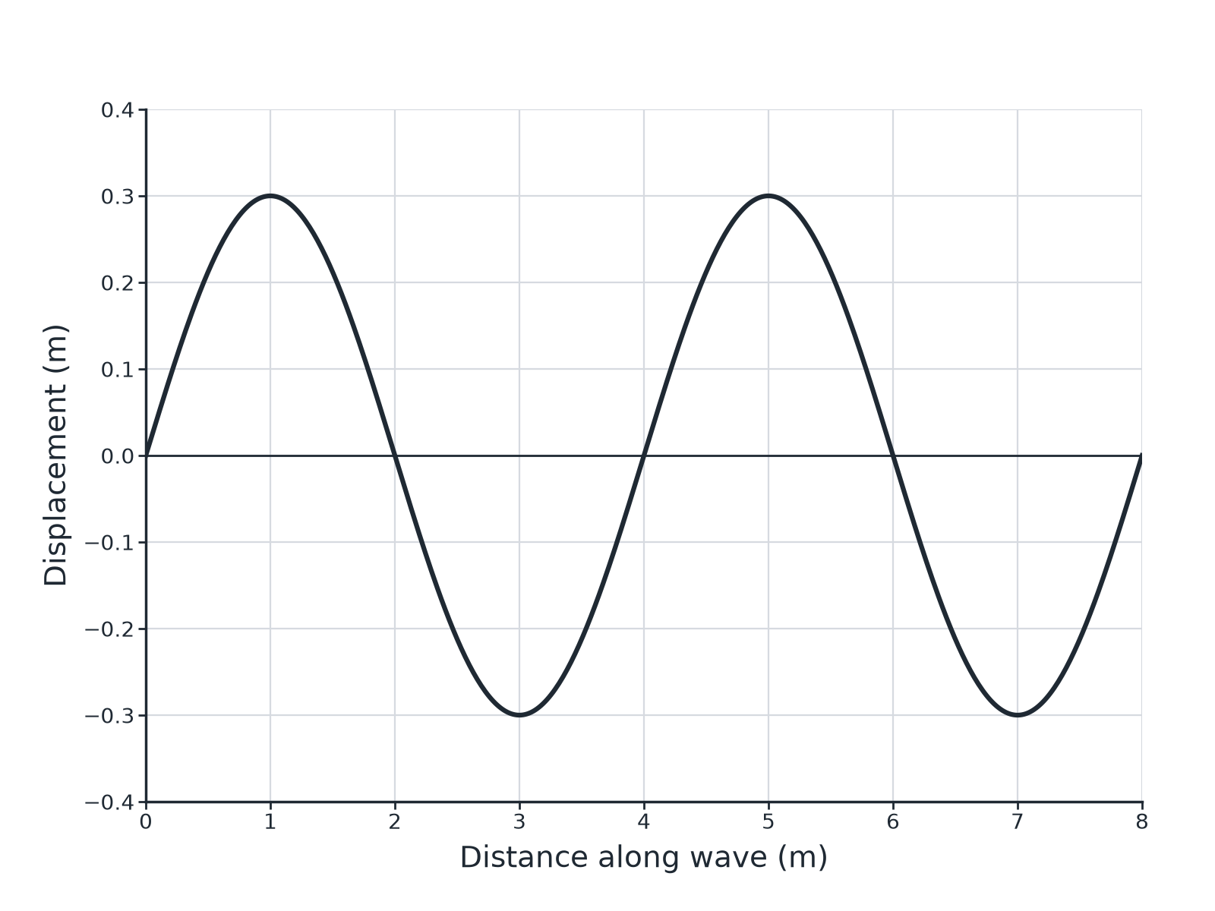

Question 2 · mark scheme
4 marks available. Award a mark for each point made.
▸ Amplitude 0.30 m. 1 mark
▸ Wavelength 4.0 m. 1 mark
▸ Correct substitution. 1 mark
▸ 20 m/s. 1 mark
▸ Model answer. (a) 0.30 m. (b) 4.0 m. (c) v = fλ= 5 × 4.0 = 20 m/s.
Question 3 · 2 marks · Calculate
“A wave has a frequency of 250 Hz. Calculate its period.”
HOW TO ANSWER IT Command word: Calculate. Worth 2 marks, so plan before writing.
Question 3 · mark scheme
2 marks available. Award a mark for each point made.
▸ Correct substitution. 1 mark
▸ 0.0040 s. 1 mark
▸ Model answer. T = 1 ÷ f = 1 ÷ 250 = 0.0040 s
Question 4 · 4 marks · Describe
“Describe how you would measure the speed of sound in air using a wall and a stopwatch.”
HOW TO ANSWER IT Command word: Describe. Worth 4 marks, so plan before writing.
Question 4 · mark scheme
4 marks available. Award a mark for each point made.
▸ Measured distance to a wall. 1 mark
▸ Timing clap to echo. 1 mark
▸ Distance travelled is there and back. 1 mark
▸ Repeat and mean. 1 mark
▸ Model answer. Stand a measured distance from a large wall. Clap and start the stopwatch; stop it when you hear the echo. The sound has travelled to the wall and back, so speed = 2 × distance ÷ time. Repeat and calculate a mean.
Question 5 · 4 marks · Explain
“A sound wave travels from air into water. Its frequency is 500 Hz. The speed of sound is 330 m/s in air and 1500 m/s in water. Explain what happens to the frequency, speed and wavelength, and calculate the wavelength in water.”
HOW TO ANSWER IT Command word: Explain. Worth 4 marks, so plan before writing.
Question 5 · mark scheme
4 marks available. Award a mark for each point made.
▸ Frequency unchanged. 1 mark
▸ Speed increases. 1 mark
▸ Wavelength increases. 1 mark
▸ 3.0 m. 1 mark
▸ Model answer. The frequency stays the same (500 Hz). The speed increases. The wavelength increases: λ= 1500 ÷ 500 = 3.0 m.

