AQA GCSE PHYSICS · PAPER 2 · FOUNDATION & HIGHER
Refraction of waves
Waves · Lesson 4 of 12
Teacher copy - includes the notes for whoever is teaching from it.
Warm-up
Answer each one, then check.
1. What is reflection?
A wave bouncing off a surface
2. What is a normal?
A line at right angles to a surface
3. Does light travel faster in glass or air?
Air
4. What is a medium?
A material a wave travels through
5. What is a wavefront?
A line joining points of a wave in the same phase
Learning Objectives
1. Describe refraction as a change in direction when a wave crosses a boundary.
2. Explain refraction in terms of the change of speed (Higher tier).
3. Construct ray diagrams for refraction at the boundary between two media.
4. Use wavefront diagrams to explain refraction (Higher tier).
Refraction
Refraction is the change in direction of a wave when it passes from one medium to another, caused by a change in the speed of the wave.
Entering a denser medium (such as glass from air) the wave slows down and bends towards the normal. Leaving the denser medium it speeds up and bends away from the normal.
Refraction of Light
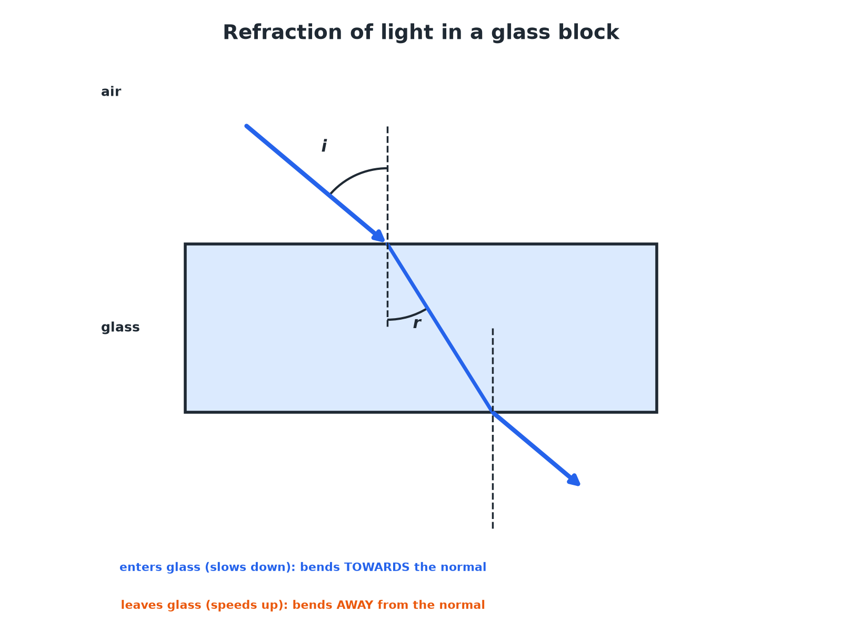
The ray emerges parallel to its original direction.
A light ray bending towards the normal entering a glass block and away from the normal on leaving.
Required Practical 9: Refraction with a Glass Block
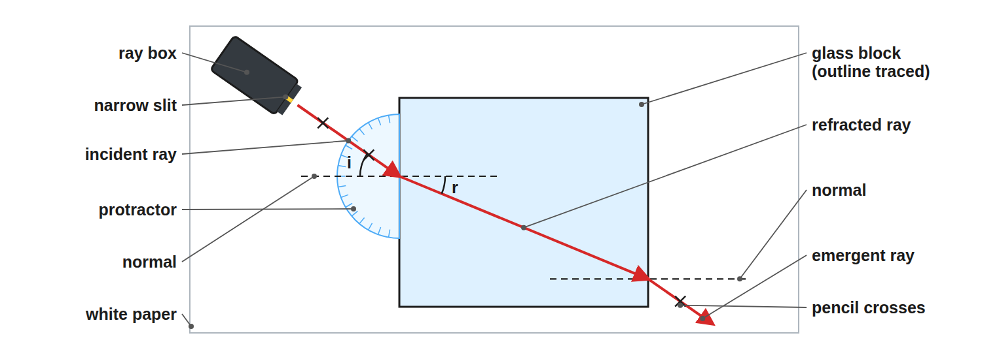
Trace the outline of the block and the rays before removing it.
A ray box beam passing through a rectangular glass block on paper with the ray path marked and a protractor.
Wavefronts and Refraction (Higher)
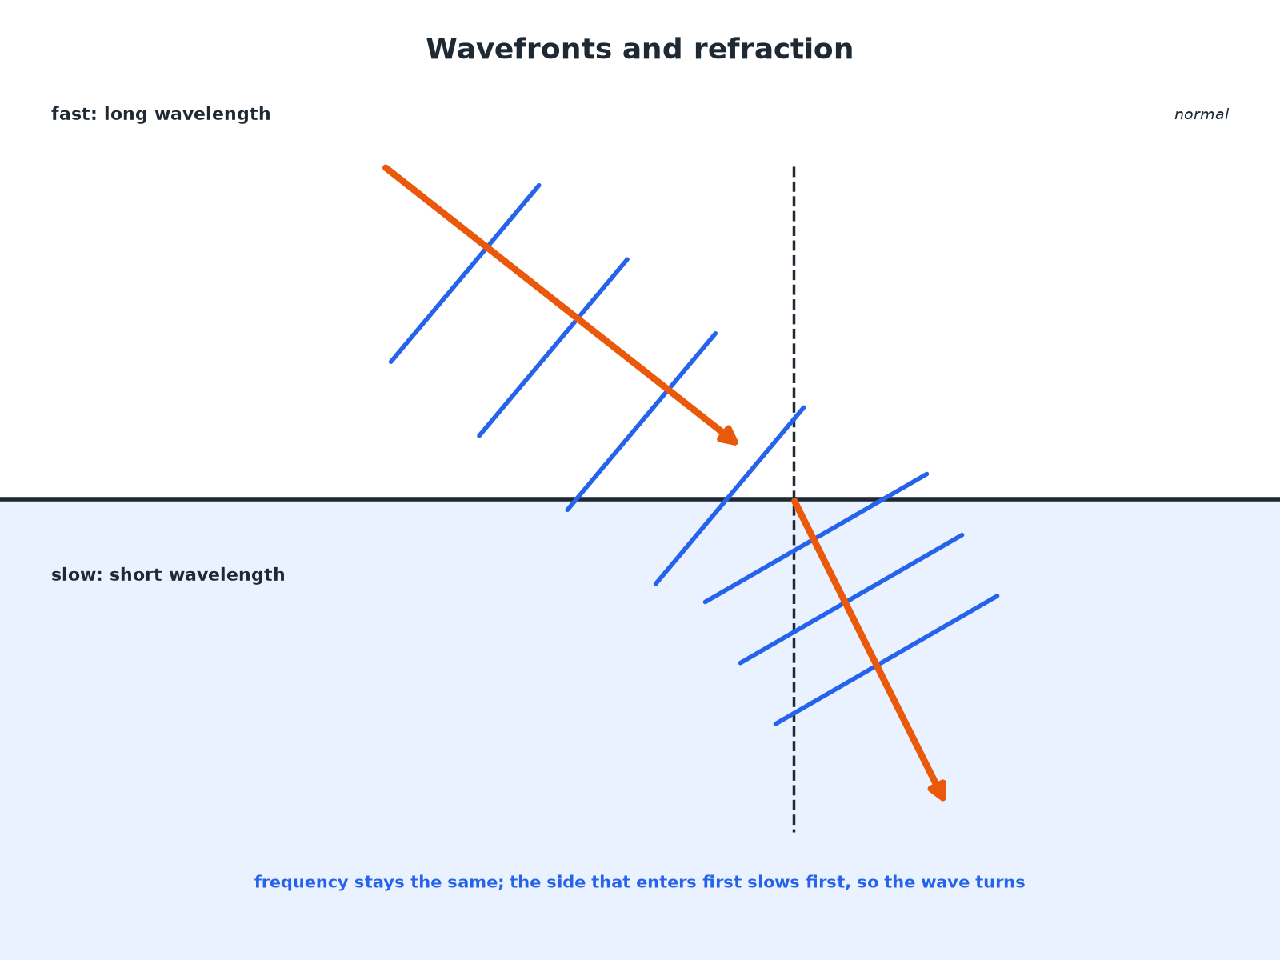
The change of speed makes the wavefront turn.
Wavefronts entering a slower medium becoming closer together and turning towards the normal.
Direction of Bending
A ray of light passes from air into glass. Describe what happens to its speed and direction.

1. Speed
Decreases in the glass
2. Direction
Bends towards the normal
Answer: It slows down and bends towards the normal.
Explaining with Wavefronts (Higher)
Use wavefronts to explain why a wave changes direction when it enters a slower medium at an angle.

1. The part of the wavefront that enters first
Slows down first
2. The rest of the wavefront
Is still travelling faster, so catches up
3. Result
The wavefront turns, so the wave direction bends towards the normal
Answer: The change of speed across the wavefront turns it.
Along the Normal
What happens to a ray that strikes the boundary at 0° to the normal?

1. Angle of incidence
0°: travelling along the normal
2. Direction
Does not change
3. Speed
Still changes
Answer: It is not refracted (no change in direction), but it still slows down.
Key Points
Exam-ready facts.
▸ Cause. A change of speed when the wave moves into a different medium.
▸ Frequency. Does not change.
▸ Different substances. EM waves can be absorbed, transmitted, refracted or reflected depending on wavelength (Higher).
▸ Practical. A ray box, glass block and protractor can be used to measure angles i and r.
Key Terms
Refraction  A change in direction of a wave caused by a change in speed. | Normal  A line at right angles to the boundary.
Angle of refraction  The angle between the refracted ray and the normal. | Wavefront  A line showing all points of a wave at the same stage.
Denser medium  A medium in which the wave travels more slowly. | Boundary  The surface between two media.
Your Task: Bend the Ray
10 minutes
Draw a ray diagram for light going from air into water at an angle, then from water into air. Label the normal and say whether the ray bends towards or away from it each time.
1. Draw the normal.
2. Decide if the speed decreases or increases.
A good answer shows: Air to water: slows down and bends towards the normal. Water to air: speeds up and bends away from the normal.
Note: Ask why a straw looks bent in a glass of water.
Can I...?
☐ Define refraction.
☐ Explain it with speed.
☐ Draw a refraction ray diagram.
☐ Say towards or away from the normal.
☐ Use wavefronts.
☐ Describe the practical.
☐ Say frequency is unchanged.
☐ Explain a ray along the normal.
Summary
✓ Refraction is a change of direction due to a change of speed.
✓ Slows: towards the normal; speeds up: away.
✓ Wavefronts turn when the speed changes (Higher).
✓ Frequency stays the same.

EXAM FOCUS
Explain why a light ray bends towards the normal as it enters a glass block. (2 marks)
It slows down.
Exam Practice: Refraction of waves
Answer all questions. Use the mark allocation as a guide to how much to write. · 16 minutes
▸ Question 1 · 2 marks · State. A ray of light passes from air into a glass block. Describe what happens to the speed of the light and the direction of the ray.
▸ Question 2 · 3 marks · Complete the diagram. The diagram shows a ray of light hitting a glass block. Complete the diagram to show the path of the ray through the block and out of the…
▸ Question 3 · 3 marks · Explain. Explain why a wave is refracted when it crosses the boundary between two media at an angle.
▸ Question 4 · 5 marks · Describe. Describe an investigation to show how a ray of light is refracted by a glass block. Your answer should include the measurements you would…
▸ Question 5 · 2 marks · Explain. A wave travels from deep water to shallow water where it slows down. State what happens to the frequency and the wavelength.
Question 1 · 2 marks · State
“A ray of light passes from air into a glass block. Describe what happens to the speed of the light and the direction of the ray.”
HOW TO ANSWER IT Command word: State. Worth 2 marks, so plan before writing.
Question 1 · mark scheme
2 marks available. Award a mark for each point made.
▸ Speed decreases. 1 mark
▸ Bends towards the normal. 1 mark
▸ Model answer. The speed decreases, and the ray bends towards the normal.
Question 2 · 3 marks · Complete the diagram
The diagram shows a ray of light hitting a glass block. Complete the diagram to show the path of the ray through the block and out of the other side. (3 marks) | 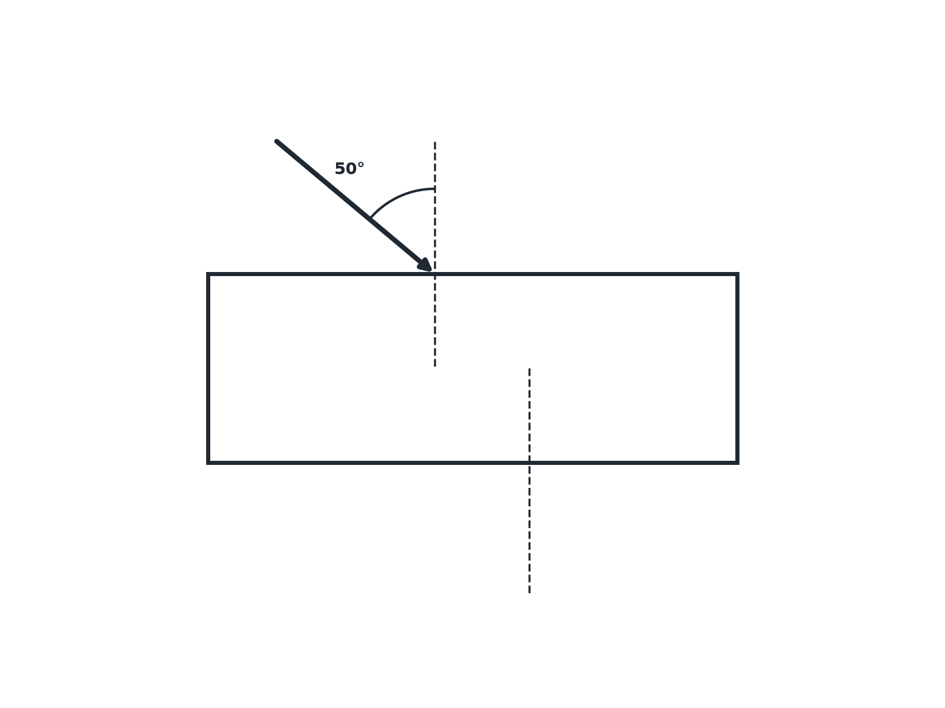

Question 2 · mark scheme
3 marks available. Award a mark for each point made.
▸ Bends towards the normal inside the glass. 1 mark
▸ Bends away from the normal on leaving. 1 mark
▸ Emergent ray parallel to the incident ray. 1 mark
▸ Model answer. The ray bends towards the normal entering the glass, then bends away from the normal leaving the block, emerging parallel to the incident ray.
Question 3 · 3 marks · Explain
“Explain why a wave is refracted when it crosses the boundary between two media at an angle.”
HOW TO ANSWER IT Command word: Explain. Worth 3 marks, so plan before writing.
Question 3 · mark scheme
3 marks available. Award a mark for each point made.
▸ Speed changes in the new medium. 1 mark
▸ Part of the wavefront changes speed first. 1 mark
▸ So the direction changes. 1 mark
▸ Model answer. The speed of the wave changes when it enters the new medium. This changes the direction of the wave, because the wavefront slows down (or speeds up) first at one side.
Question 4 · 5 marks · Describe
“Describe an investigation to show how a ray of light is refracted by a glass block. Your answer should include the measurements you would take and what you would conclude.”
HOW TO ANSWER IT Command word: Describe. Worth 5 marks, so plan before writing.
Question 4 · mark scheme
5 marks available. Award a mark for each point made.
▸ Ray box, glass block on paper, outline drawn. 1 mark
▸ Incident and emergent rays marked. 1 mark
▸ Normal drawn, angles measured. 1 mark
▸ Repeat for different angles. 1 mark
▸ Conclusion: bends towards the normal in glass. 1 mark
▸ Model answer. Place a glass block on white paper and draw around it. Shine a narrow ray from a ray box at an angle to a face. Mark the incident ray, the emergent ray and draw the ray through the block by joining the points. Draw the normal and measure the angles of incidence and refraction with a protractor. Repeat for different angles. The ray bends towards the normal entering the glass.
Question 5 · 2 marks · Explain
“A wave travels from deep water to shallow water where it slows down. State what happens to the frequency and the wavelength.”
HOW TO ANSWER IT Command word: Explain. Worth 2 marks, so plan before writing.
Question 5 · mark scheme
2 marks available. Award a mark for each point made.
▸ Frequency unchanged. 1 mark
▸ Wavelength decreases. 1 mark
▸ Model answer. The frequency stays the same. The wavelength decreases (v = fλ).

