AQA GCSE PHYSICS · PAPER 2 · FOUNDATION & HIGHER
Black body radiation
Waves · Lesson 12 of 12
Warm-up
Answer each one, then check.
1. What is infrared?
Electromagnetic radiation felt as heat
2. What makes an object hotter?
Absorbing energy faster than it emits it
3. What is absorption?
Taking in the energy of radiation
4. What is reflection?
A wave bouncing off a surface
5. What colour surface absorbs best?
Matt black
Learning Objectives
1. State that all bodies emit and absorb infrared radiation.
2. Describe a perfect black body and why it is the best emitter.
3. Explain that the intensity and wavelength distribution of emission depend on temperature.
4. Explain how the temperature of a body or of the Earth is related to absorption and emission (Higher tier).
Black Body Radiation
All bodies, whatever their temperature, emit and absorb infrared radiation. The hotter the body, the more infrared it radiates in a given time.
A perfect black body absorbs all the radiation that falls on it and is also the best possible emitter.
Required Practical 10: Infrared from Different Surfaces
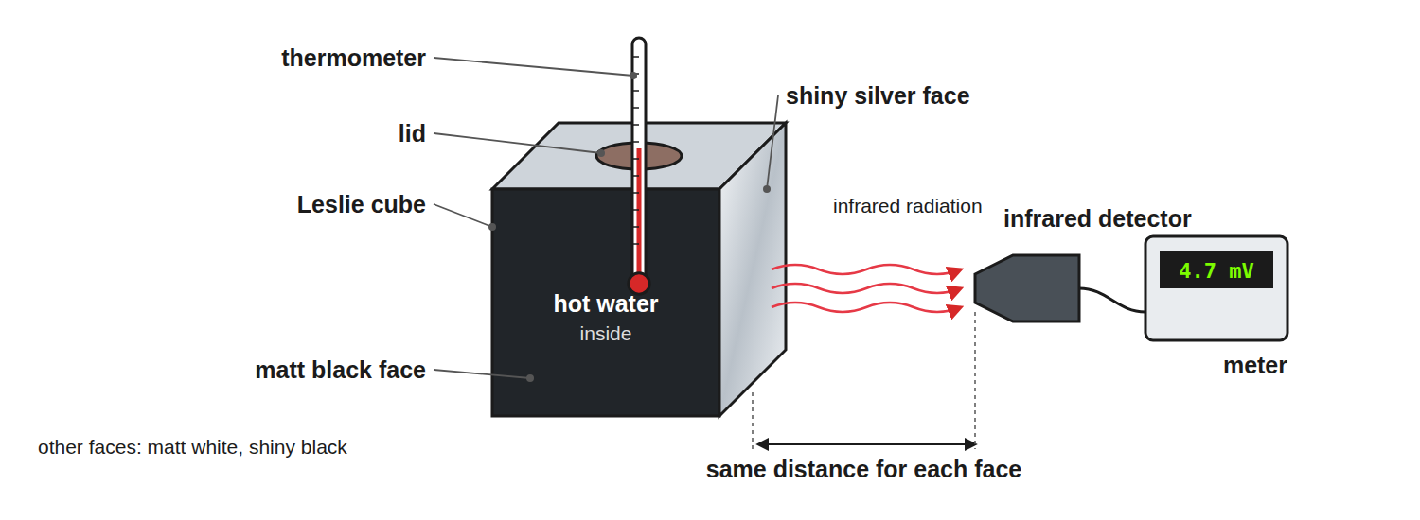
Keep the distance and the water temperature the same for each face.
A Leslie cube of hot water with different surfaces and an infrared detector measuring the radiation from one face.
Emission at Different Temperatures
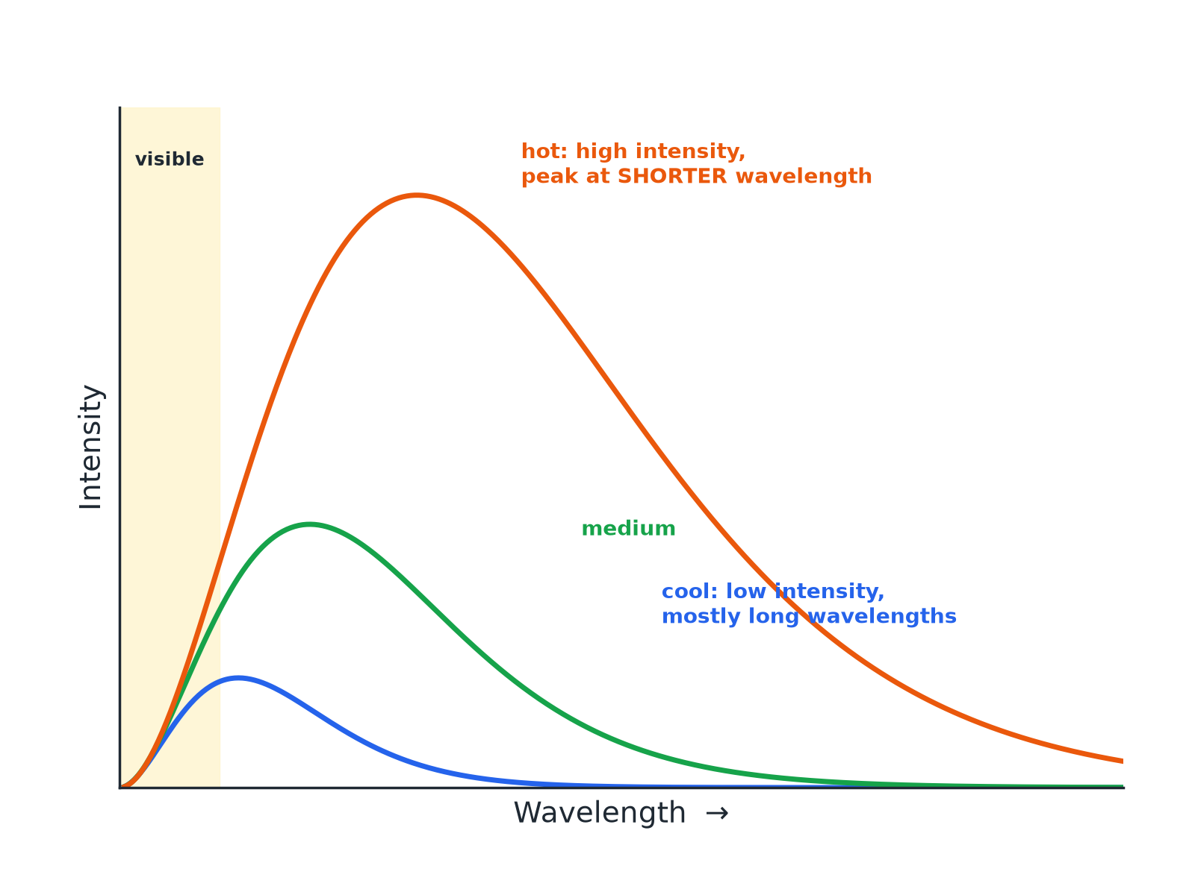
Higher temperature means greater intensity and shorter wavelengths.
Emission curves for bodies at different temperatures: hotter bodies emit more and with shorter peak wavelength.
Earth's Energy Balance (Higher)
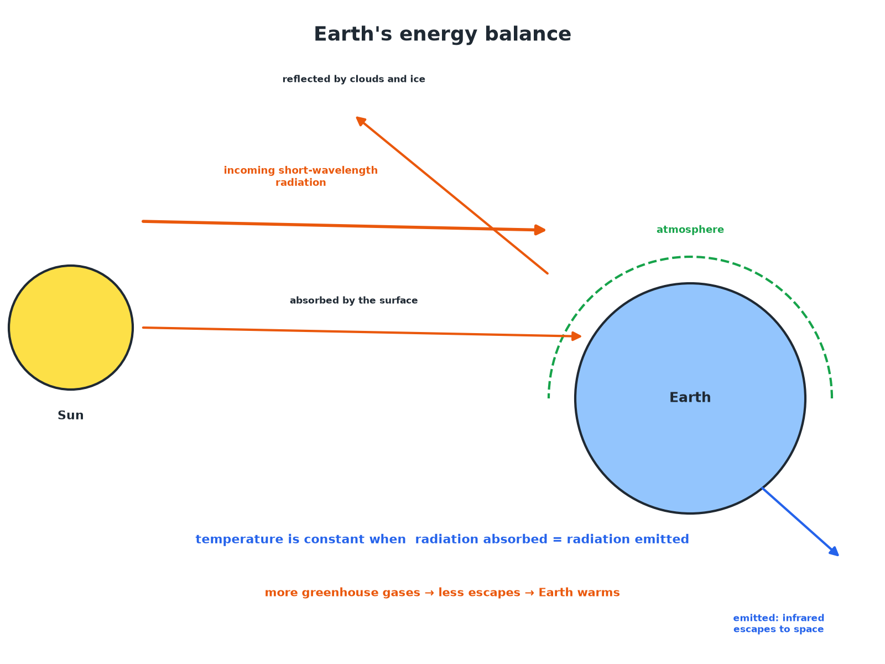
Constant temperature means absorption equals emission.
The Earth absorbing and reflecting radiation from the Sun and emitting infrared radiation, with the balance determining its temperature.
Required Practical 10: Method
Compare how surfaces radiate infrared.
1  Fill the cube  Fill a Leslie cube with hot water and put in the lid. | 2  Detector  Hold the infrared detector at the same distance from each face. | 3  Record  Note the detector reading for each surface. | 4  Control  Keep the distance, water temperature and time the same. | 5  Result  The matt black surface emits most infrared; the shiny silver surface emits least.
A Body at Constant Temperature (Higher)
Explain why a body at a constant temperature is absorbing and emitting radiation at the same rate.

1. Absorbing more than emitting
The temperature rises
2. Emitting more than absorbing
The temperature falls
3. Constant temperature
Absorption equals emission
Answer: If the rates are equal the temperature does not change.
The Earth's Temperature (Higher)
Explain what happens to the temperature of the Earth's surface if the atmosphere absorbs more of the infrared radiation emitted by the surface.

1. More is absorbed
And re-radiated back to the surface
2. Emission to space
Decreases
3. Absorption exceeds emission
So the surface temperature rises until a new balance
Answer: The temperature of the surface increases.
Key Points
Learn these.
▸ All bodies. Emit infrared, whatever their temperature.
▸ Hotter. More radiation in a given time and a shorter peak wavelength.
▸ Good absorber. Also a good emitter (matt black surfaces).
▸ Good reflector. A poor absorber and a poor emitter (shiny silver).
Key Terms
Black body  An object that absorbs all the radiation that hits it. | Emit  Give out radiation.
Absorb  Take in radiation. | Intensity  The amount of radiation per second per unit area.
Infrared  Electromagnetic radiation emitted by all objects. | Equilibrium  When absorption equals emission.
Your Task: Hot or Cold?
10 minutes
Two cans of hot water, one matt black and one shiny silver, cool for 10 minutes. Which cools faster? Explain.
1. Compare emission.
2. Use the black body idea.
A good answer shows: The matt black can, because it is a better emitter of infrared radiation, so it loses energy faster.
Can I...?
☐ State that all bodies emit infrared.
☐ Define a perfect black body.
☐ Say a good absorber is a good emitter.
☐ Describe Required Practical 10.
☐ Explain the effect of temperature.
☐ Describe the curves.
☐ Explain constant temperature.
☐ Explain the Earth's energy balance.
Summary
✓ All bodies emit and absorb infrared.
✓ A perfect black body absorbs all radiation and is the best emitter.
✓ Hotter bodies emit more with shorter wavelengths.
✓ Temperature is steady when absorption equals emission.

EXAM FOCUS
Explain why a matt black surface is a better emitter of infrared radiation than a shiny silver surface. (2 marks)
Good absorbers are good emitters.

