AQA GCSE PHYSICS · PAPER 2 · FOUNDATION & HIGHER
Black body radiation
Waves · Lesson 12 of 12
Teacher copy - includes the notes for whoever is teaching from it.
Warm-up
Answer each one, then check.
1. What is infrared?
Electromagnetic radiation felt as heat
2. What makes an object hotter?
Absorbing energy faster than it emits it
3. What is absorption?
Taking in the energy of radiation
4. What is reflection?
A wave bouncing off a surface
5. What colour surface absorbs best?
Matt black
Learning Objectives
1. State that all bodies emit and absorb infrared radiation.
2. Describe a perfect black body and why it is the best emitter.
3. Explain that the intensity and wavelength distribution of emission depend on temperature.
4. Explain how the temperature of a body or of the Earth is related to absorption and emission (Higher tier).
Black Body Radiation
All bodies, whatever their temperature, emit and absorb infrared radiation. The hotter the body, the more infrared it radiates in a given time.
A perfect black body absorbs all the radiation that falls on it and is also the best possible emitter.
Required Practical 10: Infrared from Different Surfaces
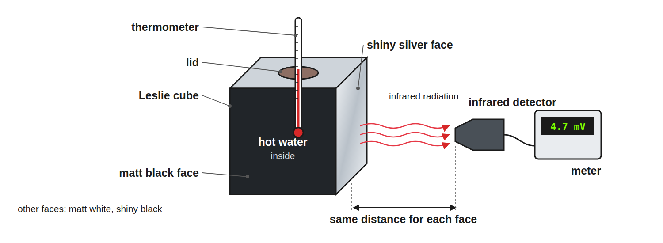
Keep the distance and the water temperature the same for each face.
A Leslie cube of hot water with different surfaces and an infrared detector measuring the radiation from one face.
Emission at Different Temperatures
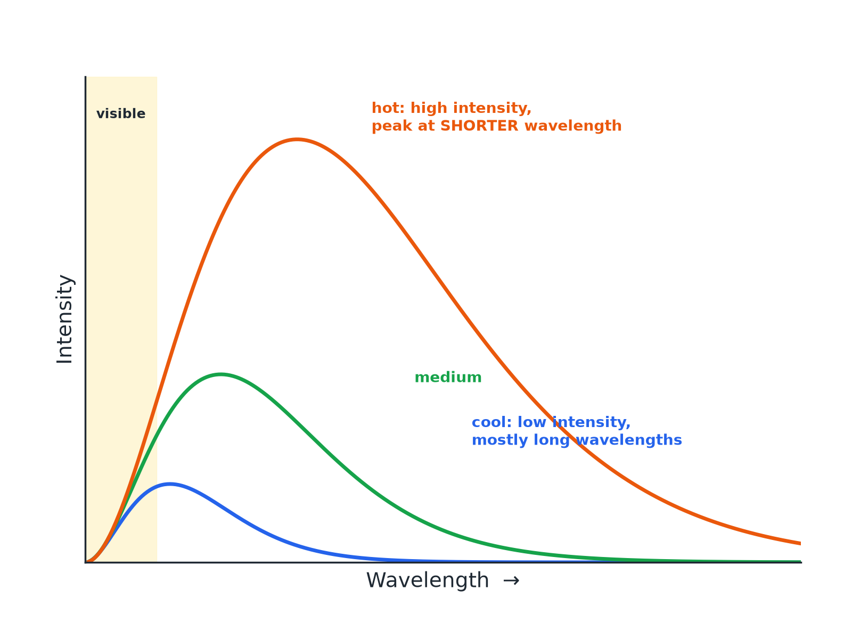
Higher temperature means greater intensity and shorter wavelengths.
Emission curves for bodies at different temperatures: hotter bodies emit more and with shorter peak wavelength.
Earth's Energy Balance (Higher)
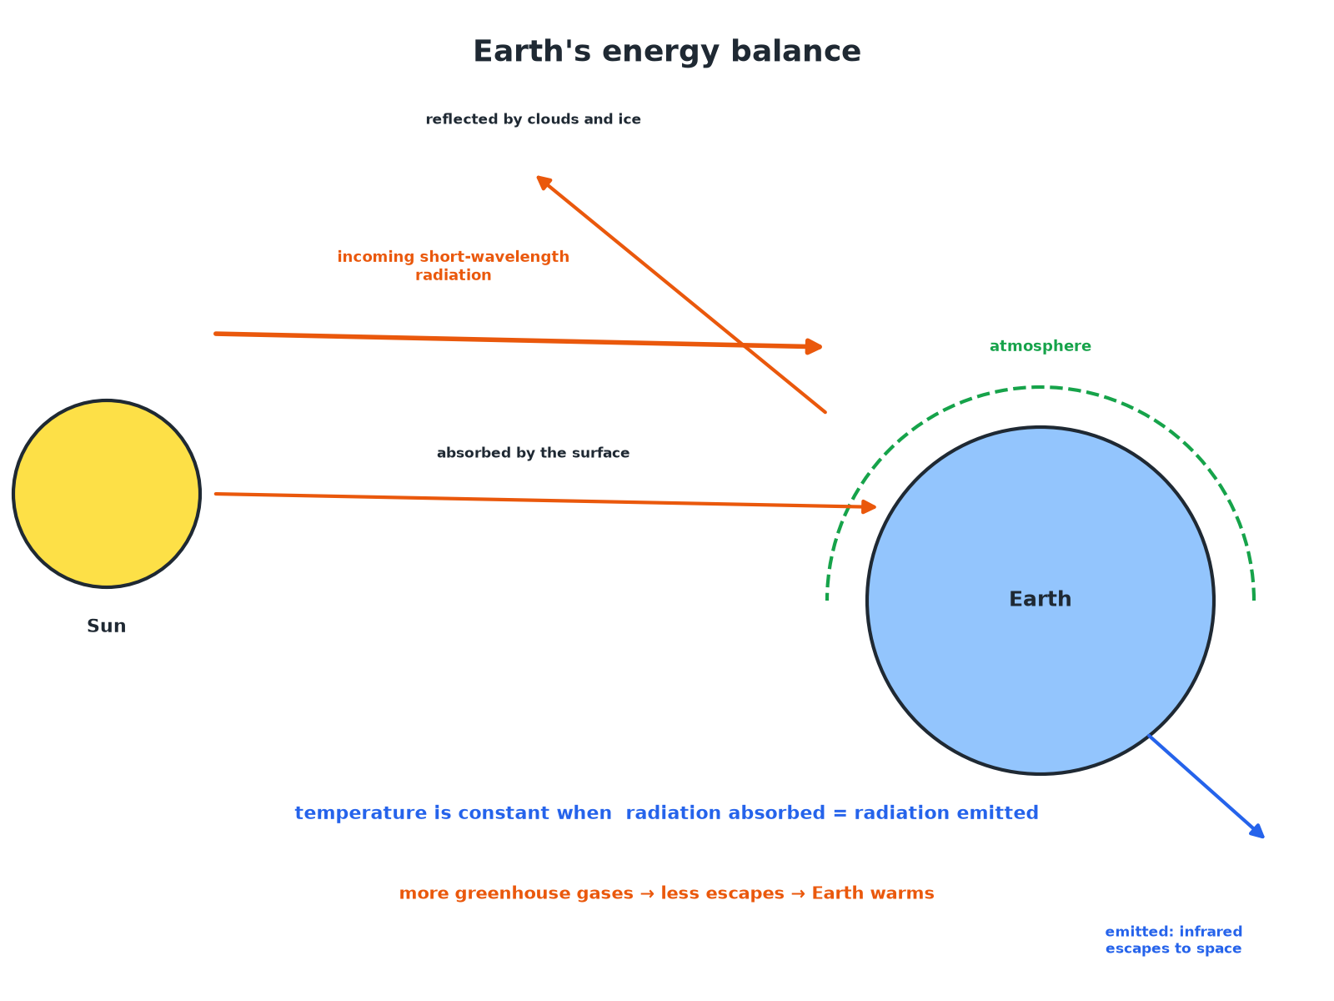
Constant temperature means absorption equals emission.
The Earth absorbing and reflecting radiation from the Sun and emitting infrared radiation, with the balance determining its temperature.
Required Practical 10: Method
Compare how surfaces radiate infrared.
1  Fill the cube  Fill a Leslie cube with hot water and put in the lid. | 2  Detector  Hold the infrared detector at the same distance from each face. | 3  Record  Note the detector reading for each surface. | 4  Control  Keep the distance, water temperature and time the same. | 5  Result  The matt black surface emits most infrared; the shiny silver surface emits least.
A Body at Constant Temperature (Higher)
Explain why a body at a constant temperature is absorbing and emitting radiation at the same rate.

1. Absorbing more than emitting
The temperature rises
2. Emitting more than absorbing
The temperature falls
3. Constant temperature
Absorption equals emission
Answer: If the rates are equal the temperature does not change.
The Earth's Temperature (Higher)
Explain what happens to the temperature of the Earth's surface if the atmosphere absorbs more of the infrared radiation emitted by the surface.

1. More is absorbed
And re-radiated back to the surface
2. Emission to space
Decreases
3. Absorption exceeds emission
So the surface temperature rises until a new balance
Answer: The temperature of the surface increases.
Key Points
Learn these.
▸ All bodies. Emit infrared, whatever their temperature.
▸ Hotter. More radiation in a given time and a shorter peak wavelength.
▸ Good absorber. Also a good emitter (matt black surfaces).
▸ Good reflector. A poor absorber and a poor emitter (shiny silver).
Key Terms
Black body  An object that absorbs all the radiation that hits it. | Emit  Give out radiation.
Absorb  Take in radiation. | Intensity  The amount of radiation per second per unit area.
Infrared  Electromagnetic radiation emitted by all objects. | Equilibrium  When absorption equals emission.
Your Task: Hot or Cold?
10 minutes
Two cans of hot water, one matt black and one shiny silver, cool for 10 minutes. Which cools faster? Explain.
1. Compare emission.
2. Use the black body idea.
A good answer shows: The matt black can, because it is a better emitter of infrared radiation, so it loses energy faster.
Note: Ask which would warm faster in the Sun.
Can I...?
☐ State that all bodies emit infrared.
☐ Define a perfect black body.
☐ Say a good absorber is a good emitter.
☐ Describe Required Practical 10.
☐ Explain the effect of temperature.
☐ Describe the curves.
☐ Explain constant temperature.
☐ Explain the Earth's energy balance.
Summary
✓ All bodies emit and absorb infrared.
✓ A perfect black body absorbs all radiation and is the best emitter.
✓ Hotter bodies emit more with shorter wavelengths.
✓ Temperature is steady when absorption equals emission.

EXAM FOCUS
Explain why a matt black surface is a better emitter of infrared radiation than a shiny silver surface. (2 marks)
Good absorbers are good emitters.
Exam Practice: Black body radiation
Answer all questions. Use the mark allocation as a guide to how much to write. · 17 minutes
▸ Question 1 · 2 marks · State. State whether a matt black surface or a shiny silver surface is a better emitter of infrared radiation, and give the reason.
▸ Question 2 · 4 marks · Describe. A student investigates how the surface of a Leslie cube affects the infrared radiation emitted. Describe how the investigation is carried…
▸ Question 3 · 3 marks · Use the graph. The graph shows how the intensity of radiation emitted by a hot object depends on the wavelength at two different temperatures, A and B…
▸ Question 4 · 3 marks · Explain. The temperature of a cup of tea stays constant at 50 °C when it is kept warm by a heater. Explain this in terms of radiation.
▸ Question 5 · 4 marks · Explain. Explain how the Earth's temperature is related to the radiation it absorbs and emits. Explain what happens if the atmosphere contains more…
Question 1 · 2 marks · State
“State whether a matt black surface or a shiny silver surface is a better emitter of infrared radiation, and give the reason.”
HOW TO ANSWER IT Command word: State. Worth 2 marks, so plan before writing.
Question 1 · mark scheme
2 marks available. Award a mark for each point made.
▸ Matt black. 1 mark
▸ Good absorber is a good emitter. 1 mark
▸ Model answer. A matt black surface, because a good absorber is also a good emitter.
Question 2 · 4 marks · Describe
“A student investigates how the surface of a Leslie cube affects the infrared radiation emitted. Describe how the investigation is carried out and how to keep it a fair test.”
HOW TO ANSWER IT Command word: Describe. Worth 4 marks, so plan before writing.
Question 2 · mark scheme
4 marks available. Award a mark for each point made.
▸ Hot water in a Leslie cube. 1 mark
▸ Detector at each face. 1 mark
▸ Control distance and temperature. 1 mark
▸ Compare readings. 1 mark
▸ Model answer. Fill a Leslie cube with hot water. Use an infrared detector to measure the radiation from each of the different faces. Keep the detector at the same distance from each face and keep the water temperature the same. Record the readings; the matt black face should give the greatest reading.
Question 3 · 3 marks · Use the graph
The graph shows how the intensity of radiation emitted by a hot object depends on the wavelength at two different temperatures, A and B. (a) Which curve is for the hotter object? (b) Give two reasons for your answer. (3 marks) | 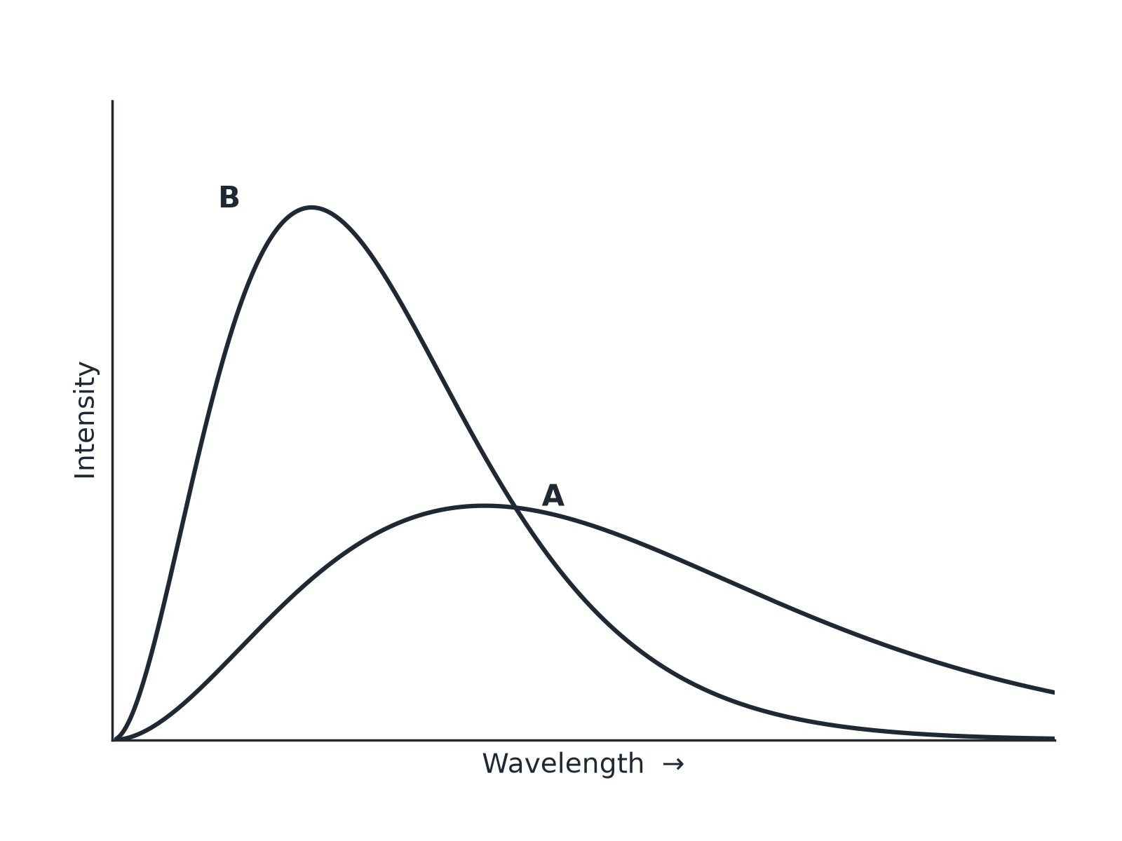

Question 3 · mark scheme
3 marks available. Award a mark for each point made.
▸ Curve B. 1 mark
▸ Higher intensity. 1 mark
▸ Peak at shorter wavelength. 1 mark
▸ Model answer. (a) Curve B. (b) It has a higher intensity (more radiation emitted), and its peak is at a shorter wavelength.
Question 4 · 3 marks · Explain
“The temperature of a cup of tea stays constant at 50 °C when it is kept warm by a heater. Explain this in terms of radiation.”
HOW TO ANSWER IT Command word: Explain. Worth 3 marks, so plan before writing.
Question 4 · mark scheme
3 marks available. Award a mark for each point made.
▸ Absorbs energy at some rate. 1 mark
▸ Emits at the same rate. 1 mark
▸ So constant temperature. 1 mark
▸ Model answer. The tea absorbs radiation and energy from the heater at the same rate as it emits radiation to the surroundings, so its temperature stays constant.
Question 5 · 4 marks · Explain
“Explain how the Earth's temperature is related to the radiation it absorbs and emits. Explain what happens if the atmosphere contains more greenhouse gases.”
HOW TO ANSWER IT Command word: Explain. Worth 4 marks, so plan before writing.
Question 5 · mark scheme
4 marks available. Award a mark for each point made.
▸ Temperature depends on absorption and emission. 1 mark
▸ Constant when equal. 1 mark
▸ Greenhouse gases absorb emitted infrared. 1 mark
▸ So the temperature increases. 1 mark
▸ Model answer. The Earth's temperature is constant when it absorbs radiation from the Sun at the same rate as it emits infrared to space. More greenhouse gases absorb more of the emitted infrared and send some back, so the surface absorbs more than it emits and its temperature rises.

