AQA GCSE PHYSICS · PAPER 2 · FOUNDATION & HIGHER
Poles and magnetic fields
Magnetism and electromagnetism · Lesson 1 of 8
Teacher copy - includes the notes for whoever is teaching from it.
Warm-up
Answer each one, then check.
1. Name a magnetic material.
Iron, steel, nickel or cobalt
2. What is a force?
A push or a pull
3. What is a non-contact force?
A force acting without objects touching
4. What do we call the ends of a magnet?
Poles
5. What do we use to find north?
A compass
Learning Objectives
1. Describe the forces between magnetic poles.
2. Describe permanent and induced magnets.
3. Describe the magnetic field of a bar magnet and draw its field lines.
4. Explain how a compass shows the direction of a magnetic field and why it shows the Earth has a magnetic field.
5. Describe how to plot a magnetic field with a compass.
Magnetic Poles
Like poles repel and unlike poles attract. These forces are non-contact forces. A magnetic field is the region around a magnet where a force acts on another magnet or on a magnetic material.
The force is strongest at the poles, where the field lines are closest together. Field lines point from north to south outside the magnet.
Magnetic Field of a Bar Magnet
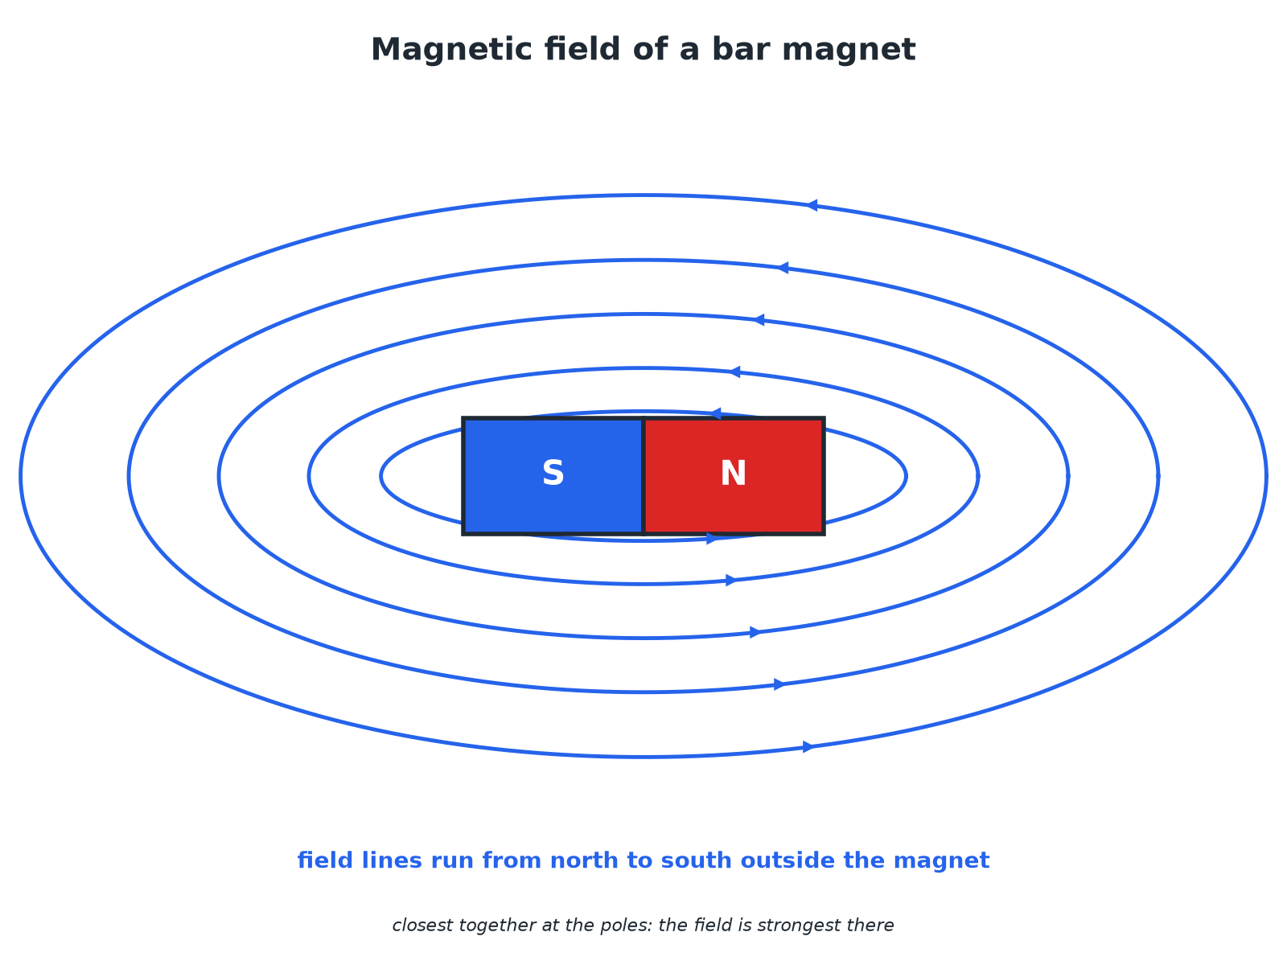
Field lines are closest at the poles.
The magnetic field lines of a bar magnet pointing from the north pole to the south pole.
Plotting a Magnetic Field with a Compass
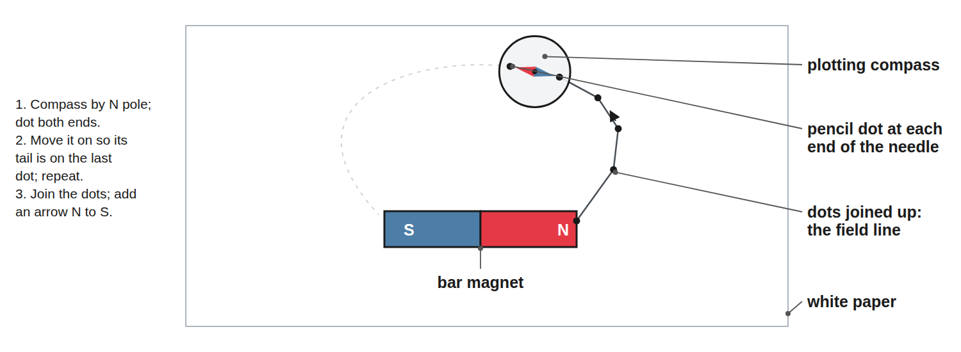
Mark each end of the needle, then move the compass.
A bar magnet on paper with a small compass being moved along to plot a field line.
Permanent or Induced?
PERMANENT MAGNET | INDUCED MAGNET
▸ Always has its own magnetic field.  ▸ Made of hard magnetic material.  ▸ Can attract AND repel another magnet. | ▸ Becomes a magnet only while in another magnetic field.  ▸ Made of a magnetic material such as iron.  ▸ Always ATTRACTED to the magnet; loses most magnetism when removed.
Magnetic Forces
Learn the rules.
Situation | What happens
North and south poles near each other | Attract
Two north poles (or two south poles) | Repel
A magnet near an unmagnetised iron nail | Nail becomes an induced magnet and is attracted
Compass needle near a magnet | Needle lines up with the field
Why a Compass Points North
Explain why the needle of a compass points towards the Earth's north.

1. The compass needle
A small bar magnet free to turn
2. The Earth
Has its own magnetic field, like a giant bar magnet
3. Result
The needle lines up with the Earth's field and points along it
Answer: The Earth has a magnetic field and the needle aligns with it.
Key Points
Learn these.
▸ Direction. Field lines run from north to south outside the magnet.
▸ Strength. Stronger where the lines are closer together.
▸ Distance. The field gets weaker as you move away.
▸ Magnetic materials. Iron, steel, cobalt and nickel.
Key Terms
Magnetic pole  The end of a magnet where the force is strongest. | Magnetic field  The region around a magnet where a force acts on another magnet or a magnetic material.
Permanent magnet  A magnet that always produces its own magnetic field. | Induced magnet  A material that becomes magnetic only when in a magnetic field.
Field line  A line showing the direction of the force on a north pole. | Compass  A small magnet that lines up with a magnetic field.
Your Task: Field Lines
10 minutes
Sketch the field lines between a north pole and a south pole facing each other, then between two north poles. Add arrows.
1. Lines leave N, enter S.
2. Lines never cross.
A good answer shows: Between N and S: lines run from N to S across the gap. Between two N poles: lines curve away from each other and never join.
Note: Ask learners to compare where the field is strongest.
Can I...?
☐ State the rules for poles.
☐ Describe permanent and induced magnets.
☐ Name magnetic materials.
☐ Draw a bar magnet field.
☐ Put arrows on field lines.
☐ Describe a compass.
☐ Explain the Earth's field.
☐ Describe plotting a field.
Summary
✓ Like poles repel, unlike poles attract.
✓ Field lines run north to south.
✓ Induced magnets are always attracted.
✓ A compass shows the Earth has a magnetic field.

EXAM FOCUS
Explain why an iron nail is attracted to a magnet. (2 marks)
The nail becomes an induced magnet.
Exam Practice: Poles and magnetic fields
Answer all questions. Use the mark allocation as a guide to how much to write. · 14 minutes
▸ Question 1 · 2 marks · State. State what happens when (a) two north poles are brought together and (b) a north pole and a south pole are brought together.
▸ Question 2 · 2 marks · Describe. What is the difference between a permanent magnet and an induced magnet?
▸ Question 3 · 3 marks · Explain. A student brings one end of a bar of iron near a magnet. The iron is attracted. Explain why the iron is always attracted and never repelled.
▸ Question 4 · 4 marks · Describe. Describe how you would use a plotting compass to plot the magnetic field of a bar magnet.
▸ Question 5 · 2 marks · Explain. A compass needle points north. Explain what this tells you about the Earth.
Question 1 · 2 marks · State
“State what happens when (a) two north poles are brought together and (b) a north pole and a south pole are brought together.”
HOW TO ANSWER IT Command word: State. Worth 2 marks, so plan before writing.
Question 1 · mark scheme
2 marks available. Award a mark for each point made.
▸ Repel. 1 mark
▸ Attract. 1 mark
▸ Model answer. (a) They repel. (b) They attract.
Question 2 · 2 marks · Describe
“What is the difference between a permanent magnet and an induced magnet?”
HOW TO ANSWER IT Command word: Describe. Worth 2 marks, so plan before writing.
Question 2 · mark scheme
2 marks available. Award a mark for each point made.
▸ Permanent: always magnetic. 1 mark
▸ Induced: only magnetic in a field. 1 mark
▸ Model answer. A permanent magnet always has its own magnetic field. An induced magnet becomes a magnet only when it is in another magnetic field, and loses most of its magnetism when removed.
Question 3 · 3 marks · Explain
“A student brings one end of a bar of iron near a magnet. The iron is attracted. Explain why the iron is always attracted and never repelled.”
HOW TO ANSWER IT Command word: Explain. Worth 3 marks, so plan before writing.
Question 3 · mark scheme
3 marks available. Award a mark for each point made.
▸ Iron becomes an induced magnet. 1 mark
▸ Nearest end is the opposite pole. 1 mark
▸ Unlike poles attract. 1 mark
▸ Model answer. The iron becomes an induced magnet. The end nearest the magnet becomes the opposite pole to the magnet's pole, and unlike poles attract.
Question 4 · 4 marks · Describe
“Describe how you would use a plotting compass to plot the magnetic field of a bar magnet.”
HOW TO ANSWER IT Command word: Describe. Worth 4 marks, so plan before writing.
Question 4 · mark scheme
4 marks available. Award a mark for each point made.
▸ Magnet on paper, compass near a pole. 1 mark
▸ Mark both ends of the needle. 1 mark
▸ Move compass along and repeat; join the dots. 1 mark
▸ Repeat from other starting points and add arrows from north to south. 1 mark
▸ Model answer. Place the magnet on paper and draw round it. Put the compass near one pole and mark the positions of both ends of the needle with dots. Move the compass so that one end is on the last dot and mark again. Repeat and join the dots to make a field line. Repeat from different starting points.
Question 5 · 2 marks · Explain
“A compass needle points north. Explain what this tells you about the Earth.”
HOW TO ANSWER IT Command word: Explain. Worth 2 marks, so plan before writing.
Question 5 · mark scheme
2 marks available. Award a mark for each point made.
▸ Needle lines up with a magnetic field. 1 mark
▸ The Earth has a magnetic field. 1 mark
▸ Model answer. The needle is a magnet and it lines up with the Earth's magnetic field, so the Earth has a magnetic field.

