EDEXCEL GCSE BUSINESS · PAPER 2
Business and globalisation
Growing the business · Lesson 3 of 4
Teacher copy - includes the notes for whoever is teaching from it.
Last Lesson
Answer from memory before the answers appear.
1. Give two reasons why business objectives change.
Any two of: market conditions, technology, performance, legislation, internal reasons.
2. What does exiting a market mean?
Stopping selling in a location or segment.
3. What is profit maximisation?
Aiming to make as much profit as possible.
4. From Topic 1: what does SPICED mean?
Strong Pound, Imports Cheap, Exports Dear.
Learning Objectives
1. Explain what globalisation is.
2. Explain imports and exports and their impact on businesses.
3. Explain why businesses change location and what multinationals are.
4. Explain barriers to international trade: tariffs and trade blocs.
5. Explain how businesses compete internationally.
What Is Globalisation?
Globalisation is the process by which the world's economies are becoming increasingly connected.
▸ Trade. Goods and services are bought and sold between countries more than ever before.
▸ Communication. The internet lets businesses sell and communicate worldwide instantly.
▸ Transport. Container ships and air freight move goods around the world cheaply.
▸ For businesses. Globalisation means new markets and cheaper supplies - but also new competition from around the world.
PART ONE
Imports and Exports
Buying from abroad and selling abroad.
Imports and Exports
IMPORTS | EXPORTS
▸ Goods and services bought from other countries.  ▸ Give businesses access to cheaper or better materials and products.  ▸ Give customers more choice.  ▸ But: UK businesses face competition from foreign imports. | ▸ Goods and services sold to other countries.  ▸ Give businesses access to much bigger markets.  ▸ Can increase sales and allow growth.  ▸ But: harder to understand foreign customers, and exchange rates add risk.
The World's Goods on the Move
Most of the goods traded between countries travel in shipping containers. Cheap, reliable shipping means a UK shop can sell products made on the other side of the world - and a UK manufacturer can sell to customers on every continent. | 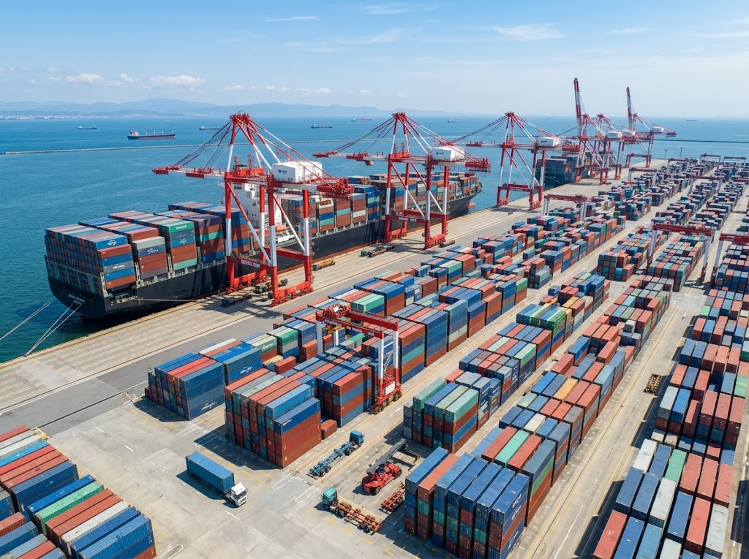  Container ships carry most of the world's traded goods.

PART TWO
Multinationals and Location
Businesses that operate in more than one country.
Changing Business Location
Globalisation lets businesses locate parts of their operations abroad.
▸ Lower costs. Wages, rent and taxes may be much lower in other countries.
▸ Closer to customers. Producing near a big overseas market cuts transport costs and time.
▸ Access to materials and skills. Some countries have raw materials or skilled workers the business needs.
▸ The downsides. Jobs lost in the home country, longer supply chains, language and cultural differences, and damage to reputation if working conditions are poor.
Multinational Companies (MNCs)
A multinational company has its headquarters in one country and operates in several others.
▸ Examples. Coca-Cola, Toyota, Unilever and McDonald's all make or sell products in many countries.
▸ Benefits to MNCs. Huge markets, economies of scale, and the chance to locate each activity where it is cheapest.
▸ Benefits to host countries. Jobs, investment, taxes and new skills and technology.
▸ Drawbacks for host countries. Local businesses may struggle to compete, and profits may leave the country.
PART THREE
Barriers to International Trade
Not all trade is free.
Tariffs and Trade Blocs
Governments can make international trade easier or harder.
▸ Tariff. A tax on imported goods. It makes imports more expensive, protecting home businesses from foreign competition.
▸ Impact of tariffs. A business importing materials pays more, raising its costs; a business exporting may sell less if other countries put tariffs on its goods.
▸ Trade bloc. A group of countries that agree to trade freely with each other, with few or no tariffs between them, such as the European Union (EU).
▸ Impact of trade blocs. Businesses inside the bloc trade easily with each other, but businesses outside may face tariffs and extra rules when selling into it.
Competing Internationally
How businesses win customers in other countries.
▸ Using the internet. E-commerce lets even a small business sell worldwide from its own website or online marketplaces.
▸ Changing the marketing mix. Adapting the product, price, promotion and place for each country - different flavours, sizes, languages and prices.
▸ Understanding local culture. Names, colours and adverts that work in one country may offend or confuse in another.
▸ Keeping costs down. Competing with businesses in low-cost countries means being efficient or offering something they cannot.
Case Study
CASE STUDY
Dyson: Moving Production Abroad
James Dyson first made his vacuum cleaners in Malmesbury, Wiltshire. In 2002 Dyson moved most of its manufacturing to Malaysia, where costs were lower and it was closer to its suppliers and to fast-growing markets in Asia. Around 800 production jobs were lost in the UK, although Dyson kept its research and design in Britain. The move shows the trade-off of globalisation: lower costs and access to new markets, against job losses at home and criticism in the UK press.

2002  Dyson moves manufacturing to Malaysia | 800  UK production jobs lost
Key Terms
Globalisation  The process by which the world's economies are becoming increasingly connected. | Import  A good or service bought from another country.
Export  A good or service sold to another country. | Multinational company (MNC)  A business with its headquarters in one country that operates in several countries.
Tariff  A tax on imported goods. | Trade bloc  A group of countries that trade freely with each other, with few or no tariffs between them.
Free trade
Trade between countries without barriers such as tariffs.
Your Task: Going Global
12 minutes
A UK company makes premium dog food and wants to start selling in Japan and the USA. Suggest how it should adapt each part of its marketing mix for these markets, and identify one barrier to trade it might face.
1. Product changes.
2. Price changes.
3. Promotion changes.
4. Place changes.
5. One barrier to trade.
A good answer shows: A specific change to each of the 4Ps for an overseas market, plus a trade barrier such as a tariff or product rules.
Note: Look for cultural awareness - pack sizes, languages on the label, local pet-food regulations.
Can I...?
☐ Explain what globalisation is.
☐ Explain imports and their impact.
☐ Explain exports and their impact.
☐ Explain why businesses change location.
☐ Explain what a multinational is.
☐ Explain the impact of tariffs.
☐ Explain the impact of trade blocs.
☐ Explain how businesses compete internationally.
Summary
✓ Globalisation connects the world's economies through trade, communication and transport.
✓ Imports give cheaper supplies but more competition; exports give bigger markets but more risk.
✓ Businesses move production abroad for lower costs and to be closer to markets; MNCs operate in many countries.
✓ Tariffs and trade blocs affect the cost of trade; businesses compete internationally online and by adapting the marketing mix.

EXAM FOCUS
Explain one impact on a UK business of a tariff being placed on the materials it imports. (3 marks)
Tariffs raise the price of imports. Take the chain through to costs, prices, sales and profit.
Exam Practice: Business and Globalisation
Answer all questions. Use the context of the business in the question where one is given. · 20 minutes
▸ Question 1 · 1 mark · Define. Define the term 'tariff'.
▸ Question 2 · 2 marks · Outline. Outline one benefit to a business of exporting its products.
▸ Question 3 · 3 marks · Explain. Explain one impact on a UK business of a tariff being placed on the materials it imports.
▸ Question 4 · 9 marks · Justify. Justify which one of these two options Highland Knitwear Ltd should choose.
Question 1 · 1 mark · Define
“Define the term 'tariff'.”
HOW TO ANSWER IT Command word: Define. Worth 1 mark, so plan before writing.
Question 1 · mark scheme
1 mark available. Award a mark for each point made.
▸ A tax on imports. 1 mark
▸ Model answer. A tax placed on imported goods.
Question 2 · 2 marks · Outline
“Outline one benefit to a business of exporting its products.”
HOW TO ANSWER IT Command word: Outline. Worth 2 marks, so plan before writing.
Question 2 · mark scheme
2 marks available. Award a mark for each point made.
▸ A benefit identified, e.g. bigger market / more sales / spread risk. 1 mark
▸ Developed. 1 mark
▸ Model answer. It can reach a much larger market (1), increasing its sales beyond what it could achieve in the UK alone (1).
Question 3 · 3 marks · Explain
“Explain one impact on a UK business of a tariff being placed on the materials it imports.”
HOW TO ANSWER IT Command word: Explain. Worth 3 marks, so plan before writing.
Question 3 · mark scheme
3 marks available. Award a mark for each point made.
▸ An impact identified, e.g. higher costs / higher prices / lower profit / switch suppliers. 1 mark
▸ First linked point of explanation. 1 mark
▸ Second linked point of explanation. 1 mark
▸ Model answer. Its costs would rise (1). The tariff makes each imported material more expensive (1). The business must either raise its prices, which could reduce sales, or accept a lower profit on each product (1).
Question 4 · 9 marks · Justify
“Justify which one of these two options Highland Knitwear Ltd should choose.”
— Highland Knitwear Ltd makes wool jumpers in Scotland. Its UK sales are falling. Option 1: Start exporting to Japan, where there is strong demand for Scottish wool, selling through…
HOW TO ANSWER IT Command word: Justify. Worth 9 marks, so plan before writing.
Question 4 · mark scheme
9 marks available. Award a mark for each point made.
▸ AO2 (Application, 3 marks): uses the context - Scottish wool, Japan, the department store, Asian production. Level 1-3
▸ AO3a (Analysis, 3 marks): chains of reasoning about each option. Level 1-3
▸ AO3b (Evaluation, 3 marks): a justified choice with a supported judgement. Level 1-3
▸ Model answer. Option 1 would give Highland Knitwear access to a new market with strong demand, replacing its falling UK sales. Its Scottish origin is part of the product's appeal in Japan, so it could charge a premium price. However, it would need to adapt its marketing mix, and changes in the exchange rate could make its jumpers more expensive for Japanese customers. Option 2 would cut costs sharply, letting it compete on price in the UK. But moving production would mean its jumpers are no longer made in Scotland, which could destroy its brand's appeal, and Scottish workers would lose their jobs, damaging its reputation. On balance Highland Knitwear should choose Option 1, because its "made in Scotland" heritage is its unique selling point, and Option 2 would throw it away. This depends on the Japanese department store agreement giving it enough sales to make exporting worthwhile.

