EDEXCEL GCSE BUSINESS · PAPER 2
Ethics, the environment and business
Growing the business · Lesson 4 of 4
Teacher copy - includes the notes for whoever is teaching from it.
Last Lesson
Answer from memory before the answers appear.
1. What is globalisation?
The process by which the world's economies are becoming increasingly connected.
2. What is a tariff?
A tax on imported goods.
3. What is a multinational company?
A business with headquarters in one country that operates in several countries.
4. Give one way a business can compete internationally.
Selling online, or adapting the marketing mix for each country.
Learning Objectives
1. Explain ethical considerations for businesses.
2. Explain the trade-off between ethics and profit.
3. Explain environmental considerations, including sustainability.
4. Explain the impact of pressure group activity on a business's marketing mix.
What Are Business Ethics?
Ethics are moral principles about what is right and wrong. An ethical business does what is morally right, not just what is legal.
▸ Employees. Paying fair wages, providing safe working conditions and treating staff with respect.
▸ Suppliers. Paying a fair price, especially to small producers in poorer countries, and paying on time.
▸ Customers. Honest advertising, safe products and fair prices.
▸ Animals and society. Avoiding animal testing, and not selling products that harm people.
Fair Trade and Ethical Sourcing
Ethical sourcing means making sure products are made in fair and safe conditions.
▸ Fair trade. Schemes that guarantee farmers in poorer countries a fair minimum price for their crops, plus extra money for their communities.
▸ Supply chains. Large businesses buy from factories and farms around the world; ethical businesses check how those workers are treated.
▸ Higher costs. Paying fair prices and checking suppliers costs more, so products may be more expensive.
▸ Customer appeal. Many customers will pay more for products they know are ethically made.
A Fair Price for the Farmer
A cup of coffee in a UK café may start on a small farm thousands of miles away. Ethical businesses make sure the farmers who grow their coffee are paid fairly - even though it means paying more than the lowest price they could get. | 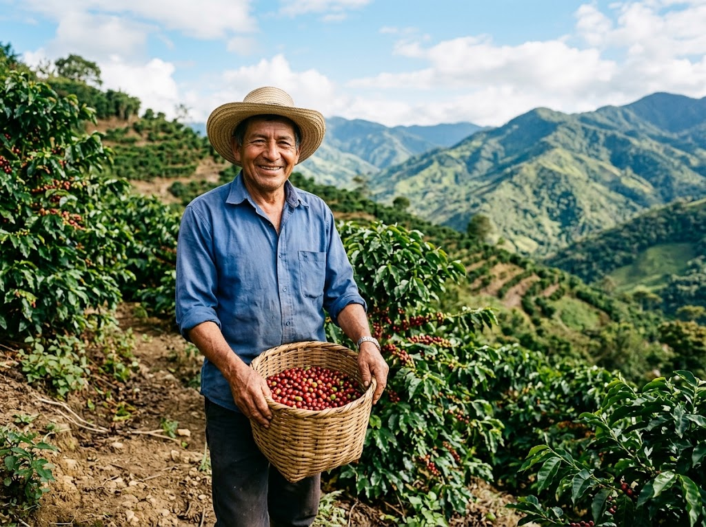  Fair trade guarantees farmers a fair minimum price for their crops.

PART ONE
Ethics or Profit?
The trade-off every business faces.
The Ethics-Profit Trade-off
ETHICS CAN REDUCE PROFIT | ETHICS CAN INCREASE PROFIT
▸ Paying fair wages and prices raises costs.  ▸ Checking suppliers takes time and money.  ▸ Ethical materials are often more expensive.  ▸ Refusing unethical but profitable business loses sales. | ▸ Customers prefer ethical businesses and pay more.  ▸ A good reputation brings loyal customers.  ▸ Well-treated staff work harder and stay longer.  ▸ Avoids the costly scandal of being exposed.
PART TWO
The Environment
What businesses do to the planet.
Environmental Considerations
Business activity can harm the environment.
▸ Pollution. Air, water and noise pollution from factories and transport.
▸ Waste. Packaging, unsold products and waste sent to landfill.
▸ Using up resources. Raw materials, energy and water that may run out.
▸ Climate change. Carbon emissions from energy use, transport and production.
Sustainability
Sustainability means meeting today's needs without harming the ability of future generations to meet theirs.
▸ Renewable energy. Using solar and wind power instead of fossil fuels.
▸ Less waste. Reducing packaging, recycling and reusing materials.
▸ Sustainable materials. Using materials that can be replaced, such as wood from managed forests.
▸ Cleaner transport. Electric delivery vans and fewer, fuller deliveries.
Plastic or Refill?
The same products, packaged two very different ways.
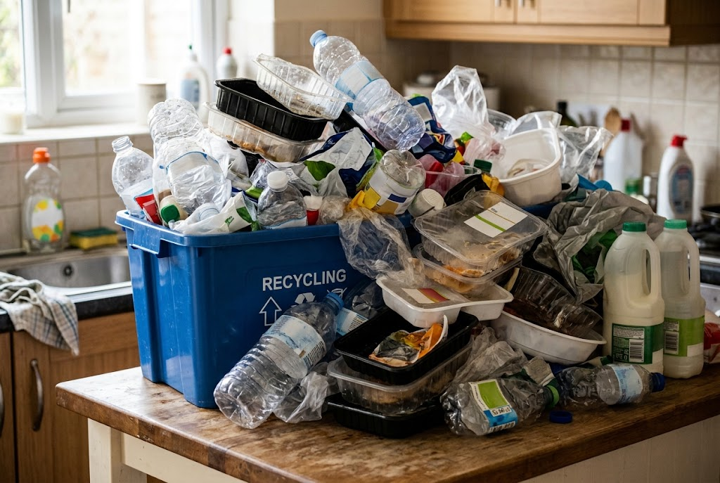  Single-use plastic: cheap, but wasteful. | 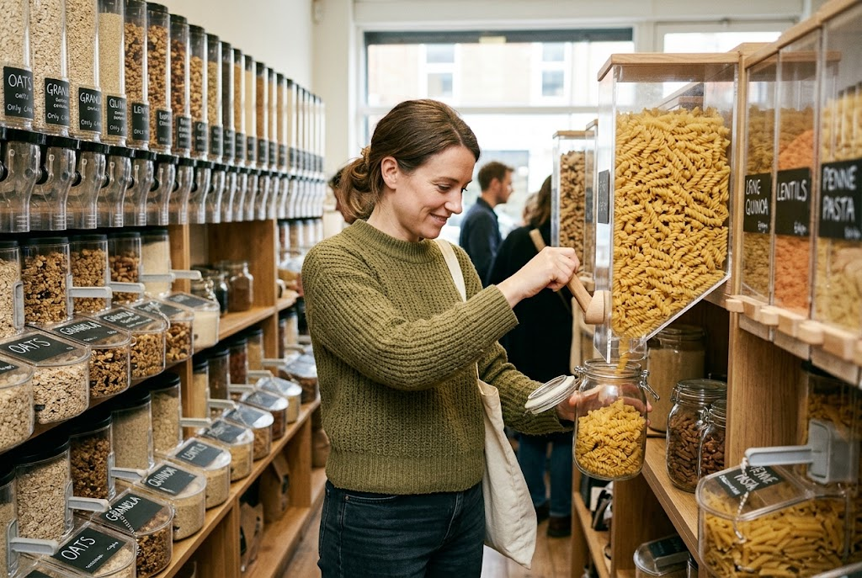  Refill: less waste, often at higher cost to the business.

Going Green: For and Against
BENEFITS TO THE BUSINESS | COSTS TO THE BUSINESS
▸ Attracts customers who care about the environment.  ▸ A better reputation and brand image.  ▸ Some changes cut costs, such as using less energy or packaging.  ▸ Avoids fines and future environmental laws. | ▸ Greener materials and energy can cost more.  ▸ New equipment, such as electric vans, is expensive.  ▸ Higher costs may mean higher prices.  ▸ Competitors that do not go green may be cheaper.
Pressure Groups and the Marketing Mix
Pressure groups campaign to change how businesses behave on ethical and environmental issues.
▸ Product. A business may change ingredients or materials - removing palm oil, or using recycled plastic.
▸ Price. Ethical changes can raise costs, so prices may rise.
▸ Promotion. A business may promote its new ethical credentials, or pull adverts that caused offence.
▸ Place. A business may stop selling through a retailer, or in a country, that a pressure group has criticised.
Case Study
CASE STUDY
Rana Plaza: The Cost of Cheap Clothes
In April 2013 the Rana Plaza building in Bangladesh collapsed. It housed several clothing factories making cheap clothes for well-known Western brands, and more than 1,100 workers were killed. Cracks had appeared in the building the day before, but workers were ordered back inside. The disaster led to pressure group campaigns, customer anger and a legally binding safety agreement signed by many clothing brands. It showed that the lowest possible cost can come at a terrible human price - and that customers expect brands to know how their products are made.

2013  The Rana Plaza factory building collapses | 1,100+  Workers killed
Key Terms
Ethics  Moral principles about what is right and wrong. | Ethical business  A business that does what is morally right, not just what is legal.
Fair trade  A scheme guaranteeing farmers in poorer countries a fair price for their products. | Supply chain  All the businesses involved in making a product and getting it to the customer.
Sustainability  Meeting today's needs without harming future generations' ability to meet theirs. | Carbon footprint  The amount of carbon dioxide produced by a business's activities.
Pressure group
An organised group that tries to change the behaviour of businesses or the government.
Your Task: The Ethical Boardroom
15 minutes
A chain of clothing stores could cut costs by 20% by switching to a factory abroad with poor safety records. Split into two sides: one argues for switching (profit), one against (ethics). Then agree a final decision and explain how the business should communicate it to customers.
1. Arguments for switching.
2. Arguments against switching.
3. The final decision, and why.
4. How to tell customers.
A good answer shows: Arguments on both sides linked to costs, reputation, customers and staff, with a justified decision.
Note: Push the "ethics" side to use business arguments too - reputation, customer loyalty and the risk of a scandal all affect profit.
Can I...?
☐ Explain what business ethics are.
☐ Explain ethical treatment of employees and suppliers.
☐ Explain fair trade.
☐ Explain the ethics-profit trade-off.
☐ Explain environmental impacts of business.
☐ Explain sustainability.
☐ Explain the benefits and costs of going green.
☐ Explain how pressure groups affect the marketing mix.
Summary
✓ Ethical businesses treat employees, suppliers and customers fairly - often at a higher cost.
✓ Ethics can reduce profit through higher costs, or increase it through reputation and loyalty.
✓ Businesses harm the environment through pollution, waste, resource use and emissions; sustainability reduces this.
✓ Pressure groups can force changes to the marketing mix.

EXAM FOCUS
Explain one way that behaving ethically could increase a business's profit. (3 marks)
Ethics questions reward balance: ethics costs money in the short term, but can win customers and protect reputation. Show you understand both.
Exam Practice: Ethics, the Environment and Business
Answer all questions. Use the context of the business in the question where one is given. · 20 minutes
▸ Question 1 · 1 mark · Define. Define the term 'sustainability'.
▸ Question 2 · 2 marks · Outline. Outline one way a pressure group could affect a business's marketing mix.
▸ Question 3 · 3 marks · Explain. Explain one way that behaving ethically could increase a business's profit.
▸ Question 4 · 9 marks · Justify. Justify which one of these two options FreshBite PLC should choose.
Question 1 · 1 mark · Define
“Define the term 'sustainability'.”
HOW TO ANSWER IT Command word: Define. Worth 1 mark, so plan before writing.
Question 1 · mark scheme
1 mark available. Award a mark for each point made.
▸ Meeting present needs without harming future generations / not using up resources. 1 mark
▸ Model answer. Meeting the needs of today without harming the ability of future generations to meet their needs.
Question 2 · 2 marks · Outline
“Outline one way a pressure group could affect a business's marketing mix.”
HOW TO ANSWER IT Command word: Outline. Worth 2 marks, so plan before writing.
Question 2 · mark scheme
2 marks available. Award a mark for each point made.
▸ A way identified linked to one of the 4Ps. 1 mark
▸ Developed. 1 mark
▸ Model answer. A pressure group campaign could force the business to change its product (1), for example removing an ingredient such as palm oil that damages rainforests (1).
Question 3 · 3 marks · Explain
“Explain one way that behaving ethically could increase a business's profit.”
HOW TO ANSWER IT Command word: Explain. Worth 3 marks, so plan before writing.
Question 3 · mark scheme
3 marks available. Award a mark for each point made.
▸ A way identified, e.g. more customers / reputation / staff loyalty / avoiding scandal. 1 mark
▸ First linked point of explanation. 1 mark
▸ Second linked point of explanation. 1 mark
▸ Model answer. It could attract more customers (1). Many customers prefer to buy from businesses they see as ethical, and may pay a higher price for ethically made products (1). This increases the business's sales and revenue, which can outweigh the extra costs of behaving ethically (1).
Question 4 · 9 marks · Justify
“Justify which one of these two options FreshBite PLC should choose.”
— FreshBite PLC sells sandwiches and salads in 400 shops. It uses single-use plastic packaging. An environmental pressure group has started a social media campaign against it…
HOW TO ANSWER IT Command word: Justify. Worth 9 marks, so plan before writing.
Question 4 · mark scheme
9 marks available. Award a mark for each point made.
▸ AO2 (Application, 3 marks): uses the context - 400 shops, the campaign, 8p per item, the two options. Level 1-3
▸ AO3a (Analysis, 3 marks): chains of reasoning about each option. Level 1-3
▸ AO3b (Evaluation, 3 marks): a justified choice with a supported judgement. Level 1-3
▸ Model answer. Option 1 removes the cause of the campaign. Compostable packaging shows FreshBite is serious about the environment, which should end the pressure group's campaign and attract customers who care about plastic waste. However, 8p per item across 400 shops is a large extra cost, which will either reduce profit or raise prices, and price-sensitive customers may go elsewhere. Option 2 is cheaper, and shows some action. But the pressure group is likely to see it as "greenwashing", continuing its campaign, and customers may still see FreshBite as a plastic polluter, damaging its reputation. On balance FreshBite should choose Option 1, because the social media campaign threatens its reputation across all 400 shops, and a half-measure is unlikely to stop it. However, this depends on whether it can pass on some of the 8p cost without losing too many customers.

