EDEXCEL GCSE BUSINESS · PAPER 2
Product
Making marketing decisions · Lesson 1 of 5
From Topic 1
Answer from memory before the answers appear.
1. Name the four Ps of the marketing mix.
Product, price, promotion and place.
2. What is a unique selling point?
A feature that makes a product different from all its competitors.
3. What is an integrated marketing mix?
One where the four Ps fit together for the target market.
4. Name two ways to add value.
Any two of: convenience, branding, quality, design, USP.
Learning Objectives
1. Explain the design mix: function, aesthetics and cost.
2. Explain the stages of the product life cycle.
3. Explain extension strategies.
4. Explain the importance of differentiating a product.
PART ONE
The Design Mix
Three things every product must balance.
The Design Mix
Function  How well the product works and does its job - its features, reliability and ease of use. | Aesthetics  How the product looks, feels, smells, sounds or tastes - its appeal to the senses.
Cost
How cheaply it can be made, so it can be sold at a price customers will pay and still make a profit.
Balancing the Design Mix
No product can be the best at everything, so businesses decide which element matters most.
▸ Function first. Safety equipment and medical products must work perfectly, whatever they look like.
▸ Aesthetics first. Fashion, jewellery and luxury goods sell mainly on how they look.
▸ Cost first. Supermarket own-brand basics are designed to be as cheap as possible to make.
▸ Target market. The balance depends on what the target customers value and are willing to pay for.
From Idea to Shelf
Design decides the balance of function, aesthetics and cost before a product is made.
  Design: balancing how it works, looks and costs. |   The finished product, ready to sell.

PART TWO
The Product Life Cycle
Every product's story, from launch to decline.
The Product Life Cycle
The product life cycle shows how a product's sales change over time. Knowing which stage a product is in helps a business decide how to price and promote it - and when to try to extend its life. | 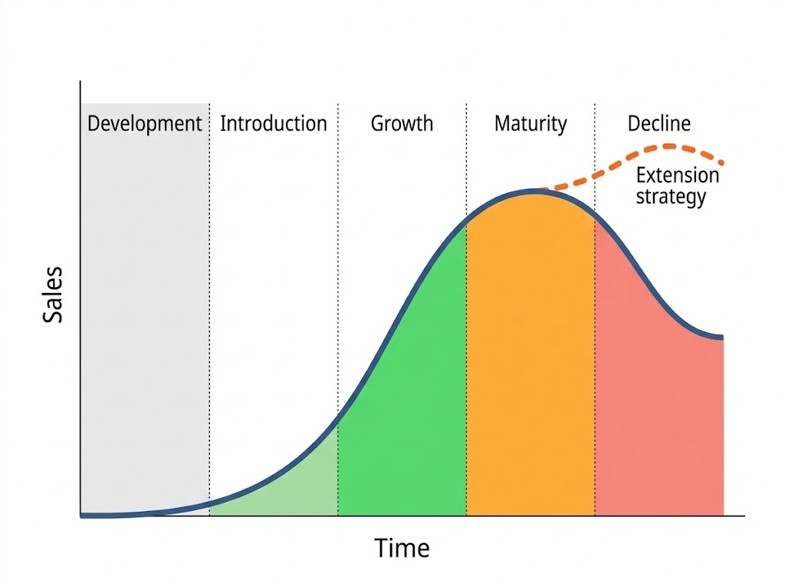  Sales rise, peak and fall - unless an extension strategy lifts them again.

The Five Stages
Stage | Sales | Profit | What the business does
Development | None | Negative: R&D costs | Researches, designs and tests the product
Introduction | Low, rising slowly | Usually a loss | Heavy promotion to make customers aware
Growth | Rising fast | Profit begins | Increases distribution; competitors may appear
Maturity | At their peak, levelling off | Highest | Defends market share; considers extension strategies
Decline | Falling | Falling | Uses extension strategies or withdraws the product
Extension Strategies
An extension strategy is an action taken to make a product last longer before it declines.
▸ New features. Adding improvements or new versions - new flavours, sizes or technology.
▸ New markets. Selling to a new target market or in new countries.
▸ Repackaging and rebranding. Giving the product a fresh look or a new image.
▸ Advertising and price cuts. A new promotional campaign or a lower price to win back customers.
PART THREE
Differentiation
Standing out from the competition.
The Importance of Differentiation
Product differentiation means making a product different from competitors' products.
▸ How. Through design, features, quality, branding, packaging or a unique selling point.
▸ Why it matters. A differentiated product gives customers a reason to choose it over rivals.
▸ Higher prices. Customers will often pay more for a product they see as better or unique.
▸ Loyalty. A distinctive product and brand builds customer loyalty and repeat sales.
Case Study
CASE STUDY
Lucozade: A Second Life
Lucozade was created in 1927 by a Newcastle chemist as a drink to give energy to people recovering from illness, and for decades it was sold in chemists wrapped in orange cellophane. By the late 1970s sales were falling, as the product had reached decline. In the 1980s its owners used an extension strategy: they repositioned Lucozade as an energy drink for sport, with new packaging and adverts featuring Olympic athlete Daley Thompson. The new target market - active young people - gave the product a whole new life.

1927  Lucozade created as a drink for the sick | 1980s  Relaunched as a sports and energy drink
Key Terms
Design mix  The balance of function, aesthetics and cost in a product's design. | Function  How well a product works.
Aesthetics  How a product appeals to the senses. | Product life cycle  The stages a product goes through: development, introduction, growth, maturity and decline.
Extension strategy  An action taken to extend the life of a product before it declines. | Product differentiation  Making a product different from competitors' products.
Your Task: Save the Product
12 minutes
A brand of fizzy orange drink has been sold for 30 years, and sales have been falling for three years. Identify which stage of the life cycle it is in, then suggest three different extension strategies and say which you would choose and why.
1. Identify the stage.
2. Suggest three extension strategies.
3. Choose one and justify it.
A good answer shows: Decline identified, three distinct extension strategies (e.g. sugar-free version, new packaging, new market), and a justified choice.
Can I...?
☐ Explain the design mix.
☐ Explain how the design mix is balanced.
☐ Name the five stages of the product life cycle.
☐ Describe sales and profit at each stage.
☐ Explain extension strategies.
☐ Explain the importance of differentiation.
Summary
✓ The design mix balances function, aesthetics and cost.
✓ The product life cycle: development, introduction, growth, maturity and decline.
✓ Extension strategies: new features, new markets, repackaging, advertising and price cuts.
✓ Differentiation gives customers a reason to choose the product over rivals.

EXAM FOCUS
Explain one extension strategy a business could use for a product in decline. (3 marks)
Name the strategy, explain how it attracts customers again, and link it to sales rising and the product lasting longer.

