EDEXCEL GCSE BUSINESS · PAPER 2
Price
Making marketing decisions · Lesson 2 of 5
Teacher copy - includes the notes for whoever is teaching from it.
Last Lesson
Answer from memory before the answers appear.
1. Name the three parts of the design mix.
Function, aesthetics and cost.
2. Name the five stages of the product life cycle.
Development, introduction, growth, maturity and decline.
3. Give one extension strategy.
New features, new markets, repackaging, advertising or price cuts.
4. What is product differentiation?
Making a product different from competitors' products.
Learning Objectives
1. Explain the pricing strategies: penetration, skimming, cost-plus, competitive and promotional.
2. Calculate a price using cost-plus pricing.
3. Explain the factors that influence pricing: technology, competition, market segments and the product life cycle.
PART ONE
Pricing Strategies
Five ways to set a price.
Penetration Pricing
Setting a low price when a product is launched, to attract customers and gain market share quickly.
▸ How it works. A low price persuades customers to try the product and switch from rivals. Once the product is established, the price rises.
▸ Advantages. Quickly builds sales and market share; discourages competitors from entering.
▸ Disadvantages. Low profit at first; customers may leave when the price rises.
▸ Used for. New products entering competitive markets, such as streaming services and new snacks.
Price Skimming
Setting a high price when a product is launched, then lowering it over time.
▸ How it works. Early adopters who want the product first will pay a high price. As demand from them falls, the price is cut to attract more customers.
▸ Advantages. High profit on each early sale, helping recover development costs; creates a premium image.
▸ Disadvantages. Low sales at first; high profits attract competitors.
▸ Used for. New technology with a strong brand or a unique feature, such as new phones and games consoles.
Cost-plus Pricing
Adding a percentage mark-up to the cost of making the product.
▸ How it works. Price = cost per unit + a percentage of that cost as profit.
▸ Advantages. Simple, and ensures every sale covers its costs.
▸ Disadvantages. Ignores what competitors charge and what customers will pay.
▸ Used for. Businesses such as builders and manufacturers who need every job to cover its costs.
Calculating a Cost-plus Price
Find the mark-up, then add it to the cost.
A candle costs £8 to make. The business adds a 50% mark-up. Calculate the selling price.

1. Find the mark-up
50% of £8 = £8 × 0.5 = £4
2. Add it to the cost
£8 + £4 = £12
Answer: Selling price = £12
Competitive Pricing
Setting a price similar to competitors' prices.
▸ How it works. The business looks at what rivals charge and sets a similar price, or just below.
▸ Advantages. Avoids losing customers to cheaper rivals.
▸ Disadvantages. Profit depends on costs being as low as competitors'; can lead to a price war.
▸ Used for. Products that are very similar to rivals', such as petrol, bread and basic groceries.
Promotional Pricing
Temporarily reducing prices to boost sales.
▸ How it works. Discounts, sales, "buy one get one free" and special offers for a limited time.
▸ Advantages. Quickly boosts sales, clears old stock and attracts new customers.
▸ Disadvantages. Lower profit per item; customers may wait for the next offer rather than pay full price.
▸ Used for. Seasonal stock, new products and slow-selling lines.
Price as a Promotion
A sale is promotional pricing at its simplest: a temporary cut in price to bring customers in. It works - but a business that runs sales too often trains its customers never to pay full price. | 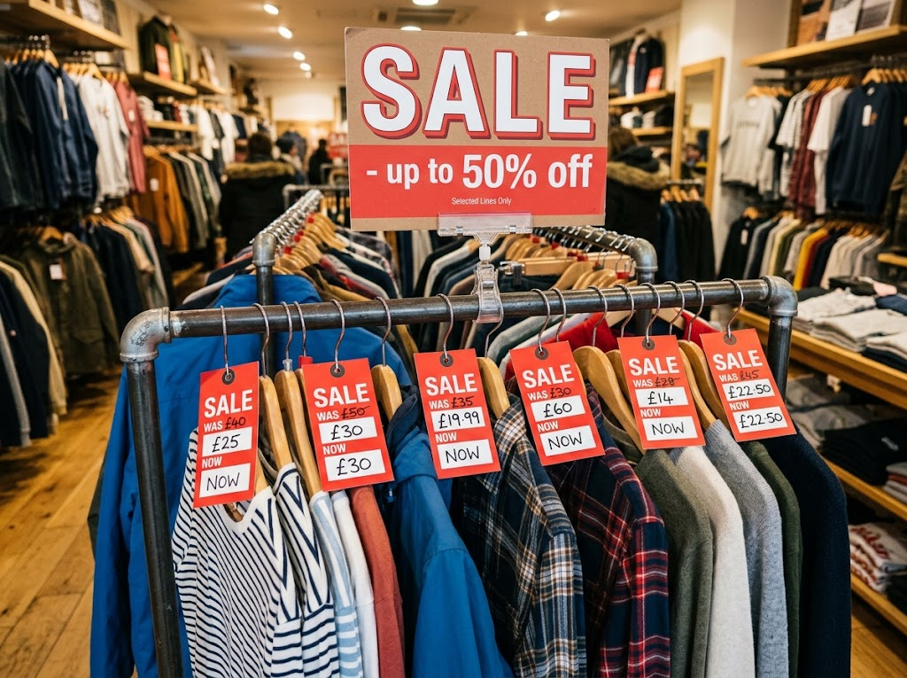  Promotional pricing: a temporary price cut to boost sales and clear stock.

PART TWO
What Influences Pricing?
The factors behind the choice.
Influences on Pricing Strategies
Technology  Price comparison websites make customers more price-sensitive; new technology can cut costs, allowing lower prices. | Competition  In a competitive market prices must stay close to rivals'; with few competitors, prices can be higher.
Market segments  Different segments will pay different prices - students want low prices; luxury buyers accept high ones. | Product life cycle  Launch may use penetration or skimming; maturity uses competitive pricing; decline may use promotional pricing.
Which Strategy When?
Situation | Likely strategy
A new snack entering a crowded market | Penetration
A new, unique games console | Skimming
A builder quoting for a new kitchen | Cost-plus
A petrol station with rivals on the same road | Competitive
A shop clearing summer stock in September | Promotional
Case Study
CASE STUDY
Apple: Skimming the New iPhone
Each year Apple launches new iPhone models at high prices. Loyal customers who want the latest technology are willing to pay, giving Apple a high profit on each early sale. When the next models arrive, Apple cuts the price of the older ones or keeps them on sale at a lower price, reaching customers who would not pay the launch price. Apple's strong brand and loyal customers make price skimming possible - a new business with an unknown brand could not do the same.

High  Launch prices for the newest models | Lower  Prices for older models once new ones arrive
Key Terms
Pricing strategy  The method a business uses to set the price of a product. | Penetration pricing  A low launch price to gain market share quickly.
Price skimming  A high launch price that is lowered over time. | Cost-plus pricing  Adding a percentage mark-up to the cost of a product.
Competitive pricing  Setting a price similar to competitors'. | Promotional pricing  Temporarily reducing prices to boost sales.
Mark-up
The percentage added to cost to set the price.
Your Task: Price It
12 minutes
Recommend a pricing strategy for each product and justify it: a new energy drink from an unknown brand; the first ever folding smartphone from a famous brand; a local plumber's call-out charge; a supermarket's own-brand milk; last season's football shirts. Then calculate the price of a product costing £15 with a 40% mark-up.
1. Choose a strategy for each product.
2. Justify each choice.
3. Calculate the cost-plus price.
A good answer shows: A suitable strategy for each with a reason linked to competition, brand, costs or life cycle stage; cost-plus price £21.
Note: Skimming only works with a strong brand or a unique product - check they spot that for the folding phone.
Can I...?
☐ Explain penetration pricing.
☐ Explain price skimming.
☐ Explain cost-plus pricing.
☐ Calculate a cost-plus price.
☐ Explain competitive pricing.
☐ Explain promotional pricing.
☐ Explain the influences on pricing.
Summary
✓ Penetration: low launch price for market share. Skimming: high launch price, lowered later.
✓ Cost-plus: cost + mark-up. Competitive: match rivals. Promotional: temporary discounts.
✓ Influences: technology, competition, market segments and the product life cycle.

EXAM FOCUS
Explain one disadvantage of price skimming for a business launching a new product. (3 marks)
Strategy questions need context: say why the strategy suits (or does not suit) this product and this market.
Exam Practice: Price
Answer all questions. Show your working in calculations. · 20 minutes
▸ Question 1 · 1 mark · Define. Define the term 'penetration pricing'.
▸ Question 2 · 2 marks · Calculate. A business makes garden benches for £60 each and uses cost-plus pricing with a 35% mark-up. Calculate the selling price of a bench. You are…
▸ Question 3 · 3 marks · Explain. Explain one disadvantage of price skimming for a business launching a new product.
▸ Question 4 · 9 marks · Justify. Justify which one of these two options SnapFit Ltd should choose.
Question 1 · 1 mark · Define
“Define the term 'penetration pricing'.”
HOW TO ANSWER IT Command word: Define. Worth 1 mark, so plan before writing.
Question 1 · mark scheme
1 mark available. Award a mark for each point made.
▸ Low launch price / to gain market share. 1 mark
▸ Model answer. Setting a low price when a product is launched to attract customers and gain market share quickly.
Question 2 · 2 marks · Calculate
“A business makes garden benches for £60 each and uses cost-plus pricing with a 35% mark-up. Calculate the selling price of a bench. You are advised to show your working.”
HOW TO ANSWER IT Command word: Calculate. Worth 2 marks, so plan before writing.
Question 2 · mark scheme
2 marks available. Award a mark for each point made.
▸ Correct method: cost + (cost × 35%). 1 mark
▸ Correct answer: £81. 1 mark (award 2 marks for the correct answer with no working)
▸ Model answer. £60 × 0.35 = £21. £60 + £21 = £81
Question 3 · 3 marks · Explain
“Explain one disadvantage of price skimming for a business launching a new product.”
HOW TO ANSWER IT Command word: Explain. Worth 3 marks, so plan before writing.
Question 3 · mark scheme
3 marks available. Award a mark for each point made.
▸ A disadvantage identified, e.g. low sales / attracts competitors / needs strong brand. 1 mark
▸ First linked point of explanation. 1 mark
▸ Second linked point of explanation. 1 mark
▸ Model answer. Sales may be low at first (1). Only early adopters are willing to pay the high launch price (1). This means the business may take longer to build market share, and the high profits may encourage competitors to launch cheaper rivals (1).
Question 4 · 9 marks · Justify
“Justify which one of these two options SnapFit Ltd should choose.”
— SnapFit Ltd has developed a new fitness tracker watch. It has a unique feature: it measures hydration levels, which no competitor can do. The market for fitness trackers is large…
HOW TO ANSWER IT Command word: Justify. Worth 9 marks, so plan before writing.
Question 4 · mark scheme
9 marks available. Award a mark for each point made.
▸ AO2 (Application, 3 marks): uses the context - the hydration feature, unknown brand, competitive market, £249 and £99. Level 1-3
▸ AO3a (Analysis, 3 marks): chains of reasoning about each strategy. Level 1-3
▸ AO3b (Evaluation, 3 marks): a justified choice with a supported judgement. Level 1-3
▸ Model answer. Option 1, skimming, suits a product with a unique feature: SnapFit's hydration sensor gives early adopters a reason to pay £249, and the high profit per sale would help recover its development costs. However, SnapFit is an unknown brand in a market dominated by famous names, and customers may not trust a new brand at a premium price, so sales could be very low. Option 2, penetration, would encourage customers to try an unknown brand, quickly building sales and market share and making SnapFit well known. But £99 gives a much lower profit per watch, and it may be hard to raise the price later. On balance SnapFit should choose Option 2, because as an unknown brand its biggest challenge is persuading customers to try it at all, and a low price combined with its unique feature gives them a strong reason to switch. This depends on whether £99 still covers its costs.

