EDEXCEL GCSE BUSINESS · PAPER 2
Promotion
Making marketing decisions · Lesson 3 of 5
Teacher copy - includes the notes for whoever is teaching from it.
Last Lesson
Answer from memory before the answers appear.
1. What is penetration pricing?
A low launch price to gain market share.
2. What is price skimming?
A high launch price, lowered over time.
3. How do you calculate a cost-plus price?
Cost + (cost × mark-up %).
4. Give one influence on pricing.
Technology, competition, market segments or the product life cycle.
Learning Objectives
1. Explain the main promotional methods: advertising, sponsorship, product trials, sales promotions, public relations and branding.
2. Explain how promotion is chosen to suit different market segments.
3. Explain how technology is used in promotion: targeted adverts, viral advertising, social media and e-newsletters.
PART ONE
Promotional Methods
The tools a business uses to tell customers about its products.
Promotional Methods
Advertising  Paid messages on TV, radio, cinema, billboards, in print or online. Reaches many people, but can be expensive. | Sponsorship  Paying to have the brand linked to an event, team or programme. Builds awareness and a positive image.
Product trials  Free samples or free trials, so customers can try before they buy. | Sales promotions  Short-term offers: discounts, "buy one get one free", competitions, vouchers and loyalty points.
Public relations (PR)  Getting positive coverage in the media without paying for it directly - press releases, events and launches. | Branding  Creating a recognisable name, logo and image that customers trust and remember.
Old Media and New
A billboard reaches everyone who passes; an influencer reaches exactly the right followers.
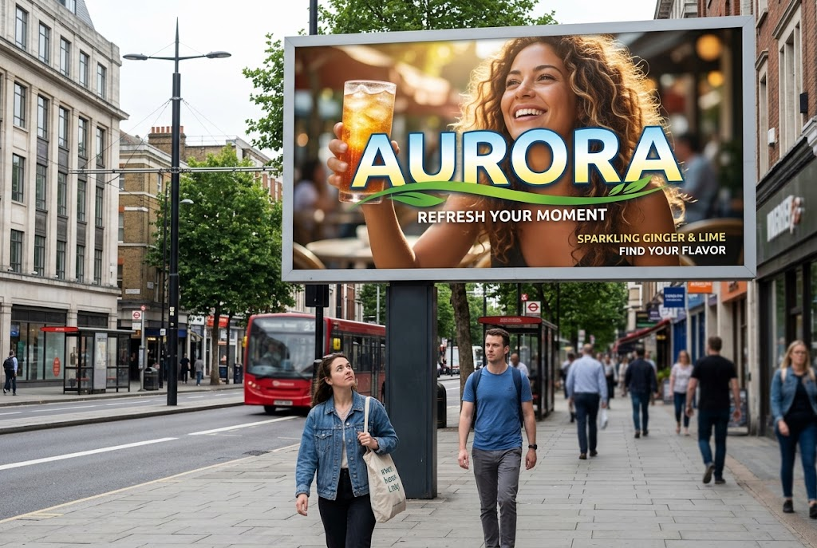  Traditional advertising: seen by everyone who passes. | 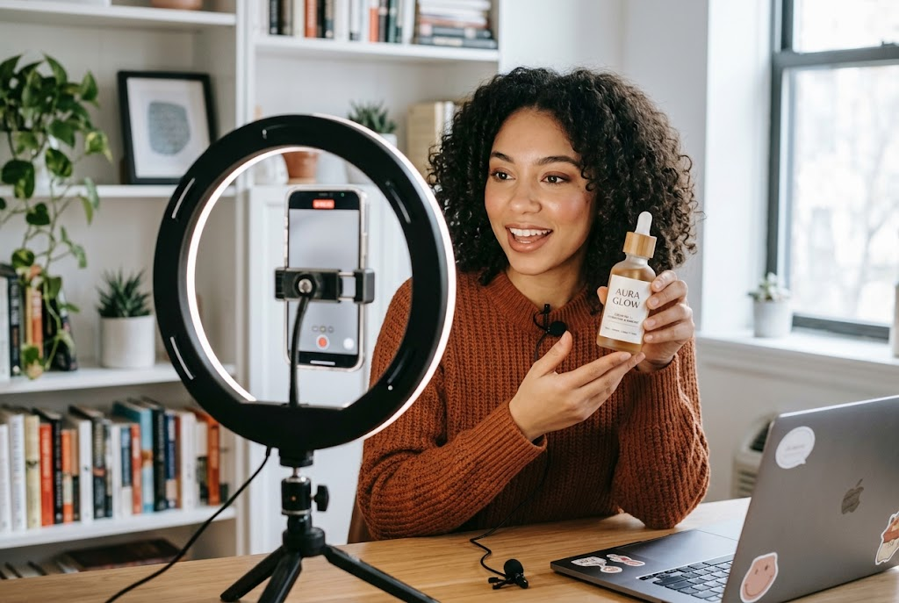  Social media: aimed at exactly the right followers.

Promotion for Different Market Segments
The best promotion reaches the target customers where they are.
▸ Teenagers and young adults. Social media, influencers and online video.
▸ Older customers. TV, radio, newspapers and direct mail.
▸ Local customers. Leaflets, local radio, local newspapers and community sponsorship.
▸ Business customers. Trade magazines, exhibitions and email.
▸ Budget. Large businesses can afford TV and national sponsorship; small ones rely on cheaper methods.
PART TWO
Technology and Promotion
How digital media has changed promotion.
Promotion Using Technology
Technology lets businesses target customers precisely and cheaply.
▸ Targeted online advertising. Adverts shown only to people whose searches, location, age and interests match the target market.
▸ Viral advertising. Content that customers share with each other on social media, spreading the message for free.
▸ Social media. Posts, stories and videos that build a following and let customers engage with the brand.
▸ E-newsletters. Emails sent to customers who have signed up, with news, offers and new products.
Traditional or Digital Promotion?
TRADITIONAL (TV, PRINT, BILLBOARDS) | DIGITAL (ONLINE, SOCIAL MEDIA, EMAIL)
▸ Reaches a very large audience.  ▸ Builds trust and brand image.  ▸ Very expensive, especially TV.  ▸ Hard to measure exactly who saw it.  ▸ Cannot be targeted precisely. | ▸ Cheap, and suits small budgets.  ▸ Targeted at exactly the right customers.  ▸ Results can be measured - clicks, views and sales.  ▸ Customers can share it, spreading it further.  ▸ But: easy to ignore, and bad feedback spreads fast too.
Case Study
CASE STUDY
John Lewis: The Christmas Advert
Since 2007 the department store John Lewis has launched a big-budget Christmas TV advert every November. The adverts - such as "The Long Wait" in 2011 and "The Man on the Moon" in 2015 - tell emotional stories and have become an event in their own right. They are shown on TV, but are also watched and shared millions of times online, reported in newspapers and discussed on social media. John Lewis combines traditional advertising, viral sharing and public relations in one campaign.

2007  John Lewis's first big Christmas advert | Millions  Online views and shares each year
Key Terms
Promotion  Communicating with customers to persuade them to buy. | Advertising  Paid-for communication through media such as TV, print, billboards and online.
Sponsorship  Paying to link a brand with an event, team or programme. | Sales promotion  A short-term offer to boost sales, such as a discount or free gift.
Public relations (PR)  Gaining positive media coverage without paying for it directly. | Branding  Giving a product a recognisable name, logo and image.
Viral advertising  Promotion that spreads as customers share it online. | Targeted advertising  Online adverts shown only to people who match the target market.
Your Task: Plan a Campaign
15 minutes
A new brand of protein bar aimed at 18-30-year-olds who go to the gym is launching with a £20,000 budget. Plan a promotional campaign using at least three methods, including one use of technology. Explain why each suits the target market and budget.
1. Choose three methods.
2. Include one digital method.
3. Explain why each suits the target market.
4. Keep within the budget.
A good answer shows: Three or more methods matched to young gym-goers, with at least one digital method, and a sensible use of the budget - no £1 million TV campaign.
Note: Push them to explain why each method reaches this segment specifically.
Can I...?
☐ Explain advertising.
☐ Explain sponsorship.
☐ Explain product trials.
☐ Explain sales promotions.
☐ Explain public relations.
☐ Explain branding.
☐ Match promotion to market segments.
☐ Explain how technology is used in promotion.
Summary
✓ Methods: advertising, sponsorship, product trials, sales promotions, PR and branding.
✓ The right method depends on the market segment and the budget.
✓ Technology: targeted adverts, viral advertising, social media and e-newsletters.
✓ Digital promotion is cheap, targeted and measurable.

EXAM FOCUS
Explain one benefit to a business of using social media to promote its products. (3 marks)
Always link the method to the target market: a promotion is only good if it reaches the right customers at a cost the business can afford.
Exam Practice: Promotion
Answer all questions. Use the context of the business in the question where one is given. · 20 minutes
▸ Question 1 · 1 mark · Define. Define the term 'sponsorship'.
▸ Question 2 · 2 marks · Outline. Outline one benefit to a business of using product trials.
▸ Question 3 · 3 marks · Explain. Explain one benefit to a business of using social media to promote its products.
▸ Question 4 · 9 marks · Justify. Justify which one of these two options Riverside Garden Centres Ltd should choose.
Question 1 · 1 mark · Define
“Define the term 'sponsorship'.”
HOW TO ANSWER IT Command word: Define. Worth 1 mark, so plan before writing.
Question 1 · mark scheme
1 mark available. Award a mark for each point made.
▸ Paying to be associated with an event / team / programme. 1 mark
▸ Model answer. When a business pays to have its brand linked with an event, team or programme.
Question 2 · 2 marks · Outline
“Outline one benefit to a business of using product trials.”
HOW TO ANSWER IT Command word: Outline. Worth 2 marks, so plan before writing.
Question 2 · mark scheme
2 marks available. Award a mark for each point made.
▸ A benefit identified. 1 mark
▸ Developed. 1 mark
▸ Model answer. Customers can try the product for free before buying (1), so they are more confident it is good and more likely to buy it (1).
Question 3 · 3 marks · Explain
“Explain one benefit to a business of using social media to promote its products.”
HOW TO ANSWER IT Command word: Explain. Worth 3 marks, so plan before writing.
Question 3 · mark scheme
3 marks available. Award a mark for each point made.
▸ A benefit identified, e.g. targeted / cheap / viral sharing / measurable. 1 mark
▸ First linked point of explanation. 1 mark
▸ Second linked point of explanation. 1 mark
▸ Model answer. Adverts can be targeted at the business's exact market segment (1). They are shown only to people of the right age, location and interests (1). This means less money is wasted on people who will not buy, so promotion is more cost-effective (1).
Question 4 · 9 marks · Justify
“Justify which one of these two options Riverside Garden Centres Ltd should choose.”
— Riverside Garden Centres Ltd has five garden centres in the south of England. Most of its customers are aged over 50. It has £50,000 to spend on promotion. Option 1: Sponsor a…
HOW TO ANSWER IT Command word: Justify. Worth 9 marks, so plan before writing.
Question 4 · mark scheme
9 marks available. Award a mark for each point made.
▸ AO2 (Application, 3 marks): uses the context - five centres, customers over 50, £50,000, the two options. Level 1-3
▸ AO3a (Analysis, 3 marks): chains of reasoning about each option. Level 1-3
▸ AO3b (Evaluation, 3 marks): a justified choice with a supported judgement. Level 1-3
▸ Model answer. Option 1 suits Riverside's target market. Customers over 50 are more likely to listen to local radio, and a gardening programme reaches exactly the people interested in gardening in the south of England. Sponsorship would link the brand to expert gardening advice for a whole year. However, the business cannot easily measure how many sales it produces. Option 2 is precisely targeted and measurable, and could attract younger customers to widen its market. But most of its current customers are over 50, and they use social media less, so much of the budget may not reach them. On balance Riverside should choose Option 1, because it reaches its existing core customers in the right area, with a message about gardening they care about. However, this depends on the radio programme having enough local listeners to justify £50,000.

