EDEXCEL GCSE BUSINESS · PAPER 2
Place
Making marketing decisions · Lesson 4 of 5
Teacher copy - includes the notes for whoever is teaching from it.
Last Lesson
Answer from memory before the answers appear.
1. Name three promotional methods.
Any three of: advertising, sponsorship, product trials, sales promotions, PR, branding.
2. What is targeted advertising?
Online adverts shown only to people who match the target market.
3. What is public relations?
Gaining positive media coverage without paying for it directly.
4. How should promotion match a market segment?
Use methods and media the target customers actually see.
Learning Objectives
1. Explain distribution channels and the role of intermediaries.
2. Explain the role of retailers and e-tailers (e-commerce).
3. Explain multi-channel distribution.
4. Explain the advantages and disadvantages of each method of distribution.
What Is Place?
Place is about how and where customers can buy a product.
▸ Distribution. The process of getting products from the producer to the customer.
▸ Distribution channel. The route a product takes from producer to customer.
▸ Intermediary. A business in the middle of the channel, such as a wholesaler or retailer.
▸ Why it matters. Customers can only buy a product if it is available where and when they want it.
Distribution Channels
Channel | Route | Example
Direct | Producer to consumer | A farm shop, or a brand's own website
One intermediary | Producer to retailer to consumer | A clothing brand sold in department stores
Two intermediaries | Producer to wholesaler to retailer to consumer | Sweets sold to a wholesaler, then to corner shops
Intermediaries
Intermediaries sit between the producer and the customer.
▸ Wholesaler. Buys large quantities from producers and sells smaller quantities to retailers. Breaks bulk, stores stock and delivers.
▸ Retailer. Sells to the final customer, in shops or online.
▸ Advantages. Producers reach many more customers and do not need their own shops.
▸ Disadvantages. Each intermediary adds its own profit, raising the final price, and the producer has less control over how its product is sold.
Breaking Bulk
A corner shop could never order a lorry-load of crisps straight from the factory. A wholesaler buys in bulk from many producers and sells to small shops in the quantities they need - adding a margin for the service. | 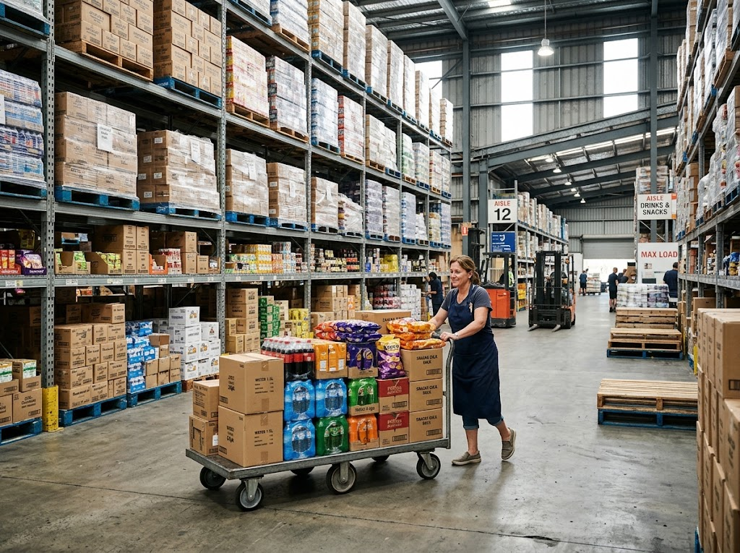  A wholesaler buys in bulk from producers and sells smaller amounts to shops.

PART ONE
Retailers and E-tailers
Shops, websites, or both.
Retailers or E-tailers?
RETAILERS (PHYSICAL SHOPS) | E-TAILERS (E-COMMERCE)
▸ Customers can see, touch and try products.  ▸ Face-to-face service and advice.  ▸ Customers take products home immediately.  ▸ But: high costs of rent and staff.  ▸ Limited to customers who can visit. | ▸ Lower costs: no shop rent.  ▸ Reach customers anywhere, 24 hours a day.  ▸ Can offer a huge range.  ▸ But: delivery costs and returns.  ▸ Customers cannot try before buying.
Two Ways to Buy
The same product, bought in a shop or delivered to the door.
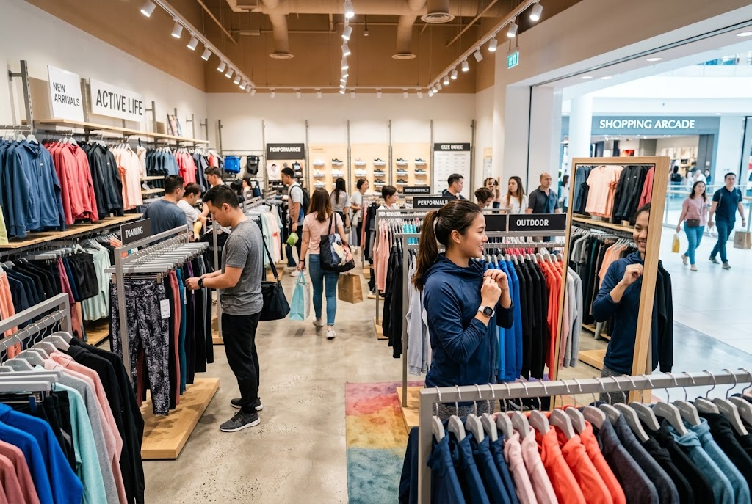  Retail: try it on, take it home today. | 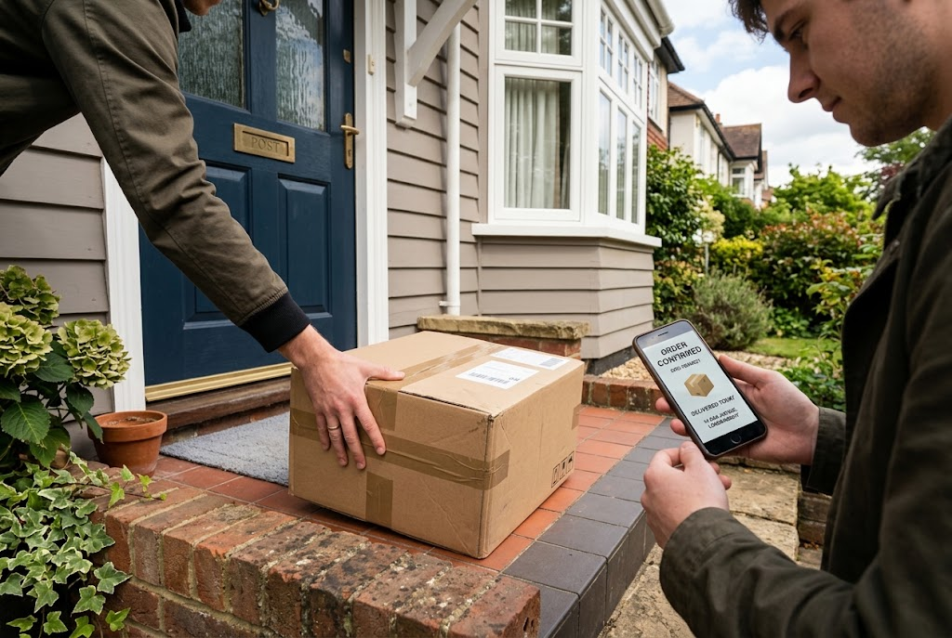  E-commerce: ordered online, delivered to the door.

Multi-channel Distribution
Multi-channel distribution means selling through more than one channel at once.
▸ How it works. A business sells in its own shops, on its own website, through an app, on online marketplaces and through other retailers.
▸ Click-and-collect. Customers order online and collect from a shop - combining the convenience of both.
▸ Advantages. Reaches more customers, in the way each prefers to shop, so sales rise.
▸ Disadvantages. More complex and expensive to manage; prices and stock must be consistent across every channel.
Case Study
CASE STUDY
Gymshark: From Online to the High Street
Gymshark began in 2012 as a purely online business, selling gym clothing through its own website and promoting it on social media. For ten years it had no shops. In 2022 it opened its first permanent flagship store, on Regent Street in London, where customers could try on clothes, join workouts and meet the brand in person. By adding a physical store to its website, Gymshark moved to multi-channel distribution - reaching customers who want to try before they buy.

2012  Gymshark starts as an online-only business | 2022  Its first flagship store opens on Regent Street
Key Terms
Place  How and where customers can buy a product. | Distribution channel  The route a product takes from producer to customer.
Intermediary  A business between the producer and the customer, such as a wholesaler or retailer. | Wholesaler  A business that buys in bulk from producers and sells smaller quantities to retailers.
Retailer  A business that sells to the final customer. | E-tailer  A retailer that sells online.
Multi-channel distribution
Selling through several channels at once.
Your Task: Choose the Channel
12 minutes
Recommend a distribution channel for each product and explain why: handmade wedding cakes; a new brand of crisps; luxury watches; a mobile phone game; fresh flowers from a local grower. Then choose one and explain how it could use multi-channel distribution.
1. Choose a channel for each product.
2. Explain why.
3. Plan multi-channel distribution for one.
A good answer shows: A suitable channel for each, linked to the product and customer, and a realistic multi-channel plan.
Note: Look for reasons: perishability for flowers and cakes, wide availability for crisps, an exclusive image for watches.
Can I...?
☐ Explain what a distribution channel is.
☐ Describe the three main channels.
☐ Explain the role of wholesalers.
☐ Explain the role of retailers.
☐ Explain e-tailers and e-commerce.
☐ Compare retailers and e-tailers.
☐ Explain multi-channel distribution.
Summary
✓ Place is how products get from producer to customer.
✓ Channels can be direct, or use intermediaries such as wholesalers and retailers.
✓ Retailers offer a physical experience; e-tailers offer low costs and wide reach.
✓ Multi-channel distribution reaches more customers but is harder to manage.

EXAM FOCUS
Explain one benefit to a business of using multi-channel distribution. (3 marks)
Link the channel to the product and the customer - fresh food needs a short channel; a mass-market snack needs as many channels as possible.
Exam Practice: Place
Answer all questions. Use the context of the business in the question where one is given. · 20 minutes
▸ Question 1 · 1 mark · Define. Define the term 'e-tailer'.
▸ Question 2 · 2 marks · Outline. Outline one disadvantage to a producer of selling through a wholesaler.
▸ Question 3 · 3 marks · Explain. Explain one benefit to a business of using multi-channel distribution.
▸ Question 4 · 6 marks · Analyse. Analyse the impact on Tidal Beauty Ltd of selling its products through the chain of chemists.
Question 1 · 1 mark · Define
“Define the term 'e-tailer'.”
HOW TO ANSWER IT Command word: Define. Worth 1 mark, so plan before writing.
Question 1 · mark scheme
1 mark available. Award a mark for each point made.
▸ A business selling online / online retailer. 1 mark
▸ Model answer. A retailer that sells its products online.
Question 2 · 2 marks · Outline
“Outline one disadvantage to a producer of selling through a wholesaler.”
HOW TO ANSWER IT Command word: Outline. Worth 2 marks, so plan before writing.
Question 2 · mark scheme
2 marks available. Award a mark for each point made.
▸ A disadvantage identified, e.g. lower profit / higher price / less control. 1 mark
▸ Developed. 1 mark
▸ Model answer. The wholesaler adds its own profit (1), so either the final price is higher or the producer receives less for each product (1).
Question 3 · 3 marks · Explain
“Explain one benefit to a business of using multi-channel distribution.”
HOW TO ANSWER IT Command word: Explain. Worth 3 marks, so plan before writing.
Question 3 · mark scheme
3 marks available. Award a mark for each point made.
▸ A benefit identified. 1 mark
▸ First linked point of explanation. 1 mark
▸ Second linked point of explanation. 1 mark
▸ Model answer. It can reach more customers (1). Some customers prefer to shop in stores while others prefer to buy online (1). By selling through both, the business meets each customer's preference, increasing its total sales (1).
Question 4 · 6 marks · Analyse
“Analyse the impact on Tidal Beauty Ltd of selling its products through the chain of chemists.”
— Tidal Beauty Ltd makes natural skincare products. It currently sells only through its own website. A national chain of chemists has offered to stock its products in 300 stores…
HOW TO ANSWER IT Command word: Analyse. Worth 6 marks, so plan before writing.
Question 4 · mark scheme
6 marks available. Award a mark for each point made.
▸ AO2 (Application, 3 marks): uses the context - skincare, website only, 300 stores, 40% of the price. Level 1-3
▸ AO3a (Analysis, 3 marks): chains of reasoning about sales, profit and control. Level 1-3
▸ Model answer. Selling through 300 chemists would make Tidal Beauty's products available to many more customers, including those who prefer to see and test skincare in a shop before buying. This would increase awareness of the brand and could greatly increase its sales volume. However, the chain would take 40% of the retail price, so Tidal Beauty would earn much less profit on each product than it does selling direct from its website. It would also lose some control over how its products are displayed and priced. This means that although sales would rise, Tidal Beauty must sell enough extra products to make up for the lower profit on each one.

