EDEXCEL GCSE BUSINESS · PAPER 2
Using the marketing mix to make business decisions
Making marketing decisions · Lesson 5 of 5
Last Lesson
Answer from memory before the answers appear.
1. What is a distribution channel?
The route a product takes from producer to customer.
2. What does a wholesaler do?
Buys in bulk from producers and sells smaller quantities to retailers.
3. What is multi-channel distribution?
Selling through several channels at once.
4. Give one advantage of an e-tailer over a shop.
Lower costs, wider reach or 24-hour opening.
Learning Objectives
1. Explain how each element of the marketing mix influences the others.
2. Explain how to use the marketing mix to build competitive advantage.
3. Explain how an integrated marketing mix influences competitive advantage.
4. Use the marketing mix to make and justify business decisions.
Each P Affects the Others
Change one element of the mix, and the others usually have to change too.
▸ Product affects price. A higher-quality product costs more to make and can justify a higher price.
▸ Price affects promotion. A low price may be the main message of the promotion; a premium price needs promotion that builds a premium image.
▸ Promotion affects place. Promoting nationally only works if the product is available nationally.
▸ Place affects price. Selling through intermediaries adds costs, so the price rises; selling direct online can lower it.
One Change, Four Effects
Decision | Product | Price | Promotion | Place
Launch a premium range | Better ingredients and packaging | Higher | Stylish, aspirational adverts | Upmarket stores and own website
Target students | Smaller, simpler versions | Lower, with student discounts | Social media and campus events | Near universities and online
Enter a new country | Adapted to local tastes | Set for local incomes and rivals | In the local language and media | Local retailers or a local website
Competitive Advantage
Competitive advantage is anything that makes a business more attractive to customers than its rivals.
▸ Through product. A better, unique or more reliable product that rivals cannot match.
▸ Through price. Lower costs that allow lower prices, or a premium brand that allows higher ones.
▸ Through promotion. A strong, trusted brand that customers recognise and choose.
▸ Through place. Being easier to buy from - more locations, faster delivery, better online shopping.
An Integrated Mix Builds Advantage
When all four Ps work together, the advantage is hard for rivals to copy.
▸ Consistency. Every element sends the same message to the same target market.
▸ Hard to copy. A rival can copy a price, but not a whole mix built over years.
▸ Clear positioning. Customers know exactly what the business stands for.
▸ A weak link. One element that does not fit - a cheap-looking advert for a luxury product - damages the whole mix.
A Mix That Fits
Every element of this launch says the same thing: premium. The packaging, the price, the display and the store all match - and that consistency is what convinces customers the product is worth paying more for. | 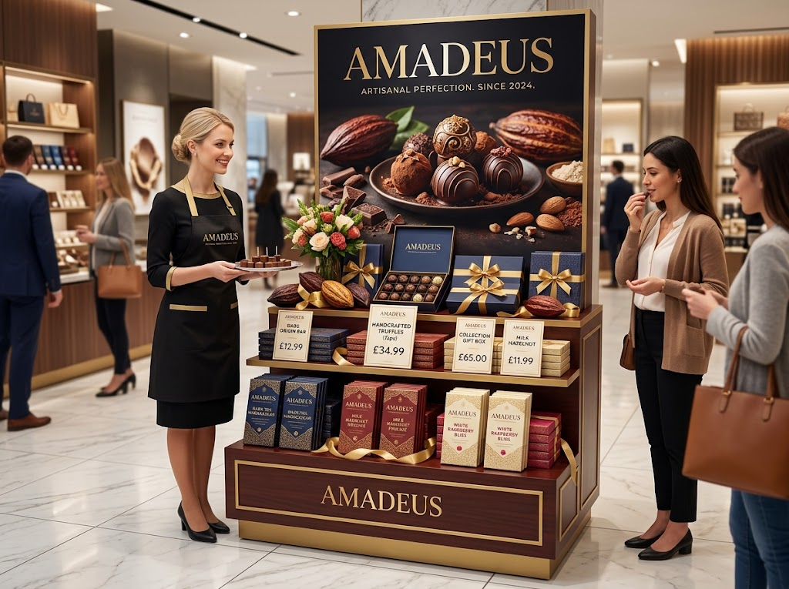  Premium product, premium price, stylish promotion, upmarket place: an integrated mix.

Case Study
CASE STUDY
Primark: A Low-Cost Mix
Primark sells fashionable clothing at very low prices, and every element of its marketing mix supports that. Its product is on-trend but simple and made in huge quantities to keep costs down. Its prices are among the lowest on the high street. For most of its history it spent very little on traditional advertising, relying on social media, word of mouth and customers sharing their purchases online. And it sold mainly through large stores in busy locations rather than online, avoiding the costs of delivery and returns. The integrated low-cost mix is hard for rivals to copy.

Low  Prices, costs and advertising spend | Stores  Its main place, rather than online delivery
Key Terms
Marketing mix  The combination of product, price, promotion and place. | Integrated marketing mix  A mix where all four Ps fit together for the same target market.
Competitive advantage  Anything that makes a business more attractive to customers than its rivals. | Positioning  How a business wants customers to see its product compared with competitors'.
Your Task: Build the Mix
15 minutes
A bakery chain wants to launch a new range of gluten-free cakes. Choose a target market, then decide all four Ps so that they fit together. Finally, explain what gives your range a competitive advantage.
1. Choose a target market.
2. Decide the product, price, promotion and place.
3. Check they fit together.
4. Explain the competitive advantage.
A good answer shows: A clear target market with all four Ps consistent with it, and a competitive advantage linked to at least one P.
Can I...?
☐ Explain how each P influences the others.
☐ Explain competitive advantage.
☐ Explain how an integrated mix creates competitive advantage.
☐ Use the mix to make and justify a business decision.
Summary
✓ Each element of the marketing mix affects the others.
✓ Competitive advantage can come from product, price, promotion or place.
✓ An integrated mix is consistent, clear and hard for rivals to copy.

EXAM FOCUS
Explain one way a business could use its marketing mix to gain a competitive advantage. (3 marks)
In mix questions, show the knock-on effect: a change to one P should lead you to explain how at least one other P changes too.

