EDEXCEL GCSE BUSINESS · PAPER 2
Using the marketing mix to make business decisions
Making marketing decisions · Lesson 5 of 5
Teacher copy - includes the notes for whoever is teaching from it.
Last Lesson
Answer from memory before the answers appear.
1. What is a distribution channel?
The route a product takes from producer to customer.
2. What does a wholesaler do?
Buys in bulk from producers and sells smaller quantities to retailers.
3. What is multi-channel distribution?
Selling through several channels at once.
4. Give one advantage of an e-tailer over a shop.
Lower costs, wider reach or 24-hour opening.
Learning Objectives
1. Explain how each element of the marketing mix influences the others.
2. Explain how to use the marketing mix to build competitive advantage.
3. Explain how an integrated marketing mix influences competitive advantage.
4. Use the marketing mix to make and justify business decisions.
Each P Affects the Others
Change one element of the mix, and the others usually have to change too.
▸ Product affects price. A higher-quality product costs more to make and can justify a higher price.
▸ Price affects promotion. A low price may be the main message of the promotion; a premium price needs promotion that builds a premium image.
▸ Promotion affects place. Promoting nationally only works if the product is available nationally.
▸ Place affects price. Selling through intermediaries adds costs, so the price rises; selling direct online can lower it.
One Change, Four Effects
Decision | Product | Price | Promotion | Place
Launch a premium range | Better ingredients and packaging | Higher | Stylish, aspirational adverts | Upmarket stores and own website
Target students | Smaller, simpler versions | Lower, with student discounts | Social media and campus events | Near universities and online
Enter a new country | Adapted to local tastes | Set for local incomes and rivals | In the local language and media | Local retailers or a local website
Competitive Advantage
Competitive advantage is anything that makes a business more attractive to customers than its rivals.
▸ Through product. A better, unique or more reliable product that rivals cannot match.
▸ Through price. Lower costs that allow lower prices, or a premium brand that allows higher ones.
▸ Through promotion. A strong, trusted brand that customers recognise and choose.
▸ Through place. Being easier to buy from - more locations, faster delivery, better online shopping.
An Integrated Mix Builds Advantage
When all four Ps work together, the advantage is hard for rivals to copy.
▸ Consistency. Every element sends the same message to the same target market.
▸ Hard to copy. A rival can copy a price, but not a whole mix built over years.
▸ Clear positioning. Customers know exactly what the business stands for.
▸ A weak link. One element that does not fit - a cheap-looking advert for a luxury product - damages the whole mix.
A Mix That Fits
Every element of this launch says the same thing: premium. The packaging, the price, the display and the store all match - and that consistency is what convinces customers the product is worth paying more for. | 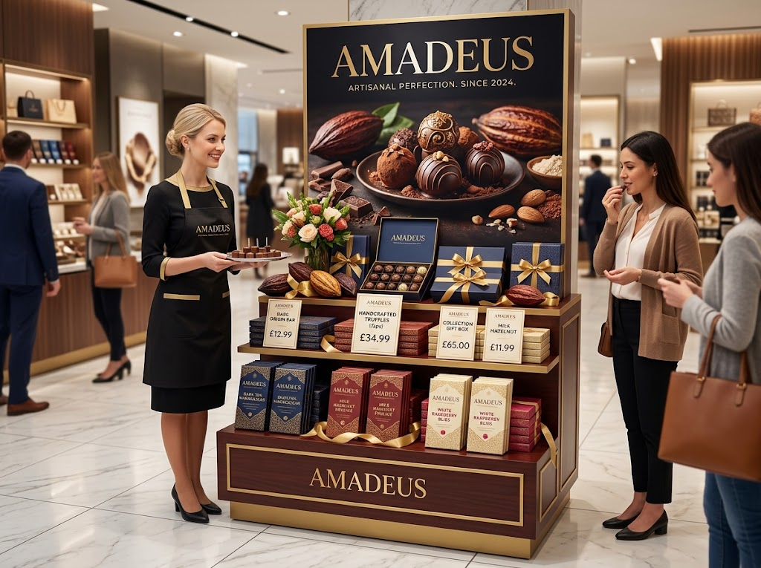  Premium product, premium price, stylish promotion, upmarket place: an integrated mix.

Case Study
CASE STUDY
Primark: A Low-Cost Mix
Primark sells fashionable clothing at very low prices, and every element of its marketing mix supports that. Its product is on-trend but simple and made in huge quantities to keep costs down. Its prices are among the lowest on the high street. For most of its history it spent very little on traditional advertising, relying on social media, word of mouth and customers sharing their purchases online. And it sold mainly through large stores in busy locations rather than online, avoiding the costs of delivery and returns. The integrated low-cost mix is hard for rivals to copy.

Low  Prices, costs and advertising spend | Stores  Its main place, rather than online delivery
Key Terms
Marketing mix  The combination of product, price, promotion and place. | Integrated marketing mix  A mix where all four Ps fit together for the same target market.
Competitive advantage  Anything that makes a business more attractive to customers than its rivals. | Positioning  How a business wants customers to see its product compared with competitors'.
Your Task: Build the Mix
15 minutes
A bakery chain wants to launch a new range of gluten-free cakes. Choose a target market, then decide all four Ps so that they fit together. Finally, explain what gives your range a competitive advantage.
1. Choose a target market.
2. Decide the product, price, promotion and place.
3. Check they fit together.
4. Explain the competitive advantage.
A good answer shows: A clear target market with all four Ps consistent with it, and a competitive advantage linked to at least one P.
Note: Check the Ps agree with each other - premium ingredients with a bargain price and cheap promotion do not fit.
Can I...?
☐ Explain how each P influences the others.
☐ Explain competitive advantage.
☐ Explain how an integrated mix creates competitive advantage.
☐ Use the mix to make and justify a business decision.
Summary
✓ Each element of the marketing mix affects the others.
✓ Competitive advantage can come from product, price, promotion or place.
✓ An integrated mix is consistent, clear and hard for rivals to copy.

EXAM FOCUS
Explain one way a business could use its marketing mix to gain a competitive advantage. (3 marks)
In mix questions, show the knock-on effect: a change to one P should lead you to explain how at least one other P changes too.
Exam Practice: Using the Marketing Mix
Answer all questions. Use the context of the business in the question where one is given. · 25 minutes
▸ Question 1 · 1 mark · Define. Define the term 'competitive advantage'.
▸ Question 2 · 2 marks · Outline. Outline one way that a change in product could affect the price element of the marketing mix.
▸ Question 3 · 3 marks · Explain. Explain one way a business could use its marketing mix to gain a competitive advantage.
▸ Question 4 · 12 marks · Evaluate. Evaluate whether Bloom Coffee PLC should respond to the competition by cutting its prices.
Question 1 · 1 mark · Define
“Define the term 'competitive advantage'.”
HOW TO ANSWER IT Command word: Define. Worth 1 mark, so plan before writing.
Question 1 · mark scheme
1 mark available. Award a mark for each point made.
▸ An advantage over competitors that attracts customers. 1 mark
▸ Model answer. Something that makes a business more attractive to customers than its competitors.
Question 2 · 2 marks · Outline
“Outline one way that a change in product could affect the price element of the marketing mix.”
HOW TO ANSWER IT Command word: Outline. Worth 2 marks, so plan before writing.
Question 2 · mark scheme
2 marks available. Award a mark for each point made.
▸ A way identified. 1 mark
▸ Developed. 1 mark
▸ Model answer. Improving the quality of the product increases its costs (1), so the business may need to raise the price - which customers may accept because the product is better (1).
Question 3 · 3 marks · Explain
“Explain one way a business could use its marketing mix to gain a competitive advantage.”
HOW TO ANSWER IT Command word: Explain. Worth 3 marks, so plan before writing.
Question 3 · mark scheme
3 marks available. Award a mark for each point made.
▸ A way identified, linked to one or more Ps. 1 mark
▸ First linked point of explanation. 1 mark
▸ Second linked point of explanation. 1 mark
▸ Model answer. It could make its product different from competitors' through a unique feature (1). This gives customers a reason to choose it over rivals (1). As a result, the business can win market share and may be able to charge a higher price, increasing its profit (1).
Question 4 · 12 marks · Evaluate
“Evaluate whether Bloom Coffee PLC should respond to the competition by cutting its prices.”
— Bloom Coffee PLC owns 120 coffee shops across the UK, charging slightly higher prices than its rivals. It promotes itself mainly through a loyalty app. Over the past year its…
HOW TO ANSWER IT Command word: Evaluate. Worth 12 marks, so plan before writing.
Question 4 · mark scheme
12 marks available. Award a mark for each point made.
▸ AO2 (Application, 4 marks): uses the context - 120 shops, higher prices, loyalty app, 8% fall, rivals' TV adverts. Level 1-4
▸ AO3a (Analysis, 4 marks): chains of reasoning about price and the rest of the mix. Level 1-4
▸ AO3b (Evaluation, 4 marks): a supported judgement, with "it depends on". Level 1-4
▸ Model answer. Cutting prices could win back price-sensitive customers who have switched to the new competitors, and could stop the 8% fall in sales. Combined with offers on its loyalty app, lower prices might encourage customers to return regularly. However, Bloom already charges more than its rivals, which suggests customers see it as higher quality. Cutting prices could damage that image and start a price war with two large competitors who may be able to cut further, reducing Bloom's profit on every cup. Instead, Bloom could use its other Ps: improving its product, using its app to reward loyal customers, or promoting what makes it different. A price cut alone does not make its mix more competitive. Overall, Bloom should not rely on cutting prices across the board, because its competitive advantage is quality, not price. It depends on why customers are leaving: if research shows price is the main reason, targeted app discounts may be better than a general price cut.

