EDEXCEL GCSE BUSINESS · PAPER 2
Business operations
Making operational decisions · Lesson 1 of 4
Teacher copy - includes the notes for whoever is teaching from it.
From Making Marketing Decisions
Answer from memory before the answers appear.
1. Name the three parts of the design mix.
Function, aesthetics and cost.
2. What is an extension strategy?
An action taken to extend a product's life.
3. What is cost-plus pricing?
Adding a percentage mark-up to the cost of a product.
4. What is competitive advantage?
Anything that makes a business more attractive to customers than its rivals.
Learning Objectives
1. Explain the purpose of business operations.
2. Explain job, batch and flow production, with their advantages and disadvantages.
3. Explain what productivity is.
4. Explain the impact of technology on production: costs, productivity, quality and flexibility.
What Are Business Operations?
Operations are the activities that turn inputs into the goods and services a business sells.
▸ Inputs. Raw materials, components, labour, machinery and energy.
▸ The process. Making, assembling, preparing or delivering the product or service.
▸ Outputs. Finished goods or services, sold to customers.
▸ The aim. To produce products of the right quality, at the right cost, in the right quantity, at the right time.
PART ONE
Production Processes
Job, batch and flow.
Three Production Processes
Job production  One product made at a time, usually to a customer's individual order. Every product is unique - a wedding dress, a bespoke kitchen, a building. | Batch production  A group of identical products made together, then the process switches to a different batch - loaves of bread, then rolls; a batch of red paint, then blue.
Flow production
Identical products made continuously on a production line, often by machines - cars, cans of drink, chocolate bars.
One at a Time, or Thousands a Day?
The two extremes of production.
  Job production: every suit is unique. | 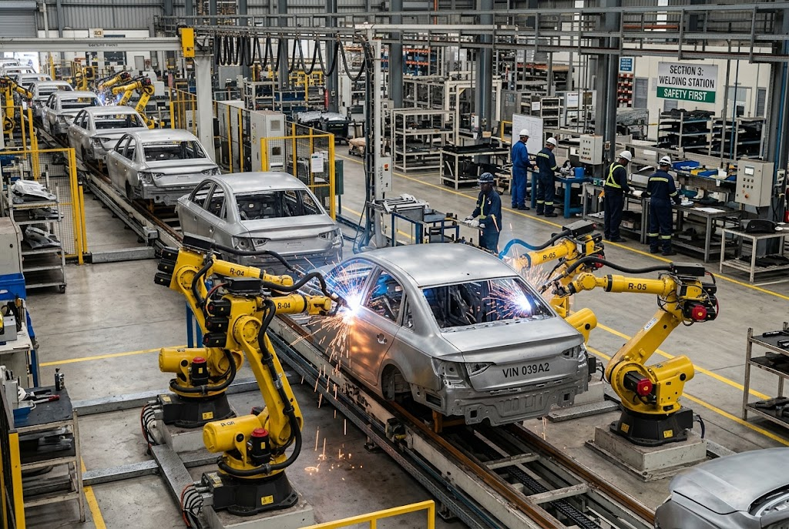  Flow production: identical cars, non-stop.

Comparing Production Processes
Feature | Job | Batch | Flow
Number made | One at a time | Groups of identical items | Huge numbers, continuously
Product | Unique, made to order | Same within a batch | Identical
Cost per unit | High | Medium | Low
Workers | Highly skilled | Semi-skilled | Mostly machines, less skilled
Flexibility | Very high | Some | Very low
Example | Wedding dress | Bread | Cars
Batch by Batch
A bakery is the classic example of batch production. It makes a batch of rolls, then switches to croissants, then to loaves. Each batch is identical, but the business can still offer variety - at the cost of time lost changing over between batches. |   Batch production: one batch of rolls, then a batch of croissants.

Flexibility or Low Cost?
JOB AND BATCH PRODUCTION | FLOW PRODUCTION
▸ Flexible: products can be changed or customised.  ▸ Suits small orders and variety.  ▸ Customers get what they want.  ▸ But: higher cost per unit, so prices are usually higher.  ▸ Skilled staff are expensive. | ▸ Very low cost per unit through economies of scale, so the business can charge competitive prices and still make a profit.  ▸ Consistent quality from machines.  ▸ Huge output.  ▸ But: expensive to set up.  ▸ Inflexible: hard to change the product, and boring, repetitive work.
PART TWO
Technology and Production
How machines and computers change operations.
Productivity
Productivity is the output produced per worker, or per machine, in a period of time.
▸ Example. A bakery worker who makes 400 loaves a day is more productive than one who makes 300.
▸ Why it matters. Higher productivity means more output for the same cost, so the cost of each unit falls.
▸ How to raise it. Better technology, training, and motivated staff.
The Impact of Technology on Production
Costs  Machines are expensive to buy, but reduce labour costs and waste, so cost per unit falls over time. | Productivity  Robots and automated machines work faster and non-stop, producing far more output.
Quality  Computer-controlled machines make every product to exactly the same standard, with fewer mistakes. | Flexibility  Modern computer-aided machines can be reprogrammed quickly, so even flow production can offer some variety.
Case Study
CASE STUDY
Morgan: Still Built by Hand
The Morgan Motor Company has made cars in Malvern, Worcestershire, since 1910. While most car makers use flow production with thousands of robots, Morgan still builds its cars largely by hand, using skilled craftspeople and, on many models, a frame made partly of ash wood. Customers can choose colours, leather and details for their own car. Output is tiny compared with a mass-market factory and each car costs far more - but customers pay for a hand-built, personalised car that flow production could never offer.

1910  Morgan founded in Malvern | By hand  How most of each car is built
Key Terms
Operations  The activities that turn inputs into goods and services. | Job production  Making one unique product at a time, usually to order.
Batch production  Making a group of identical products together before switching to another batch. | Flow production  Making identical products continuously on a production line.
Productivity  Output per worker or per machine in a period of time. | Automation  Using machines and computers to carry out tasks with little human input.
Your Task: Which Process?
10 minutes
Choose the best production process for each and explain why: a custom-built garden shed; 50,000 identical cans of cola a day; 200 birthday cards in each of 20 designs; a portrait painting; frozen pizzas in six flavours.
1. Choose job, batch or flow.
2. Explain your choice.
A good answer shows: Job for the shed and the portrait, flow for the cola, batch for the cards and the pizzas, each with a reason about quantity, variety and cost.
Note: Pizzas are debatable - flow within a flavour, batch between flavours. Reward a justified answer.
Can I...?
☐ Explain what operations are.
☐ Explain job production.
☐ Explain batch production.
☐ Explain flow production.
☐ Compare the three processes.
☐ Explain productivity.
☐ Explain how technology affects costs and productivity.
☐ Explain how technology affects quality and flexibility.
Summary
✓ Job production: unique products, high cost, very flexible.
✓ Batch production: groups of identical products, some flexibility.
✓ Flow production: identical products continuously, low unit cost, inflexible.
✓ Technology affects costs, productivity, quality and flexibility.

EXAM FOCUS
Explain one drawback to a business of using job production. (3 marks)
Make one point, then add two linked steps ("this means...", "as a result...") that develop it. Listing several points only earns 1 mark.
Exam Practice: Business operations
Show your workings in calculations. · 25 minutes
▸ Question 1 · 2 marks · Multiple choice. Which two of the following are likely to increase the productivity of a business? Select two answers. A Excessive communication; B Pressure…
▸ Question 2 · 2 marks · Multiple choice. Which two of the following are examples of goods? Select two answers. A Cars; B Education; C Hairdressing; D Televisions; E Train journeys.
▸ Question 3 · 2 marks · Multiple choice. Which two of the following are services? Select two answers. A Accountancy; B Biscuits; C Furniture; D Hairdressing; E Shoes.
▸ Question 4 · 2 marks · Outline. Outline one benefit to KFC of using batch production in its restaurants.
▸ Question 5 · 3 marks · Explain. Explain one drawback to a business of using job production.
▸ Question 6 · 3 marks · Explain. Explain one impact on a business of using flow production.
▸ Question 7 · 6 marks · Analyse. Analyse the benefit to Tesla of using flow production in its new factory.
Question 1 · 2 marks · Multiple choice
“Which two of the following are likely to increase the productivity of a business? Select two answers. A Excessive communication; B Pressure groups; C Retraining employees; D Increased product range; E Introducing new technology.”
HOW TO ANSWER IT Command word: Multiple choice. Worth 2 marks, so plan before writing.
Question 1 · mark scheme
2 marks available. Award a mark for each point made.
▸ C - Retraining employees. 1 mark
▸ E - Introducing new technology. 1 mark
▸ Model answer. C Retraining employees and E Introducing new technology.
Question 2 · 2 marks · Multiple choice
“Which two of the following are examples of goods? Select two answers. A Cars; B Education; C Hairdressing; D Televisions; E Train journeys.”
HOW TO ANSWER IT Command word: Multiple choice. Worth 2 marks, so plan before writing.
Question 2 · mark scheme
2 marks available. Award a mark for each point made.
▸ A - Cars. 1 mark
▸ D - Televisions. 1 mark
▸ Model answer. A Cars and D Televisions - physical products. Education, hairdressing and train journeys are services.
Question 3 · 2 marks · Multiple choice
“Which two of the following are services? Select two answers. A Accountancy; B Biscuits; C Furniture; D Hairdressing; E Shoes.”
HOW TO ANSWER IT Command word: Multiple choice. Worth 2 marks, so plan before writing.
Question 3 · mark scheme
2 marks available. Award a mark for each point made.
▸ A - Accountancy. 1 mark
▸ D - Hairdressing. 1 mark
▸ Model answer. A Accountancy and D Hairdressing. Biscuits, furniture and shoes are goods.
Question 4 · 2 marks · Outline
“Outline one benefit to KFC of using batch production in its restaurants.”
— KFC is a fast food chain that sells fried chicken. Its popular products, including Popcorn Chicken, Boneless Chicken boxes and Zinger Tower burgers, are freshly cooked in batches…
HOW TO ANSWER IT Command word: Outline. Worth 2 marks, so plan before writing.
Question 4 · mark scheme
2 marks available. Award a mark for each point made.
▸ A benefit in context, e.g. fry several portions at once / still customise orders. 1 mark
▸ Linked development, e.g. higher productivity / meets requests like no mayonnaise. 1 mark
▸ Model answer. KFC can fry several chicken portions at the same time (1), so the productivity of cooking will be higher than with job production (1).
Question 5 · 3 marks · Explain
“Explain one drawback to a business of using job production.”
HOW TO ANSWER IT Command word: Explain. Worth 3 marks, so plan before writing.
Question 5 · mark scheme
3 marks available. Award a mark for each point made.
▸ Identifies a drawback, e.g. slower / products not identical. 1 mark
▸ First linked point, e.g. lower productivity. 1 mark
▸ Second linked point, e.g. higher cost per unit. 1 mark
▸ Model answer. Job production is slower than batch or flow production (1). Therefore productivity may be lower (1). As a result, the cost of producing each unit may rise (1).
Question 6 · 3 marks · Explain
“Explain one impact on a business of using flow production.”
HOW TO ANSWER IT Command word: Explain. Worth 3 marks, so plan before writing.
Question 6 · mark scheme
3 marks available. Award a mark for each point made.
▸ Identifies an impact, e.g. automation / less flexibility. 1 mark
▸ First linked point of explanation. 1 mark
▸ Second linked point of explanation. 1 mark
▸ Model answer. The business will be able to automate the production line (1). As a result, productivity may rise (1), so the unit cost of making each item should fall (1).
Question 7 · 6 marks · Analyse
“Analyse the benefit to Tesla of using flow production in its new factory.”
— Tesla wanted to reduce the price of its Model 3 electric car from $50 000 to $35 000 by 2019, but its California factory suffered from low productivity and Tesla made a $976…
HOW TO ANSWER IT Command word: Analyse. Worth 6 marks, so plan before writing.
Question 7 · mark scheme
6 marks available. Award a mark for each point made.
▸ Can produce large numbers of Model 3 cars. AO2 application
▸ A more efficient method for the mass market. AO2 application
▸ Can meet growing demand, increasing sales revenue. AO3a analysis
▸ Average cost falls, so the price can be cut to $35 000 profitably. AO3a analysis
▸ Levels. Level 1 (1-2), Level 2 (3-4), Level 3 (5-6)
▸ Model answer. Flow production would let Tesla produce large numbers of Model 3 cars, and it is a much more efficient way of making electric cars for the mass market. As the market for electric cars grows, Tesla will be able to meet demand, generating more sales revenue. Because productivity is higher, the average cost of producing each Model 3 should fall, solving the low productivity problem of its California factory. Lower costs would let Tesla cut the price to its $35 000 target and still make a profit, helping it move away from its $976 million loss.

