EDEXCEL GCSE BUSINESS · PAPER 2
Working with suppliers
Making operational decisions · Lesson 2 of 4
Last Lesson
Answer from memory before the answers appear.
1. Name the three production processes.
Job, batch and flow.
2. Which process has the lowest cost per unit?
Flow production.
3. What is productivity?
Output per worker in a period of time.
4. Give one impact of technology on production.
Lower unit costs, higher productivity, better quality or more flexibility.
Learning Objectives
1. Interpret a bar gate stock graph.
2. Explain just-in-time (JIT) stock control.
3. Explain the factors in choosing a supplier: quality, delivery, availability, cost and trust.
4. Explain the effect of logistics and supply decisions on costs, reputation and customer satisfaction.
Why Manage Stock?
Stock is the raw materials, components and finished goods a business holds.
▸ Too much stock. Ties up cash, costs money to store and insure, and may go out of date, be damaged or stolen.
▸ Too little stock. Production stops and customers are let down, so sales and reputation suffer.
▸ The balance. Enough stock to keep running and meet demand, without wasting money holding too much.
PART ONE
Bar Gate Stock Graphs
A picture of stock rising and falling.
Reading a Bar Gate Stock Graph
A bar gate stock graph shows stock falling as it is used, then jumping back up when a delivery arrives. Here the business uses 200 units a week. When stock falls to 400 it reorders; one week later 800 units arrive, just as stock reaches the 200-unit buffer. | 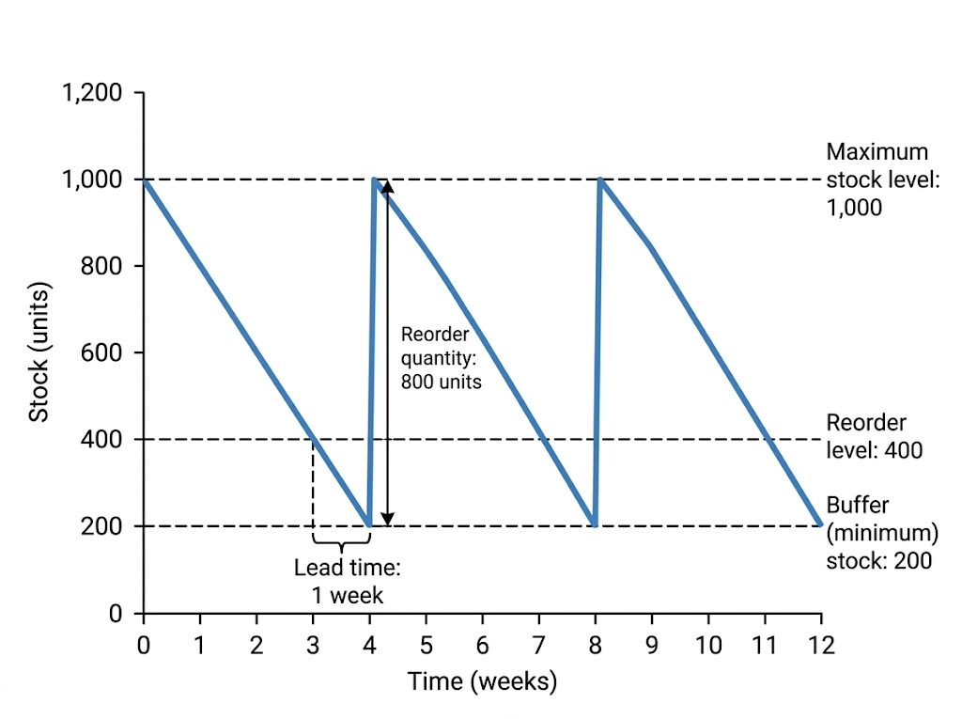  Stock falls as it is used, is reordered at 400 units, and is topped back up to 1,000 when the delivery arrives.

The Parts of a Bar Gate Stock Graph
Term | Meaning | On the graph
Maximum stock level | The most stock the business wants to hold | 1,000 units
Reorder level | The stock level at which a new order is placed | 400 units
Buffer (minimum) stock | The lowest level stock should fall to, kept for emergencies | 200 units
Reorder quantity | The amount ordered each time | 800 units
Lead time | The time between placing an order and it arriving | 1 week
Using the Graph
Work out what is used during the lead time.
The business uses 200 units a week and reorders when stock falls to 400 units. The lead time is 1 week. How much stock will be left when the delivery arrives, and what will stock be after the 800-unit delivery?

1. Stock used during the lead time
200 units a week × 1 week = 200 units
2. Stock left when the delivery arrives
400 - 200 = 200 units (the buffer stock)
3. Stock after the delivery
200 + 800 = 1,000 units (the maximum)
Answer: 200 units left; 1,000 units after the delivery.
PART TWO
Just-in-Time
Holding almost no stock at all.
Just-in-Time (JIT) Stock Control
ADVANTAGES | DISADVANTAGES
▸ Very little money tied up in stock.  ▸ Low storage, insurance and waste costs.  ▸ Less space needed, so smaller premises.  ▸ Stock is always fresh and up to date. | ▸ Production stops if a delivery is late.  ▸ Relies on very reliable suppliers.  ▸ Frequent small deliveries can cost more.  ▸ Cannot meet a sudden rise in demand.  ▸ Loses bulk-buying discounts.
How JIT Works
Just-in-time means ordering materials to arrive exactly when they are needed, and holding little or no stock.
▸ Frequent deliveries. Suppliers deliver small amounts often, sometimes several times a day.
▸ Close relationships. The business and its suppliers share production plans so deliveries arrive on time.
▸ Suits. Businesses with reliable suppliers nearby and predictable demand, such as car makers and supermarkets.
PART THREE
Choosing Suppliers
Procurement: finding and buying from the right suppliers.
Factors in Choosing a Supplier
Quality  Materials must be good enough to make a quality product; poor materials mean faults and complaints. | Delivery  The cost, speed and reliability of delivery - late deliveries stop production.
Availability  The supplier must be able to supply the quantities needed, when they are needed. | Cost  A lower price reduces the business's costs, but the cheapest is not always the best.
Trust
A reliable supplier with a good track record, who communicates honestly when problems arise.
Stock on the Shelves
Modern businesses track every item of stock with barcodes and software. The system can warn managers - or even order automatically - when stock reaches the reorder level. | 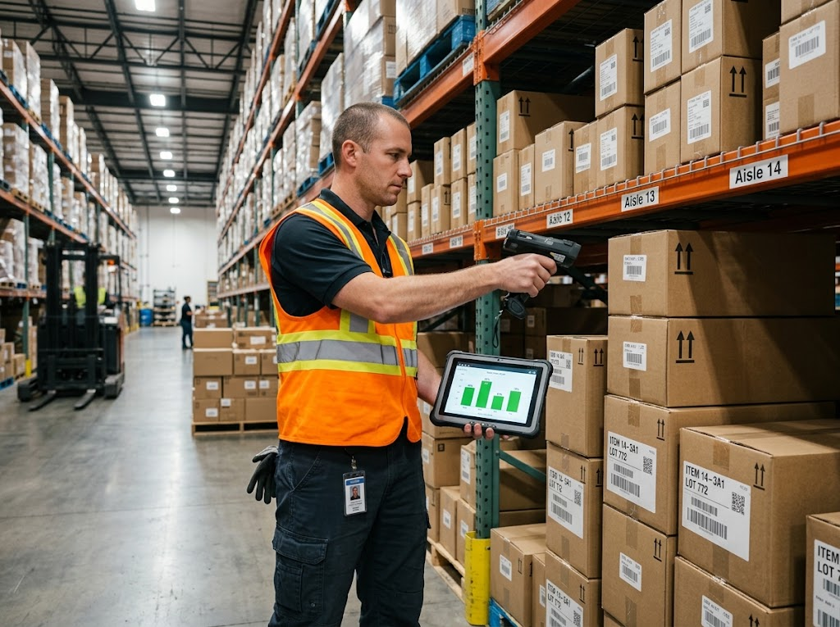  Barcode scanning keeps an exact, up-to-date record of stock.

The Effect of Supply Decisions
Logistics is the management of getting materials in and products out on time. Supply decisions affect the whole business.
▸ Costs. Cheaper suppliers and efficient deliveries reduce costs; unreliable ones cause expensive delays.
▸ Reputation. Poor-quality materials or unethical suppliers can damage the business's reputation.
▸ Customer satisfaction. Products in stock, of good quality and delivered on time keep customers happy and loyal.
Case Study
CASE STUDY
Toyota and the Chip Shortage
Toyota developed just-in-time production in Japan, and car makers around the world copied it. JIT kept their stock costs extremely low. But in 2021 a worldwide shortage of computer chips showed the risk. Modern cars need hundreds of chips, and car makers holding little stock could not get enough. Factories around the world, including in the UK, had to cut or stop production, and customers waited months for new cars. Many businesses began holding more buffer stock of key parts.

JIT  Developed by Toyota in Japan | 2021  A global chip shortage stops car production
Key Terms
Stock  Raw materials, components and finished goods held by a business. | Bar gate stock graph  A graph showing how stock levels rise and fall over time.
Reorder level  The stock level at which a new order is placed. | Buffer stock  The minimum stock kept for emergencies.
Lead time  The time between ordering stock and it arriving. | Just-in-time (JIT)  Ordering stock to arrive exactly when it is needed, holding little or none.
Procurement  Finding and buying the materials and services a business needs. | Logistics  Managing the movement of materials and products into and out of a business.
Your Task: Stock Detective
12 minutes
A café uses 50 bags of coffee beans a week. Its maximum stock is 300 bags, its reorder level is 150 bags, its buffer stock is 50 bags and the lead time is 2 weeks. Sketch the bar gate stock graph for 12 weeks. Then explain one risk if the supplier's lead time increased to 3 weeks.
1. Draw the graph with the levels labelled.
2. Mark the reorder point and delivery each time.
3. Explain the risk of a longer lead time.
A good answer shows: A correct saw-tooth graph with all levels labelled, and the risk that the café runs out - stock would fall to 0 before delivery.
Can I...?
☐ Explain why businesses manage stock.
☐ Read and label a bar gate stock graph.
☐ Calculate stock levels from a graph.
☐ Explain just-in-time.
☐ Give advantages and disadvantages of JIT.
☐ Explain the five factors in choosing a supplier.
☐ Explain how supply decisions affect costs, reputation and customer satisfaction.
Summary
✓ A bar gate stock graph shows maximum stock, reorder level, buffer stock, reorder quantity and lead time.
✓ JIT holds little stock, cutting costs, but relies on reliable suppliers.
✓ Suppliers are chosen on quality, delivery, availability, cost and trust.
✓ Supply decisions affect costs, reputation and customer satisfaction.

EXAM FOCUS
Explain one disadvantage to a business of using just-in-time stock control. (3 marks)
For bar gate graphs, read the numbers carefully off the axes and show your working. For JIT, link any answer to the reliability of suppliers.

