EDEXCEL GCSE BUSINESS · PAPER 2
Managing quality
Making operational decisions · Lesson 3 of 4
Last Lesson
Answer from memory before the answers appear.
1. What is buffer stock?
The minimum stock kept for emergencies.
2. What is just-in-time?
Ordering stock to arrive exactly when needed, holding little or none.
3. Name three factors in choosing a supplier.
Any three of: quality, delivery, availability, cost, trust.
4. What is lead time?
The time between ordering stock and it arriving.
Learning Objectives
1. Explain what quality means.
2. Explain quality control.
3. Explain quality assurance.
4. Explain the importance of quality in controlling costs and gaining competitive advantage.
What Is Quality?
A quality product meets or exceeds customers' expectations - and does so every time.
▸ Fit for purpose. It does what customers need it to do.
▸ Consistent. Every product is made to the same standard.
▸ Not the same as luxury. A cheap product can be high quality if it meets the expectations of customers who buy it.
▸ Services too. Quality applies to service - speed, friendliness and reliability.
Quality Control or Quality Assurance?
QUALITY CONTROL | QUALITY ASSURANCE
▸ Checking finished products for faults, usually at the end of production.  ▸ Done by specialist inspectors.  ▸ Faulty products are thrown away or reworked.  ▸ Finds problems after they have happened.  ▸ Can be wasteful: materials and time are lost on every faulty product. | ▸ Checking quality at every stage of production.  ▸ Every worker is responsible for their own work.  ▸ Aims to prevent faults happening in the first place.  ▸ Less waste, as faults are caught early.  ▸ Needs training, and staff who care about quality.
Checking Every Detail
Quality control inspectors check finished products, or a sample of them, before they are sent to customers. It stops faulty products reaching customers - but by the time a fault is found, the materials and time have already been used. | 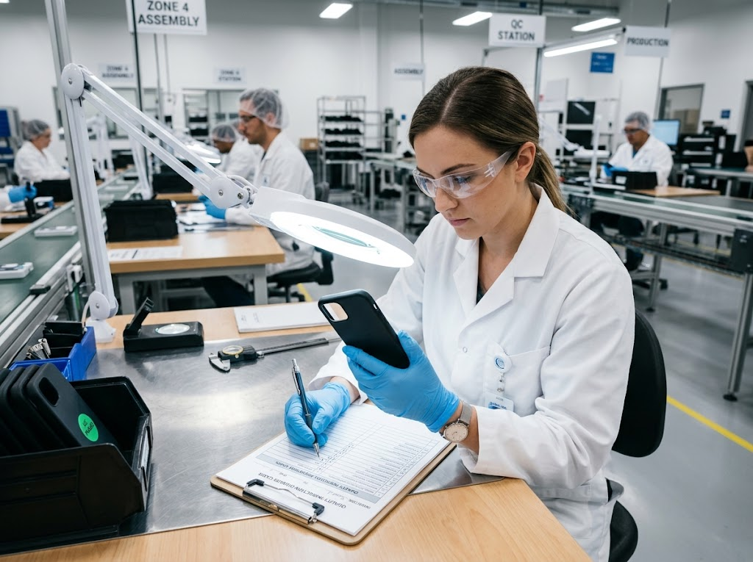  Quality control: inspecting finished products for faults.

PART ONE
Why Quality Matters
Quality is about costs as well as customers.
The Importance of Quality
Controlling costs  Fewer faulty products means less waste, fewer returns and less money spent fixing mistakes. | Competitive advantage  A reputation for quality helps a business stand out from rivals and win customers.
Premium prices  Customers will often pay more for a product they trust to be well made. | Customer loyalty  Customers who get good quality every time come back and recommend the business.
The Cost of Poor Quality
When quality fails, the costs mount up quickly.
▸ Waste. Faulty products must be scrapped or reworked.
▸ Returns and refunds. Customers return faulty goods and demand their money back.
▸ Product recalls. Dangerous faults can force a business to recall every product sold - extremely expensive.
▸ Reputation. Bad reviews and news stories drive customers away for years.
Case Study
CASE STUDY
The Galaxy Note 7 Recall
In August 2016 Samsung launched the Galaxy Note 7 smartphone. Within weeks, reports emerged of phones overheating and catching fire because of faulty batteries. Airlines banned the phone from flights. Samsung recalled millions of phones, and when replacement phones also caught fire, it stopped making the Note 7 altogether in October 2016. The failure cost Samsung billions of dollars and damaged its reputation - a clear example of how poor quality can cost far more than getting it right would have done.

2016  Galaxy Note 7 launched and recalled | Billions  The cost of the failure, in US dollars
Key Terms
Quality  Meeting or exceeding customers' expectations, consistently. | Quality control  Checking finished products for faults.
Quality assurance  Checking quality at every stage of production to prevent faults. | Product recall  When a business asks customers to return a product because it is faulty or dangerous.
Competitive advantage
Anything that makes a business more attractive to customers than its rivals.
Your Task: Build Quality In
12 minutes
A sandwich factory has had complaints about missing ingredients and wrong labels. Design a quality assurance system for it: list three checks at different stages of production, and explain how each would prevent the problem rather than just finding it.
1. One check when ingredients arrive.
2. One check during assembly.
3. One check at labelling.
4. How each prevents problems.
A good answer shows: Three checks at different stages (ingredients arriving, assembly, labelling) with each explained as preventing faults.
Can I...?
☐ Explain what quality means.
☐ Explain quality control.
☐ Explain quality assurance.
☐ Compare quality control and quality assurance.
☐ Explain how quality controls costs.
☐ Explain how quality gives a competitive advantage.
☐ Explain the costs of poor quality.
Summary
✓ Quality means meeting customers' expectations, every time.
✓ Quality control checks finished products; quality assurance builds quality into every stage.
✓ High quality controls costs and gives a competitive advantage.
✓ Poor quality brings waste, returns, recalls and damaged reputation.

EXAM FOCUS
Explain one benefit to a business of using quality assurance rather than quality control. (3 marks)
The difference is when quality is checked: control finds faults at the end, assurance prevents them throughout. Link your answer to costs or reputation.

