EDEXCEL GCSE BUSINESS · PAPER 2
Business calculations
Making financial decisions · Lesson 1 of 2
From Topic 1
Answer from memory before the answers appear.
1. How do you calculate revenue?
Price × quantity sold.
2. How do you calculate total costs?
Fixed costs + total variable costs.
3. How do you calculate profit?
Total revenue - total costs.
4. How do you calculate interest as a percentage?
(Total repayment - borrowed amount) ÷ borrowed amount × 100.
Learning Objectives
1. Calculate gross profit.
2. Calculate net profit.
3. Calculate the gross profit margin.
4. Calculate the net profit margin.
5. Interpret profit and profit margins to judge performance.
PART ONE
Gross and Net Profit
Two measures of profit, telling two different stories.
Gross Profit
Gross profit = sales revenue - cost of sales.
▸ Sales revenue. The money received from selling products.
▸ Cost of sales. The direct cost of making or buying the products that were sold - raw materials, stock bought to sell and production wages.
▸ What it shows. How much profit the business makes from its products, before paying for everything else.
▸ Example. Bright Bikes sells £500,000 of bikes. The bikes and parts it sold cost £300,000. Gross profit = £500,000 - £300,000 = £200,000.
Net Profit
Net profit = gross profit - other operating expenses and interest.
▸ Other operating expenses. The costs of running the business that are not part of cost of sales - rent, salaries of office staff, marketing, insurance and utilities.
▸ Interest. The cost of borrowing - interest paid on loans and overdrafts.
▸ What it shows. The true profit left for the owners after every cost has been paid.
▸ Example. Bright Bikes' other operating expenses are £120,000 and it pays £10,000 interest. Net profit = £200,000 - £120,000 - £10,000 = £70,000.
Bright Bikes Ltd: Income Statement
Item | £
Sales revenue | 500,000
Cost of sales | (300,000)
Gross profit | 200,000
Other operating expenses | (120,000)
Interest | (10,000)
Net profit | 70,000
Reading the Accounts
Revenue alone tells an owner little. Gross profit shows whether the business is buying and making its products at the right cost; net profit shows whether it is controlling everything else. The margins let the owner compare one year with another. | 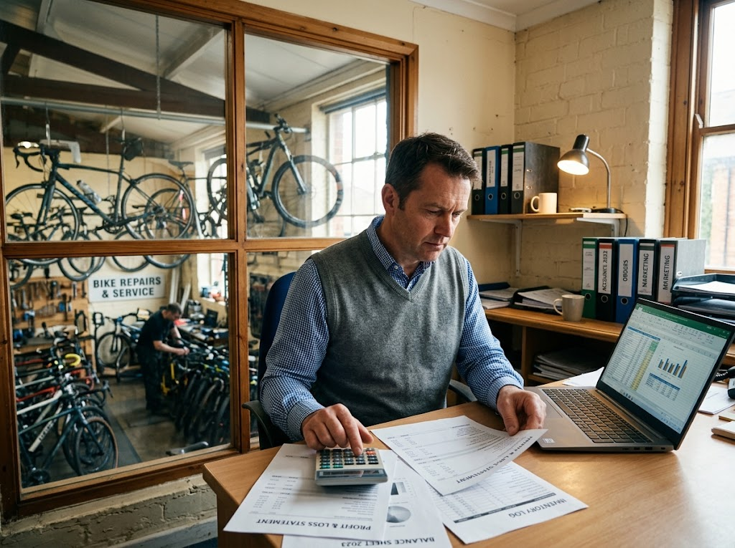  Gross profit, net profit and margins tell an owner how the business is really doing.

PART TWO
Profit Margins
Turning profit into a percentage.
Gross Profit Margin
Gross profit margin (%) = (gross profit ÷ sales revenue) × 100.
▸ What it shows. How many pence of gross profit the business makes from every £1 of sales.
▸ A higher margin. Means the business buys or makes its products cheaply compared with its selling price.
▸ How to improve it. Raise prices, or find cheaper suppliers and cut the cost of sales.
Bright Bikes' Gross Profit Margin
Divide, then multiply by 100.
Bright Bikes' gross profit is £200,000 and its sales revenue is £500,000. Calculate its gross profit margin.

1. Write the formula
GPM = (gross profit ÷ sales revenue) × 100
2. Put in the numbers
= (£200,000 ÷ £500,000) × 100
3. Work it out
= 0.4 × 100 = 40%
Answer: Gross profit margin = 40%
Net Profit Margin
Net profit margin (%) = (net profit ÷ sales revenue) × 100.
▸ What it shows. How many pence of net profit the business keeps from every £1 of sales, after all costs.
▸ A higher margin. Means the business controls its costs well.
▸ The gap between margins. A big gap between gross and net margin means operating expenses and interest are taking a large share - a sign to control overheads.
Bright Bikes' Net Profit Margin
Same method, using net profit.
Bright Bikes' net profit is £70,000 and its sales revenue is £500,000. Calculate its net profit margin.

1. Write the formula
NPM = (net profit ÷ sales revenue) × 100
2. Put in the numbers
= (£70,000 ÷ £500,000) × 100
3. Work it out
= 0.14 × 100 = 14%
Answer: Net profit margin = 14%
Bright Bikes at a Glance
£200,000  Gross profit | 40%  Gross profit margin | £70,000  Net profit | 14%  Net profit margin
Case Study
CASE STUDY
Supermarkets: Pennies in the Pound
The UK's big supermarkets sell billions of pounds of food and household goods every year, but their net profit margins are usually very low - often just a few pence of profit for every pound customers spend. Competition on price is fierce, so they keep prices low and make their profit through enormous sales volumes. A luxury brand, by contrast, may sell far less but keep a much larger share of every pound as profit. Comparing margins, not just profit in pounds, shows how differently businesses make their money.

Few pence  Net profit per £1 of sales at a typical UK supermarket | Volume  How supermarkets make their profit
Key Terms
Sales revenue  The money received from selling products. | Cost of sales  The direct cost of making or buying the products sold.
Gross profit  Sales revenue minus cost of sales. | Other operating expenses  Costs of running the business not included in cost of sales, such as rent and salaries.
Net profit  Gross profit minus other operating expenses and interest. | Gross profit margin  Gross profit as a percentage of sales revenue.
Net profit margin  Net profit as a percentage of sales revenue. | Income statement  A financial statement showing a business's revenue, costs and profit over a period.
Your Task: Run the Accounts
15 minutes
A sports shop has sales revenue of £250,000, cost of sales of £150,000, other operating expenses of £60,000 and interest of £5,000. Calculate its gross profit, net profit, gross profit margin and net profit margin. Then suggest one way to improve each margin.
1. Calculate gross profit.
2. Calculate net profit.
3. Calculate both margins.
4. Suggest improvements.
A good answer shows: Gross profit £100,000; net profit £35,000; GPM 40%; NPM 14%; a way to cut cost of sales or raise prices, and a way to cut overheads.
Can I...?
☐ Explain cost of sales.
☐ Calculate gross profit.
☐ Explain other operating expenses.
☐ Calculate net profit.
☐ Calculate gross profit margin.
☐ Calculate net profit margin.
☐ Read an income statement.
☐ Suggest how to improve margins.
Summary
✓ Gross profit = sales revenue - cost of sales.
✓ Net profit = gross profit - other operating expenses and interest.
✓ Gross profit margin = (gross profit ÷ sales revenue) × 100.
✓ Net profit margin = (net profit ÷ sales revenue) × 100.

EXAM FOCUS
Calculate the net profit margin for a business with net profit of £45,000 and sales revenue of £300,000. (2 marks)
Write the formula, show the division, give the answer with a % sign. Margins always divide by sales revenue - never by costs.

