EDEXCEL GCSE BUSINESS · PAPER 2
Organisational structures
Making human resource decisions · Lesson 1 of 4
Teacher copy - includes the notes for whoever is teaching from it.
From Making Financial Decisions
Answer from memory before the answers appear.
1. How do you calculate gross profit?
Sales revenue - cost of sales.
2. How do you calculate net profit margin?
(Net profit ÷ sales revenue) × 100.
3. What does ARR show?
Average annual profit from an investment as a percentage of its cost.
4. Give one limitation of financial data.
It looks backwards, ignores non-financial factors, or relies on forecasts.
Learning Objectives
1. Explain hierarchical and flat structures, span of control and chain of command.
2. Explain centralised and decentralised structures.
3. Explain the importance of effective communication and the barriers to it.
4. Explain different ways of working, and the effect of technology on them.
What Is an Organisational Structure?
An organisational structure shows how a business is organised: the roles, who is responsible for what, and who reports to whom.
▸ Organisation chart. A diagram showing the structure, with each role and the lines of authority between them.
▸ Levels of hierarchy. The number of layers of management from the top to the bottom.
▸ Chain of command. The line of authority through which instructions pass down and information passes up.
▸ Span of control. The number of employees who report directly to one manager.
PART ONE
Tall or Flat?
Two very different shapes.
Hierarchical and Flat Structures
The same number of staff can be organised in very different ways. A tall structure has many managers each looking after a few people; a flat structure has few managers each looking after many. | 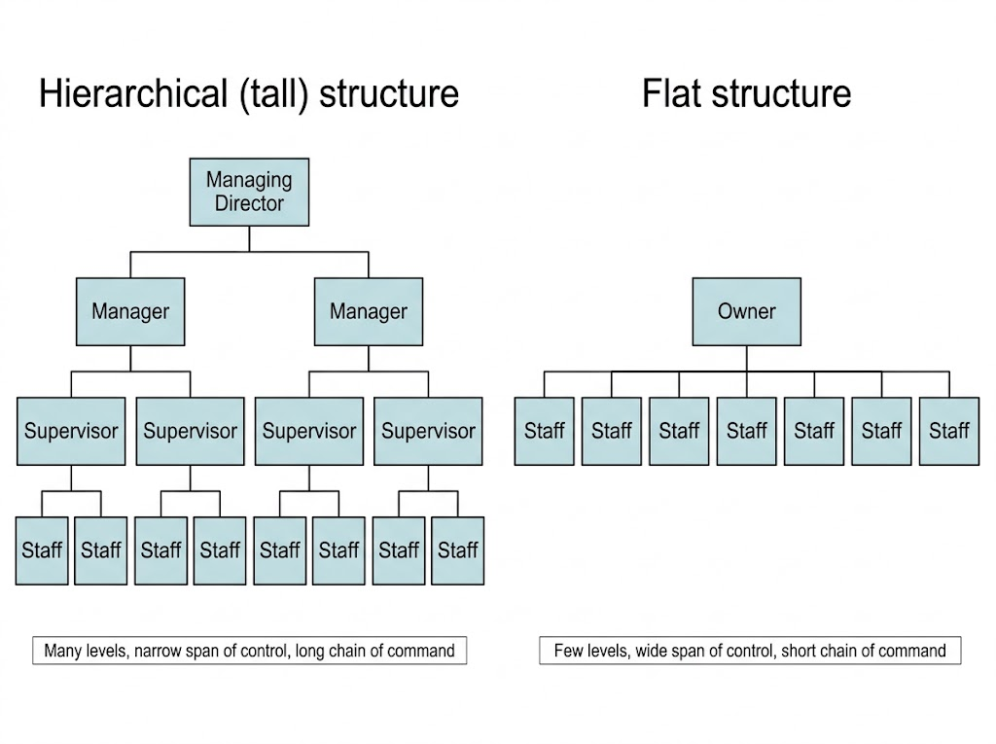  A tall structure has many levels and narrow spans of control; a flat structure has few levels and wide spans.

Hierarchical or Flat?
HIERARCHICAL (TALL) STRUCTURE | FLAT STRUCTURE
▸ Many levels of hierarchy.  ▸ Narrow span of control: managers supervise few staff closely.  ▸ Clear roles and promotion opportunities.  ▸ But: long chain of command, so communication and decisions are slow.  ▸ Many managers, so high wage costs. | ▸ Few levels of hierarchy.  ▸ Wide span of control: managers supervise many staff.  ▸ Fast communication and decisions.  ▸ Staff have more responsibility, which can motivate them.  ▸ But: managers may be overloaded, and there are fewer promotion opportunities.
PART TWO
Who Makes the Decisions?
Centralised or decentralised.
Centralised or Decentralised?
CENTRALISED | DECENTRALISED
▸ Decisions are made by a few senior managers at the top, often at head office.  ▸ Consistent decisions across the whole business.  ▸ Senior managers have experience and see the big picture.  ▸ But: slow, and head office may not understand local needs.  ▸ Staff lower down may feel undervalued. | ▸ Decision-making is passed down to managers in branches or departments.  ▸ Faster decisions that suit local customers.  ▸ Staff feel trusted, which motivates them.  ▸ But: decisions may be inconsistent between branches.  ▸ Local managers may lack experience.
PART THREE
Communication
Getting the message through.
The Importance of Effective Communication
Effective communication means the right message reaches the right people at the right time and is understood.
▸ Why it matters. Staff know what to do, mistakes are avoided, and customers are served well.
▸ Motivation. Staff who are kept informed and listened to feel valued.
▸ Too little communication. Staff do not know what is expected, leading to mistakes and poor morale.
▸ Too much communication. Information overload: important messages are lost among hundreds of emails.
Barriers to Communication
Too many levels  In a tall structure, messages pass through many people and can be delayed or changed. | Language and jargon  Technical terms or a different language can confuse the receiver.
Distance and technology  Staff in different places, or technology that fails, make communication harder. | Attitudes  Staff who distrust managers, or managers who do not listen, block communication.
PART FOUR
Different Ways of Working
Not everyone works nine to five.
Ways of Working
Type | Meaning | Benefit to the business
Full-time | Working a full working week, often around 35-40 hours | Staff are always available and committed
Part-time | Working fewer hours than full-time | Covers busy periods cheaply; attracts people who cannot work full-time
Flexible hours | Staff choose when they work, within limits | Motivates staff and helps retain them
Permanent | A contract with no end date | Loyal, experienced staff
Temporary | A contract for a fixed period | Covers busy seasons or absences without a long-term cost
Freelance | Self-employed people hired for specific jobs | Specialist skills only when needed
Technology and Ways of Working
Technology has changed how, when and where people work.
▸ Remote working. Laptops, video calls and cloud software let staff work from home, cutting office costs.
▸ Efficiency. Software and automation speed up tasks and reduce mistakes.
▸ Flexible working. Staff can work at different times and still stay connected.
▸ Drawbacks. Isolation, harder teamwork, and staff who never switch off from work.
Working from Anywhere
Video calls and cloud software mean many office jobs can now be done from anywhere. Businesses save on office space and can hire people who live far away - but have to work harder to keep teams communicating well. |   Technology lets staff work from home and stay connected.

Case Study
CASE STUDY
Timpson: Upside-down Management
Timpson, the shoe repair and key-cutting chain, runs what it calls "upside-down management" - a highly decentralised approach. Staff in each shop are trusted to run it their own way: they set their own prices for some jobs, decide how to serve customers and can spend up to £500 to settle a customer complaint without asking head office. Head office exists to support the shops rather than to control them. Timpson believes staff who are trusted give better service, and the business is well known for its customer service and staff loyalty.

£500  What shop staff can spend to settle a complaint | Decentralised  Decisions made in each shop, not at head office
Key Terms
Organisational structure  How a business is organised: its roles, responsibilities and lines of authority. | Hierarchy  The levels of management in a business.
Chain of command  The line of authority from the top to the bottom of a business. | Span of control  The number of employees who report directly to one manager.
Centralised  Decisions are made by senior managers at the top. | Decentralised  Decision-making is passed down to managers and staff lower down.
Freelance  Self-employed and hired for specific jobs. | Remote working  Working away from the business's premises, often from home.
Your Task: Restructure the Business
15 minutes
A chain of 20 cafés has a tall, centralised structure: every decision - from menu changes to staff rotas - is made at head office. Customers complain that cafés are slow to respond to problems. Recommend changes to the structure, and explain one benefit and one risk of your changes.
1. Recommend changes.
2. Explain one benefit.
3. Explain one risk.
A good answer shows: A move towards a flatter, more decentralised structure, with a benefit (faster, local decisions; motivated managers) and a risk (inconsistency, inexperienced managers).
Note: The best answers mention span of control and chain of command explicitly.
Can I...?
☐ Explain span of control and chain of command.
☐ Compare hierarchical and flat structures.
☐ Compare centralised and decentralised structures.
☐ Explain why effective communication matters.
☐ Explain barriers to communication.
☐ Explain full-time, part-time and flexible working.
☐ Explain permanent, temporary and freelance contracts.
☐ Explain the effect of technology on ways of working.
Summary
✓ Tall structures: many levels, narrow spans, slow communication. Flat structures: few levels, wide spans, fast communication.
✓ Centralised: decisions at the top. Decentralised: decisions passed down.
✓ Effective communication avoids mistakes and motivates staff; barriers include levels, jargon, distance and attitudes.
✓ Ways of working: full-time, part-time, flexible, permanent, temporary, freelance - changed by technology.

EXAM FOCUS
Explain one disadvantage to a business of having a hierarchical structure. (3 marks)
Use the key terms - span of control, chain of command, levels of hierarchy - and link them to speed of decisions, communication or costs.
Exam Practice: Organisational Structures
Answer all questions. Use the context of the business in the question where one is given. · 20 minutes
▸ Question 1 · 1 mark · Define. Define the term 'span of control'.
▸ Question 2 · 2 marks · Outline. Outline one benefit to a business of employing freelance workers.
▸ Question 3 · 3 marks · Explain. Explain one disadvantage to a business of having a hierarchical structure.
▸ Question 4 · 6 marks · Analyse. Analyse the impact of decentralisation on Nova Fitness PLC.
Question 1 · 1 mark · Define
“Define the term 'span of control'.”
HOW TO ANSWER IT Command word: Define. Worth 1 mark, so plan before writing.
Question 1 · mark scheme
1 mark available. Award a mark for each point made.
▸ Number of subordinates directly responsible to a manager. 1 mark
▸ Model answer. The number of employees who report directly to one manager.
Question 2 · 2 marks · Outline
“Outline one benefit to a business of employing freelance workers.”
HOW TO ANSWER IT Command word: Outline. Worth 2 marks, so plan before writing.
Question 2 · mark scheme
2 marks available. Award a mark for each point made.
▸ A benefit identified. 1 mark
▸ Developed. 1 mark
▸ Model answer. The business only pays for specialist skills when it needs them (1), so it avoids the cost of employing a full-time specialist all year (1).
Question 3 · 3 marks · Explain
“Explain one disadvantage to a business of having a hierarchical structure.”
HOW TO ANSWER IT Command word: Explain. Worth 3 marks, so plan before writing.
Question 3 · mark scheme
3 marks available. Award a mark for each point made.
▸ A disadvantage identified, e.g. slow communication / high cost of managers / staff feel distant. 1 mark
▸ First linked point of explanation. 1 mark
▸ Second linked point of explanation. 1 mark
▸ Model answer. Communication can be slow (1). Messages must pass down a long chain of command through many levels of management (1). This means decisions take longer and messages can be changed along the way, so the business may respond slowly to customers (1).
Question 4 · 6 marks · Analyse
“Analyse the impact of decentralisation on Nova Fitness PLC.”
— Nova Fitness PLC runs 60 gyms. Until now all decisions have been made at head office. It plans to decentralise, letting each gym manager decide on class timetables, local…
HOW TO ANSWER IT Command word: Analyse. Worth 6 marks, so plan before writing.
Question 4 · mark scheme
6 marks available. Award a mark for each point made.
▸ AO2 (Application, 3 marks): uses the context - 60 gyms, timetables, promotions, rotas. Level 1-3
▸ AO3a (Analysis, 3 marks): chains of reasoning about benefits and drawbacks. Level 1-3
▸ Model answer. Decentralisation would let each gym manager respond to local customers. A manager knows which classes are popular in their area and when members want to train, so timetables and promotions can be better suited to local demand, which could increase memberships. Managers given more responsibility are also likely to feel trusted and motivated, improving their performance. However, with 60 managers making their own decisions, gyms may become inconsistent - different standards and promotions could confuse customers and weaken the Nova brand. Some managers may also lack the experience to make good decisions, so head office would need to invest in training them.

