EDEXCEL GCSE MATHS · HIGHER TIER
Surds
Number · Lesson 7 of 7
Teacher copy - includes the notes for whoever is teaching from it.
Last Lesson and Before
Answer each one, then check.
1. What is √36?
6
2. What is √4 × √9?
2 × 3 = 6 - the same as √36.
3. Expand 3(x + 2).
3x + 6
4. Last lesson: write 4 × 10³ as an ordinary number.
4000
5. Which of these is a whole number: √16 or √17?
√16 = 4. √17 is not a whole number.
Learning Objectives
1. Know what rational and irrational numbers are, and what a surd is.
2. Simplify surds such as √72.
3. Multiply, divide, add and subtract surds.
4. Expand brackets containing surds.
5. Rationalise the denominator of a fraction such as 6/(√3).
What Is a Surd?
A surd is a root that cannot be written exactly as a fraction or a terminating or recurring decimal.
▸ Rational numbers. Can be written as a fraction of two integers: ¾, −7, 0.6, √25 = 5.
▸ Irrational numbers. Cannot: √2 = 1.414 213 56…, π= 3.141 592 65… The decimals never end and never repeat.
▸ Surds. Roots that are irrational: √2, √10, ∛5. √9 is not a surd, because √9 = 3.
▸ Why use them. √2 is exact; 1.414 is not. When a question says "give your answer in surd form", it wants the exact answer.
Rational or Irrational?
RATIONAL | IRRATIONAL
▸ ¾  ▸ 0.666…= ⅔  ▸ √25 = 5  ▸ −7  ▸ √(4/9) = ⅔ | ▸ √2  ▸ √10  ▸ π  ▸ ∛5  ▸ 1 + √3
The Rules for Surds
Roots can be split up and combined when multiplying and dividing - but not when adding.
▸ Multiplying. √a × √b = √ab. √2 × √8 = √16 = 4.
▸ Dividing. √a/(√b) = √(a/b). √50/(√2) = √25 = 5.
▸ A surd times itself. √a × √a = a. √7 × √7 = 7.
▸ Not for adding. √(a + b) is NOT √a + √b: √(9 + 16) = √25 = 5, but √9 + √16 = 7.
Surds in Right-Angled Triangles
Surds turn up all the time in geometry. A right-angled triangle with shorter sides 1 and 1 has a hypotenuse of exactly √2 - a length you can draw perfectly but never write exactly as a decimal. | 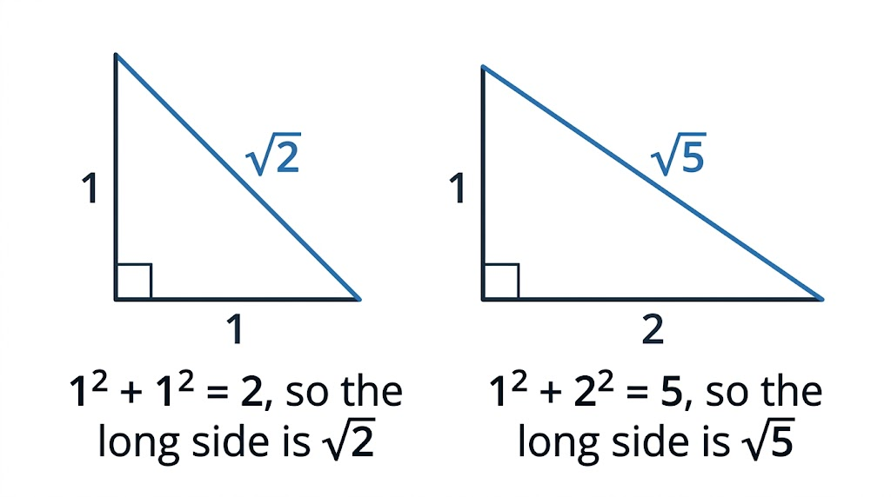  The long side of a right-angled triangle is often a surd.

PART ONE
Simplifying Surds
Take out the biggest square factor.
Simplifying a Surd
Simplify √72

1. Find the largest square number that is a factor of 72
Square numbers: 4, 9, 16, 25, 36 ... and 36 × 2 = 72
2. Split the root
√72 = √36 × √2
3. Work out the square root
√36 = 6
Answer: √72 = 6√2
Adding Surds
Simplify √50 + √18

1. Simplify each surd
√50 = √25 × √2 = 5√2 and √18 = √9 × √2 = 3√2
2. They are now "like surds" - both multiples of √2
5√2 + 3√2
3. Add them like algebra: 5x + 3x = 8x
8√2
Answer: 8√2
Expanding Brackets with Surds
Expand and simplify (3 + √2)(5 − √2)

1. First times first
3 × 5 = 15
2. Outer and inner
3 × (−√2) = −3√2 and √2 × 5 = 5√2
3. Last times last
√2 × (−√2) = −2
4. Collect like terms
15 − 2 = 13 and −3√2 + 5√2 = 2√2
Answer: 13 + 2√2
PART TWO
Rationalising the Denominator
Getting the surd out of the bottom of a fraction.
Rationalising the Denominator
To rationalise a fraction like a/(√b), multiply the top AND the bottom by √b.
▸ Why it works. Multiplying top and bottom by the same number does not change a fraction's value, and √b × √b = b removes the surd from the bottom.
▸ Example. 6/(√3) = (6 × √3)/(√3 × √3) = 6√3/3 = 2√3.
▸ Always simplify. Cancel any common factors, and simplify any surd left on top.
▸ Exam wording. "Rationalise the denominator" and "give your answer in the form a√b" both mean do this.
Rationalising
Rationalise the denominator of 10/(√5). Give your answer in its simplest form.

1. Multiply the top and the bottom by √5
(10 × √5)/(√5 × √5)
2. The bottom becomes a whole number
√5 × √5 = 5
3. So
10√5/5
4. Simplify
10 ÷ 5 = 2
Answer: 2√5
Case Study
CASE STUDY
A4 Paper and the Square Root of 2
Every A-size sheet of paper - A3, A4, A5 - has its long side √2 times its short side. That is the one shape that stays exactly the same when you fold it in half: halve the long side of a sheet with sides 1 and √2 and you get sides √2/2 and 1, which is the same shape again. It is why an A4 page shrinks perfectly onto A5 on a photocopier. An A4 sheet is 210 mm by 297 mm, and 297 ÷ 210 = 1.414…, which is √2 to the nearest millimetre.

210 × 297 mm  The size of an A4 sheet | 1 : √2  The ratio of the sides of every A-size sheet
Folding A-Size Paper
Halving an A-size sheet always makes the next size down, with exactly the same shape. The ratio of the sides is 1 : √2 at every size - a surd you use every day. | 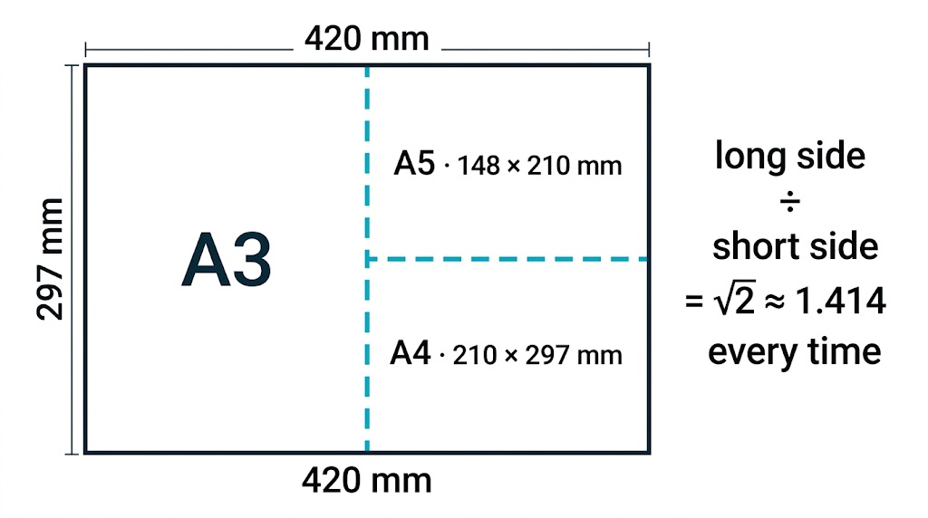  Fold A3 in half and you get A4; fold A4 in half and you get A5.

Key Terms
Rational number  A number that can be written as a fraction of two integers. | Irrational number  A number that cannot be written as a fraction; its decimal never ends or repeats.
Surd  A root that is irrational, such as √2 or √10. | Like surds  Multiples of the same surd, such as 5√2 and 3√2, which can be added and subtracted.
Simplest form  A surd with the largest possible square number taken out, e.g. 6√2. | Rationalise the denominator  Rewrite a fraction so there is no surd on the bottom.
Your Task: Surd Simplifying Race
12 minutes
Simplify each. (a) √12 (b) √45 (c) √200 (d) √8 + √32 (e) √75 − √27 (f) √3 × √15 (g) (1 + √3)² (h) 12/(√6)
1. Look for the largest square factor.
2. Simplify before adding or subtracting.
3. Rationalise any surd in the denominator.
A good answer shows: (a) 2√3 (b) 3√5 (c) 10√2 (d) 2√2 + 4√2 = 6√2 (e) 5√3 − 3√3 = 2√3 (f) √45 = 3√5 (g) 1 + 2√3 + 3 = 4 + 2√3 (h) 12√6/6 = 2√6
Note: Part (g) catches students who square each term separately and get 1 + 3 = 4. Expand it as two brackets.
Can I...?
☐ Explain what a surd is.
☐ Say whether a number is rational or irrational.
☐ Simplify a surd such as √72.
☐ Multiply and divide surds.
☐ Add and subtract like surds.
☐ Expand brackets containing surds.
☐ Rationalise a denominator like a/(√b).
☐ Give an exact answer in surd form.
Summary
✓ A surd is an irrational root, and gives an exact value.
✓ √ab = √a × √b: take out the largest square factor to simplify.
✓ Only like surds can be added or subtracted.
✓ Rationalise a/(√b) by multiplying the top and the bottom by √b.

EXAM FOCUS
Rationalise the denominator of 12/(√3). Give your answer in its simplest form. (2 marks)
"Exact" or "surd form" means do not use a decimal. Leave the root in the answer and simplify it as far as it goes.
Exam Practice: Surds
Answer all questions. Show your working. All questions are non-calculator. · 25 minutes
▸ Question 1 · 1 mark · Non-calculator. Write √45 in the form k√5, where k is an integer.
▸ Question 2 · 2 marks · Non-calculator. Rationalise the denominator of 12/(√3). Give your answer in its simplest form.
▸ Question 3 · 3 marks · Non-calculator. Expand and simplify (2 + √3)(4 − √3). Give your answer in the form a + b√3, where a and b are integers.
▸ Question 4 · 3 marks · Non-calculator · Show that. Show that √98 + √8 = 9√2
▸ Question 5 · 3 marks · Non-calculator. The diagram shows the right-angled triangle ABC. AB = √5 cm and BC = √11 cm. Work out the length of AC.
▸ Question 6 · 3 marks · Non-calculator. A rectangle has length (3 + √5) cm and width (3 − √5) cm. Work out the area of the rectangle.
Question 1 · 1 mark · Non-calculator
“Write √45 in the form k√5, where k is an integer.”
HOW TO ANSWER IT Command word: Non-calculator. Worth 1 mark, so plan before writing.
Question 1 · mark scheme
1 mark available. Award a mark for each point made.
▸ 3√5. B1
▸ Model answer. √45 = √9 × √5 = 3√5
Question 2 · 2 marks · Non-calculator
“Rationalise the denominator of 12/(√3). Give your answer in its simplest form.”
HOW TO ANSWER IT Command word: Non-calculator. Worth 2 marks, so plan before writing.
Question 2 · mark scheme
2 marks available. Award a mark for each point made.
▸ Multiplying the top and the bottom by √3. M1
▸ 4√3. A1
▸ Model answer. 12/(√3) × √3/(√3) = 12√3/3 = 4√3
Question 3 · 3 marks · Non-calculator
“Expand and simplify (2 + √3)(4 − √3). Give your answer in the form a + b√3, where a and b are integers.”
HOW TO ANSWER IT Command word: Non-calculator. Worth 3 marks, so plan before writing.
Question 3 · mark scheme
3 marks available. Award a mark for each point made.
▸ At least 3 of the 4 terms correct: 8, −2√3, 4√3, −3. M1
▸ All 4 terms correct. M1
▸ 5 + 2√3. A1
▸ Model answer. 8 − 2√3 + 4√3 − 3 = 5 + 2√3
Question 4 · 3 marks · Non-calculator · Show that
“Show that √98 + √8 = 9√2”
HOW TO ANSWER IT Command word: Non-calculator · Show that. Worth 3 marks, so plan before writing.
Question 4 · mark scheme
3 marks available. Award a mark for each point made.
▸ √98 = 7√2 or √8 = 2√2. M1
▸ Both simplified correctly. M1
▸ Correctly added to reach 9√2. A1
▸ Model answer. √98 = √49 × √2 = 7√2. √8 = √4 × √2 = 2√2. 7√2 + 2√2 = 9√2.
Question 5 · 3 marks · Non-calculator
The diagram shows the right-angled triangle ABC. AB = √5 cm and BC = √11 cm. Work out the length of AC. (3 marks) | 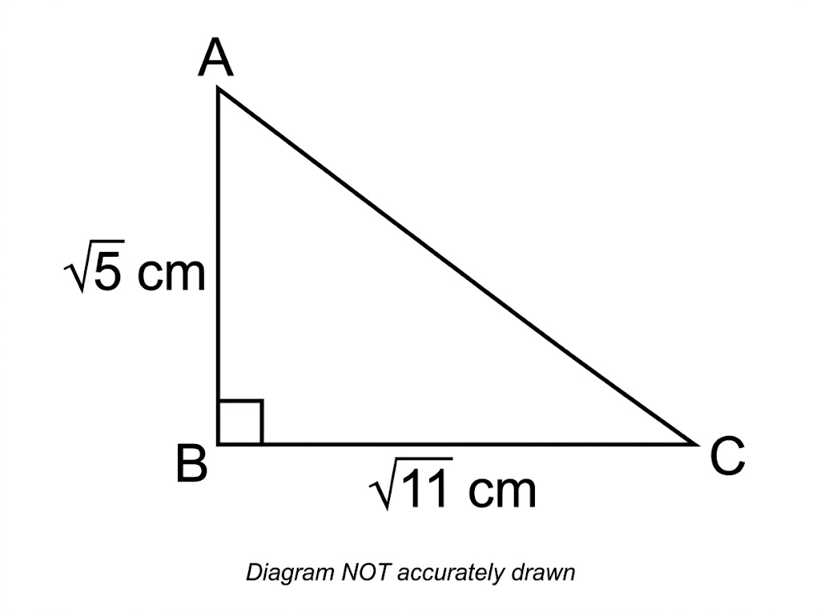

Question 5 · mark scheme
3 marks available. Award a mark for each point made.
▸ (√5)² + (√11)² or 5 + 11. M1
▸ √16. M1
▸ 4 (cm). A1
▸ Model answer. AC² = (√5)² + (√11)² = 5 + 11 = 16, so AC = √16 = 4 cm.
Question 6 · 3 marks · Non-calculator
“A rectangle has length (3 + √5) cm and width (3 − √5) cm. Work out the area of the rectangle.”
HOW TO ANSWER IT Command word: Non-calculator. Worth 3 marks, so plan before writing.
Question 6 · mark scheme
3 marks available. Award a mark for each point made.
▸ Area = (3 + √5)(3 − √5). M1
▸ At least 3 of the 4 terms correct: 9, −3√5, +3√5, −5. M1
▸ 4 (cm²). A1
▸ Model answer. (3 + √5)(3 − √5) = 9 − 3√5 + 3√5 − 5 = 4 cm²

