EDEXCEL GCSE MATHS · FOUNDATION & HIGHER
Equations
Algebra · Lesson 3 of 7
Teacher copy - includes the notes for whoever is teaching from it.
Last Lesson and Before
Answer each one, then check.
1. Solve x + 7 = 12.
x = 5
2. What is the inverse of "multiply by 4"?
Divide by 4.
3. Work out −6 ÷ 2.
−3
4. Last lesson: expand 3(x − 2).
3x − 6
5. Last lesson: factorise 6x + 9.
3(2x + 3)
Learning Objectives
1. Solve linear equations with the unknown on both sides.
2. Solve equations with brackets.
3. Solve equations with fractions.
4. Form equations from words and diagrams.
5. Solve problems by forming and solving an equation.
Keeping the Balance
An equation says two things are equal. Solving it means finding the value of the letter that makes it true.
▸ Same on both sides. Add, subtract, multiply or divide both sides by the same thing, and the equation stays true.
▸ Inverse operations. Undo + with −, and × with ÷.
▸ One step at a time. Write each step on a new line, with the = signs lined up.
▸ Check. Put your answer back into the original equation. Both sides should give the same number.
An Equation Is a Balance
The scales stay level as long as you do the same thing to both pans. Take 2 counters off each side and 3 bags balance 9 counters; share them out and each bag must hold 3. That is exactly how you solve 3x + 2 = 11. | 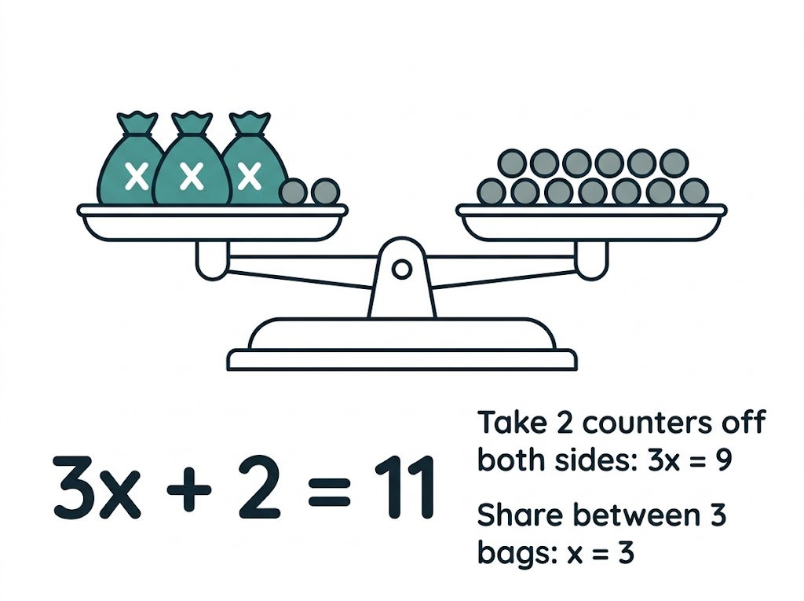  3x + 2 = 11: take 2 from both sides, then divide by 3.

A Method for Any Linear Equation
Not every equation needs every step - skip the ones that do not apply.
1  Brackets  Expand any brackets. | 2  Fractions  Multiply both sides to clear any fractions. | 3  Letters  Collect the letter terms on the side with more of them. | 4  Numbers  Collect the numbers on the other side. | 5  Divide  Divide by the number in front of the letter.
The Unknown on Both Sides
Solve 5x − 7 = 2x + 11

1. Subtract 2x from both sides (there are more xs on the left)
3x − 7 = 11
2. Add 7 to both sides
3x = 18
3. Divide both sides by 3
x = 6
4. Check: both sides give 23
5(6) − 7 = 23 and 2(6) + 11 = 23
Answer: x = 6
Equations with Brackets
Solve 3(2x − 1) = 4(x + 5)

1. Expand both brackets
6x − 3 = 4x + 20
2. Subtract 4x from both sides
2x − 3 = 20
3. Add 3 to both sides
2x = 23
4. Divide by 2
x = 11.5
Answer: x = 11.5 (or 23/2)
Equations with Fractions
Solve (2x + 1)/3 = (x − 2)/2

1. Multiply both sides by 3 and by 2 (by 6)
2(2x + 1) = 3(x − 2)
2. Expand
4x + 2 = 3x − 6
3. Subtract 3x
x + 2 = −6
4. Subtract 2
x = −8
5. Check: both sides give −5
(−16 + 1)/3 = −5 and (−8 − 2)/2 = −5
Answer: x = −8
Two Fractions on One Side
Solve x/4 + x/6 = 5

1. The lowest common multiple of 4 and 6 is 12: multiply every term by 12
3x + 2x = 60
2. Collect like terms
5x = 60
3. Divide by 5
x = 12
Answer: x = 12
PART TWO
Forming Equations
Turning words and diagrams into algebra.
From Words to an Equation
Four steps turn a problem into an equation you can solve.
▸ Choose a letter. Let x be the thing you do not know - say exactly what it stands for.
▸ Write expressions. Write everything else in terms of x.
▸ Make an equation. Use the fact the question gives you: a total, a perimeter, angles adding to 180°.
▸ Answer the question. Solve for x, then use it to find what the question actually asked for.
A Perimeter Problem
A rectangle has length (3x + 2) cm and width (x − 1) cm. Its perimeter is 42 cm. Find the length and the width.

1. Perimeter = 2 lengths + 2 widths
2(3x + 2) + 2(x − 1) = 42
2. Expand
6x + 4 + 2x − 2 = 42
3. Simplify
8x + 2 = 42
4. Solve
8x = 40, so x = 5
5. Answer the question
Length = 3(5) + 2 = 17, width = 5 − 1 = 4
Answer: Length 17 cm, width 4 cm (check: 2 × 17 + 2 × 4 = 42)
A Word Problem
An adult cinema ticket costs £4 more than a child ticket. Two adult tickets and three child tickets cost £38. Find the price of each ticket.

1. Let a child ticket cost £x
An adult ticket costs £(x + 4)
2. Write the equation
2(x + 4) + 3x = 38
3. Expand and simplify
2x + 8 + 3x = 38, so 5x + 8 = 38
4. Solve
5x = 30, so x = 6
Answer: Child £6, adult £10 (check: 2 × 10 + 3 × 6 = 38)
Key Terms
Equation  A statement that two expressions are equal, true for particular values of the letter. | Solve  Find the value of the letter that makes the equation true.
Solution  The value that makes the equation true. | Inverse operation  The operation that undoes another: − undoes +, ÷ undoes ×.
Linear equation
An equation where the highest power of the letter is 1.
Your Task: Equation Relay
15 minutes
Solve each equation; each answer is used in the next. (a) 4x + 3 = 23. (b) Let a be your answer to (a): solve 2y − a = y + 1. (c) Let b be your answer to (b): solve 3(z − 2) = b + z. (d) Let c be your answer to (c): solve w/2 + w/3 = c + 1.
1. Solve each equation in turn.
2. Check each answer before passing it on.
3. The first team with a correct (d) wins.
A good answer shows: (a) x = 5 (b) y = 6 (c) 3z − 6 = 6 + z, so z = 6 (d) 5w/6 = 7, so w = 8.4
Note: A wrong answer anywhere carries through - which makes checking each answer by substitution worthwhile.
Can I...?
☐ Solve two-step equations.
☐ Solve equations with the unknown on both sides.
☐ Solve equations with brackets.
☐ Solve equations with one fraction.
☐ Solve equations with two fractions.
☐ Check a solution by substituting.
☐ Form an equation from words.
☐ Form an equation from a diagram.
Summary
✓ Do the same to both sides to keep the equation balanced.
✓ Expand brackets, clear fractions, collect letters, collect numbers, divide.
✓ Clear fractions by multiplying every term by the LCM of the denominators.
✓ For word problems: choose a letter, write expressions, form an equation, then answer the question asked.

EXAM FOCUS
Solve 4(3 − 2x) = 2(x + 11) (3 marks)
Write each step on a new line. If the final answer is wrong, the method marks for expanding and collecting terms are still there to win.
Exam Practice: Equations
Answer all questions. Show your working. Questions 1 to 4 are non-calculator. · 25 minutes
▸ Question 1 · 2 marks · Non-calculator. Solve 7x + 4 = 3x − 12
▸ Question 2 · 3 marks · Non-calculator. Solve 4(3 − 2x) = 2(x + 11)
▸ Question 3 · 3 marks · Non-calculator. Solve (5x − 2)/3 = (x + 4)/2
▸ Question 4 · 4 marks · Non-calculator. The diagram shows a triangle. The sizes of its angles, in degrees, are 2x + 10, 3x − 5 and x + 25. Work out the size of the largest angle.
▸ Question 5 · 4 marks · Calculator. Amy is 3 times as old as Ben. In 8 years' time, Amy will be twice as old as Ben. How old is Amy now?
Question 1 · 2 marks · Non-calculator
“Solve 7x + 4 = 3x − 12”
HOW TO ANSWER IT Command word: Non-calculator. Worth 2 marks, so plan before writing.
Question 1 · mark scheme
2 marks available. Award a mark for each point made.
▸ 4x = −16, or a correct first step collecting x terms or numbers. M1
▸ x = −4. A1
▸ Model answer. 4x = −16, so x = −4
Question 2 · 3 marks · Non-calculator
“Solve 4(3 − 2x) = 2(x + 11)”
HOW TO ANSWER IT Command word: Non-calculator. Worth 3 marks, so plan before writing.
Question 2 · mark scheme
3 marks available. Award a mark for each point made.
▸ Both brackets expanded correctly. M1
▸ Correctly collects x terms on one side and numbers on the other. M1
▸ x = −1. A1
▸ Model answer. 12 − 8x = 2x + 22, so −10 = 10x and x = −1.
Question 3 · 3 marks · Non-calculator
“Solve (5x − 2)/3 = (x + 4)/2”
HOW TO ANSWER IT Command word: Non-calculator. Worth 3 marks, so plan before writing.
Question 3 · mark scheme
3 marks available. Award a mark for each point made.
▸ Multiplies both sides to clear the fractions, e.g. 2(5x − 2) = 3(x + 4). M1
▸ 7x = 16. M1
▸ x = 16/7 (or 22/7). A1
▸ Model answer. 2(5x − 2) = 3(x + 4), so 10x − 4 = 3x + 12, 7x = 16 and x = 16/7.
Question 4 · 4 marks · Non-calculator
The diagram shows a triangle. The sizes of its angles, in degrees, are 2x + 10, 3x − 5 and x + 25. Work out the size of the largest angle. (4 marks) | 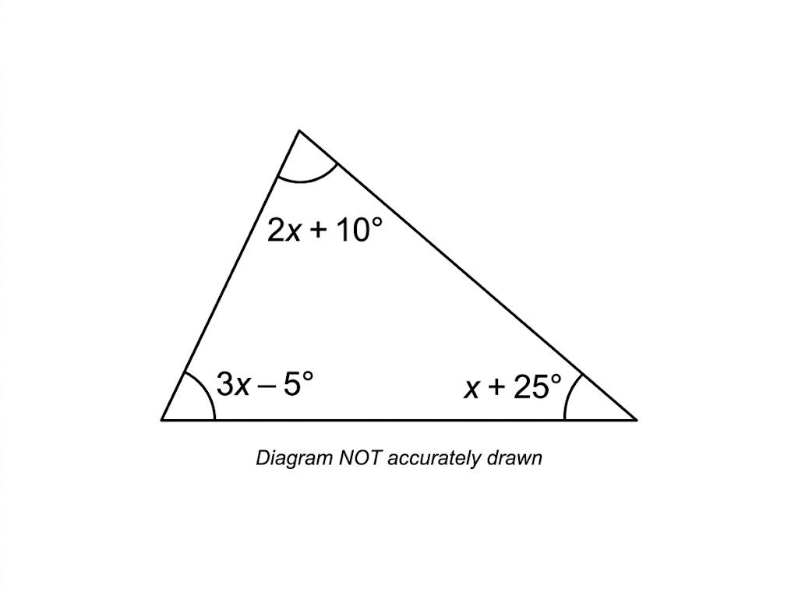

Question 4 · mark scheme
4 marks available. Award a mark for each point made.
▸ Sets the sum of the angles equal to 180. P1
▸ 6x + 30 = 180. P1
▸ x = 25. P1
▸ 70°. A1
▸ Model answer. (2x + 10) + (3x − 5) + (x + 25) = 180, so 6x + 30 = 180, 6x = 150 and x = 25. The angles are 60°, 70° and 50°. The largest angle is 70°.
Question 5 · 4 marks · Calculator
“Amy is 3 times as old as Ben. In 8 years' time, Amy will be twice as old as Ben. How old is Amy now?”
HOW TO ANSWER IT Command word: Calculator. Worth 4 marks, so plan before writing.
Question 5 · mark scheme
4 marks available. Award a mark for each point made.
▸ Ben = b and Amy = 3b, or equivalent. P1
▸ 3b + 8 = 2(b + 8). P1
▸ b = 8. P1
▸ Amy is 24. A1
▸ Model answer. Let Ben be b. Amy is 3b. In 8 years: 3b + 8 = 2(b + 8), so 3b + 8 = 2b + 16 and b = 8. Amy is 24.

