EDEXCEL GCSE MATHS · FOUNDATION & HIGHER
Scatter graphs
Interpreting and representing data · Lesson 3 of 6
Teacher copy - includes the notes for whoever is teaching from it.
Last Lesson and Before
Answer each one, then check.
1. Last lesson: what is a trend?
The general direction of data over time.
2. Last lesson: what goes on the horizontal axis of a time series?
Time
3. Plot (4, 7): which way first?
4 across, then 7 up.
4. Which is continuous: height or number of pets?
Height
Learning Objectives
1. Plot a scatter graph from two sets of data.
2. Describe the correlation: positive, negative or none.
3. Say whether correlation is strong or weak.
4. Identify outliers.
5. Explain that correlation does not prove that one thing causes another.
What Is a Scatter Graph?
A scatter graph shows two sets of data about the same people or things.
▸ Bivariate data. Two measurements for each item: a student's height AND their shoe size.
▸ One point each. Each item is one point, plotted using its two values as coordinates.
▸ Do not join the points. The points are separate items; there is no order to follow.
▸ Look at the shape. The pattern of the points shows whether the two measurements are related.
Types of Correlation
Positive correlation means as one value increases, so does the other. Negative correlation means as one increases, the other decreases. No correlation means there is no clear relationship at all. | 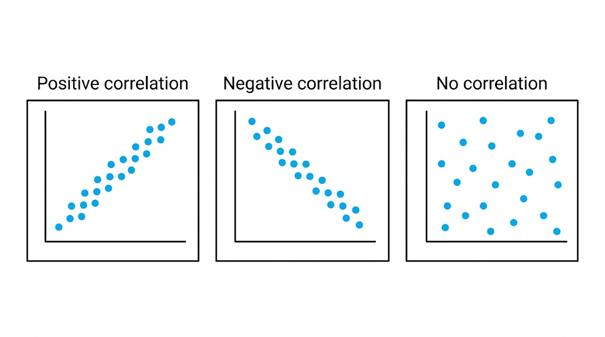  Up together, one up and one down, or no pattern at all.

Describing Correlation
Positive  As one goes up, the other goes up. Height and shoe size. | Negative  As one goes up, the other goes down. The age of a car and its value.
No correlation  No relationship. Height and score in a maths test. | Strong or weak  Strong: the points lie close to a straight line. Weak: they are more spread out but still show a pattern.
Outliers
An outlier is a point that does not fit the pattern of the rest.
▸ Spotting one. A point well away from the others - for example, a very old car that is worth a lot because it is a classic.
▸ Why it happens. A mistake in recording the data, or a genuinely unusual item.
▸ What to do. Do not simply delete it. Note it, and think about why it is different.
▸ In the exam. You may be asked to circle it or give its coordinates.
Correlation Is Not Causation
WHAT CORRELATION SHOWS | WHAT IT DOES NOT SHOW
▸ Two things tend to change together.  ▸ It can help you make predictions.  ▸ It can suggest an idea worth testing. | ▸ That one thing causes the other.  ▸ Ice cream sales and sunburn are positively correlated - but ice cream does not cause sunburn.  ▸ Both are caused by a third thing: hot, sunny weather.
Case Study
CASE STUDY
"Storks Deliver Babies"
In 2000 the statistician Robert Matthews published a paper called "Storks Deliver Babies (p = 0.008)". Using data from 17 European countries, he showed a genuine positive correlation between the number of breeding pairs of storks in a country and the number of babies born there each year. Of course storks do not deliver babies. Bigger countries simply have more room for storks AND more people having babies. His point was that a strong correlation, however convincing it looks, never proves that one thing causes the other.

2000  Matthews publishes the stork paper | 17  European countries in his data
Key Terms
Scatter graph  A graph plotting two sets of data about the same items as points. | Bivariate data  Data with two values for each item.
Correlation  A relationship between two sets of data. | Positive correlation  As one value increases, the other increases.
Negative correlation  As one value increases, the other decreases. | Outlier  A value that does not fit the pattern of the rest of the data.
Your Task: Correlated or Not?
10 minutes
For each pair, predict the correlation (positive, negative or none) and say whether one could cause the other. (a) Temperature outside and number of hot drinks sold. (b) Hours of revision and test score. (c) Arm span and height. (d) House number and number of people living there. (e) Number of firefighters at a fire and the damage done.
1. Predict the correlation.
2. Decide if one causes the other.
3. Look for a hidden third factor.
A good answer shows: (a) Negative; plausibly causal. (b) Positive; plausibly causal, but other factors matter. (c) Strong positive; both depend on body size. (d) None. (e) Positive - but firefighters do not cause damage: bigger fires need more firefighters AND cause more damage.
Note: Part (e) is the one to discuss: a real correlation with an obvious hidden third factor.
Can I...?
☐ Plot a scatter graph.
☐ Describe positive correlation.
☐ Describe negative correlation.
☐ Recognise no correlation.
☐ Say if correlation is strong or weak.
☐ Identify an outlier.
☐ Interpret correlation in context.
☐ Explain that correlation is not causation.
Summary
✓ A scatter graph plots two measurements for each item; do not join the points.
✓ Correlation is positive, negative or none, and strong or weak.
✓ An outlier does not fit the pattern.
✓ Correlation does not prove causation: look for a third factor.

EXAM FOCUS
Describe the relationship between the temperature and the number of hot chocolates sold. (1 mark)
"Describe the relationship" wants a sentence in context: "as the temperature increases, the number of hot chocolates sold decreases". Just "negative" may not get the mark.
Exam Practice: Scatter Graphs
Answer all questions. · 15 minutes
▸ Question 1 · 3 marks · Calculator. The scatter graph shows the midday temperature and the number of hot chocolates sold by a café on 12 days. (a) What type of correlation…
▸ Question 2 · 2 marks · Calculator. Data from one summer shows positive correlation between ice cream sales and the number of people with sunburn. Jo says, "Eating ice cream…
▸ Question 3 · 1 mark · Calculator. Which of these pairs is most likely to show negative correlation? A: a person's height and their arm span. B: the age of a car and its…
Question 1 · 3 marks · Calculator
The scatter graph shows the midday temperature and the number of hot chocolates sold by a café on 12 days. (a) What type of correlation does the graph show? (b) One of the points is an outlier. Write down its coordinates. (c) Describe the relationship between the temperature and the number of hot… (3 marks) | 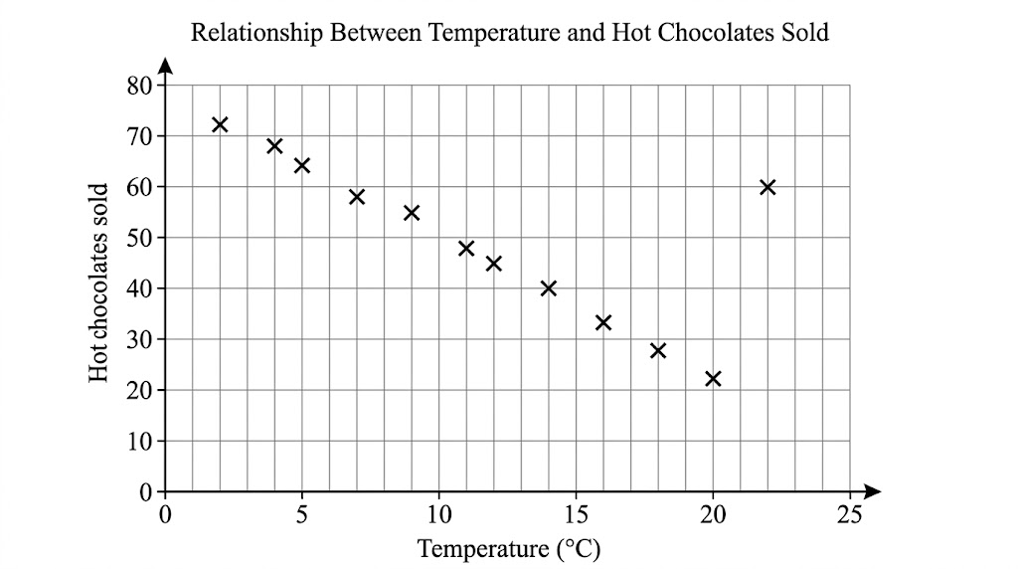

Question 1 · mark scheme
3 marks available. Award a mark for each point made.
▸ (a) Negative. B1
▸ (b) (22, 60). B1
▸ (c) A statement in context, e.g. the warmer it is, the fewer hot chocolates are sold. C1
▸ Model answer. (a) Negative correlation. (b) (22, 60). (c) As the temperature increases, the number of hot chocolates sold decreases.
Question 2 · 2 marks · Calculator
“Data from one summer shows positive correlation between ice cream sales and the number of people with sunburn. Jo says, "Eating ice cream causes sunburn." Is Jo correct? Explain your answer.”
HOW TO ANSWER IT Command word: Calculator. Worth 2 marks, so plan before writing.
Question 2 · mark scheme
2 marks available. Award a mark for each point made.
▸ No, with a statement that correlation does not prove causation. C1
▸ A third factor identified, e.g. hot or sunny weather. C1
▸ Model answer. No. Correlation does not show that one causes the other. Both ice cream sales and sunburn increase because of a third factor - hot, sunny weather.
Question 3 · 1 mark · Calculator
“Which of these pairs is most likely to show negative correlation? A: a person's height and their arm span. B: the age of a car and its value. C: a person's house number and their age.”
HOW TO ANSWER IT Command word: Calculator. Worth 1 mark, so plan before writing.
Question 3 · mark scheme
1 mark available. Award a mark for each point made.
▸ B. B1
▸ Model answer. B - as a car gets older, its value goes down.

