EDEXCEL GCSE MATHS · FOUNDATION & HIGHER
Exam Practice: Line of Best Fit
Line of best fit · Interpreting and representing data · Lesson 4 of 6 · 6 marks · 15 minutes
Name Date
Answer all questions. Draw any lines you use on the graph.
Question 1 CALCULATOR [5 marks]
The scatter graph shows the number of hours ten students revised and their test scores. (a) One point is an outlier. Write down its coordinates. (b) Draw a line of best fit on the graph. (c) Use your line to estimate the score of a student who revised for 5.5 hours. (d) Explain why it may not be sensible to use your line to estimate the score of a student who revised for 20 hours.
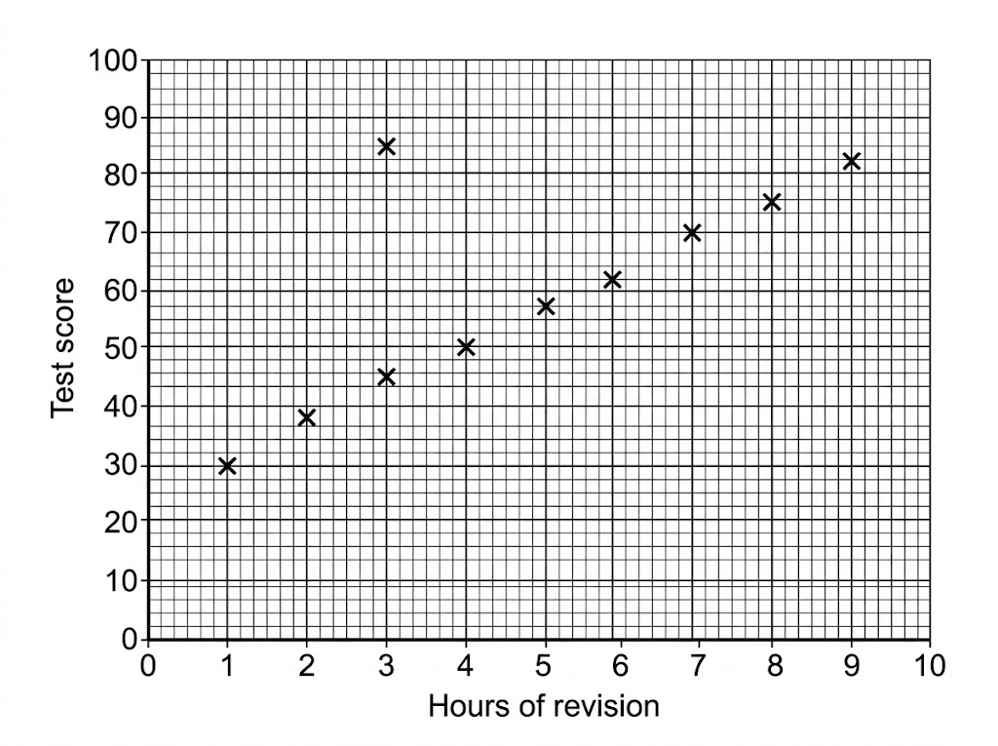

Question 2 CALCULATOR [1 mark]
What is the difference between interpolation and extrapolation?

Answers
Check your answer only once you have written one.
Question 1 [5 marks]
(a) (3, 85). (b) A straight line through the middle of the other nine points. (c) About 60 (accept 57 to 63). (d) 20 hours is far outside the range of the data (extrapolation), and the line would predict a score above 100, which is impossible.
▸ (a) (3, 85) B1
▸ (b) A single straight line within the band of the points, ignoring the outlier B1
▸ (c) Reading from their line at 5.5 hours M1
▸ (c) An answer in the range 57 to 63 A1
▸ (d) A reason such as outside the range of the data, or the score cannot exceed 100 C1
Question 2 [1 mark]
Interpolation is estimating a value inside the range of the data; extrapolation is estimating a value outside the range of the data.
▸ Both described correctly B1

