EDEXCEL GCSE MATHS · FOUNDATION & HIGHER
Line of best fit
Interpreting and representing data · Lesson 4 of 6
Teacher copy - includes the notes for whoever is teaching from it.
Last Lesson
Answer each one, then check.
1. What does positive correlation mean?
As one value increases, the other increases.
2. What is an outlier?
A value that does not fit the pattern.
3. Does correlation prove that one thing causes another?
No
4. Which correlation: temperature and hot drinks sold?
Negative
Learning Objectives
1. Draw a line of best fit on a scatter graph.
2. Use a line of best fit to estimate values (interpolation).
3. Explain why extrapolation can be unreliable.
4. Decide how reliable an estimate is.
5. Deal with outliers when drawing a line of best fit.
Drawing a Line of Best Fit
A line of best fit is a single straight line that follows the trend of the points.
▸ Straight, with a ruler. One straight line - not a curve, and not dot to dot.
▸ Through the middle. About the same number of points on each side, following the slope of the pattern.
▸ Ignore outliers. An outlier would pull the line away from the rest.
▸ Not always from 0. The line does not have to go through the origin.
▸ Only with correlation. If there is no correlation, there is no line of best fit.
A Line of Best Fit in Use
To estimate a value, go from the known value to the line of best fit, then across to the other axis. Here, a car 4.5 years old is estimated to be worth about £6700. The estimate is reasonable because 4.5 years is inside the range of the data. | 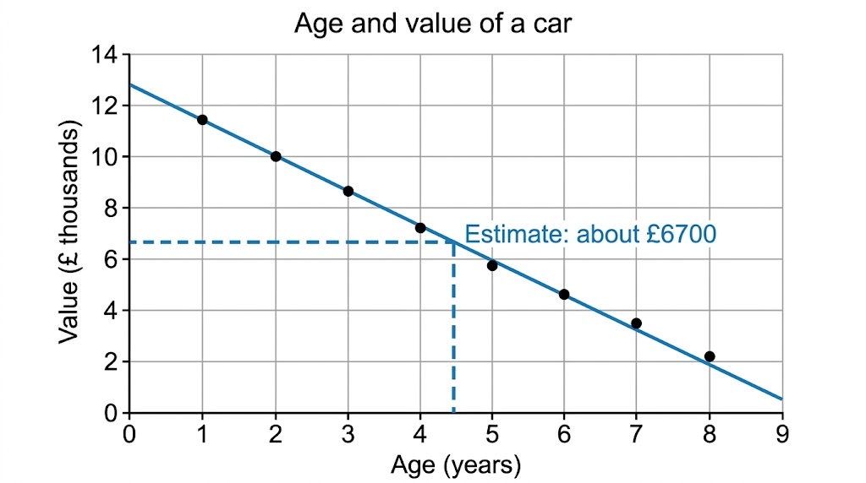  Up from 4.5 years, across to about £6700.

Interpolation and Extrapolation
INTERPOLATION - INSIDE THE DATA | EXTRAPOLATION - OUTSIDE THE DATA
▸ Estimating within the range of values you have.  ▸ A 4.5-year-old car, when the data covers 1 to 8 years.  ▸ Usually reliable, if the correlation is strong. | ▸ Estimating beyond the range of values you have.  ▸ A 15-year-old car, when the data stops at 8 years.  ▸ Unreliable: the pattern may not continue - the line would say the car is worth less than nothing.
Using a Line of Best Fit
Use the car graph to estimate (a) the value of a car that is 4.5 years old, and (b) the age of a car worth £9000.

1. (a) Go up from 4.5 on the age axis to the line
then across to the value axis
2. Read the value
about 6.7 (£ thousands)
3. (b) Go across from 9 on the value axis to the line
then down to the age axis
4. Read the age
about 2.8 years
Answer: (a) About £6700 (b) About 2.8 years (accept answers close to these)
How Reliable Is the Estimate?
An estimate from a line of best fit is only as good as the data behind it.
▸ Strong correlation. Points close to the line give more reliable estimates.
▸ Inside the data. Interpolation is more reliable than extrapolation.
▸ Enough data. Estimates from 30 points are more reliable than from 5.
▸ Sensible values. A line might predict a negative price or a test score over 100 - a sign it has gone too far.
Key Terms
Line of best fit  A straight line drawn through the middle of the points on a scatter graph, following the trend. | Interpolation  Estimating a value inside the range of the data.
Extrapolation  Estimating a value outside the range of the data. | Reliable  Likely to be accurate.
Outlier
A point that does not fit the pattern, ignored when drawing the line.
Your Task: Plot, Fit, Estimate
15 minutes
Ten students recorded their arm span and height, in cm: (150, 152), (155, 154), (158, 160), (162, 161), (165, 167), (168, 166), (171, 172), (175, 174), (178, 180), (182, 181). Plot a scatter graph, draw a line of best fit, estimate the height of a student with an arm span of 173 cm, and explain whether you could use the graph for an adult with an arm span of 200 cm.
1. Choose sensible scales and label the axes.
2. Plot the points and draw the line.
3. Estimate, and comment on reliability.
A good answer shows: Strong positive correlation; the line is close to height = arm span. Estimate for 173 cm: about 173 cm. An arm span of 200 cm is outside the data (extrapolation), so the estimate would be less reliable.
Note: The line should run close to y = x - a nice discussion point about why arm span and height are so closely linked.
Can I...?
☐ Draw a line of best fit.
☐ Leave out outliers when drawing it.
☐ Estimate a y-value from an x-value.
☐ Estimate an x-value from a y-value.
☐ Explain interpolation.
☐ Explain extrapolation.
☐ Say why an estimate might be unreliable.
☐ Spot an estimate that makes no sense.
Summary
✓ One straight line through the middle of the points, ignoring outliers.
✓ Up (or across) to the line, then across (or down) to read the estimate.
✓ Interpolation is inside the data and usually reliable; extrapolation is outside it and often not.
✓ Stronger correlation and more data give more reliable estimates.

EXAM FOCUS
Explain why it may not be sensible to use the line of best fit to estimate the score of a student who revised for 20 hours. (1 mark)
When asked to estimate from a graph, draw the lines you use on the graph. An answer in the accepted range earns the marks, and the lines show the examiner your method.
Exam Practice: Line of Best Fit
Answer all questions. Draw any lines you use on the graph. · 15 minutes
▸ Question 1 · 5 marks · Calculator. The scatter graph shows the number of hours ten students revised and their test scores. (a) One point is an outlier. Write down its…
▸ Question 2 · 1 mark · Calculator. What is the difference between interpolation and extrapolation?
Question 1 · 5 marks · Calculator
The scatter graph shows the number of hours ten students revised and their test scores. (a) One point is an outlier. Write down its coordinates. (b) Draw a line of best fit on the graph. (c) Use your line to estimate the score of a student who revised for 5.5 hours. (d) Explain why it may not be… (5 marks) | 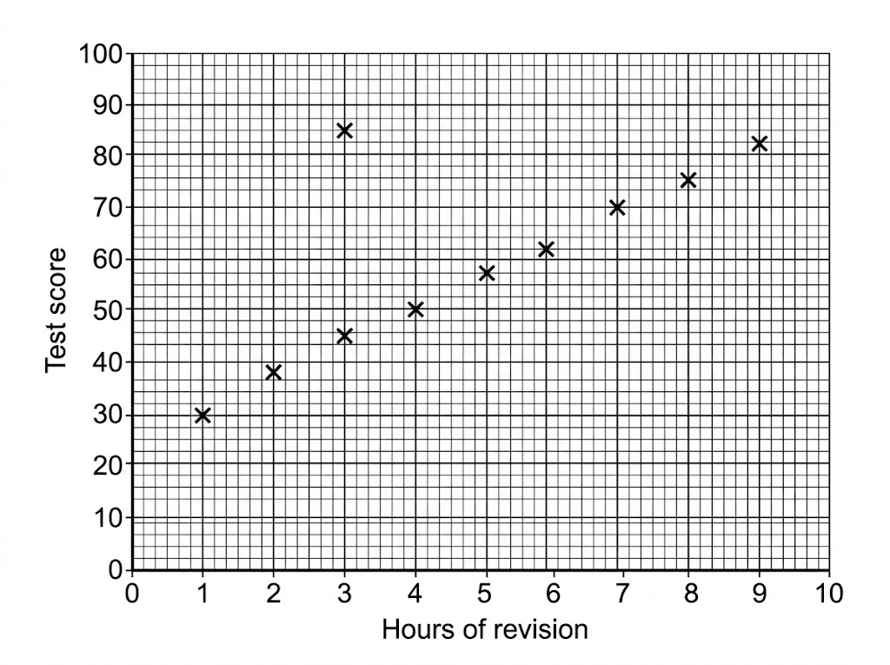

Question 1 · mark scheme
5 marks available. Award a mark for each point made.
▸ (a) (3, 85). B1
▸ (b) A single straight line within the band of the points, ignoring the outlier. B1
▸ (c) Reading from their line at 5.5 hours. M1
▸ (c) An answer in the range 57 to 63. A1
▸ (d) A reason such as outside the range of the data, or the score cannot exceed 100. C1
▸ Model answer. (a) (3, 85). (b) A straight line through the middle of the other nine points. (c) About 60 (accept 57 to 63). (d) 20 hours is far outside the range of the data (extrapolation), and the line would predict a score above 100, which is impossible.
Question 2 · 1 mark · Calculator
“What is the difference between interpolation and extrapolation?”
HOW TO ANSWER IT Command word: Calculator. Worth 1 mark, so plan before writing.
Question 2 · mark scheme
1 mark available. Award a mark for each point made.
▸ Both described correctly. B1
▸ Model answer. Interpolation is estimating a value inside the range of the data; extrapolation is estimating a value outside the range of the data.

