EDEXCEL GCSE MATHS · FOUNDATION & HIGHER
Statistical diagrams 2
Interpreting and representing data · Lesson 6 of 6
Teacher copy - includes the notes for whoever is teaching from it.
Last Lesson
Answer each one, then check.
1. Find the median of 3, 5, 8, 10.
6.5 - the mean of 5 and 8.
2. What is the range of 12, 4, 19, 7?
19 − 4 = 15
3. What is a modal class?
The class with the highest frequency.
4. What is the midpoint of the class 20 < t ≤ 30?
25
Learning Objectives
1. Draw and read an ordered stem-and-leaf diagram, with a key.
2. Find averages and the range from a stem-and-leaf diagram.
3. Draw a frequency polygon for grouped data.
4. Compare two sets of data using an average and the range.
5. Recognise graphs that are misleading.
Stem-and-Leaf Diagrams
A stem-and-leaf diagram sorts data into order while keeping every value.
▸ Stem and leaf. Split each value: for 73, the stem is 7 (the tens) and the leaf is 3 (the units).
▸ Ordered. Write the leaves in order from smallest to largest along each row.
▸ Key. Always include one, such as "7 then 3 means 73 beats per minute", written with a bar between the stem and the leaf.
▸ Shape. Turned on its side, it looks like a bar chart of the data.
Resting Pulse Rates of 15 People
Key: 7 then 3 means 73 beats per minute.
Stem | Leaves
5 | 8
6 | 2 5 7
7 | 0 1 1 3 6 8
8 | 0 2 5
9 | 1 4
Reading a Stem-and-Leaf Diagram
Use the pulse rate diagram to find the median, the mode and the range.

1. Count the values
1 + 3 + 6 + 3 + 2 = 15, so the median is the 8th value
2. Count along the leaves to the 8th
58, 62, 65, 67, 70, 71, 71, 73
3. The mode: the only repeated value
71
4. The range: largest − smallest
94 − 58 = 36
Answer: Median 73, mode 71, range 36 beats per minute
Back-to-Back Stem-and-Leaf Diagrams
Two sets of data share one stem, with one set's leaves on each side.
▸ Layout. The stem runs down the middle. The leaves of one set go to the right; the other set's go to the left.
▸ Reading the left side. The leaves on the left are read from the stem outwards: a leaf 4 by stem 6 on the left means 64.
▸ Two keys. One for each side, so there is no confusion.
▸ Why. Two groups can be compared at a glance - for example, pulse rates before and after exercise.
PART TWO
Frequency Polygons
Grouped data drawn as a line.
Drawing a Frequency Polygon
A frequency polygon plots the midpoint of each class against its frequency.
▸ Midpoints. Work out the midpoint of each class.
▸ Plot. Plot (midpoint, frequency) for each class.
▸ Join. Join the points with straight lines. Do not join the last point back to the first.
▸ Compare. Two frequency polygons on the same axes compare two sets of data clearly.
A Frequency Polygon
This is the journey time data from last lesson. The peak at 15 minutes shows the modal class, 10 < t ≤ 20, straight away. Drawing a second polygon on the same axes - say, for another year group - would let you compare the two. | 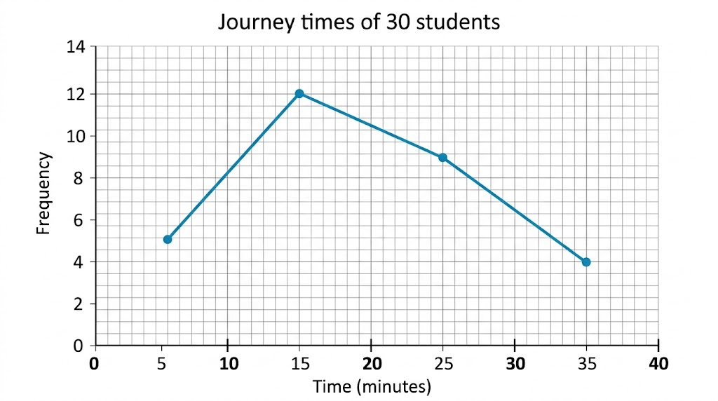  Each point sits above the middle of its class.

Comparing Distributions
To compare two sets of data, always compare an average AND a measure of spread - in context.
▸ An average. "The median pulse rate after exercise (112) is higher than before (73), so pulse rates were higher on average after exercise."
▸ The spread. "The range after exercise (22) is smaller than before (36), so the pulse rates after exercise were more consistent."
▸ In context. Use the words of the question: "pulse rates", not "the data".
▸ Two sentences. One for the average, one for the spread - that is what most mark schemes want.
PART THREE
Misleading Graphs
How a graph can give the wrong impression.
Spot the Trick
Sales rose from 92 to 98 - about 6%. Start the axis at 90 and the rise looks enormous. Look out for axes that do not start at zero, uneven scales, missing labels, and 3D charts that make the nearest sections look bigger. | 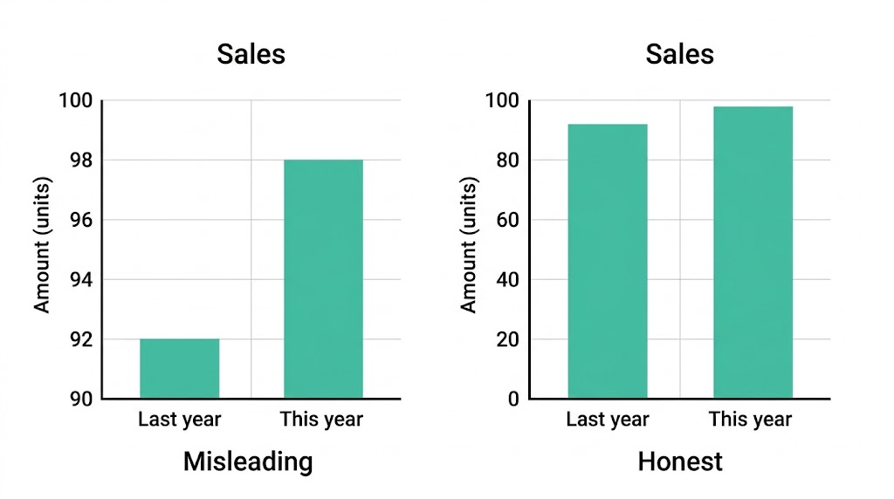  The same numbers, two very different impressions.

Key Terms
Stem-and-leaf diagram  A diagram that orders data by splitting each value into a stem and a leaf. | Key  The line that explains how to read a diagram, e.g. 7 then 3 means 73.
Frequency polygon  A graph joining points plotted at the midpoints of classes against their frequencies. | Distribution  How the values of a set of data are spread out.
Misleading graph
A graph that gives a false impression of the data.
Your Task: Before and After
15 minutes
Measure your resting pulse for 15 seconds and multiply by 4. Then do 1 minute of star jumps and measure it again. Collect the class results and draw a back-to-back stem-and-leaf diagram of "before" and "after". Find the median and range of each, and write two sentences comparing them.
1. Collect the data.
2. Draw the back-to-back diagram with keys.
3. Find the median and range of each.
4. Compare in two sentences.
A good answer shows: A back-to-back diagram with ordered leaves and two keys; medians and ranges for both sets; one comparison of the medians and one of the ranges, both in context.
Note: Any student who should not exercise can record and plot the data instead.
Can I...?
☐ Draw an ordered stem-and-leaf diagram with a key.
☐ Find the median and range from a stem-and-leaf diagram.
☐ Read a back-to-back stem-and-leaf diagram.
☐ Draw a frequency polygon.
☐ Compare two data sets using an average.
☐ Compare two data sets using the range.
☐ Write comparisons in context.
☐ Explain why a graph is misleading.
Summary
✓ Stem-and-leaf: ordered leaves and a key; it keeps every value.
✓ Frequency polygon: plot (midpoint, frequency) and join with straight lines.
✓ Compare with an average AND a measure of spread, in context.
✓ Misleading graphs: check that the axes start at zero and the scales are even.

EXAM FOCUS
Compare the times taken by the two groups. (2 marks)
Two marks means two comparisons: one about an average (which is higher) and one about the spread (which is more consistent), both in the context of the question.
Exam Practice: Statistical Diagrams 2
Answer all questions. Show your working. All questions are non-calculator. · 20 minutes
▸ Question 1 · 3 marks · Non-calculator. Here are the times, in seconds, that 12 students took to solve a puzzle: 23, 35, 41, 28, 32, 45, 38, 26, 31, 40, 36, 29. Draw an ordered…
▸ Question 2 · 2 marks · Non-calculator. For the puzzle times in the last question, find (a) the median (b) the range.
▸ Question 3 · 2 marks · Non-calculator. A second group of students solved the same puzzle. Their median time was 38 seconds and their range was 15 seconds. Compare the times of…
▸ Question 4 · 2 marks · Non-calculator. A company used this graph in an advert to show that its sales had "soared". Give two reasons why the graph is misleading.
▸ Question 5 · 2 marks · Non-calculator. The table shows the heights, h cm, of 25 plants. 0 < h ≤ 10: 3 plants. 10 < h ≤ 20: 8 plants. 20 < h ≤ 30: 10 plants. 30 < h ≤ 40: 4…
Question 1 · 3 marks · Non-calculator
“Here are the times, in seconds, that 12 students took to solve a puzzle: 23, 35, 41, 28, 32, 45, 38, 26, 31, 40, 36, 29. Draw an ordered stem-and-leaf diagram to show this information.”
HOW TO ANSWER IT Command word: Non-calculator. Worth 3 marks, so plan before writing.
Question 1 · mark scheme
3 marks available. Award a mark for each point made.
▸ A correct stem-and-leaf diagram with the leaves in order. B2
▸ A correct diagram with the leaves not in order, or one error. B1
▸ A correct key. B1
▸ Model answer. Stem 2: 3 6 8 9. Stem 3: 1 2 5 6 8. Stem 4: 0 1 5. Key: 2 then 3 means 23 seconds.
Question 2 · 2 marks · Non-calculator
“For the puzzle times in the last question, find (a) the median (b) the range.”
HOW TO ANSWER IT Command word: Non-calculator. Worth 2 marks, so plan before writing.
Question 2 · mark scheme
2 marks available. Award a mark for each point made.
▸ (a) 33.5. B1
▸ (b) 22. B1
▸ Model answer. (a) In order: 23, 26, 28, 29, 31, 32, 35, 36, 38, 40, 41, 45. The median is (32 + 35)/2 = 33.5 seconds. (b) 45 − 23 = 22 seconds.
Question 3 · 2 marks · Non-calculator
“A second group of students solved the same puzzle. Their median time was 38 seconds and their range was 15 seconds. Compare the times of the two groups.”
HOW TO ANSWER IT Command word: Non-calculator. Worth 2 marks, so plan before writing.
Question 3 · mark scheme
2 marks available. Award a mark for each point made.
▸ A correct comparison of the medians, in context. C1
▸ A correct comparison of the ranges, in context. C1
▸ Model answer. The first group had a lower median (33.5 s against 38 s), so on average they solved the puzzle faster. The second group had a smaller range (15 s against 22 s), so their times were more consistent.
Question 4 · 2 marks · Non-calculator
A company used this graph in an advert to show that its sales had "soared". Give two reasons why the graph is misleading. (2 marks) | 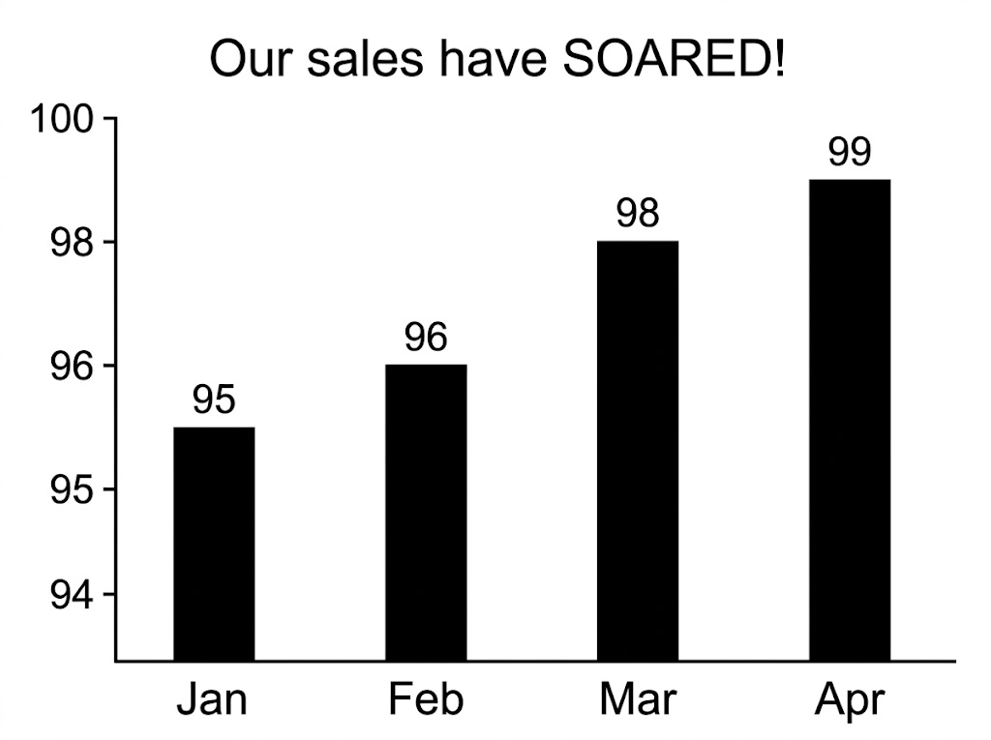

Question 4 · mark scheme
2 marks available. Award a mark for each point made.
▸ One valid reason, e.g. the axis does not start at 0. C1
▸ A second valid reason, e.g. no axis label, or an uneven scale. C1
▸ Model answer. The vertical axis does not start at zero, so the increase looks much bigger than it is. The vertical axis has no label or units, and the scale is uneven.
Question 5 · 2 marks · Non-calculator
“The table shows the heights, h cm, of 25 plants. 0 < h ≤ 10: 3 plants. 10 < h ≤ 20: 8 plants. 20 < h ≤ 30: 10 plants. 30 < h ≤ 40: 4 plants. Write down the coordinates of the points you would plot to draw a frequency polygon.”
HOW TO ANSWER IT Command word: Non-calculator. Worth 2 marks, so plan before writing.
Question 5 · mark scheme
2 marks available. Award a mark for each point made.
▸ All four points correct. B2
▸ Midpoints correct, or at least two points correct. B1
▸ Model answer. (5, 3), (15, 8), (25, 10), (35, 4)

